**Digitization Of Takepan Sasak Manuscipt Based on the OPF Flipbook**

**LM Samsu1*, M Saiful, I Fathurrahman and H Bahtiar**

Faculty of Engineering, Hamzanwadi University, Lombok, Indonesia

*[lmsamsu311275@gmail.com](mailto:lmsamsu311275@gmail.com)

**Abstrak.** This study aims to preserve the Takepan Sasak manuscript, studied and known by the public. This study uses evaluative methods and Kvisoft Flipbook Maker software. The process stages consist of data collection, analysis, digitization, testing and experimentation, and evaluation. The results of this study are in the form of a Sasak Takepan Manuscript flipbook which is expected to be accessed by the public digitally in a 3-dimensional model.

Keywords— Takepan Sasak, Digitalization, OPF Flipbook, e-book

**1.Introduction**

West Nusa Tenggara has many cultural heritages that must be protected in order to be preserved. One of them is Lombok Island which holds a large collection of manuscripts. In fact, this island is known as a "conservation laboratory" of Old Javanese manuscripts from an Islamic perspective[1]. For example, the SasakTakepan Manuscript which is made and written on dry palm leaves using the reramputan language which is a mixture of several languages such as Sasak, Balinese, Javanese, and Malay which is known as the jejawan script which comes from the Javanese language ancient[2]. Takepan has a historical value that is still kept by the community until now[3] and even become one of the subjects in the local school curriculum[4]. However, many people still do not know these historical objects because they are lost, borrowed, or even traded. Although the number is starting to decrease, over time it will experience degradation due to termites, fungi, and scratches on the writing so that the letters in front of them cannot be read[5].

In today's digital era, the electronic book is an innovation that can be used by the public.The use of this technology is supported by the government in delivering information from conventional to electronic books or e-books([6]). One of the e-books, namely the Flipbook, is a 3-dimensional digital book that has an animated display like a book by combining elements of text, images, videos so that it is interesting([7–9]). Research[10] shows that the use of flipbooks is feasible and very practical.Another study [11] states that kvsof flipbook-based digital book design is very good and keeps the book from being damaged. Therefore, research[12] concluded that the media using flipbooks is one of the smart solutions and alternatives in today's digital era.So that the takepan manuscript can be preserved, studied, and known by the public or the general public. Therefore, there is a need for digitization[13], namely ebooks that make it easy to access the contents of the Lombok Sasak Takepan. So that in this research, the researcher made an electronic book or flipbook through the Kvisoft Flipbook Maker.

**2. Literature**

## Research conducted by A. M. Abror, Suryani and friends with the journal "Digital Flipbook Empowerment as A Development Means for History Learning Media" concluded that electronic-based books can be understood by students, especially history subjects[12].

According to Divayana DGH in the journal "The Design of Digital Book Content for Assessment and Evaluation Courses by Adopting Superitem Concept Based on Kvisoft Flipbook Maker in the era of Industry 4.0" using Kvisoft Flipbook Maker in making digital books to produce a good appearance and design and keep books from broken[11].

The research conducted by Hidayatulloh and Mukhlis entitled "Developing Electrical Circuits Flipbook Using Flipbuilder" uses a Flipbuilder that is integrated with PhET Simulation software called an electric circuit flipbook. Produce an e-book that is attractive and easy to learn and can be accessed easily[10].

Menurut Caroline T. Schroeder dalam penelitiannya yang berjudul "The Digital Humanities as Cultural Capital: Implications for Biblical and Religious Studies", digitalisasi adalah proses menerjemahkan informasi seperti buku, rekaman suara, gambar atau video, menjadi bit-bit yang mana bit-bit tersebut merupakan unit dasar informasi di computer[14].

Meanwhile, according to S. Bandi, M. Angadi, and J. Shivarama in their journals, digitization is the process of converting any form of printed or other documents into a digital presentation[15].

## 2.1 Manuskrip

Philology is a science that studies manuscripts related to the writings of the past with the assumption that the writings contain values that are still relevant to modern life[16].

## 2.1Digitization

Information is important, especially in the industrial era 4.0. Utilization of increasingly advanced technological devices, people can take advantage of social media as information without having to meet face to face. Where the information becomes digital previously in analog format.This process is called digitization because it is a process of changing from an analog document to an electronic document [13,16].

## 2.2OPF FlipBook

OPF is an XML-based electronic book format created by electronic book systems. E-books or e-books in this format are used when Kvisoft Flipbook Maker is rendering to create an e-book with realistic 3D Flash effects and stunning page-turning..A flipbook that can be presented in an electronic format is capable of displaying interactive simulations by combining text, images, audio, video, animation, and navigation [17,18] .

**3.Method**

This study uses an evaluative method. The subject of the research was the Lombok Sasak Takepan manuscript in East Lombok The first phase of research began with the collection of existing Takepan manuscript data from several sources. After that, the researcher conducted an analysis to determine the software used in the digitizing process. The digitization process uses Kvisoft Flipbook Maker software.

To facilitate the manufacture of this digitization system, a research design stage is carried out which aims to describe the process of the system to be built. The following is figure 1. The diagram of the stages of the digitization process in this study consists of:

**Figure 1.** Research Method

*3.1. The data collection stage*

This is the initial stage which is to collect data on the takepan manuscript located in Lombok east of sakra village West Nusa Tenggara

*3.2. Analysis Phase*

The system analysis stage is the stage of identifiers and designing the digitization of the SasakTakepan script and the required needs.

*3.3. Digitalization and System Development Stage*

The stages of the design process, namely creating a storyboard in the form of text and images, are followed by the development of a design to create an electronic book using Kvisoft Flipbook Maker software.

*3.4.Experiment and Testing*

The results that have been tested from the electronic book and see whether the resulting system can match the wishes of the researcher.

*3.5. Evaluation*

The final stage is carried out to correct existing deficiencies by comparing the final result with the previous results, whether this interactive model can be implemented by the community in studying the TakepanSasak script.

# **Results and discussion**

In the Figure 2. It is the design result of Kvisoft Flipbook Maker which contains the ebook manuscript of takepan Lombok in * .exe format.

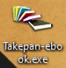

**Figure 2.** E-book TakepanSasakLombok

The following Figure 3. shows the cover of the Takepan Sasak Lombok e-book in 3D with features such as zoom out, zoom in, print, full screen, and etc.

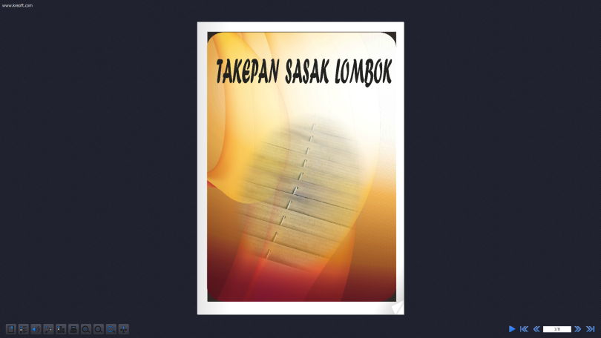

**Figure 3.** Cover e-book TakepanSasak Lombok

One of the advantages of the Takepan Sasak Lombok ebook is easy access as in Figure 4. because there are navigation buttons such as the first page, previous, play, next, and etc.

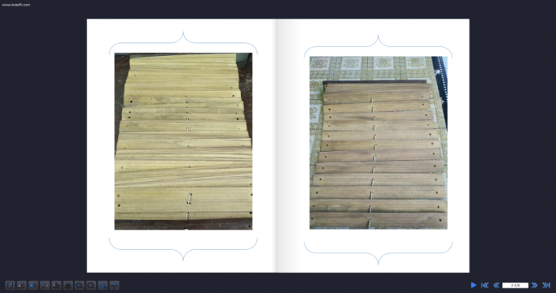

**Figure 4.** One of the contents pages of the e-book TakepanSasak

1. **Conclusion**

The TakepanSasak Lombok which is made from palm leaves is very easily damaged due to degradation over time so that it cannot be read.The flipbook is an alternative that can preserve local culture, especially TakepanSasak because it can be accessed digitally and studied by the wider community.

**Acknowledgment**

Finally, I would like to thank everyone who played an important role in the success of this research. This journal is far from perfect, but it is expected to be useful not only for researchers, but also for readers. For this reason, constructive criticism and suggestions are welcome.

**References**

[1] Rosidi A 2008 Melihat Masa Lalu Orang Sasak. [Online]. Available: http://terune-sasak.blogspot.com/2008/12/meliat-masa-lalu-orang-sasak.html.

[2] Hamid S A 2013 Translation of Manuscripts in Lombok : an Effort To Understand the Sasak ’ S Cultural Values *Mabasan* **7** 75–84.

[3] Primadesi Y 2012 Peran Masyarakat Lokal dalam Usaha Pelestarian Naskah-Naskah Kuno Paseban *Komposisi J. Pendidik. Bahasa, Sastra, dan Seni* **11.**

[4] Saiful M, Samsu L M and Fathurrahman I 2020 Perancangan Kerangka Crowdsourcing Berbasis Wisdom Of Crowds Untuk Kamus Naskah Lontar (Takepan) Sasak Online *Infotek J. Inform. dan Teknol.* **3** 165–73.

[5] Samsu L and Fathurrahman I 2020 Adaptive Thresholding Algorithms and Morphological to Improve the Quality of Takepan Sasak Image Readability *J. Phys. Conf. Ser.* **1539** 012031.

[6] Abdul Ghofur R K 2015 PENGEMBANGAN e-BOOK BERBASIS FLASH KVisoft FlipBook PADA MATERI KINEMATIKA GERAK LURUS SEBAGAI SARANA BELAJAR SISWA SMA KELAS X *J. Inov. Pendidik. Fis.* **Vol. 04** 2

[7] Hardiansyah D 2016 Pengembangan Media Flash Flipbook dalam Pembelajaran Perakitan Komputer untuk Meningkatkan Hasil Belajar Siswa Kelas X TKJ SMK Negeri 7 Surabaya *It-Edu* **1** 5–11.

[8] Diani R, Hartati N S and Email C A 2018 Flipbook berbasis literasi Islam: Pengembangan media pembelajaran fisika dengan 3D pageflip professional *Flip. Berbas. literasi Islam Pengemb. media pembelajaran Fis. dengan 3D pageflip Prof.* **4** 234–44.

[9] Damarsasi, D. G., & Saptorini S 2018 Pengembangan E-Modul Berbasis Flip Book Maker Materi *J. Pendidik. Ilmu Sos.* **27** 1–10.

[10] Hidayatulloh M 2019 DEVELOPING ELECTRICAL CIRCUITS FLIPBOOK USING FLIPBUILDER *Int. J. Innov. Educ. Res.* **7** 124–34.

[11] Divayana D G H, Suyasa P W A, Ariawan I P W, Mahendra I W E and Sugiharni G A D 2019 The Design of Digital Book Content for Assessment and Evaluation Courses by Adopting Superitem Concept Based on Kvisoft Flipbook Maker in era of Industry 4.0 *J. Phys. Conf. Ser.* **1165** 012020.

[12] A M A, Suryani N and Ardianto D T 2020 Digital Flipbook Empowerment as A Development Means for History Learning Media *JPI (Jurnal Pendidik. Indones.* **8** 266.

[13] Zahidah Z, Noorhidawati A and Zainab A N 2013 Exploring the needs of Malay manuscript studies community for an e-learning platform *Malaysian J. Libr. Inf. Sci.* **16** 31–47.

[14] Schroeder B C T 2016 Biblical and Religious Studies *J. Relig. Media Digit. Cult.* **5** 21–49.

[15] Bandi S, Angadi M and Shivarama J 2015 Best Practices in Digitisation: Planning and Workflow Processes *Emerg. Technol. Futur. Libr. Issues Challenges* 332–9.

[16] Bandi S, Angadi M and Shivarama J 2015 Best Practices in Digitisation: Planning and Workflow Processes *Emerg. Technol. Futur. Libr. Issues Challenges* 332–9.

[17] Burch M and Weiskopf D 2014 A Flip-Book of Edge-Splatted Small Multiples for Visualizing Dynamic Graphs *Proceedings of the 7th International Symposium on Visual Information Communication and Interaction - VINCI ’14* vol 2014-Augus (New York, New York, USA: ACM Press) pp 29–38.

[18] Baroroh-Baried S, Sutrisno S, Soeratno S C, Sawu K Z I and Istanti K Z 1994 Pengantar teori filologi *Yogyakarta BPPF Fak. Sastra Univ. Gadjah Mada.*