***Augmented reality:* Physics on Wave and Vibration**

SD Aji, T Setyowati, S Jumina and MN Hudha

Universitas Kanjuruhan Malang, Jl.S. Supriadi no. 48, Malang 65148, Indonesia

[*sudi@unikama.ac.id](mailto:*sudi@unikama.ac.id)

**Abstract:** Augmented reality (AR) is a technology that can be used in the classroom. This study aims to create an AR application and pilot the AR application in the vibrations and waves learning. Furthermore, to see if there are differences in the learning interest and physics learning outcomes by using the AR application in the learning process. The research method used to develop this application is by adapting the 4D Thiagarajan model (Define, Design, Develop, and Disseminate). The result shows there are differences in physics learning outcomes and learning interests of students studying physics using AR. AR and the use of media can be a solution for learning physics in the future.

1. **Introduction**

Augmented reality (AR) is a technology that combines the real world with interactive virtual worlds [1] [2]. AR has enormous benefits in improving the teaching and learning process because AR has a visualization aspect that will arouse students' interest in learning. Furthermore, it will help students to understand concretely the material presented through 3D visual representations by involving user interactions in the AR frame. By using AR technology, students will be able to understand the subject matter concretely because they get a unique sensation of explanation and learning and are directly involved in the process.

The use of AR in education has been practiced widely. Among them are in the field of learning biology [3], learning chemistry [4], history [5], and so on. Even in the field of astronomical physics [6], there are already those who make. But we are trying to make vibration and wave learning using AR.

The concept of vibration and waves is a physics concept that is closely related to the everyday phenomenon. This concept is chosen because of the need for learning media on the topic of vibrations and waves for middle school students [7]; the abstract concepts of vibrations and waves require the need for an appropriate medium as this concept is hard to present in class, so it requires media to explain it better in the classroom. Without proper media, it might also lead to low learning outcomes because students are less interested in science/physics lessons [8]. This study aims to create AR applications and try out AR applications in learning vibrations and waves.

1. **Method**

The research method used to develop this application is by adapting the 4D Thiagarajan model (Define, Design, Develop, and Disseminate) [9] [10]. The media design developed as illustrated in Figure 1. After developing a media, then the dissemination step was carried out using a Quasi-experiment using a post-test control group design to measure student learning interest and learning outcomes.

The population in this study were the grade VIII students of SMP PGRI 06 Malang, in the 2019/2020 academic year. The purposive sampling technique was used as the sampling technique. The sample in this study amounted to 60 people. In detail, there are 30 people in the experimental class and 30 people in the control class. The data collection techniques used were the provision of test results and student interest in learning questionnaires. The data obtained were then analyzed using a two-way ANOVA analysis.

Showing AR Video on Waves and Vibration

Splash Screen

Main Menu

AR Camera

Subject Matters

Guideline

Marker Download

About

Exit

Marker Sighting

Marker Detected

Showing AR 3D Object

Push the Virtual Button to Play Video

Subject Matters

Instruction

Application History

Marker Download

**Picture 1. Application Flow Diagram**

1. **Results and Discussion**

The concepts of waves and vibration that is served by this application for example are longitudinal waves, transversal waves and the concept of pendulum as illustrated by Picture 2 and Picture 3

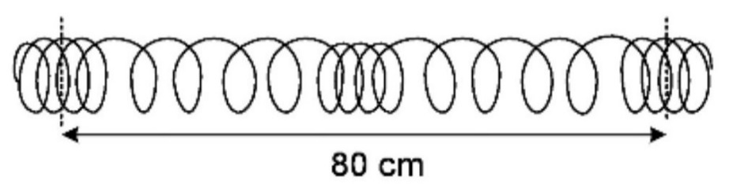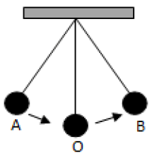

**Picture 2. The concept of Vibration and Waves found in the application**

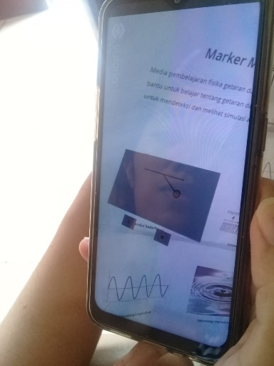

**Picture 3. The AR Application of Vibration and Waves**

The data of the Physics learning outcome and student motivation are obtained using learning outcomes test instruments and learning interest questionnaires. Both of the instruments have been validated by two physics department lecturers and one physics subject high school teacher in Malang. After the learning outcome test was validated by the physics department lecturers and the teacher, it is then given as a trial to the high school students. The learning outcome tests were then checked further for validation, reliability, difficulty level, and diversity of the questions. The learning outcome test consists of 30 multiple-choice questions; while the student motivation questionnaire consists of 24 statements. After conducting the validity test for the 30 multiple choice questions, it was then discovered that 10 of the questions are valid and 20 are not valid. These 10 questions are the one that is used in this research

Based on the results of the two-way ANOVA test, student learning outcomes show that sig > (0,001 < 0,05), then a conclusion can be drawn that the conclusion are accepted, this proves that there are differences in student learning outcomes when using AR learning media compared to students that use conventional learning media.

Students who used conventional learning media were limited in showing their creativity. When the students were required to look for information in books, the students were prone to be lazy in reading and not trying to find answers to problems being studied. Besides, the students only listened to lectures and then given questions or practice questions. Such learning conditions can make students uninterested and bored. Students will find it difficult to understand the material related to the concepts.

The efficient use of learning media can increase student interest in learning and learning effectiveness to improve student learning outcomes. The use of AR learning media can certainly increase students' interest in learning. This can be seen in the average value of student interest using AR which is higher, namely 66.8, while the control class has an average value of 62.8. The difference in the average value of the interest in learning in the experimental class and the control class is 4.0. The use of AR media can increase students' curiosity about what is being learned. Also, there are many ways to arouse student interest in learning. One of them is by making the material as attractive as possible. By designing lessons that let the student explore what they are learning, students will become active and interested in learning. The learning outcomes of students who have high learning interest will be better than the learning outcomes of students who have low learning interest [11].

Students’ interest in learning is also a very important factor which influences learning outcomes. If students like physics, then they will be naturally curious to learn and excited to take physics lessons. They can attain better learning outcomes. Someone who has a high interest in learning will have no issues to learn anything [12]. In other words, when students have an immense interest in learning, they will be more able to control themselves better so they can improve the learning outcomes [13]. Meanwhile, those with low interest in learning will find it difficult to motivate themselves to attain the expected learning outcomes [12].

Thus, this study proves that the use of media will make the students become more motivated, have a high interest in learning, and easily understand the concept of the material presented [14]. It is also proven that the use of media increases students’ concept comprehension [15]. The AR as technology-assisted education used in this study shows that students’ interaction with the targeted knowledge must be maintained by the right technology. It clearly confirms that technology provides an opportunity to intervene and direct the learning process in a better direction [16].

1. **Conclusion**

Based on the results of the research and discussion described, it can be concluded that there are differences in the learning outcomes of students who use AR learning media compared to the students who use conventional learning media. There are differences in the learning outcomes between students with high learning interests compared to low-interest students. The use of AR media can be considered as solution in learning physics in the future.

1. **References**

[1] Mei Y, Nie Q, Wang F, Lin Y and Jiang H 2019 Application of Augmented Reality Technology in Industrial Design *IOP Conf. Ser. Mater. Sci. Eng.* **573**

[2] Afandi B, Kustiawan I and Herman N D 2019 Exploration of the augmented reality model in learning *J. Phys. Conf. Ser.* **1375** 0–8

[3] Erwinsah R, Aria M and Yusup Y 2019 Application of augmented reality technology in biological learning *J. Phys. Conf. Ser.* **1402**

[4] Wulandari I, Irwansyah F S, Farida I and Ramdhani M A 2019 Development of student’s submicroscopic representation ability on molecular geometry material using Augmented Reality (AR) media *J. Phys. Conf. Ser.* **1280**

[5] Agustina R, Sutadji E, Purnomo, Suprianto D, Kusumawati E, Hudha M N D and Afif M 2018 Analysis of implementation Augmented Reality (AR) introduction of temple and ancient objects based on android to increasing student learning outcomes *IOP Conf. Ser. Mater. Sci. Eng.* **434**

[6] Herfana P, Nasir M, Azhar and Prastowo R 2019 Augmented Reality Applied in Astronomy Subject *J. Phys. Conf. Ser.* **1351**

[7] Mahfudz A Z and Billah A 2020 The development of android-based learning media on vibrations and waves topic for junior high school students *J. Phys. Conf. Ser.* **1567**

[8] Sasono M, Huriawati F and Yusro A C 2017 Pengembangan Perangkat Pembelajaran Melalui Pendekatan Konstruktivistik dengan Metode Five E (5E) Stages Learning Cycle untuk Meningkatkan Hasil Belajar dan Keterampilan Proses Sains *Momentum Phys. Educ. J.* **1** 45

[9] Huda C, Hudha M N, Ain N, Nandiyanto A B D, Abdullah A G and Widiaty I 2018 The Implementation of Blended Learning Using Android-Based Tutorial Video in Computer Programming Course II *IOP Conf. Ser. Mater. Sci. Eng.* **288**

[10] Aji S D, Hudha M N, Huda C, NANDIYANTO A B D and ABDULLAH A G 2018 the Improvement of Learning Effectiveness in the Lesson Study By Using E-Rubric *J. Eng. Sci. Technol.* **13** 1181–9

[11] Tatan Z M and Sumiati T 2011 Pengaruh Penggunaan Media Belajar dan Minat Belajar terhadap Hasil Belajar Matematika *J. Form.* **1** 70–81

[12] Lestari I 2013 Pengaruh Waktu Belajar dan Minat Belajar Terhadap Hasil Belajar Matematika *J. Form.* **3** 115–25

[13] Febriyanti C and Seruni 2014 Peran Minat dan Interaksi Siswa Dengan Guru *J. Form.* **4** 245–54

[14] Hasim N A B, Karim M M B A and Rahman N B A 2020 Aids in physics: Design and development *Momentum Phys. Educ. J.* **4** 57–63

[15] Suana W, Maharta N, Nyeneng I D P and Wahyuni S 2017 Design and Implementation of Schoology-Based Blended Learning Media for Basic Physics I Course *J. Pendidik. IPA Indones.* **6** 170–8

[16] EROL M, Hocaoğlu K and Kaya Ş 2020 Measurement of spring constants of various spring-mass systems by using smartphones: a teaching proposal *Momentum Phys. Educ. J.* **4** 1–10