Utilization of Producing Biogas from Food Waste in Anaerob Biodegester at Thermophilic Temperature

Waris1, Indah Kharismawati1, Mohamad Syaifudin Aswan1

1IKIP PGRI Jember, Jember 68121 Indonesia

E-mail: drswaris@ikipjember.ac.id

**Abstract.** The problem of food waste is increasing as food needs increase as a source of human protein. Therefore, biogas conversion can also answer the problem of household food waste treatment. The purpose of this study is to find out the producing of biogas from a mixture of food waste and liquid waste tofu in anaerobic biodegester at thermophylic temperature. The manufacture of biogas in this study using batch feeding, which is a type of digester that replenishes organic matter is done once full and then waited until biogas is produced. The manufacture of biogas is carried out for 5 weeks. The observed parameters are COD, BOD, TS, VS, and the resulting volume of biogas. From the observations obtained that, by varying substrate can decrease COD, BOD, TS, while substrate temperature can increase VS. The volume of biogas produced in the mixture of liquid waste tofu 60% and food waste 30% is 22.600 ml. The results showed that the percentage of substrate from the mixture of food waste with liquid waste tofu had an effect on increasing biogas production.

1. **Introduction**

Indonesia is a country rich in energy resources and high potential energy sources, especially the potential for new and renewable energy. The increasing number of population has resulted in increasing energy needs. The system for meeting the energy needs of urgent research, including increasing the use of new and renewable energy sources. [1] The government with energy policy Presidential Decree Number 5 of 2006 and the National Energy Management Blue Print 2005-2025, is a government policy that regulates the diversification of renewable energy. Therefore, exploration of alternative sources is now a necessity. One of the potential biofuels is biogas [2].

The world community has depended on its energy sources from fossil fuels such as petroleum, natural gas and coal. However, there is an energy crisis in the world, which hit oil-producing countries with rapidly shrinking oil reserves. In addition, the use of fossil fuels which has been going on so far has a negative impact on the environment. Various environmental pollution caused by waste from various activities such as industrial activities, hospitals, livestock, transportation, markets and households have an impact on producing high carbon dioxide, methane, CO, and nitrous oxide in the air, causing the greenhouse effect and global warming events around the world [3]. The reduction of contamination by these activities can be carried out by means of waste treatment that utilizes waste through anaerobic remodeling so that the results of the processing no longer pollute the environment.

Biomass is all organic materials of relatively young age and originates from plants / animals, aquaculture industry products and waste (agriculture, plantation, forestry, livestock, fisheries), which can be processed into bioenergy [4]. Biomass has the potential to be developed into renewable energy. The potential for biomass as a source of renewable energy is very abundant from agricultural / livestock residues, municipal / domestic waste and food processing industries which have not been optimally exploited. The potential for organic waste biomass is more efficient if the processing system is improved. This can be done by utilizing anaerobic biodigester technology. Technology for treating both liquid and solid waste is the key to maintaining environmental sustainability [5].

The processing of organic waste into biogas has been tried and developed in several regions in Indonesia, especially those who own livestock businesses that utilize anaerobic biodigester technology. Anaerobic biodigester technology is a simple technology, easy to practice, and uses equipment that is relatively cheap and easy to obtain [6]. Food waste and tofu industrial wastewater can be used as an alternative to organic substrates in the anaerobic biodigester. The results of the anaerobic renovation are expected to reduce waste pollutants and produce renewable energy in the form of biogas so that it can overcome the problem of the current energy crisis. Apart from producing biogas products, it also produces liquid fertilizer that can be used for agriculture [7]. The use of biogas as an alternative energy can also support government programs in reducing CO2 emissions resulting from development activities compared to CO2 production from fossil energy sources or other biomass energy.

Biogas can be made from cow dung or livestock waste [8], kitchen waste, agricultural waste and liquid waste, for example palm oil liquid waste [9], as well as vegetable and fruit waste. Based on previous studies regarding the use of agricultural and livestock waste for biogas production with anaerobic reforms, this research will utilize food waste biomass from tofu industrial waste and restaurant waste to produce biogas. The research was conducted using anaerobic remodeling with different substrate concentration variations for biogas production using a thermophilic temperature.

1. **Method**

This study used a completely randomized design with a substrate variation factor of food waste mixture with tofu industrial waste water with different concentrations and substrate temperatures using a thermophilic temperature (45oC – 500oC).

Table 1. The experimental design of anaerobic overhaul of liquid waste tofu and organic food waste

|  |  |  |  |
| --- | --- | --- | --- |
| Group | Substrate | Inokulum (10%) | Agitation |
| A | liquid waste tofu 90% | Tofu waste activated sludge | 2x |
| B | liquid waste tofu 60% + food waste 30% | Tofu waste activated sludge | 2x |
| C | liquid waste tofu 45% + food waste 45% | Tofu waste activated sludge | 2x |

Table 1. shows the grouping of experimental designs of anaerobic tofu liquid waste and organic food waste by dividing them into 3 groups. Group A i.e. liquid waste tofu 90% and tofu waste actived sludge 10%, group B i.e. liquid waste tofu 60%+food waste 30% and tofu waste actived sludge 10%, group C i.e. liquid waste tofu 45%+food waste 45% and tofu waste actived sludge 10%.

COD measurement: reflux, leibiq condenser, erlenmeyer, pipette and titration equipment. BOD measurement: 250 ml Winkler bottle and titration device. Total solids (Evaporation Method), volatile solids (Volatile Solids), and suspended solids: plates, stirrers, ovens, desiccators, analytical scales, filter paper, aluminum. PH and temperature measurements: pH meter and thermometer. Biogas measurement by counting the total volume of 600 ml plastic bottles.

The material used as a substrate for tofu liquid waste and organic food waste, meanwhile the active sludge inoculum of tofu waste. The solution used: Ca(OH)2 solution as an alkaline atmosphere (so that the pH becomes neutral). For COD measurement, namely K2Cr2O7 solution; Ag2SO4; Fe (NH4)2 (SO4)2 6H2O; feroin indicator; HgSO4; concentrated H2SO4 solution. For the measurement of BOD, concentrated MnSO4, H2SO4 4N solution, KI 10%, Amylum, 0.025 N Thiosulfate solution, Na2S203, 5H2O were used.

The production of biogas in this study uses batch feeding, which is a type of digester in which the filling of organic material is carried out once a full and then waits until the biogas is produced. The substrate that is still acidic is then neutralized by adding Ca(OH)2 as an alkaline atmosphere. The source of inoculum as much as 10% of the 4 L working volume of the digester, namely 0,4 L, is first entered into the digester then added to the substrate as much as 90% of the 4 L working volume of the digester, which is 3,6 L. After the inoculum and substrate are inserted, the biodegester is tightly closed for the fermentation process. This process lasts for five weeks. After the biogas is formed, the biogas will be flowed from the biodigester into a gas collecting bottle (600 ml bottle size) through a small tube. Previously, the gas collection bottle contained 600 ml of water. When the gas enters the gas collecting bottle, the water will be pushed out and the biogas will enter the bottle (replacing the water). Thus, it can be seen that the volume of gas entering the gas collecting bottle is the same as the volume of water that comes out of the gas collecting bottle. During the fermentation process, agitation is carried out twice a day.

1. **Result and discussion**

Biogas decay from tofu liquid waste with inokulum sludge active waste tofu that is there are 3 groups of substrates. At the beginning of the study was carried out measurements of the physical and chemical character of liquid waste tofu and restaurant waste. The physical and chemical character of liquid waste tofu and food waste before undergoing an anerob overhaul and after undergoing an overhaul is presented in table 2.

Table 2. Characterization of tofu liquid waste mixture with food waste before and after anaerobic restoration at thermophilic temperature

|  |  |  |  |  |  |  |
| --- | --- | --- | --- | --- | --- | --- |
|  | Substrate Group | pH | COD (gr/l) | BOD (gr/l) | TS (gr/l) | VS (gr/l) |
| Before anaerobic remodeling | A  B  C | 7,11  7,16  7,16 | 2,18  9,24  12,54 | 0,82  2,45  2,69 | 9,56  41,22  60,62 | 3,8  11,27  13,93 |
|  | Substrate Group | pH | COD (gr/l) | BOD (gr/l) | TS (gr/l) | VS (gr/l) |
| After  anaerobic makeovers | A  B  C | 7,63  7,93  8,18 | 0,87  2,47  4,16 | 0,61  1,79  1,98 | 5,54  11,85  17,64 | 4,91  12,15  13,75 |

In this study, tofu wastewater was used as a substrate in the production of biogas. The tofu liquid waste used is in the form of liquid waste from boiling soybeans, importing soybean porridge, remaining water for collecting soy milk, printing water and pressing water. Based on physical observations, the waste substrate has characteristics, namely clear yellow color, there are still suspended or deposited solids and smells of soybean stew. This wastewater discharge still contains a lot of organic substances, such as carbohydrates, fats, solutes containing suspended or deposited solids. The presence of high enough organic matter (indicated by COD and BOD values) causes microbes to become active and decompose the organic matter biologically into organic acids. CH4, NH3, and H2S gases arise which smell foul [10]. The level of acidity of the tofu liquid waste before food waste is added is still acidic.

In this study, the substrate with an initial pH of 7 was a good condition for biogas production. The results obtained indicate that neutral pH stimulates the development of methane (methanogens) bacteria so that at this pH the acetic acid degrading bacteria grow and develop optimally. This has an impact on biogas production because anaerobic changes are strongly influenced by environmental factors. The main controlling factors include: pH, temperature, and toxic compounds [11]. The measurement results obtained indicate that there is an effect of changes in the pH of the substrate during the anaerobic remodeling process. At thermophilic temperature or high temperature, there is an increase in pH from week 0 to week 4 then decrease until week 5. Changes in the pH of this substrate are very sensitive to microbial activity that plays a role in the anaerobic fermentation process. This process of change has an impact on biogas production. [12] At thermophilic temperature, the condition of the substrate is increasingly alkaline resulting in reduced biogas production. According to [13], increasing pH can accelerate the process of decay and remodeling so that it can indirectly accelerate biogas production.

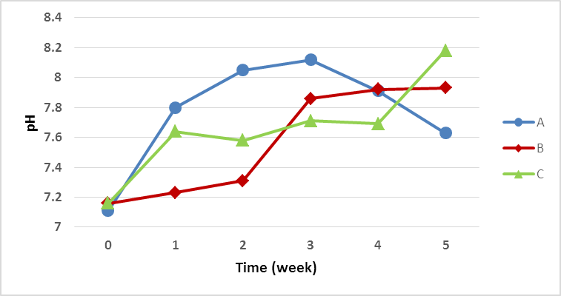

Figure 1. Changes in substrate pH during anaerobic breakdown at thermophilic temperature

Figure 1. pH measurement results during 5 weeks of biogas production. The difference in biogas production is influenced by changes in the pH of substrates in anaerobic biodigester. In the thermophilic temperature treatment, the pH of the substrate in groups A, B and C tended to increase and the volume of biogas produced fluctuated from week 1 to week 5. The fourth week of biogas production in group B experienced a decrease in production, indicated by the substrate pH of 7,92. At week 5, group B returned to produce biogas, but in small amounts because the pH conditions this week were close to alkaline, namely 7,93. Decreased biogas production is also due to changes in environmental conditions in the anaerobic biodigester (abiotic factors such as pH and temperature) and the lack of bacteria that degrade organic matter. In group C, biogas production increased from week 0 to week 4 and decreased at week 5. The increase in the pH of the substrate until the 4th week was 7,69 and it was still neutral, while the 5th week the pH of the substrate became alkaline, namely 8,18. At this alkaline substrate pH causes biogas production to decrease. The optimum level of acidity for the development of methane-forming bacteria is at pH 6,8 to 8.The anaerobic digestion rate will decrease at higher or lower pH conditions [14]. In this study, the increased or alkaline pH of the substrate (more than 8) led to decreased biogas production.

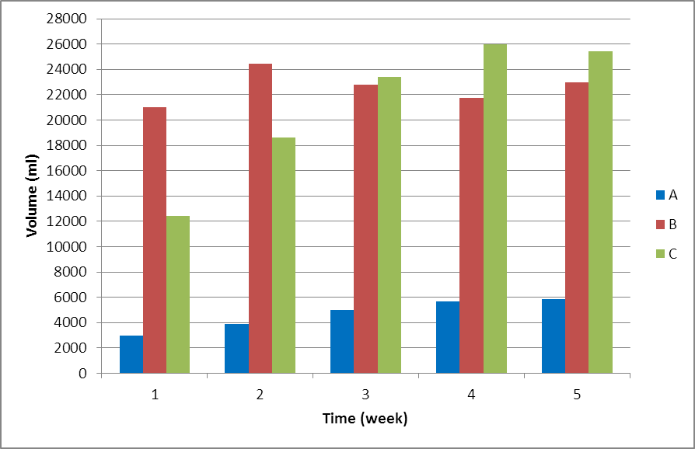

Figure 2. Volume of biogas resulting from anaerobic remodeling at thermophilic temperature

Figure 2. biogas production volume for 5 weeks. In week 1 and 2 the highest volume of biogas produced at thermophilic temperature was group B (60% tofu liquid waste + 30% food waste) with the second week pH was 7,16 which resulted in a biogas production volume of 24.460 ml. while the lowest was produced by group A (control) at week 1st with a pH of 7,68, which is 2.960 ml. After anaerobic overhaul for 1 week. The biogas production of each group at week 4 to 5 increased. The best average volume of biogas at thermophilic temperature for 5 weeks was group B (60% tofu liquid waste + 30% food waste) which resulted in a biogas production volume of 22.600 ml.

Table 3. Biogas volume from food waste substrate mixture at thermophilic temperature

|  |  |  |  |  |  |  |
| --- | --- | --- | --- | --- | --- | --- |
| Group | Biogas Volume (ml) | | | | | Average biogas volume (ml) |
| Week 1 | Week 2 | Week 3 | Week 4 | Week 5 |
| A | 2960 | 3890 | 4980 | 5690 | 5880 | 4680 |
| B | 20990 | 24460 | 22800 | 21770 | 22980 | 22600 |
| C | 12420 | 18600 | 23390 | 25500 | 25870 | 21156 |

From table 3. Overall it can be said that for 5 weeks the highest volume of biogas was in group B (60% tofu waste + 30% food waste) with an average volume of 22.600 ml. The biogas formed in this research is the result of the degradation process of COD mixed waste by microbes in anaerobic sludge which is the main medium for degradation in this anaerobic biodigester system. Although the processing of biogas resulting from anaerobic remodeling for each treatment was not the same, the overall biogas produced was proportional to the reduction in COD.

The addition of food waste substrate to tofu waste can increase biogas production. The availability of food (organic matter) for microbes causes the growth of microbial biomass to increase. This is in accordance with the opinion of [15], which states that the longer the seeding takes place, the more the microbial load increases because microbial cells undergo division or proliferation. Microbes need sufficient time to reproduce if the required components are available, then microbes will grow rapidly just as microbes need nutrients for their growth.

1. **Conclusion**

Research on biogas production from food waste has been carried out, and it was observed that by varying the substrate it can reduce COD, BOD, TS, while substrate temperature can increase VS. From the results of the research data showed that anaerobic overhaul at thermophilic temperature for 5 weeks produced the highest biogas from the yield of 60% tofu liquid waste substrate and 20% food waste was 22.600 ml. This shows that the percentage of the substrate from the mixture of food waste and tofu liquid waste has an effect on increasing biogas production. Another thing also shows that the thermophilic temperature in the anaerobic reform process can increase the production of biogas.

**References**

[1] KESDM 2006 Blueprint Pengelolaan Energi Nasional Tahun 2006-2025 *Kementeri. Energi dan Sumber Daya Miner.* 1–78

[2] Liguori V 2016 Numerical investigation: Performances of a standard biogas in a 100 kWe MGT *Energy Reports* **2** 99–106

[3] Saracevic E, Koch D, Stuermer B, Mihalyi B, Miltner A and Friedl A 2019 Economic and global warming potential assessment of flexible power generation with biogas plants *Sustain.* **11**

[4] Ardelean A V, Moisescu C and Ardelean I I 2019 the Potential of Photosynthetic Biomass Resulted From Synthetic Wastewater Treatment As Renewable Source of Valuable Compounds *Curr. Trends Nat. Sci.* **8** 42–7

[5] Zakrzewski J and Chabelski T 2016 the Fuelcal Technology of Processing Biomass Waste Into Multi-Component Organic-Mineral Fertilisers and Calcium-Organic Fertilisers Orcal *Inżynieria Ekol.* **46** 166–74

[6] Arthurson V 2009 Closing the global energy and nutrient cycles through application of biogas residue to agricultural land - potential benefits and drawbacks *Energies* **2** 226–42

[7] Sarker S, Lamb J J, Hjelme D R and Lien K M 2019 A review of the role of critical parameters in the design and operation of biogas production plants *Appl. Sci.* **9**

[8] Abdulkareem A 2005 Refining biogas produced from biomass: An alternative to cooking gas *Leonardo J. Sci.* 1–8

[9] Makisha N and Semenova D 2018 Production of biogas at wastewater treatment plants and its further application *MATEC Web Conf.* **144** 04016

[10] Nugraha W D, Syafrudin, Permana W S, Matin H H A and Budiyono 2018 The Influence of NaOH Pretreatment to Biogas Production from Rice Husk Waste by Using Solid State Anaerobic Digestion (SS-AD) *Adv. Sci. Lett.* **24** 9875–6

[11] T.Z.D. de Mes, A.J.M. Stams, J.H. Reith G Z 2003 Methane production by anaerobic digestion of wastewater and solid wastes *Dutch Biol. Hydrog. Found.* 58–102

[12] Seruga P, Krzywonos M and Wilk M 2018 Thermophilic co-digestion of the organic fraction of municipal solid wastes—the influence of food industry wastes addition on biogas production in full-scale operation *Molecules* **23**

[13] Tchobanoglous G, Burton F L and Stensel H D 2003 Wastewater Engineering: Treatment and Reuse *Metcalf & Eddy Inc* p 1846

[14] Zdebik D, Głodniok M and Zawartka P 2015 Anaerobic Digestion Model Analysis of the Fermentation Process in Psychrophilic and Mesophilic Chamber in Accordance With the Amount of Biogas Sourced *Inżynieria Ekol.* **42** 63–71

[15] Soeparno 1992 Ilmu dan teknologi daging *Gadjah Mada University Press, Yogyakarta* p 346