E-Counseling Application to Overcome Isolated Students Using the Backward Chaining Method

A E Budianto¹*, M F I Othman², Y B A Rahim³, M Ahsan⁴, W Setiyaningsih⁵
Universitas Kanjuruhan Malang¹, Universiti Teknikal Malaysia Malaka², Universiti Teknikal Malaysia Malaka³, Universitas Kanjuruhan Malang⁴, Universitas Kanjuruhan Malang⁵

*endybudianto@unikama.ac.id
mohdfairuz@utem.edu.my, yahaya@utem.edu.my, ahsan@unikama.ac.id, wiji@unikama.ac.id

Abstract. Counseling services are not only carried out face-to-face in a closed room, but can be done via a remote format via Android in the form of an “E-Counseling” application which can be interpreted as the process of organizing counseling electronically. Guidance and counseling services are alternative efforts that will be made by counselors in an effort to overcome isolated students. One of the causes of student alienation is a lack of social interest and a lack of students' ability to adapt to their environment. Thus resulting in alienation of students from classmate interactions. The application of E-Counseling in the use of guidance and counseling services is expected to help overcome the isolated behavior of students in interacting. By using the Backward Chaining method which can help isolated students to recognize and accept themselves, recognize and accept their environment positively and dynamically, and make decisions to direct and manifest themselves effectively and productively. The conclusion is that the existence of the E-Counseling application can overcome the problem of isolated student behavior in their interactions along with the increasing social interest of students by increasing the number of friends they have and no longer being shunned or kept away from their environment.

- Introduction
Guidance and counseling are part of education in schools. In this case, schools or institutions that are considered important in carrying out their role as places of learning for students, socializing and adapting to their environment [1]. Thus the school does not only play a role as a place to get knowledge, but it also plays a role in developing the potential of students to have spirituality, religion, self-control, personality, intelligence, noble character and skills needed by themselves, society, nation and state.
In line with that research aims, the implementation of counseling is also not only done face-to-face (FtF) in a closed room, but can be done through a remote format with the help of technology, hereinafter referred to as e-counseling. The term (electronic counseling) which can be interpreted briefly is the process of providing counseling electronically [2].
By looking at and analyzing these problems, this study seeks to make an e-counseling application to explain alienated students using the Backward Chaining method as an use of guidance and counseling services to overcome isolated students, so that students can adapt to their environment and help provide information. precisely and quickly. regarding the identification of isolated student problems

- Method
The backward chaining method is used to build various types of expert systems, and especially interactive systems that simulate conversions between users and experts[3]. Using the backward chain technique, the system will know what to ask and when to ask the right questions. It helps to break down complex problems into easy, small, fixable parts, and the system uses them automatically when needed. Backward Chaining Backward chaining, referred to as goal-driven reasoning, is an efficient way to solve problems modeled as structured problem selection[4]. The purpose of this inference method is to make the best choice out of many possibilities. This method is suitable for use in diagnostic problems, as in Figure 1. Backward Chaining [4]:

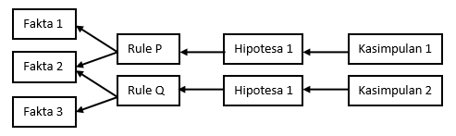

In this method, the process starts from a conclusion. Then the conclusions are matched leading to the conclusion of a rule. If there are rules that have the same conclusion as the conclusion being sought, a fact finding is carried out by asking the user to make sure the premise of the rule is met. For example, as in Figure 2 Example of Backward Chaining:
Rule 1:
IF A = 1 and B = 2 THEN C = 3
Rule 2:
IF D = 4 and C = 3 THEN E = 5
Rule 3:
IF D = 4 THEN F = 6
Facts:
A, B
Goal:
Prove H
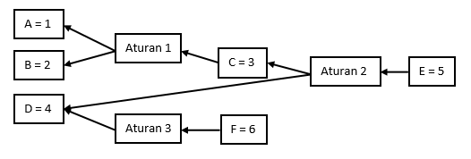

In Figure 2 Example of Backward Chaining[4] , an example of the goal chosen is E = 5. Data starting from E = 5 is a goal or conclusion. At E = 5, we examine the rules that have this conclusion and it turns out that there are rules that have that conclusion, namely Rule 2.In Rule 2 there is the premise C = 3 and D = 4. For D = 4, it can be immediately proved the truth because there is no rule that has this conclusion, while for C = 3 there is a rule that has this conclusion, namely Rule 1.In Rule 1 there is the premise A = 1 and B = 2. Because there is no rule at A = 1 and B = 2, it can be immediately verified. Verification of the truth is generally done by looking for facts by asking users. Examination starts from goals to data relating to the rules being implemented. In the trace, the system only displays data relating to the rules that were executed[5]. Backward Chaining uses a goal-driven approach, starting from the expectation of what you want to happen (hydration), then looking for evidence that supports (or contradicts) those expectations[3][6]. The following is a picture of the backward chaining method[7], as in Figure 2. Backward Chaining Process [8]:

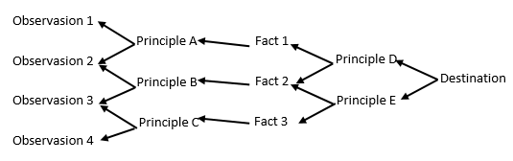
PHP can be integrated (embedded) into a web server, or it can act as a separate CGI program[9]. The superior and most powerful characteristic in PHP is the database integration layer database integration layer[10]. PHP supported databases are: Oracle, Adabas-D, Sybase, Filepro, mSQL, Velocis, MySQL, Informix, Solid, dBase, ODBC, Unix dbm, Unix dbm, PostgreSQL.
- Results and Discussion
The factors that affect the isolation of students based on the sociometric questionnaire are as follows[11][12] in Table 1. Sociometry of isolated students:

Table 1. Sociometry of isolated students
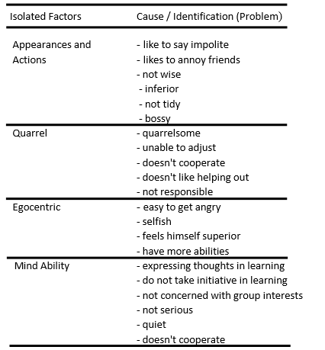

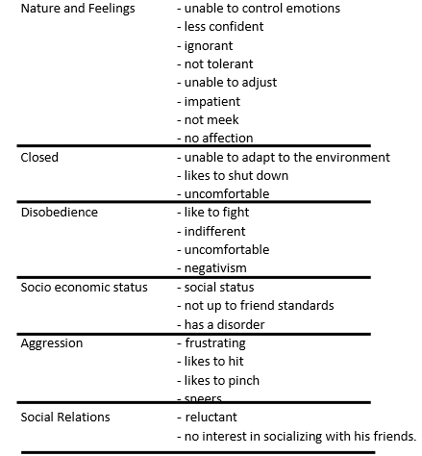
3.1.Flowchart System
The following is the E-Counseling System Flow in the Use of Guidance and Counseling Services to Overcome Isolated Students Using the Backward Chaining Method[13][14], as in Figure 4. Flowchart system with Backward Chaining model :
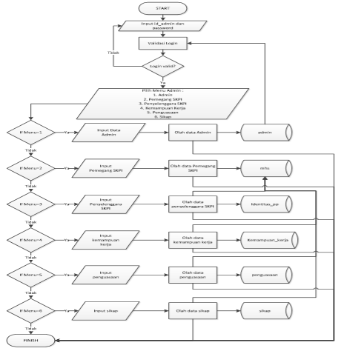
  - Friend Treatment
The peer treatment of the two isolated students has increased after getting treatment[15]. It can be seen from the frequent counselee friends invite to play together and the reduction in ridicule that counselees often receive[16]. In both VB and RR, friends in their class began to often invite them to play together, and the two who were initially teased by their respective classmates had now decreased[17]. The following is the percentage acquisition per indicator of isolated students after treatment is applied, as in Figure 5. Acquisition on isolated student presentations after treatment is given :
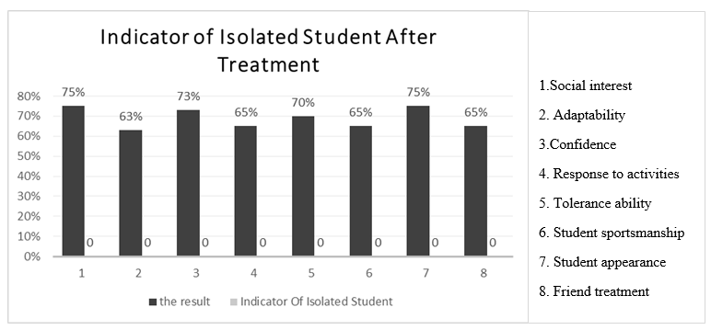
Based on Figure 5 , the percentage per indicator of isolated students after treatment is known to have increased[10]. In the indicator of social interest students get a percentage of 75% with a high category. The ability to adjust to isolated students is moderate with the percentage gain as much as 63%. The self-confidence of isolated students is in the medium category with the acquisition of 73%. The response during the activity increased to 65% in the medium category. Tolerance ability also increased to moderate with a percentage of 70%. Isolated students' sportsmanship ability obtained a percentage of 65% in the moderate category. In the performance indicator, isolated students are still the same, the percentage acquisition is 73% in the high category. And the peer treatment indicator increased to 65% in the moderate category. From the two diagrams presented above, it can be obtained a comparison between the percentages before and after treatment as follows, in Figure 6 Comparison of Percentage Scale Assessment of Isolated Student Behavior Before and After Counseling :

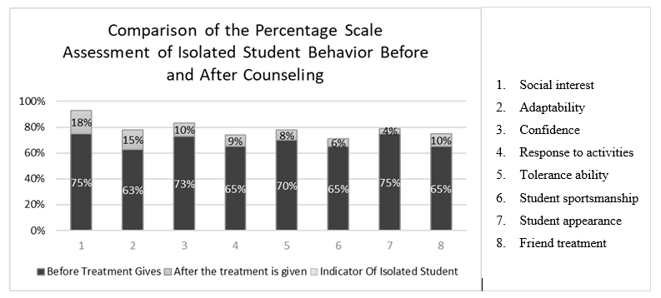

Based on the Figure 6, some differences can be seen in several indicators, namely the indicators of social interest which have increased by 18%, the ability to adapt has increased by 15%, self-confidence has increased by 10%, the response to activities has increased by 9%, tolerance increased by 8%, student sportsmanship ability was 6%, student performance was 4%, and the treatment of friends increased by 10%.
- Conclusion
Based on the problems that have been discussed and resolved through this research, there are several conclusions: 1). Based on the test results, this e-counseling application helps and provides comfortable and easy counseling using the Backward Chaining method. 2). Using the Backward Chaining method can help isolated students to know and accept themselves, recognize and accept their environment positively and dynamically, and make decisions to direct and manifest themselves effectively and productively according to themselves. 3). With the e-counseling application, it can be used as a form of providing modern counseling services that apply information technology that is not limited by time and place. 4). Isolation problems of students through e-counseling services become problems in learning, playing, and telling stories. The counseling technique used is non-interactive, namely information services by following diagnostics, namely identification of isolated problems, diagnosis, prognosis and presentation of information for problem management. 5). Application modeling can provide solutions for control measures in accordance with the results of the problem of isolation and the factors of students becoming isolated.

References
[1] J. Wodarski and J. Frimpong, “Application of E-Therapy Programs to the Social Work Practice,” J. Hum. Behav. Soc. Environ., vol. 23, no. 1, pp. 29–36, 2013.
[2] M. Hrivnak, D. Coble, and R. Byrd, “Digital Commons @ East Tennessee State University Cybercounseling : Legal and Ethical Considerations Cybercounseling : Legal and Ethical Considerations,” 2015.
[3] A. Herliana, V. A. Setiawan, and R. T. Prasetio, “Penerapan Inferensi Backward Chaining Pada Sistem Pakar Diagnosa Awal Penyakit Tulang,” J. Inform., vol. 5, no. 1, pp. 50–60, 2018.
[4] R. P. Z. dan M. Ayub, “Aplikasi Metode Backward Chaining untuk Mengenali Kerusakan Mesin Mobil,” Fak. Teknol. Informasi, Univ. Kristen Maranatha, Bandung, vol. volume 4, no. no 2, pp. 105–120, 2015.
[5] F. Mishna, “Online + Face to Face Counselling 2013-2014 REPORT,” no. September, 2014.
[6] S. Shrader et al., “Interprofessional Education and Practice Guide No. 7: Development, implementation, and evaluation of a large-scale required interprofessional education foundational programme,” J. Interprof. Care, vol. 30, no. 5, pp. 615–619, 2016.
[7] L. Muchlis and F. K. Putra, “Expert System Model of Forward and Backward Chaining Methods to Detect Student Academic Stress Level,” Educ. Innov. Ment. Heal. Ind. Era 4.0, pp. 88–93, 2020.
[8] R. Kurniawan and N. Falah, “Aplikasi Sistem Pakar Untuk Diagnosa Penyakit Hernia Menggunakan Metode Forward Chaining Dan Backward Chaining,” I N F O R M a T I K a, vol. 8, no. 2, p. 24, 2019.
[9] N. M. Edwin, “Software Frameworks, Architectural and Design Patterns,” J. Softw. Eng. Appl., vol. 07, no. 08, pp. 670–678, 2014.
[10] E. O. Alvandi, “Cybertherapogy: A Conceptual Architecting of Presence for Counselling via Technology,” Int. J. Psychol. Educ. Stud., vol. 6, no. 1, pp. 30–45, 2019.
[11] C. S. Lupi, M. Ward-Peterson, and C. Castro, “Non-Directive Pregnancy Options Counseling: Online Instructional Module, Objective Structured Clinical Exam, and Rater and Standardized Patient Training Materials,” MedEdPORTAL J. Teach. Learn. Resour., vol. 13, p. 10566, 2017.
[12] F. Mishna, D. Levine, M. Bogo, and M. Van Wert, “Cyber Counselling: An Innovative Field Education Pilot Project,” Soc. Work Educ., vol. 32, no. 4, pp. 484–492, 2013.
[13] A. E. Budianto, A. Aziz, and N. Hidayah, “ICT application in cyber counseling as a teacher accelerator with optimizing WhatsApp based mobile computing,” J. Phys. Conf. Ser., vol. 1375, no. 1, pp. 0–9, 2019.
[14] I. Williams and P. O’Connor, “Power in the Counseling Relationship: The Role of Ignorance,” J. Hum. Serv. Training, Res. Pract., vol. 4, no. 2, pp. 1–37, 2019.
[15] M. J. Mallen, I. M. Jenkins, D. L. Vogel, and S. X. Day, “Online counselling: An initial examination of the process in a synchronous chat environment,” Couns. Psychother. Res., vol. 11, no. 3, pp. 220–227, 2011.
[16] L. Murphy, D. Mitchell, and R. Hallett, “A comparison of client characteristics in cyber and In- person counseling,” Annu. Rev. CyberTherapy Telemed., vol. 9, no. 1, pp. 121–124, 2011.
[17] C. D. Schmidt, G. B. Hardinge, and L. J. Rokutani, “Expanding the school counselor repertoire through STEM-focused career development,” Career Dev. Q., vol. 60, no. 1, pp. 25–35, 2012.

Acknowledgment
The authors would like to thank the research funding institute: DIKTI and the Institute for Research and Community Service (LPPM) Kanjuruhan University Malang.

