**Technology of Holobox Augmented Reality**

***Grebeg* Pancasila Rite for Mathematics Learning**

**in Elementary School**

**Septinaningrum1,4, W Setiawan 1,2, A Syukron Surur 1,2, M Agustin 1,3**

1Program Studi Pendidikan Dasar, Jl. Dr. Setiabudi No. 229 Bandung 40154, Indonesia

2Departemen Pendidikan Ilmu Komputer, Universitas Pendidikan Indonesia, Jl. Dr. Setiabudi No. 229 Bandung 40154, Indonesia

3Departemen Pendidikan Anau Usia Dini, Universitas Pendidikan Indonesia, Jl. Dr. Setiabudi No. 229 Bandung 40154, Indonesia

4Jurusan Pendidikan Guru Madrasah Ibtidaiyah, IAIN Tulungagung, Jl. Mayor Sujadi Timur No. 46 Tulungagung 66221, Indonesia

*Corresponding Author: [Septinaningrum@mail.com](mailto:Septinaningrum@mail.com)

**Abstract.** The Grebeg Pancasila Rite is one of Indonesian indigenous local wisdom. This rite is originally from Blitar City, East Java Province which is enriched with symbols, meanings and, internalized values ​​and characters. However, this tradition is limited used for annual event to commemorate the birth of Pancasila on the first of June. On the other hand, this tradition can be used effectively as a medium of Mathematics learning. The lack of real life experience and the ignorance to this learning content in the students’ learning make the students difficultly understand the meaning and hardly acquire the skills and knowledge which can be applied in their real life. Besides being enriched with character and local wisdom values, the Pancasila celebration rites is also enriched with symbolic meaning with high artistic values consisting of geometrical concept in every rite. This study is objected to develop technology-based multimedia design; Holobox AugmentedReality (AR) where the content is about Grebeg Pancasila for Mathematics Learning; flat and space structure in Elementary School. The method use in this multimedia development design was the multimedia development method Development Life Cycle according to Luther consisting of six stages; concept, design, material collection, assembly, testing, and distribution. The result of the study showed that cultural variety in local wisdom of Grebeg Pancasila can be developed to be technology Holobox AR-based multimedia for Mathematics Learning in Elementary Schools.

**Keywords: Holobox Augmented Reality, Mathematics Learning, *Grebeg* Pancasila.**

1. **INTRODUCTION**

Grebeg Pancasila Rite is one of indigenous Indonesian local wisdoms. This rite is originally comes from the City of Blitar, in East Java Province which is rich with symbols, meanings and, internalized values, character, multiliteracy learning and multicultural education [1][2][3][4][5]. However, it is still used only for annual event held to commemorate the birth of Pancasila on June 1st. Various strategies have been used, especially by optimizing Grebep Pancasila as cultural tourism and communicating the value of Pancasila on social media [6][7]. Whereas, if it is used more effectively, the Grebeg Pancasila Rite can be a learning medium of character and values for the society, including for the students of Elementary School who haven’t been involved directly in the procession. The lack of real life experience of the students and the absence of the content in the school curriculum have contributed to the students’ difficulty to understand meaning and to acquire knowledge and skills that can be useful for their life, including for Mathematics learning. The solution to this problem is the utilization of technology to solve these problems.

The use of technology in delivering information has grown rapidly. The use of smart phone as a learning media is considered effective because it can interest the students especially elementary school students. However, the utilization of the smart phone in learning process is still viewed ineffective. The highest percentage use of smart phone is for social media, it is only about 15 % used for learning need [8][9]. The concept of Mathematics can be learnt by the students in three stages; *enactive, iconic* and *symbolic*. The enactive stage where students learn while manipulating objects, the iconic stage where the students present knowledge through visual images, symbolic stage where they represent knowledge in symbols. Mathematics learning must be actively and dynamically done improving the personality through experience and interaction with others. According to the level of thinking, elementary school students level of thinking is in the stage of concrete operational meaning that they understand concept through activities using real objects or real activities that are acceptable for their minds. Therefore, Mathematics learning in Elementary School requires concrete modeling and real life experience. One modeling which is real and concrete is the use of *Holobox Augmented Reality* technology which is now widely used in delivering information. AR is a technology combining various objects in virtual world into the real world and it can be implemented in *smart phones* as an innovation in learning media [8][10]. The use of learning media is a way to develop the students competence to critically comprehend learning materials and they are able to know more than teacher (Carol. 2002. *Media Education in The Primary School.* Newyork & London: in The Tylor & Francis e-Library). Holobox is derived from Hologram Box which is a simple technology design created by combining screen monitor/tablet laid out and projected on top of the glass case so that it can display the shadow of the object similar to a hologram. The object displayed with holobox in this design is in the shape of a quadrangle (pyramid). The pyramid size is adapted to the screen will be displayed.

The use of 3D hologram videos in learning is growing rapidly. AIP *Conference Proceedings* entitled "*3D Hologram Introduction of Solar System Based on Android*", explains the final result of a more attractive and modern 3D hologram animation construction with the working principle of an inverted pyramid and *smartphone* Android as a visualization medium. In this study, the research method applied in making the 3D hologram application for the introduction of the solar system is literature study and the development of Luther's version of the multimedia method[11].

SNATIF Proceedings entitled "3D Holograms for Introducing Indonesia’s Animals Variety", in this study utilizing the facilities of Blender and Camtasia Studio software to design and create an animation to provide information about the diversity of Indonesian animals. The method or stages in used in this design was the Luther-Sutopo version of multimedia development[12].

Based on the research result and design, it can therefore be concluded that the Design of Digital Dinosaur Fossils with the Utilization of Digital Technology *Holobox* at the Bandung Geology Museum is able to provide new experiences for visitors to receive information about Disnosaurus Fossils because they are displayed in a dimensional digital holographic form with an interactive visual impression and dynamic.

Visitors can feel more freedom in exploring fossil information indefinitely given the limited content and available showrooms [13]. The conclusion from the research entitled "*3D Hologram* Interactive Media Introduction to the Process of Making Jenang as an Effort to Preserve the Typical of Kudus Culinary" can interest to the society, especially the younger generation (at least elementary school level) to learn the typical culinary of Kudus, by presenting the process of making Holy jenang usinganimation. *3dhologram*, and is equipped with a sound andcontroller *android* for the reflex pyramid[14]. The advantages of using *Holobox* AR that it can be used to visualize and interact with objects in 3-dimensional (3D) form. AR is widely implemented in various fields because of its advantages including comfortable, inexpensive, and can be implemented in various multimedia needs, is *real time* and interactive so it is widely used in various fields [10][15].

In cultural aspect, AR is widely used to introduce cultural heritage. Cultural heritage has an important role strengthen the nation's identity for its huge cultural values ​​that must be preserved. The introduction of cultural heritage objects such as museums, *keris*, *batik* is a need for the society. Research reported the application of AR technology in cultural aspects including creating catalogs of Javanese script learning, fossil replicas of collections of historical objects, animals and animal fossils in geology and zoology museums, to overcome the limitations of historical space [16][15]. On the other hand, in tourism sector, it is used as a brochure [17]. The use of AR is to overcome space limitations and to ease people in finding information.

Biology learning as one of the medical disciplines us AR technology as a virtual laboratory for particular learning concept and materials. It is use to ease people to understand for example the materials such as; microscopic materials, anatomy and physiology of animals and humans. The supply of materials has been more diverse and the ethical debate on the use of corpses and animals in experiments can be resolved [18]. Moreover, AR technology has been used at different level of education; from elementary to higher education level for dynamic learning media to support smart learning [10].

In higher education level, AR technology is used as an effective learning strategy. Students apparently feel alive and motivated to use the technology in their learning [19][20]. Another advantage of using the technology are that the students get tolerant, improved, behave positively, realistic, motivated, creative, collaborative, learn constructively, and get the best learning experiences (Ismaeel & Al Mulhim, 2019). The foreign language learning also becomes practical and applicable so the students can solve privacy issues and the availability of the classroom teachers [21]. In elementary school level particularly, there has been a significant improvement such as the students’ performance, knowledge, motivation, collaboration, innovation and creativity. Furthermore, the students’ positive attitude, enthusiasm, character and participation become observably better [22][23][24].

Based on the explanation above, the researcher wanted to design a technology-based multimedia of Holobox AR for Mathematics learning by using Grebeg Pancasila rite in Elementary School. She utilized facilities from Blender and Camtasia Studio software to design and create animation capable to provide information about symbols in Grebeg Pancasila rite for Mathematics learning on the concept of rectangular flat shapes and conical spaces.

1. **METHOD**

The main objective of this study is to design and develop Holobox Augmented Reality based media for Mathematics learning in elementary schools. Generally, the method in designing this multimedia development uses the multimedia development method of the *Development Life Cycle* from Luther, consisting of six stages; concept, design, material collection, assembly, testing, and distribution[14].

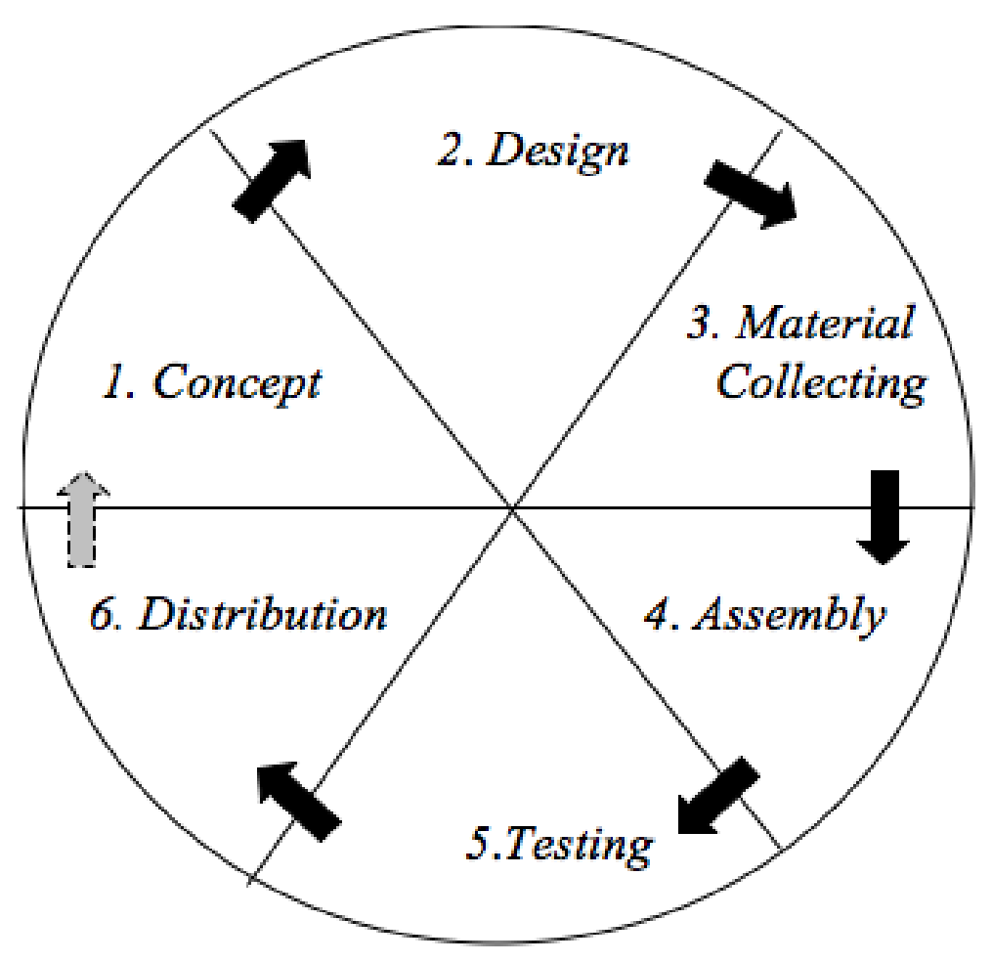

**Figure 1.** Luther’s Multimedia Development Model.

* 1. *Concept*

At this stage, the researcher carried out objective analysis, user or audience identification, determined the type of application, application purpose and general specifications. Some things that must be done at this stage are:

1. Determining the purpose of making the application
2. Performing an audience analysis
3. Compiling a description of the animation concept created by determining the type of application (presentation, interactive, ect.) and general specifications of animation (display, title, icon and menu).
   1. *Design*

On At this stage, the media design is carried out through a *story board* to describe the description of each scene. To connect each scene to another scene, it is in the flowchart section to describe the media design flow in detail.

Specifications are made in detail so that at the next stage, namely *material collection, assembly is* no longer needed*.* But in practice there will be additions and subtractions and changes to theapplication.

* 1. *Material CollectionCollecting*

Materials according to the criteria and animation needs to be developed in the media. At this stage there are several processes, namely:

1. Collecting files, text, images, clip art, photos, animation, video, audio related to making 3D holograms.
2. Conducting field studies to obtain information about the Rite of Grebeg Pancasila
   1. *Assembly.*

Animation-making stage where all objects or multimedia materials are made based on the *storyboards* that have been made at the design stage.

* 1. *Testing*

This stage serves to ensure that the results of making multimedia animations are as planned. Things that must be considered in making animation is to run well and in accordance with the user environment.

* 1. D*istribution*

At this stage, the project has completed the stage of manufacture and then do the packaging application. In thisapplication *Grebeg* Pancasila, the application file is packaged into an *executable file* (.apk) then packaged into a *self extractor.apk* file so that the file size is smaller than it actually is. This makes it easy to distribute online via the internet or offline using a CD.

1. **RESULT AND DISCUSSION**

Based on the research methodology, the following are the result of the media design:

* 1. *System Requirements Analysis*

Several data are needed to create a system, they are:

1. Image of symbols in Grebeg Pancasila containing the elements of flat and space structures. The symbol is the Indonesia’s flag interpreting a flat shape and five *gunungan* in the shape of a cone.
2. Information about *Grebeg* Pancasila
   1. *Hardware Requirements*

The hardware required is a computer (laptop), mouse and data cable.

* 1. *The Software Requirements*

Software needed for creating the application are Windows operating system, Ecclipps for android to create coding and the application system, Blender as the creator of 3D objects, and Camtasia Studio 8 for splitting videos into 4 klips.

* 1. *The Flowchart of the 3D Hologram Mechanism*

Bellow is flowchart of the animation design flow, the animation creating process, and the android remote control.

Analysis

Character Design

Texturing

Modeling

Storyboard

Ringging

Animating

Lighting

Camera Operation

Rendering

Final Editing

Animate Video Result

Android Design

Coding

Testing

Evaluating

Finishing

Post Production Stage

Production Stage

Pre Production Stage

**Figure 2.** Hologram Application Design Flowchart

In the design phases of creating an application, several stages or processes must be passed. The first stage is the pre-production stage until the testing stage the author will do an evaluation, at the evaluation stage, the writer looks for gaps and shortcomings in the application that was built by the author. So that improvements can be made before finally entering the *finishing* stage. At the finishing stage, the *hologram* display will be sharpened on the *reflection* triangleso that the natural impression and the large *hologram* will be its own impression.

* 1. *The Storyboard*

The following are some pictures of the storyboard drawn in general tabular form for the Grebeg Pancasila rite.

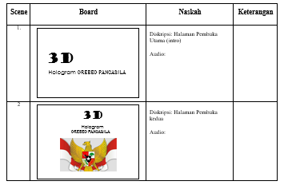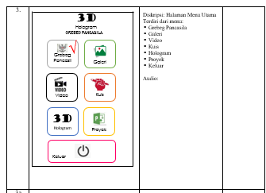

**Figure 3.** Example of a Storyboard Table

* 1. *Application Menu Display*

The following picture is the main menu page for the android 3D hologram of the Grebeg Pancasila rite

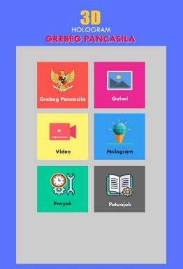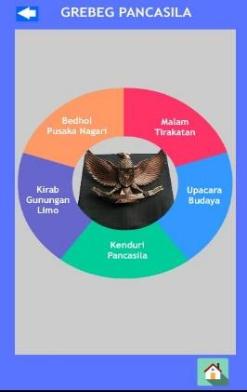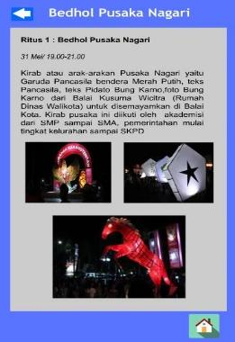

**Figure 4.** Application Menu Display

* 1. *3D Hologram*

The following is the result of a 3D hologram video design with a flag and *gunungan* symbol in *Grebeg* Pancasila Rite which will be developed to be a rectangular and conical shape for learning mathematics in elementary schools.

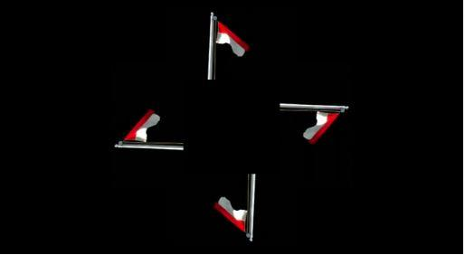

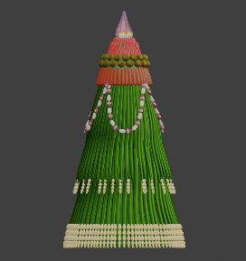 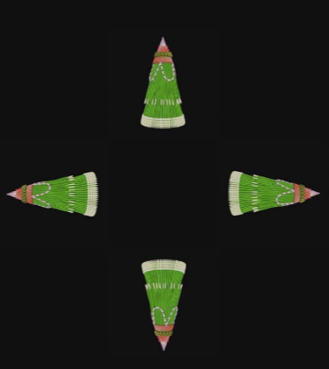 

**Figure 5.**Video of 3D Hologram

* 1. *Video Display of 3D Holobox Augmented Reality*

The following is the result of a video display 3D Holobox Augmented Reality

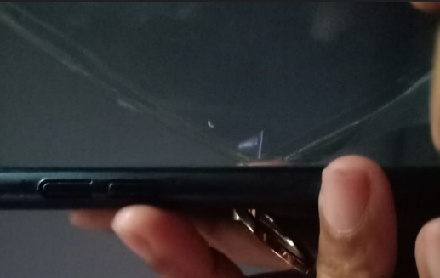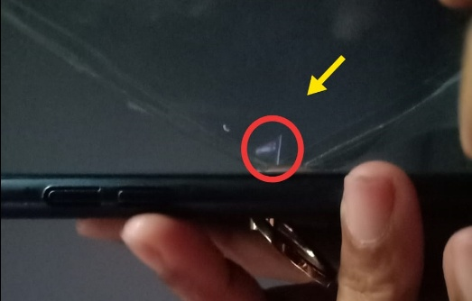

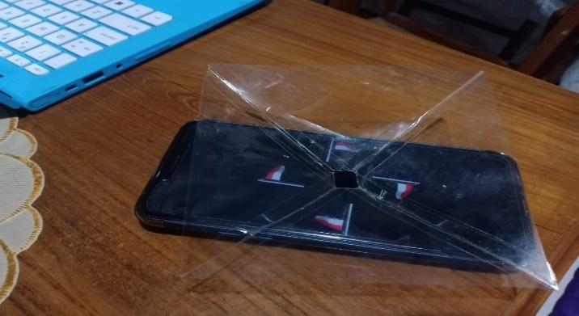

**Figure 6.**Video 3D Holobox Augmented Reality

1. **Conclusion**

Based on the research and design, it can be concluded that the use of Holobox AR technology can provide elementary school students new experiences. The application can increase students' enthusiasm for mathematics learning and for local wisdom learning of the Grebeg Pancasila rite. The use of 3D hologram technology utilizes holographic reflection in this application is capable to connect 3D objects with the real environment. Interaction by using the buttons provided on the application ease the users to use the application.

**REFERENCES**

[1] D. . W. Putriana, “Grebeg Pancasila sebagai Sarana Penanaman Nilai-Nilai Pancasila (Studi Kasus di Kota Blitar),” *Kaji. Moral dan Kewarganegaraan*, vol. 07, no. 2, pp. 1237–1252, 2019.

[2] S. Septinaningrum *et al.*, “Multiliteracy in The Rite of Grebeg Pancasila as aMedium for Character Education in Digital Era,” *Proc. 2nd Int. Conf. Local Wisdom*, no. January, pp. 389–396, 2019.

[3] Septinaningrum, “An Analysis of Multikultural Values Actualization In Grebeg Pancasila Rite , Blitar , East Java,” *Proceeding 4 Int. Semin. Soc. Stud. Hist. Educ. 2019*, 2019.

[4] Zummi, “Kajian Makna dan Nilai Karakter pada Ritus Grebeg Pancasila di Kota Blitar serta Keterkaitannya bagi Pendidikan IPS.” 2016.

[5] D. Sumitrasari, “Kajian Makna Simbolik Kirab Gunungan lImo Grebeg Pancasila.” 2012.

[6] E. Hudayanti, “Strategi Optimalisasi Grebeg Pancasila Sebagai Wisata Budaya,” *Tour. Hosp. Culin. J.*, vol. 3, no. 1, pp. 44–58, 2018.

[7] Luh Suryatni, “Komunikasi Media Sosial dan NIlai-Nilai Budaya Pancasila Sosial Media Communications and Cultural Values of Pancasila,” *J. Sist. Inf. Univ. Suryadarma*, vol. 5, no. 1, pp. 117–133, 2018.

[8] R. Wijayanti, A. P. Anugraini, A. Reality, and B. Ruang, “Pengembangan eksplorasi MAR ( Matematika Augmented Reality ) dengan penguatan karakter pada materi bangun ruang sekolah dasar,” vol. 9, no. 2, 2020.

[9] U. Ajnikhah, H. J. Saputra, and V. Purnamasari, “PENGEMBANGAN MEDIA BUKU BERGAMBAR MABARUNG ( MACAM-MACAM BANGUN RUANG ) UNTUK PEMBELAJARAN MATEMATIKA KELAS 5 SD,” vol. 3, no. 024, 2020.

[10] dkk Fatimah, “Development of Smart Content Model-based Augmented Reality to Support Smart Learning,” *J. Sci. Learn.*, vol. 2, no. 2, p. 65, 2019.

[11] & L. T. Fuadi MM, “3D Hologram Introduction of Solar System Based on Android,” *AIP Conf. Proc.*, 2018.

[12] dkk. Akbar, Rizki., “3D Hologram Pengenalan Hewan Nusantara,” *Pros. SNATIF*, pp. 19–24, 2016.

[13] A. H. Rustaman, “Perancangan Fosil Digital Dinosaurus Dengan Pemanfaatan Teknologi Holobox Di Museum Geologi Bandung,” *Desain Komun. Vis. Manaj. Desain dan Periklanan*, p. 57, 2018.

[14] R. Fibriyanti and T. Listyorini, “3D Hologram Media Interaktif Pengenalan Proses Pembuatan Jenang Sebagai Upaya Pelestarian Kuliner Khas Kudus,” *Simetris J. Tek. Mesin, Elektro dan Ilmu Komput.*, vol. 10, no. 1, pp. 333–340, 2019.

[15] P. Haryani, F. T. Industri, J. T. Informatika, J. Triyono, F. T. Industri, and J. T. Informatika, “Augmented Reality (AR) Sebagai Teknologi Interaktif dalam Pengenalan Benda Cagar Budaya Kepada Masyarakat,” vol. 8, no. 2, pp. 807–812, 2017.

[16] Wardani, “Pemanfaatan Teknologi Augmented Reality (AR) Untuk Pengenalan Aksara Jawa Pada Anak.,” *J. Din. Inform.*, 2015.

[17] C. Chien, “English for Ecotourism and Its Sustainability with Augmented Reality Technology,” *Int. Educ. Stud.*, vol. 12, no. 6, p. 134, 2019.

[18] R. Arslan, M. Kofoğlu, and C. Dargut, “Development of Augmented Reality Application for Biology Education Reyhane,” *Türk Fen Eğitimi Derg.*, vol. 17, no. 1, pp. 167–169, 2020.

[19] D. A. Ismaeel and E. N. Al Mulhim, “Influence of Augmented Reality on the Achievement and Attitudes of Ambiguity Tolerant/Intolerant Students,” *Int. Educ. Stud.*, vol. 12, no. 3, p. 59, 2019.

[20] H. Bicen and E. Bal, “Determination of student opinions in augmented reality,” *World J. Educ. Technol.*, vol. 8, no. 3, 2016.

[21] Bonner, “Augmented and Virtual Reality in the Language Classroom: Practical Ideas.,” *Teach. English with Technol.*, vol. 18, no. 3, pp. 33–53, 2018.

[22] M. Sirakaya and E. Kiliç Çakmak, “Investigating Student Attitudes towards Augmented Reality,” *Malaysia Online J. Educ. Techology*, vol. 6, no. 1, pp. 30–44, 2017.

[23] A. H. Lubis and M. N. Wangid, “Augmented Reality-assisted Pictorial Storybook: Media to Enhance Discipline Character of Primary School Students,” *Mimb. Sekol. Dasar*, vol. 6, no. 1, p. 11, 2019.

[24] J. M. Sanchez-garcia, “Use of Augmented Reality,” no. July, pp. 38–52, 2018.