The effectiveness of using magic book math in mathematics learning during the Covid-19 pandemic in senior high school

Achmad Buchori1, Dina Prasetyowati2, Wijayanto3

1,2 Mathematic Education *,* Universitas PGRI Semarang *,* Semarang, Indonesia

3 Educational Technology Information *,* Universitas PGRI Semarang *,* Semarang, Indonesia  
e-mail: [achmadbuchori@upgris.ac.id](mailto:achmadbuchori@upgris.ac.id), [dinaprasetyowati@gmail.com](mailto:dinaprasetyowati@gmail.com), [wijayanto.upgris@gmail.com](mailto:wijayanto.upgris@gmail.com)

*Abstract*—The current condition of high school mathematics textbooks has not been followed technological developments yet, one of the indicators is the use of Augmented Reality is not implemented in learning yet. This study aims at developing a valid magic book math media based on augmented reality. The development was conducted using the ADDIE development model which consists of 5 stages namely Analysis, Design, Development, Implementation and Evaluation. In this study, the development conducted only reached the Development stage. Through the Analysis and Design stage, draft I was obtained. Then, in the development stage, it was validated by experts using the material and media expert validation sheets, so the suggestions were obtained to revise draft I to draft II (a validated learning tool). In the development process, the product was validated by experts, with a value for material experts at 89.71% included in the very good category while for media experts at 92.31% in the very good category. Based on the results of the experts' validation, the magic book math media based on augmented reality is a valid product and is suitable for use. then a limited test has been conducted with the results of the average value of the experimental class x1 = 88.83 and the average control class x2 = 69.43 and tcount> ttable is 6.53> 1.78 then there are differences in student achievement between control class and experimental class, more than 95% antusiastic to using magic book math in the class virtual in Senior High School 15 Semarang.

Keywords: effectiveness, Magic Book Math, Augmented Reality, Senior high school

# **Introduction**

Today, In the education world, there are many textbooks circulating in the market, but not in accordance with the demands of the times, for example is a textbook in high school mathematics learning, so far the textbooks available are only in the printed version and have not been associated with the application of renewable technology, from this reality makes teachers must be able to package and make textbooks that are interesting for students (Billinghurst, M., Cambell, S., Poupyrev, I., Kato, K. T. H., Chinthammit, W., & Hendrickson, D. : 2000). High school schools in Semarang city and its surroundings, both public and private, have not been able to provide augmented reality based textbooks that are able to display 3D objects on every page of the textbook, therefore it is necessary to make an augmented reality based high school mathematics textbook that is able to improve students' ability to understand material mathematics in measurable terms (Buchori, A., Setyosari, P., Dasna, I. W., & Ulfa, S.: 2017).

Based on interviews with several high school mathematics teachers in Semarang city both public and private produced the fact that nearly 100% of high school schools in Semarang city still use mathematics textbooks that have not been touched by renewable technologies such as augmented reality, virtual reality, other mathematical software applications, this becomes significant findings for the development of textbooks that are able to accommodate these problems. (Burdea, G. C., & Coiffet, P. : 2003).

According to observations made by researchers at State of Senior High School 1 Semarang, the mathematics learning process is less active and less interesting, this is due to the absence of instructional media used by teachers so that students become bored quickly. Teaching and learning interactions in the classroom are inseparable from the influence of the media used by the teacher in delivering teaching material. The fastest growing now is a smartphone/smartphone. The existence of technology, especially smartphones that are now increasingly developed must be addressed wisely. The phenomenon of the high number of smartphone users is certainly a challenge and opportunity in the education world. The challenge is the abuse of negative things. Besides being a challenge, the existence of smartphones also brings great opportunities to develop technologies that are useful in the education field. One of the benefits that can be taken from the existence of this technology is to use it as an effective, creative and educative learning media. So the educational application media can continue to be developed, one of which is the technology of Augmented Reality. (Azuma, R. T. : 1997).

According to the explanation of Grasset, R., Dünser, A., & Billinghurst, M. (2008). Augmented Reality research aims to develop technologies that allow real-time integration of digital content created by computers with the real world. Augmented Reality allows users to see two-dimensional or three-dimensional virtual objects projected in the real world. This AR technology can insert certain information into the virtual world and display it in the real world with the help of equipment such as webcams, computers, Android phones, and special glasses. Users in the real world cannot see virtual objects with the naked eye, to identify the object needed by intermediaries in the form of computers and cameras that will later insert virtual objects into the real world.Based on this background, researchers was design an android-based learning media using Augmented Reality (AR).

# **LITERATURE REVIEW**

## **A. Android Smartphone**

In following the latest learning, students are expected to use their smartphones for learning, one of which is Android. Android is an operating system for Linux-based mobile devices that includes an operating system, middleware and applications (Rogers, R., Lombardo, J., Mednieks, Z., & Meike, B. : 2009). So about android Kirthika, B., Prabhu, S., & Visalakshi, S. (2015) in the journal Android Operating System: A Review says "Android is a software platform and operating system for mobile devices, based on the Linux kernel, and developed by Google and later the Open Handset Alliance (OHA) ". According to Ableson, F., Sen, R., King, C., & Ortiz, C. E. (2011).  OHA includes a consortium of 34 hardware, software and telecommunications companies including Google, HTC, Intel, Motorola, Qualcomm, T-Mobile and Nvidia. Android in learning becomes an operating system for the first Linux-based mobile devices that provides an OPENSOURCE (open) platform. This makes it easy for developers to create their applications. Many applications can be made for Android, one of which can be used as a learning medium. Therefore, researchers want to utilize Android as effective learning media.

According to Yerima, S. Y., Sezer, S., & Muttik, I. (2014), the strengths of Android are 1) Complete (complete platform), developers can take a comprehensive approach when developing the Android platform. Android is a safe operating system and provides many tools for building software and making opportunities for application developers. 2) Android is open (open source platform), Linux-based Android which is open source or open-source, so it can be easily developed by anyone. 3) Free Platform, Android is a free platform for developers. There are no fees for paying licenses or royalty fees. Android software as a complete, open, free platform and other information can be downloaded for free by visiting the website http://developer.android.com. 4) The popular operating system, Android phones are certainly different from the iPhone Operating System (IOS) which is limited to gadgets from Apple, so Android has many manufacturers, with their mainstay gadgets at quite affordable prices.

While Android Weaknesses are 1) Android is always connected to the internet. This Android system smartphone requires an active internet connection. 2) The number of advertisements displayed above or below the application. Although there is no effect on the application being used, this ad is very annoying. 3) Does not save battery power. (Park, J. K., & Choi, S. Y. : 2015). The application of Augmented Reality technology is now quite extensive, including in the field of education. Billinghurst (2002) argues that the use of augmented reality technology in the world of education is still being developed until now because it is not like computing technology in general. The augmented reality interface can integrate users, virtual objects and real environments and in its application to the school environment, there needs to be a collaboration between teachers or tutors and researchers in the field to know the compatibility of the application of augmented reality media with the curriculum in the school.

**B. Magic Book Math Media**

Magic book math is a textbook specifically for high school students that is based on Augmented Reality, which is able to display the augmented reality that is interesting to students. This opinion is in line with the conclusion of Simon, W. (1993) that as advances in the development of pedagogical concepts, applications, technology and hardware cost reduction, the use of small-scale augmented reality technology for educational institutions has become very possible in this decade (assuming a careful level of sustainable development ). However, the potential of this technology requires careful attention so that it can truly be utilized to improve educational success.

Azuma (1997) also revealed the reasons for the use of augmented reality technology in the world of education, namely: (1) supporting interaction between real and virtual environments, (2) the use of interfaces that seem real for object manipulation, (3) learning outcomes for smooth transition between environments real and virtual objects. Hansen, C., Wieferich, J., Ritter, F., Rieder, C., & Peitgen, H. O. (2010). Augmented reality (AR) obtains increasing acceptance in the operating room. However, a meaningful augmentation of the surgical view with a 3D visualization of planning data which allows reliable comparisons of distances and spatial relations is still an open request. So the developed algorithms have been embedded into a clinical prototype that has been evaluated in the operating room. To verify the expressiveness of our illustration methods, we performed a user study under controlled conditions. The study revealed a clear advantage in distance assessment with the proposed illustrative approach in comparison to classical rendering techniques.

# **METHOD**

This research method was research and development. It is a research method used to produce certain products, and test the effectiveness of these products (Sugiyono: 2010). The research model used the ADDIE learning design model. This model, as the name implies consists of five main phases or stages, namely (A) analysis, (D) design, (D) e-development, (I) implementation, and (E) valuation. The five phases or stages in the ADDIE model, need to be done systematically and systematically). In this study only carried out until the third stage, namely as follows.

1. **Analysis**

The analysis step consists of two stages, namely performance analysis and needs analysis. The first stage, performance analysis is carried out to find out and clarify whether the performance problems encountered require a solution in the form of program implementation or management improvement. In the second stage, needs analysis is a step that is needed to determine the abilities or competencies that need to be learned by students to improve learning achievement (Sugiyono: 2010).

1. **Design**

This step requires clarification of the learning program that is designed so that the program can achieve the learning objectives as expected (Private, 2010: 130). In product design, what is done is the next stage of the ADDIE model, namely design. In this step, there is a need for clarification of the learning program that is designed so that the program can achieve the learning objectives as expected (Sugiyono: 2010).

1. **Development**

This development step includes creating, buying, and modifying learning media to achieve predetermined learning goals. The step of development, in other words, includes the activity of selecting and determining methods, media and learning strategies that are suitable for use in conveying Personal material. In this development stage, the framework that has been designed will be realized to produce a product that can be implemented. At the stage of developing Android-based learning media will be made in accordance with the material after the Android-based media is completed it will be validated by media experts and material experts by the validator to get input and evaluate according to the input provided by the validator. Furthermore, the Android-based media is revised according to the input provided by the validator to improve the product. (Sugiyono: 2010).

# **RESULT AND DISCUSSION**

Based on the learning system design procedures used the ADDIE development model, the stages of research implementation for the first year that have been implemented will be explained in detail as follows.

1. **Analysis**

The analysis step consists of two stages, namely performance analysis and needs analysis. At this stage, interviews were conducted with several high school mathematics teachers in Semarang City. From the results of the interviews produced the fact that nearly 100% of senior high schools in Semarang City still use mathematics textbooks that have not been touched by renewable technologies yet such as augmented reality, virtual reality, other mathematical software applications. For this reason, it is necessary to develop textbooks that are able to accommodate these problems. Based on observations made by researchers at State Senior High School 15 Semarang, the mathematics learning process was less active and less attractive, this was due to the absence of instructional media used by teachers so that students become bored quickly. Teaching and learning interactions in the classroom were inseparable from the influence of the media used by the teacher in delivering teaching material. The existence of technology, especially smartphones that are now increasingly developed must be addressed wisely. One of the benefits that can be taken from the existence of this technology is to use it as an effective, creative and educative learning media. So the educational application media can continue to be developed, one of which is the technology of Augmented Reality (AR). (Putriani, D., & Waryanto, N. H. : 2017).

1. **Design**

At this stage, the researcher designed the product to be developed based on the results of the analysis that has been done. From this research, an android-based learning media was produced using Augmented Reality called the Magic Book Math based on augmented reality. The material in this media was class X mathematical material consisting of Equations and Inequalities of Absolute One-Variable Linear Value, Rational and Irrational Equations and Inequalities, One-Variable Linear Equation System, Dimension Three. Display Magic Book Math for the Equation and Inequality of Absolute Linear Values ​​of One Variable can be seen in the following image.

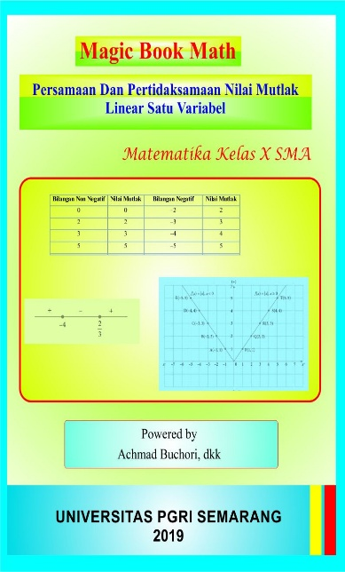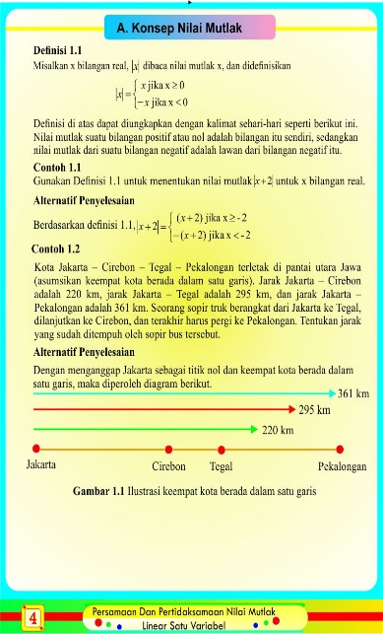

Figure 1. Magic Book Math Display

1. **Development**

At the stage of developing android-based learning media using Augmented Reality (AR) would be made in accordance with the material, after the android-based media using Augmented Reality (AR) was completed, it would be validated by media experts and material experts by the validator to get input and evaluate according to the input provided by the validator. The results of the validation will be described below.

**a. Material Validation**

Validation by the material expert is done so that the media that will be tested is truly feasible to be used in research. Development products evaluated by Lecturer of Mathematics at Universitas PGRI Semarang namely Magic Book Math based on Augmented Reality (AR) using a questionnaire that must be filled out by material experts.

The results of the validation and assessment of the learning material experts for each aspect are presented in the following table.

Table 1. Result of Material Validation

|  |  |  |  |  |
| --- | --- | --- | --- | --- |
| No. | Assessment Aspect | Expected Score | Evaluation  Score | Feasibility |
| 1. | Relevance | 24 | 22 | 91,67% |
| 2. | Accuracy | 16 | 13 | 81,25% |
| 3. | Completeness of Serving | 4 | 4 | 100% |
| 4. | Basic Concepts of Material | 8 | 7 | 87,5% |
| 5. | The suitability of the presentation with the demands of student-centred learning | 16 | 15 | 93,75% |

The next stage the researcher analyzes the overall results of the assessment by material experts.

( answer x score each choice ) = 61

n = 17

highest score = 4

Then the data above is calculated using the following formula



From the above calculation, the percentage of eligibility for Augmented Realitybased Magic Book Math is 89.71% by the material expert. After being converted to a scale conversion table, Augmented Reality based Magic Book Math media is in the range of 81% to 100%. So placing the position on the criteria is very good. Score percentage of each aspect of material validation aboved can be seen in form of clustered column diagram at the following figure.

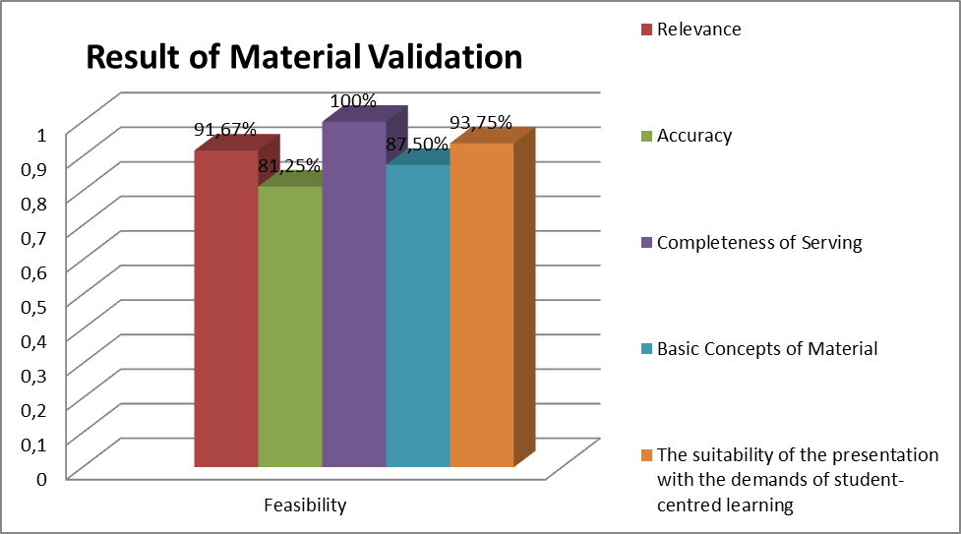

Figure 2. Result of Material Validation

Comments on expert learning materials (validation of expert judgment of materials) in general, namely the material presented is more adapted to everyday life. Comments and suggestions from learning material experts are taken into consideration for improving the design of Augmented Reality based Magic Book Math media, following up on comments and suggestions from the validator of learning material experts, it is necessary to make revisions to Augmented Reality based Magic Book Math media ). The revision made is by giving contextual problems that are in accordance with students' daily lives.

**b. Media Validation**

Validation by media experts is done so that the media that will be tested is really feasible to be used in research. Development products evaluated by media experts which is an Augmented Reality (AR) based Magic Book Math using a questionnaire that must be filled out by media experts.

The results of the validation and assessment by media experts for each aspect are presented in the following table.

Table 2. Result of Media Validation

|  |  |  |  |  |
| --- | --- | --- | --- | --- |
| No. | Assessment Aspect | Expected Score | Evaluation  Score | Feasibility |
| 1. | General Display | 24 | 22 | 91,67% |
| 2. | Special Display | 12 | 10 | 83,33% |
| 3. | Media Presentation | 16 | 16 | 100% |

The next stage the researcher analyzes the overall results of the assessment by media experts.

( answer x score each choice) = 48

n = 13

highest score = 4

Then the data above is calculated using the following formula:



From the above calculation, the percentage of eligibility for Augmented Reality (AR) based Magic Book Math is 92.31% by media experts. After being converted to a scale conversion table, Augmented Reality (AR) based Magic Book Math media is in the range of 81% - 100%. So placing the position on the criteria is very good. Score percentage of each aspect of media validation aboved can be seen in form of clustered column diagram at the following figure.

Figure 3. Result of Media Validation

Media expert comments (validation of media expert judgment) in general, namely the Augmented Reality (AR) based Magic Book Math can be used in high school mathematics learning and the Augmented Reality (AR) based Magic Book Math media is an interesting product, hopefully, this media can be applied in play store so students can easily download it. Comments and suggestions from media experts are taken into consideration for improving the design of the Magic Book Math media based on Augmented Reality (AR), following up on the comments and suggestions from the validator of media experts, it is necessary to make revisions to the Augmented Reality based Magic Book Math media. The revision is to manage Android users by registering students who have an Android so that all students can learn to use Android and try this media to be applied later in the Play Store. this research was corroborated by Parhizkar, B., & Zaman, H. B. (2009) was development of an augmented reality rare book and manuscript for special library collection The use of augmented reality will be able to model these valuable manuscripts and rare books and appear as augmented reality to ensure that the collection can be better maintained. Users will be able to open the augmented rare book, and flip the pages, as well as read the contents of the rare books and manuscripts using the peripheral equipment such as the HMD or the Marker. The AR Rare-BM developed is modeled as an augmented reality that allows users to put the augmented rare book on his palm or table and manipulate it while reading. Users can also leave a bookmark in the AR Rare-BM after reading so that they can read their favourite sections again at a later date.

**c. Student Response Results**

After the results of Magic Book Math media products based on Augmented Reality (AR) are validated to the material experts and media experts, then the Magic Book Math media media based on Augmented Reality is tested limited to students. The sample of students used for limited trials was class X students of Senior high school SMAN 15 Semarang.

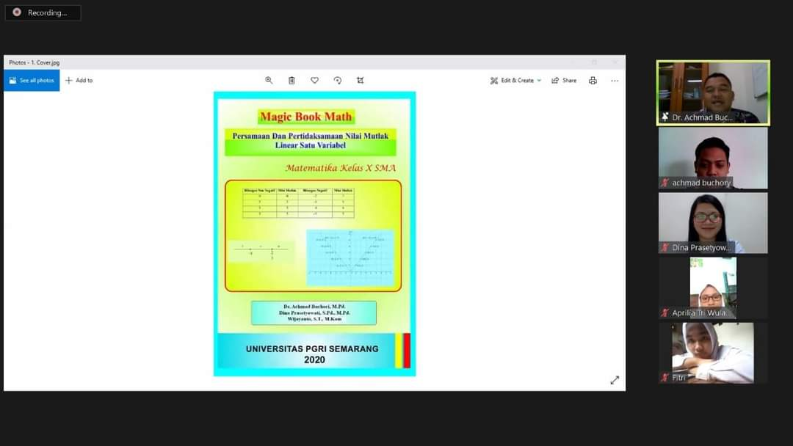

Figure 4. The process of learning mathematics with magic book math at senior high school

The results of the analysis of student responses for each question are presented in the following table:

|  |  |  |  |
| --- | --- | --- | --- |
| Number | Criteria | score | percentage |
| 1. | Learning by using math book math media is able to improve students' spatial skills more fun than just using the lecture method | 113 | 90,4 |
| 2. | I can understand math learning better | 106 | 84,8 |
| 3. | The use of magic book math media based on virtual augmented reality is able to increase student enthusiasm for learning | 109 | 87,2 |
| 4. | With the magic book math media based on virtual augmented reality, it makes me more active in learning | 104 | 83,2 |
| 5. | Good color composition and media display for interesting learning | 109 | 87,2 |
| 6. | Images presented in the magic book math media based on virtual augmented reality clarify mathematical material | 106 | 84,8 |
| 7. | Learning by using math book math media based on virtual augmented reality is able to increase interaction between students | 104 | 83,2 |
| 8. | Math book magic media based on virtual augmented reality can improve understanding of concepts and is well presented | 111 | 88,8 |
| 9. | During the learning, exercises were presented in the magic book math media based on virtual augmented reality which were able to improve students' understanding of mathematics material | 106 | 84,8 |
| 10. | The exercises in math book math media based on virtual augmented reality are in accordance with the material being taught | 106 | 84,8 |

From the above calculation, the average percentage of the feasibility of Magic Book Math based on Augmented Reality of 85.92% by students. After being converted to a scale conversion table, Augmented Reality based Magic Book Math media is in the range of 81% - 100%. So placing the position on the criteria is very good. this research was corroborated by Ferrer-Torregrosa, J., Torralba, J., Jimenez, M. A., García, S., & Barcia, J. M. (2015). ARBOOK: Development and assessment of a tool based on augmented reality for anatomy The ARBOOK group received the same standard sessions but additionally used the ARBOOK tool. At the end of the training, a written test on lower limb anatomy was done by students. Statistically significant better scorings for the ARBOOK group were found on attention–motivation, autonomous work and three-dimensional comprehension tasks. Additionally, significantly better scoring was obtained by the ARBOOK group in the written test. The results strongly suggest that the use of AR is suitable for anatomical purposes. Concretely, the results indicate how this technology is helpful for student motivation, autonomous work or spatial interpretation. The use of this type of technologies must be taken into account even more at the present moment, when new technologies are naturally

1. **Implementation of a Limited Trial**

The implementation of limited trials was carried out in senior high school 15 Semarang by taking class X IPA 2 as an experimental class and class X IPA 4 as a control class. Post test data analysis was performed to determine whether the experimental class and the control class, had a difference between conventional learning and learning using Augmented Reality based Magic Book Math media. Next the researchers analyzed the post test data that had been carried out in class X IPA 2 and class X IPA 4

To find out which learning is better, then use the t-test (right hand) by using the following formula.



Based on calculations with MS. Excel obtained the average experimental class that is x1 = 88.83 and the average control class that is x2 = 69.43 with n1 = 25, n2 = 22 and s = 12.305 so as to obtain t arithmetic = 6.53. The results of t arithmetic compared with t table. From the t distribution list with a probability of 0.95 and dk = 25, then t 0.95 is 1.78. From the calculation, the tcount is 6.53 and the table is 1.78. Because tcount> ttable is 6.53> 1.78 then Ho is rejected. Based on the above calculation because Ho is rejected, it can be concluded that learning outcomes using the Magic Book Math media based on augmented reality is better than conventional learning models. This proves there are differences in learning achievement because the teacher uses two different treatments between the control class and the experimental class with the average value of the experimental class x1 = 88.83 and the average control class x2 = 69.43. this research was corroborated by Yuen, S. C. Y., Yaoyuneyong, G., & Johnson, E. (2011). using Augmented reality make five directions for AR in education. Augmented Reality (AR) is an emerging form of experience in which the Real World (RW) is enhanced by computer-generated content tied to specific locations and/or activities. Over the last several years, AR applications have become portable and widely available on mobile de­vices. AR is becoming visible in our audio-visual media (e.g., news, entertainment, sports) and is beginning to enter other aspects of our lives (e.g., e-commerce, travel, marketing) in tangible and exciting ways. Facilitating ubiquitous learning, AR will give learners instant access to location-specific information compiled and provided by numerous sources (2009). Both the 2010 and 2011 Horizon Reports predict that AR will soon see widespread use on US college campuses. In prepa­ration, this paper offers an overview of AR, examines recent AR developments, explores the impact of AR on society, and evaluates the implications of AR for learning and education

# **conclusion**

The conclusions of this study are (1) Produced android-based learning media products using Augmented Reality called Magic Book Math based on augmented reality in which discussing senior high school grade X mathematics material, (2) Development of Augmented Reality Based Magic Book Math Media is valid and suitable for use by students. This can be seen from the assessment of material experts, media experts, and student responses where the results are in very good criteria. (3) response from student after using magic book math get very good response. (4) concluded that learning outcomes using the Magic Book Math media based on augmented reality is better than conventional learning models.

##### **Acknowledgment**

We are deeply indebted to all members of Departement of mathematics, natural science, and information technology education and we would like to thank the Ministry of Research and Technology for the support funding of this research.

##### **References**

1. Ableson, F., Sen, R., King, C., & Ortiz, C. E. (2011). *Android in action*. Manning Publications Co..
2. Azuma, R. T. (1997). A survey of augmented reality. *Presence: Teleoperators & Virtual Environments*, *6*(4), 355-385.
3. Billinghurst, M., Cambell, S., Poupyrev, I., Kato, K. T. H., Chinthammit, W., & Hendrickson, D. (2000). Magic book: Exploring transitions incollaborative arinterfaces. In *Proc. of SIGGRAPH* (p. 87).
4. Billinghurst, M., & Kato, H. (2002). Collaborative augmented reality. *Communications of the ACM*, *45*(7), 64-70.
5. Buchori, A., Setyosari, P., Dasna, I. W., & Ulfa, S. (2017). Mobile Augmented Reality Media Design with Waterfall Model for Learning Geometry in College. *International Journal of Applied Engineering Research*, *12*(13), 3773-3780.
6. Burdea, G. C., & Coiffet, P. (2003). *Virtual reality technology*. John Wiley & Sons.
7. Ferrer-Torregrosa, J., Torralba, J., Jimenez, M. A., García, S., & Barcia, J. M. (2015). ARBOOK: Development and assessment of a tool based on augmented reality for anatomy. *Journal of Science Education and Technology*, *24*(1), 119-124.
8. Grasset, R., Dünser, A., & Billinghurst, M. (2008, December). Edutainment with a mixed reality book: a visually augmented illustrative childrens' book. In *Proceedings of the 2008 international conference on advances in computer entertainment technology* (pp. 292-295). ACM.
9. Hansen, C., Wieferich, J., Ritter, F., Rieder, C., & Peitgen, H. O. (2010). Illustrative visualization of 3D planning models for augmented reality in liver surgery. *International journal of computer assisted radiology and surgery*, *5*(2), 133-141.
10. Kirthika, B., Prabhu, S., & Visalakshi, S. (2015). Android operating system: a review. *International Journal of Trend in Research and Development*, *2*(5).
11. Park, J. K., & Choi, S. Y. (2015). Studying security weaknesses of android system. *International Journal of Security and Its Applications*, *9*(3), 7-12.
12. Parhizkar, B., & Zaman, H. B. (2009, November). Development of an augmented reality rare book and manuscript for special library collection (AR Rare-BM). In *International Visual Informatics Conference* (pp. 344-355). Springer, Berlin, Heidelberg.
13. Putriani, D., & Waryanto, N. H. (2017). Pengembangan media pembelajaran berbasis Android dengan program construct 2 pada materi bangun ruang sisi datar untuk siswa SMP kelas 8. *Jurnal Pendidikan Matematika-S1*, *6*(4), 1-10.
14. Rogers, R., Lombardo, J., Mednieks, Z., & Meike, B. (2009). *Android application development: Programming with the Google SDK*. O'Reilly Media, Inc.
15. Simon, W. (1993). *Mathematical magic*. Courier Corporation.
16. Sugiyono, P. Dr. 2010. *Metode Penelitian Kuantitatif, Kualitatif, dan R&D. Bandung: CV Alfabeta*.
17. Yerima, S. Y., Sezer, S., & Muttik, I. (2014, September). Android malware detection using parallel machine learning classifiers. In *2014 Eighth International Conference on Next Generation Mobile Apps, Services and Technologies* (pp. 37-42). IEEE.
18. Yuen, S. C. Y., Yaoyuneyong, G., & Johnson, E. (2011). Augmented reality: An overview and five directions for AR in education. *Journal of Educational Technology Development and Exchange (JETDE)*, *4*(1), 11.