Eksperimental review of a travelling-wave thermoacoustic

system device

I Kharismawati1, W N Achmadin1, M M Trianggono1

1IKIP PGRI Jember, Jl. Jawa No.10 Jember 68121 Indonesia

E-mail: [indahkharismawati@ikipjember.ac.id](mailto:indahkharismawati@ikipjember.ac.id)

**Abstract.** The thermoacoustic travelling wave device system has been designed and we have tested, this thermoacoustic device consists of loud-speakers as a sound wave source with a capacity of 120W, branched-tubes resonator, and loop-tube resonator that have a regenerator with a length of 8 cm placed inside loop-tube. Regenerator is made of acrylic material which has a size of 1 mm and the distance between pores and other pores also has a distance of 1 mm. The performance of the thermoacoustic travelling wave device is observed from the temperature changes it has and is reflected in how much changes in cold reservoir temperature and hot reservoirs it can achieve. The results of the experiments obtained will be analyzed in the form of temperature charts showing temperatures in hot reservoir and cold reservoir as a function of time. The temperature difference between the two sides of the regenerator reaches 26.3oC with details of the temperature rise of the heat side of the regenerator (*Th*) up to Δ*Th* = 13,4oC and the temperature drop of the cold side of the regenerator (*Tc*) down to Δ*Tc* = 12,9oC.

1. **Introduction**

The state of the global society that implements advanced technologies as it is today makes it easier for a person to get something very quickly whenever and wherever they are. From this, many benefits, for example, that were difficult in the past, are now very practical. As with flicking your fingers, it's all going to be easy. This is supported by rapid technological advances, so technology-based companies are racing to create highly sophisticated technologies, which ultimately encourage consumers to race to get them. The development of existing technology is sure to have a negative effect on the environment[1]. With the problem of environmental destruction so that humans are required to find and develop a wide range of alternative technologies that are more efficient and have no impact on the environment, one of them thermoacoustic technology. The thermoaacoustic advantage is that the construction is relatively simpler and the availability of medium of work is abundant so that the manufacture requires a relatively cheap cost. It uses air mediums and noble gases, not using hazardous mediums such as CFCs and HFC. So there is no negative impact on the environment[2].

Thermocoustic is a field associated with phenomena where temperature differences can evoke sound waves, and conversely sound waves can produce temperature differences. Sound waves in the gas contain the effect of changes in pressure, motion, and temperature[3]. When the sound creeps in small spaces, the moving calorific will also flow to and from the walls of the space. The combination of all these movements will produce phenolytic phenomena or effects. The tool used to cause thermoacoustic effects is referred to as a thermoacoustic device[4].

Research on a travelling wave thermoacoustic refrigerator was pioneered by [5]. They demonstrated an acoustic coolant that applies the Stirling cycle experienced by the gas traveled by travelling wave in a loop tube. [6], numerically modeling two different approaches to temperature gradient integration inside thermocoustic regenerators. Thermocoustic calorific pumps can produce both cooling and heating with high temperature susceptibleness. As a coolant, thermocoustic heat pumps are capable of producing temperatures of -65 °C [7]. While [8] designed and tested a thermoacoustic refrigerator travelling wave type with a structure consisting of a resonator straight-tube and a loop-tube. By using linear motor as a source of sound and nitrogen gas that has a pressure of 0,5 MPa (± 5 atm), they can lower the temperature to 232 K. [9] have conducted research using a regenerator with a length of 50 mm, consisting of a stainless steel mesh, placed in a loop-tubes. The position and radius of the regenerator have been numerically optimized with a $r_{rege}/δ_{k}$ is 0.19 and significantly affects refrigerator performance.

Research on thermoacoustic refrigerator travelling wave type has also been conducted in Indonesia. [10] has explained about the manufacture and initial testing of a thermoacoustic refrigerator device travelling wave type. Obtained a temperature drop of 6.2 oC using a regenerator of a 40 mesh/inch stainless-steel wire material and using electric power input loudspeaker 66 W. [11] studyed the large dependence of temperature reduction on hydraulic regenerator fingers used in travelling wave thermoacoustic refrigerator devices. It was obtained that there was an optimum hydraulic finger that resulted in the largest drop in temperature. They obtained a maximum temperature drop of 18.7 oC (i.e. from 28 oC down to 9.3 oC) when using a regenerator with a hydraulic finger of 0.10 mm and a sound frequency of 30 Hz (thermal penetration depth of 0.5 mm).

1. **Method**

Travelling-wave thermoacoustic device that we have designed it consists of loud-speakers as source of sound waves with a capacity of 120 W, branched-tubes resonator, and loop-tube resenator that have a regenerator with a length of 8 cm placed inside loop-tube as shown in (Figure 1). This resonator tube is made of polyvinyl chloride (PVC) material, and this PVC tube has a diameter of 5,25 cm with a loop-tube length of 240 cm.

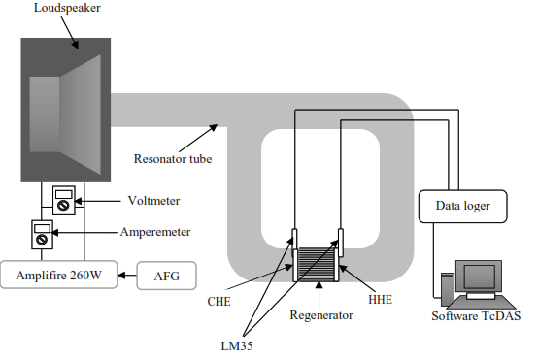

Figure 1. design of a travelling-wave thermoacoustic device

Regenerator position characteristics have been optimized numerically and are made of parallel porous acrylic material. The pores diameter of the acrylic material in the regenerator has a size of 1 mm and the distance between the pores is 1 mm. The process of making this regenerator has used laser cutting which is operated via a computer. Before starting the cutting process using laser cutting, the laser cutting program is first set according to the material to be cut so that the laser cutting produces perfect cuts. The regenerator pattern which is saved in graphic format is opened in the laser cutting program which is used to determine the direction of laser movement. Next, a regenerator will be produced in the form of a porous circular strip.

Hot heat exchanger (HHE) and *cold heat exchanger* (CHE) is an important component which functions to dissipate heat in the hot resonator area into the environment through a fluid medium. The material used for HHE and CHE must have good thermal conductivity so that they can absorb heat quickly. The materials used are copper pipes with a diameter of 4.7 mm and copper plates with a thickness of 1 mm. The copper plate is cut into rectangles 6 cm long and 2 cm wide. Then, they were given 15 holes to place copper pipes with fluid flowing as a heat waster into the environment. The chopper which has been cut is then arranged as high as 6 cm and given a distance between the layers of 1 mm. After that a copper pipe is installed in each hole in the copper plate, then the hot heat exchanger is placed in a box made of acrylic arrangement.

The temperature detection system consists of 2 digital thermometers with a temperature sensor (thermocouple) type IC-LM 35 coupled with a data logger, then this data logger is connected to a computer to display the measurement data. The use of data loggers can display data on a computer in real-time and the data can be saved in txt format. The data displayed by this digital thermometer has three-digit number with a precision of 0.1 ⁰C. This thermocouple is installed near the ends of the regenerator.

Preliminary experiments to determine the frequency of resonance by using winscope. And in the second experiment, the temperature of both reservoirs was measured using a digital thermometer (LM-35). It can be observed how much the reservoir temperature changes. The next experiment was carried out by installing an HHE heat exchanger in a hot reservoir. In this case, it will be observed how big the temperature change of the two reservoirs is, so that the temperature change can be compared with the presence or absence of the HHE heat exchanger. The performance of this traveling wave thermoacoustic device can be seen from the change in temperature it has and is reflected by how much changes in the temperature of the cold reservoir and the hot reservoir can be achieved. Furthermore, the experimental results that have been obtained will be analyzed using the graphical method in the form of a temperature graph showing the temperature in the hot and cold reservoirs as a function of time. In this case describes the process of changing the temperature of the hot reservoir air and also the increase in temperature of the cold reservoir over time of operation of the device, including the rate of temperature change and how much the temperature change is achieved.

1. **Calculation method**

The similarities of momentum and continuity in a flow pipe tube are as follows [12];

$\frac{dP}{dx}=-\frac{1}{A}\frac{iωρ_{m}}{1-χ_{v}}U$ (1)

$\frac{dU}{dx}=-\frac{iωA\left(1+\left(γ-1\right)χ_{α}\right)}{γp_{m}}P+\frac{χ_{a}-χ_{v}}{\left(1-χ_{v}\right)\left(1-σ\right)}\frac{1}{T_{m}}\frac{dT_{m}}{dx}U$ (2)

where *ω* is the frequency of the angle of the sound wave, *A* is the area of the cross section of the tube pipe tube, *ρm* is the average density, *γ* is the specific heat ratio, *σ* is the Prandtl number, $p_{m}$ is the average pressure, and *Tm* is the average temperature. *x* represents coordinates in an axial direction. Because *ρm*, *γ, σ* depend on *Tm*, the value of the air physical property is referred to the physical property data value. *P* represents a pressure fluctuation and *U* represents a fluctuation in flow speed.

$χ_{α}=\frac{2J_{1}\left(Y_{α}\right)}{Y_{a}J_{0}\left(Y_{α}\right)} , χ_{v}=\frac{2J_{1}\left(Y_{v}\right)}{Y_{v}J_{0}\left(Y_{v}\right)}$ (3)

$Y_{α}=\left(i-1\right)\sqrt{ωτ_{α}} , Y_{v}=\left(i-1\right)\sqrt{ωτ_{v}}$ (4)

where $J_{1}$ and $J_{0}$ is bessel function, and sequentially $τ_{α}$ and $τ_{v}$ are defined as $τ_{α}=r^{2}/2α$ and $τ_{v}=r^{2}/(2v)$, where $α$ is thermal diffusity and $v$ is kinematic viscosity. Each $ωτ_{α}$ and $ωτ_{v}$ is associated by $σ=v/α$ as $\frac{ωτ_{α}}{σ}={ωτ}_{v}$ [13].

The enthalpy flows along the regenerator and resonator tube should remaineconstant because they are assumed to be isolated, hence the enthalpy flowscan be written as [14];

$\dot{H}=\frac{A_{loop}}{2}Re\left[P\tilde{U}\left(1-\frac{χ_{α}-χ_{v}}{\left(1+σ\right)\left(1-χ_{v}\right)}\right)\right]+\frac{A_{loop}ρ_{m}C_{p}{\left|U\right|}^{2}}{2ω\left(1-σ^{2}\right){\left|1-χ_{v}\right|}^{2}}Im\left[χ_{α}-σ{\tilde{χ}}_{v}\right]\frac{dT_{m}}{dx}-\left(A_{solid1}k_{solid1}+A_{solid2}{εk}_{solid2}\right)\frac{dT_{m}}{dx}$ (5)

where $C_{p}$ is a specific heat constant of gas oscillations. $A_{loop}$ is a cross-sectional area of the loop-tube, $A_{solid1}$ and $k_{solid1}$ is a cross-sectional area and thermalsconductivitysof the regenerator container layer $A_{solid2}$ and $k_{solid2}$ are the cross-sectional and thermalsconductivity areas ofasolid materials consisting of regenerators. *ε* is an effective thermal conductivity reduction factor of multiple layers of regenerator plate. The value of *ε* used is 0.1 [15].

Enthalpy flow $\dot{H}$ and acoustic power flow *W* can determine heat flow on thermoacoustic, the equation is as follows;

$\dot{Q}=\dot{H}-\dot{W}$, where $\dot{W}=\frac{A_{loop}}{2}Re\left[PU\right]$ (6)

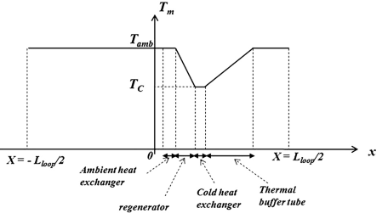

Figure 2. Temperature distribution close to cold heat exchanger [8]

The refrigerator powerais defineddas the amount of heat flowsat the cold end of the regenerator (Figure 2), this isaequal to theasum of the two heat flowscomponents; heat flow from cold heataexchanger to regenerator and heataflow fromathermal bufferatube to cold heataexchanger. This canabe stated as follows:

$Q_{C}=\left|{\dot{Q}}_{x=L_{H}+L_{reg}}\right|$ (7)

where $L_{reg}$ is the regeneratoralength, the acousticspowe $W_{in}$ is defined as follows;

$W_{in}=\left|{\dot{W}}_{x=-L_{loop/2}}-{\dot{W}}_{x=-L_{loop/2}}\right|$ (8)

The performance coefficient (COP) of the travelling-wave thermoacousticsrefrigerator can use $Q_{C}$ and $W_{in}$ equations, so that they can be stated as follows;

$COP=\frac{\left|{\dot{Q}}_{x=L_{H}+L_{reg}}\right|}{\left|{\dot{W}}_{x=-L_{loop/2}}-{\dot{W}}_{x=-L_{loop/2}}\right|}$ (9)

$COP=\frac{Q_{C}}{W_{in}}$ (10)

1. **Result and Discussion**

The results of the *Th* and *Tc* temperature experiments over time during the operation of the thermocoustic travelling wave device system were demonstrated by Fig.3. in this case, the operation is carried out with several variations in the sound frequency from 40 Hz to 49 Hz, the result of optimum frequency is 48 Hz. The optimum frequency obtained is estimated resonance frequency for the combined system between straight resonator tube and loop tube. The first the temperature of both sides of the regenerator is the same. Then when the sound wave generation system is activated, there is a change in the temperature of both sides. The heat side of the regenerator is the side that has a higher temperature than the initial temperature, and vice versa the cold side of the regenerator is the side that has a temperature lower than the original temperature. From the graph in (Figure 3), the heat side temperature of the regenerator (*Th*) rises to Δ*Th* = 13.4 oC from the initial temperature of 29.3 oC, while the cold side temperature of the regenerator (*Tc*) drops to Δ*Tc* = 12.9 oC from the initial temperature. So the temperature difference between the two sides of the regenerator is 26.3 oC.

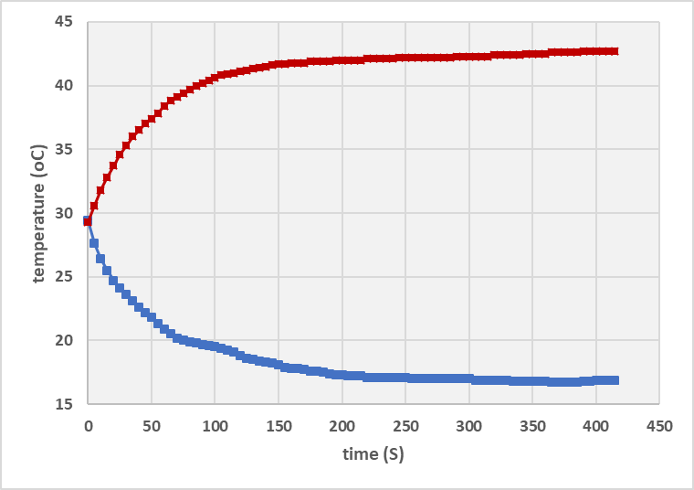

*Tc*

*Th*

Δ*Th* = 13,4 0C

Δ*Tc* = 12,9 0C

Figure 3. Graph of the results of the experiment on temperature changes over time

In the resonator tube in the heatside, the pressure will increase so that from the adiabatic nature of the gas, the temperature increases. On the coldside side, the pressure is reduced because the gas on this side is pushed to the heatside, and the temperature on the coldside will also drop. This theory could explain why temperature oscillations can occur during the movement of sound waves occurring inside the resonator tube.

When the sound wave generation system has not been activated, the gas particles (medium) in the regenerator are silent. While when the sound source is activated, gas particles will oscillate while moving the calorific from the cold side (*Th*) to the hot side (*Tc*). This phenomenon is called thermocoustic. The following thermocoustic process illustrations are used to facilitate the physic understanding of thermocoustic phenomena. The gas package is a volume of gas small enough that the pressure and temperature are uniform but large enough to review the macroscopic properties of the gas. The regenerator is assumed to be a parallel plate arrangement where the gas package moves back and forth in a parallel direction, then the gas package has the speed and pressure as a result of the sound travelling wave.

The thermocoustic heat pumping process begins when acoustic waves cause the gas inside the regenerator to move into the heatside, the gas will be compressed and the pressure increases. This compressed gas will be hotter than the wall of the nearby regenerator so that it releases heat to the regenerator and the volume of the gas shrinks. As the sound wave continues its cycle, the gas moves back to the coldside where the pressure is lower, in which case the gas becomes looser and colder than the nearby regenerator wall, so that it absorbs the calorific from the regenerator wall and expands. This cycle continues to repeat and the effect is the transfer of heatafrom the cold part to theaheat part ofathe regenerator.

1. **Conclusion**

Experimental research on the thermocoustic travelling wave device system has been conducted to have the radius and position of the regenerator optimized by calculation. The performance of the built-in thermocoustic travelling wave system has been operated. The temperature difference between the two sides of the regenerator reaches 26.3 oC with details of the temperature rise of the heat side of the regenerator (*Th*) up to Δ*Th* = 13,4 oC and the temperature drop of the cold side of the regenerator (*Tc*) down to Δ*Tc* = 12,9 oC. From these results, this thermocoustic travelling wave device system can operate properly and can be used as an alternative as a cooler and heater.

**Acknowledgment**

We would like to thank IKIP PGRI Jember for supporting this research and for its financial support.

**References**

[1] Astuti A D 2018 Implikasi Kebijakan Indonesia Dalam Menangani Kasus Pencemaran Lingkungan Oleh Pt. Freeport Terhadap Keamanan Manusia Di Mimika Papua *J. Int. Relations* **4** 547–55

[2] Babu K A and Sherjin P 2017 A Critical Review on Thermoacoustic Refrigeration and its Significance *Int. J. ChemTech Res.* **10** 540–52

[3] Avent A W and Bowen C R 2015 Principles of thermoacoustic energy harvesting *Eur. Phys. J. Spec. Top.* **224** 2967–92

[4] T.KIRANMAYEE and Kumar D M L S D 2017 DESIGN & FABRICATION OF THERMOACOUSTIC *Int. J. Emerg. Technol. Innov. Res.* **4** 407–10

[5] Yazaki T, Biwa T and Tominaga A 2002 A pistonless Stirling cooler *Appl. Phys. Lett.* **80** 157–9

[6] Jensen C, Raspet R and Slaton W 2006 Temperature gradient integration in thermoacoustic stacks *Appl. Acoust.* **67** 689–99

[7] Tijani M E H, Zeegers J C H and De Waele A T A M 2002 Construction and performance of a thermoacoustic refrigerator *Cryogenics (Guildf).* **42** 59–66

[8] Bassem M M, Ueda Y and Akisawa A 2011 Design and construction of a traveling wave thermoacoustic refrigerator *Int. J. Refrig.* **34** 1125–31

[9] Ueda Y, Mehdi B M, Tsuji K and Akisawa A 2010 Optimization of the regenerator of a traveling-wave thermoacoustic refrigerator *J. Appl. Phys.* **107**

[10] Setiawan I 2014 Pembuatan Piranti Pendingin Termoakustik Gelombang Berjalan *Prosiding Seminar Nasional Fisika Terapan IV* pp B10–4

[11] Setiawan I, Fadly M N M and Utomo A B S 2017 Experimental Demonstration of the Dependence of Temperature Decrease on the Hydraulic Radius of Regenerator in a Traveling Wave Thermoacoustic Refrigerator *J. Phys. Conf. Ser. 820*

[12] Rott N 1973 Thermally driven acoustic oscillations. Part II: Stability limit for helium *Zeitschrift für Angew. Math. und Phys. ZAMP* **24** 54–72

[13] Utami S W, Farikhah I, Khoiri N, Patonah S and Kaltsum U 2019 Kajian Numerik Pengaruh Jari-Jari Stack Terhadap Suhu Rendah Mesin Termoakustik Gelombang Berjalan *Prosiding Seminar Nasional The* pp 23–30

[14] Swift G W 2017 *Thermoacoustics: A Unifying perspective for some engines and refrigerators: Second edition*

[15] Lewis M A, Kuriyama T, Kuriyama F and Radebaugh R 1998 Measurement of beat conduction through stacked screens* *Adv. Cryog. Eng.* **43** 1611–8