Promotion & Information Media "Product Knowledge" in One Platform: Augmented Reality Technology

A D W Utami1, M Noviyanti2, N Kurniati3, P U D Satrio4, and M W Ardani5

1,4,5 Visual Communication Design Department

2 English Education Department

3 Informatics Engineering Department

Universitas Nahdlatul Ulama Sidoarjo, Indonesia

Email : [athika.dkv@unusida.ac.id](mailto:athika.dkv@unusida.ac.id)

**Abstract.** This research aims to: (1) produce promotional media as well as "product knowledge" information in an Android-based application platform with Augmented Reality technology for MaDa AMDK products; (2) determine the quality of the Android-based application platform with Augmented Reality technology as a promotional media as well as "product knowledge" information for MaDa AMDK products; and (3) find out whether there are differences in respondents' product knowledge before and after being treated. The method used to produce this platform is the Software Development Life Cycle model with the V-waterfall model. The V-model includes (1) user requirements specification stages; (2) system architecture design; (3) designing components; (4) writing program code; and (5) testing. The test results show that this platform has met ISO 25010 in functional suitability, performance efficiency, compatibility, and usability. In the functional suitability aspect with a value of 100% (very feasible), the performance efficiency aspect is concluded as "satisfied", the compatibility aspect is 100% (very feasible), and the usability aspect is 81,6% (very feasible). Also, the results of the study found that there were differences in respondents' product knowledge before and after being treated (using applications). Keywords: Augmented Reality, ISO 25010, Promotion Media, Information Media

# Introduction

Within these two decades, rapid technological developments have succeeded in entering all walks of life of society. Technological developments create a trend and then change human behavior and thought patterns in living, working, and socializing. Gartner IT Symposium / Xpo in October 2019 presented the top 10 technology trends for 2020 which are categorized into two main areas: human-centric and smart space. Multi experience is one of the keywords for technology trends that fall into the human-centric category. Multi-experience deals with the massive shift from a two-dimensional screen and keyboard interface to a much more dynamic, multi-modal kind of interface world where we're immersed in the interactive technology surrounds us. Multi-experience currently focuses on immersive experiences that use augmented reality, virtual reality, mixed reality, multi-channel human-machine interfaces, and sensing technologies [1].

Augmented Reality (AR) technology as a technology trend has been developed in various aspects, one of them is the digital marketing aspect. AR is transforming the way marketers and businesses interact with their customers [2]. The customer experiences through AR as digital new experience that transforms the customer journey into a visually immersive interactive experience. The AR in marketing can create an effective and enjoyable interactive experience by engaging the customer through technology. Wikayanto [3] said that AR-based application was developed and it was found that AR can be used as a very effective promotional media in promoting research products that have been produced by LIPI in Science & Technopark (STP) activities as well as making promotional activities more interesting and interactive. Banu Nur Affan, et al. [4] found that the usability aspect of the developed application obtained a SUS score of 79.6 indicating that the application was in the accepted category for use as a media of information and promotion of Dieng tourism. Furthermore, Augmented reality in Marketing advertising (ARMA) from Elham Baratali, et al's research [5] has found a unique and interactive way to engage the audience with the company brand. In summary, the primary intention of this project is to bring up or raise the awareness of augmented reality in the present and future especially in the marketing and advertising field. AR enrich the relationship between companies and consumers, especially at every stage of the customer journey: pre-sale, sale, and post-sale.

IKEA Place is one example of an augmented reality app developed to bring a new digital experience to the customer journey: pre-sales. IKEA Place is released and developed by IKEA, a household furniture retailer from Sweden. This application aims to provide an overview of when the furniture is installed where the consumer wants it. There are more than 2,000 accessories and furniture available and can be tried on this application. By using a cellphone camera, consumers just have to choose the furniture and accessories they want, then place them on the screen, then position the camera according to the location where the furniture to be placed as desirable, and can also adjust the scale and size of furniture and accessories according to the dimensions of the room [6].

MaDa Bottled Drinking Water, which is in Bahasa Indonesia called Air Minum Dalam Kemasan (AMDK), is a bottled drinking water product of the oxygen type produced by CV Ahlus Shafa Wal Wafa Sidoarjo. Currently, MaDa drinking water production continues to increase. Every day AMDK MaDa can produce 400 gallons, 150 boxes of 1500 ml bottles, and 100 boxes of glass packaging [7]. Based on the results of interviews and observations, the promotional media used are posters made in 2012 and are only distributed directly to distributors and consumers. MaDa is one of the AMDK players competing with more than 900 AMDK according to BPOM data and more than 700 AMDK according to data from the Ministry of Industry [8]. Therefore, it requires sales innovation from various aspects, one of them is promotional media. By utilizing all the advantages of AR technology, researchers developed an application based on android and AR which functions as a promotional media as well as information about product knowledge. It is hoped that through this application, customer experience can be improved and become increasingly engaged with the product.

# Research Method

The method used to produce this platform is the Software Development Life Cycle model with the v-waterfall model. The V-Model is a variation in the representation of the waterfall model. It depicts the relationship of quality assurance actions to the actions associated with communication, modeling, and early construction activities [9]. The V-model in figure 1 includes (1) user requirements specification stages; (2) system architecture design; (3) designing components; (4) writing program code; and (5) testing.

After developing the application, it is tested to find out whether there are differences in respondents' product knowledge before and after being treated (use of applications). Through the purposive random sampling technique, 36 respondents were obtained. Then the sample was given a pre and post-test with the application giving treatment after pre-test processing. The test given was in the form of product knowledge about the MaDa AMDK. The test results were then tested with the Paired t-test if the condition that the data were normally distributed and the scale of the interval/ratio data, while the Wilcoxon test provided that the data were not normally distributed and the scale of the data was interval/ratio [10]. The use of the Paired T orWilcoxon test is because the sample used is the same subject but has experienced two different treatments or measurements. Data analysis using the SPSS program.

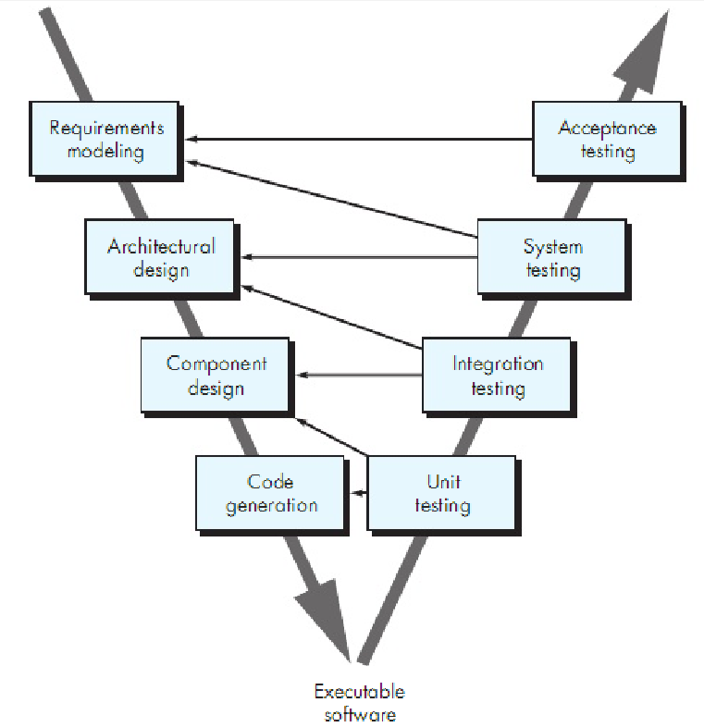

**Figure 1.** The V-Waterfall Model [9]

# Result and Discussion

* 1. Development of Application
     1. User Requirements Specification Stages*.* In this first stage, a needs analysis is carried out starting from problem identification, system user information needs, functional, and non-functional requirements [11]. Data were collected through observation and interviews with AMDK MaDa and several loyal customers. Then the collected data is analyzed into a list of user needs that need to be developed in making this application. The results obtained from the data collection stage are related to the conditions and needs of the user, namely: (1) promotional media used are only printed posters; (2) Based on the results of the previous survey, it was found that the effectiveness of poster media based on the dimensions of Empathy, Persuasion, Impact, and Communication was in the quite effective category; (3) there is a need for product information to be conveyed to consumers in a more attractive manner related to the fulfillment of the standard of healthy and proper drinking water in the MaDa AMDK; (4) in terms of infrastructure, the general public in Sidoarjo and surrounding areas are already technologically literate and place technology in the midst of fulfilling the needs of life, especially the use of smartphones [11].
     2. System Architecture Design*.* The system architecture design stages use Unified Modeling Language (UML) modeling which aims to describe the workflow of the system to be created. The system design is explained through use case diagrams in figure 2, sequence diagrams, and activity diagrams.

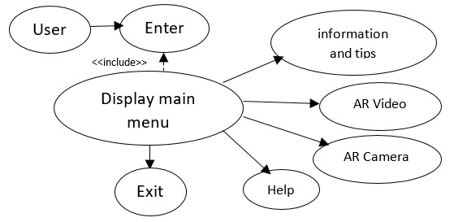

**Figure 2.** Use - Case Diagram

* + 1. Designing Components. This third stage is the design of a User Interface (UI) based on UML diagrams that have been made according to user needs. Figure 3 shows the user interface of the application.

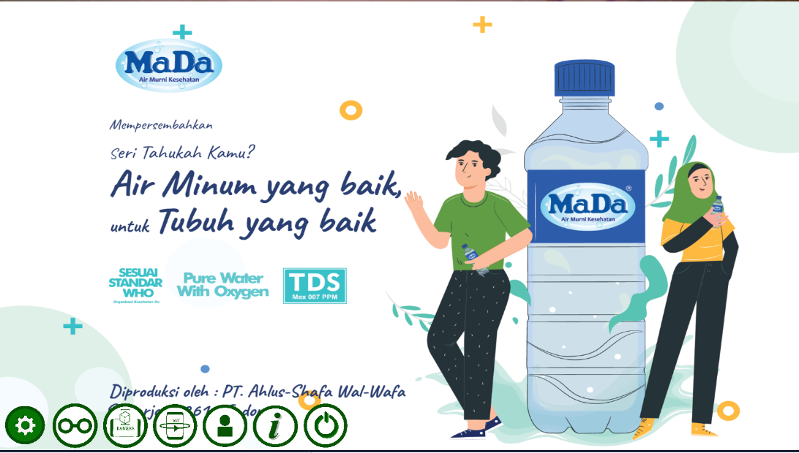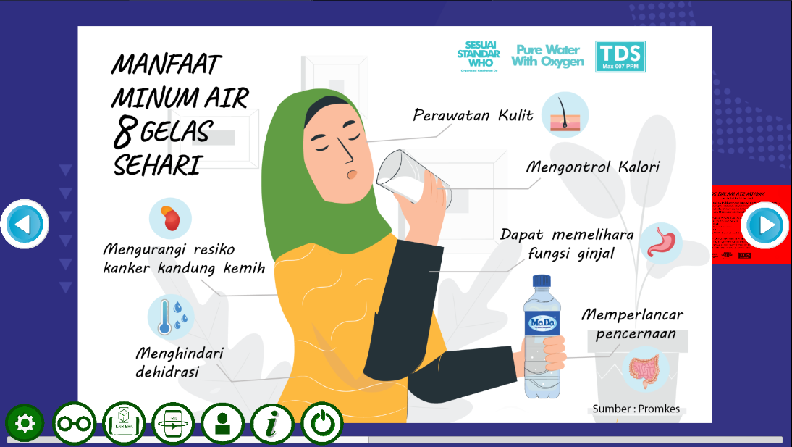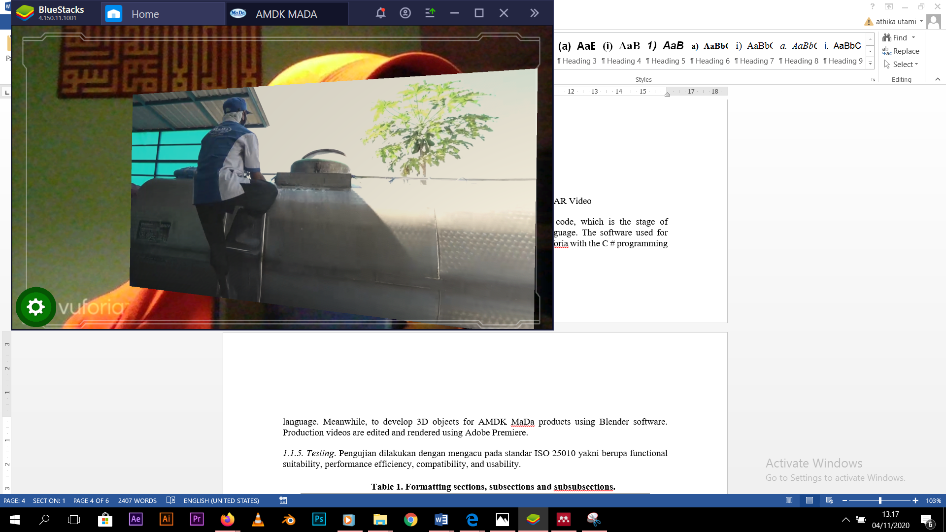

**Figure 3.** Main Menu, Information and Tips Menu, AR Video

* + 1. Writing Program Code. The fourth stage is writing program code, which is the stage of implementing a design that has been made into the programming language. The software used for Android-based application development and AR technology is Unity Vuforia with the C # programming language. Meanwhile, to develop 3D objects for AMDK MaDa products using Blender software. Production videos are edited and rendered using Adobe Premiere.
    2. Testing. There are many software testing standards, including The Bayesian Belief Network (BNN), Boehm, FURPS, McCall, Kazman, ISO 9126, and ISO 25010. The ISO 25010 standard is an international testing standard in determining the quality of software previously known as the ISO 9126 standard [12]. The test is carried out by referring to the ISO 25010 standard in the form of functional suitability, compatibility, performance efficiency, and usability.
       1. Functional suitability. The research instrument in the form of a checklist in the test case which contains a list of application functions described according to the functional requirements analysis filled by respondents of media and content experts. Based on the results of Functional Suitability testing for media, the percentage of feasibility is obtained as follows:

$$\text{Suitability Percentage} \left(\text{\%}\right)\text{=} \frac{\text{Observed Score}}{\text{Expected Score}}\text{x100=}\frac{\text{8}}{\text{8}}\text{x100\%=100\%}$$

Based on the results of Functional Suitability testing for content, the percentage of feasibility is obtained as follows:

$$\text{Suitability Percentage} \left(\text{\%}\right)\text{=} \frac{\text{Observed Score}}{\text{Expected Score}}\text{x100=}\frac{\text{5}}{\text{5}}\text{x100\%=100\%}$$

Both results of the functional suitability calculation are 100%, so it can be said that this application belongs to the "Very Feasible" category.

* + - 1. Compatibility. Testing was carried out by running applications on a variety of Android-based smartphone devices with the Advance G3 Pro, Honor 9i, Xiaomi Redmi 4A, and Oppo A5.

|  |  |  |  |  |  |
| --- | --- | --- | --- | --- | --- |
| Table 1. Compatibility Test Result | | | | | |
| **Device** | | **Android Version** | **Screen Resolution** | **Succesful** | **Failed** |
| Xiaomi Redmi 4A | | Android 6.0.1 (Marshmallow) | 720 x 1280 pixels | 1 | 0 |
| Honor 9i | | Android 8.0 Oreo | 1080 x 2280 pixels | 1 | 0 |
| Advance G3 Pro | | Android 9.0 Pie | 720 x 1520 pixels | 1 | 0 |
| Oppo A5 | | Android 9.0 Pie | 720 x 1600 pixels | 1 | 0 |

Furthermore, based on the table 1, then the calculation of the percentage score of the test results is carried out and matched with the rating scale to determine the quality level of the application compatibility aspect with the formula:

$$\text{Suitability Percentage} \left(\text{\%}\right)\text{=} \frac{\text{Observed Score}}{\text{Expected Score}}\text{x100=}\frac{\text{4}}{\text{4}}\text{x100\%=100\%}$$

The calculation of the suitability percentage is 100%, so it can be concluded that in terms of Compatibility, the application is "Very Feasible".

* + - 1. Efficiency. This test is used to measure the time it takes to load a page in the application. The analysis was carried out 5 times by calculating the average response time of the application to run each feature of the application[14]. The mean results are then compared with the user satisfaction table according to Hoxmeier & DiCesare [15]. Based on the data in table 2, it is concluded that the measurement of user satisfaction, the response time of this application is included in the category predicate "satisfied".

|  |  |  |  |  |  |  |  |  |  |  |
| --- | --- | --- | --- | --- | --- | --- | --- | --- | --- | --- |
| Table 2. Table of Performance Efficiency Test Results | | | | | | | | | | |
| **Device** | | **Response Time (seconds)** | | | | | | | |  | |
| **1** | | **2** | | **3** | | **4** | | **5** | |
| Start the Application | 0,5320 | | 0,5636 | | 0,5250 | | 0,4802 | | 0,5027 | |
| Marker detection | 18,343 | | 20,493 | | 17,928 | | 19,329 | | 20,425 | |
| Display the production video | 0,1254 | | 0,1232 | | 0,1392 | | 0,1328 | | 0,1424 | |
| Display AMDK Mada products | 0,1186 | | 0,1235 | | 0,1124 | | 0,1243 | | 0,1289 | |
| Display Information and Tips | 0,1241 | | 0,1289 | | 0,1311 | | 0,1239 | | 0,1348 | |
| Display Help | 0,1183 | | 0,1173 | | 0,1189 | | 0,1132 | | 0,1239 | |
| Close Application | 0,0983 | | 0,1129 | | 0,1117 | | 0,0932 | | 0,1089 | |
| Total | 3,73 | | 4,09 | | 3,69 | | 3,82 | | 4,05 | |
| **Total (Second)** | **3,876** | | | | | | | | | |

* + - 1. Usability. The research instrument for usability testing used the USE Questionnaire questionnaire with a 5-point Likert scale adapted from Lund [13] and given to 36 target consumer respondents. The questionnaire totaled 30 statements consisting of 4 criteria, namely usefulness, ease of use, ease of learning, and satisfaction. Based on the results of the Usability test, the percentage of feasibility is obtained as follows.

$$\text{Usability}\text{ Percentage} \left(\text{\%}\right)\text{=} \frac{\text{Total}\text{ Score}}{\text{Maximum }\text{Score}}\text{x100=}\frac{\text{3672}}{\text{4500}}\text{x100\%=}\text{81,6}\text{\%}$$

The results of the usability calculation are 81,6%, so it can be said that this application belongs to the "Very Feasible" category.

* 1. Product Knowledge of Respondents
     1. Research Respondents. Respondents of this study amounted to 36 potential customers who were given an online questionnaire. The response rate of the total distributed questionnaires was 100%.
     2. Research Instrument Test. Based on table 3, the results of the research instrument test found that the questionnaire data was valid, reliable, and not normally distributed, so the test used was the Wilcoxon test.

|  |  |  |  |
| --- | --- | --- | --- |
| Table 3. Recapitulation of Research Instrument Test Results | | | |
| No | Test Type | Result | Conclusion |
| 1 | Data Validity | r result > r table (0,2785) | Valid |
| 2 | Data Reliability | Cronbach’s Alpha > r table (0,2785) | Reliable |
| 3 | Data Normality | p result of pretest (0,019) < p-*value* (0,5)  and p result of posttest (0,015) < p-*value* (0,5) | Data are not  normally distributed |

* + 1. Wilcoxon Test. From the analysis, it was found that the pretest group means was 46,7 and the mean post-test group was 64,2. The sig value (0,004) > 0,5 then Ho is rejected, Ha is accepted: means that there is an effect of media use on the respondent's product knowledge or there is a difference between the respondent's product knowledge before and after being treated (application use).

# Conclusion

The test results show that this platform has met ISO 25010 in functional suitability, performance efficiency, compatibility, and usability. In the functional suitability aspect with a value of 100% (very feasible), the performance efficiency aspect is considered feasible because there is no memory leakage on the device running it (accepted), the compatibility aspect is 100% (very feasible), and the usability aspect is 81,6% (very feasible). Also, the results of the study found that there were differences in respondents' product knowledge before and after being treated (using applications).

# References

[1] Raiker R M 2020 Top 10 Technology Trends for 2020

[2] Shaham H 2020 9 Ways Augmented Reality Customer Experience Boosts Sales and Satisfaction *TechSee*

[3] Wikayanto A 2020 Augmented Reality Untuk Media Promosi Hasil Penelitian *J. RESTI (Rekayasa Sist. dan Teknol. Informasi)* **4** 608 – 617

[4] Affan B N, Suryanto A and Arfriandi A 2018 Implementation of augmented reality as information and promotion media on Dieng tourism area *Telkomnika (Telecommunication Comput. Electron. Control.* **3** 128–33

[5] Baratali E, Helmi M, Rahim B A, Parhizkar B and Gebril Z M 2016 Effective Of Augmented Reality (AR) In Marketing Communication; A Case Study On Brand Interactive Advertising *Int. J. Manag. Appl. Sci.* **2** 133–7

[6] Mulyana F 2018 IKEA Place, Aplikasi Augmented Reality untuk Memilih Perabot

[7] Utami A D W 2020 Analisis Efektivitas Redesain Poster Sebagai Media Promosi (Studi Kasus : AMDK Mada) *Arty J. Seni Rupa* **9**

[8] Anon 2019 Industri AMDK bidik kinerja tumbuh 10 persen sepanjang 2019 *kabarbisnis.com*

[9] Pressman R S . B R M 2015 *Software Engineering A Practitioner’s Approach* (New York: McGraw-Hill Education)

[10] Sujarweni V W 2015 *Statistik untuk Kesehatan* (Yogyakarta: Gava Media)

[11] Utami A D W F N 2019 Implementasi Teknologi Augmented Reality dalam Visualisasi Ibadah Umrah Menggunakan Metode Marker Based Tracking pada Android *J. Inf.* **4** 15–20

[12] Mistrik I, Soley R M, Ali N, Grundy J and Tekinerdogan B 2016 *Software quality assurance: In large scale and complex software-intensive systems* (USA: Morga Kaufmann)

[13] Lund A M 2001 Measuring Usability with USE Questionnaire. Usability and User Experience SIG

[14] Niknejad A 2011 A Quality Evaluation of an Android Smartphone Application *Univ. Gothenbg.* 8

[15] Hoxmeier J A C D 2000 System Response Time and User Satisfaction: An Experimental Study of Browser-based Applications *AMCIS 2000 Proceedings*