BD-Print: An Android Based for Bilingual Digital Promotion of Integrated Tourism in Garut Selatan

1R Y D Cahyani, 2Hartono, 3R M N Sakinah, 4O N Putra, and 5I E Setyawati

1English Literature Study Program, Faculty of Letters, Al-Ghifari University (UNFARI), Bandung

2English Literature Study Program, Faculty of Letters, Al-Ghifari University (UNFARI), Bandung

3English Literature Study Program, Faculty of Letters, Al-Ghifari University (UNFARI), Bandung

4Information System Study Program, Management and Informatics College (STMIK) Jabar, Bandung

5State Administration Study Program, Faculty of Social and Political Sciences, Al-Ghifari University (UNFARI), Bandung

Email: yenicahyani69@yahoo.com

**Abstract**. This study is undertaken to design an Android-based BD-Print application to assist the development of the regional potential tourism sector in the Southern Garut (Garsel). The design of the BD-Print application is expected to introduce the tourist destinations of Garsel to the international community and be developed as a promotional medium that can reach local and foreign tourists so that they can visit Garsel region in West Java Province. BD-Print can also help the local tourists and foreign tourists who want to visit Garsel. The BD-Print system development will use the System Development life Cycle approach with the Waterfall method. Hopefully, the development of the BD-Print application can promote tourism potentials and raise the economy of the surrounding area and make the dissemination of tourism information easier and more efficient.

**Key Words: application, BD-Print, promotion, integrated tourism, Android-based**

1. Introduction

Tourism development is one of the development sectors that attracts the attention of the government in Indonesia. Tourism is an inseparable part of human life, especially regarding social and economic activities. Starting from activities that were only enjoyed by a few relatively wealthy people in the early 20th century, now it has become part of human rights. This is happening not only in developed countries but is beginning to be felt in developing countries as well. Indonesia as a developing country is in its development stage, trying to build a tourism industry as a way to achieve a balanced foreign trade balance. Through this industry, it is hoped that foreign exchange earnings can increase [1]. As such, tourism is a product of modern social arrangements. Tourism planning must be based on conditions and carrying capacity with the aim of creating long-term mutually beneficial interactions between the achievement of tourism development goals, increasing the welfare of local communities, and sustainable environmental carrying capacity in the future [2]. Indonesia as a developing country is in its development stage, trying to build a tourism industry as a way to achieve a balanced foreign trade balance. The current tourism development is not only to increase foreign exchange and local government revenue. However, it is also expected to expand business opportunities in addition to providing new jobs to reduce unemployment. Tourism can increase the life standard of people living in these tourist destination areas through economic benefits. By developing facilities that support and provide recreational facilities, tourists and local residents benefit from each other. The development of a tourist area should reflect the cultural, historical and economic levels of the tourist destination[3]. The reason is because tourism can spur economic growth of the community, as well as improve the welfare of the people in the tourist area. South Garut Region (Garsel) has a wealth of tourism potential that varies, based on Regional Regulation No. 28 of 2010 on The Development of South West Java Region year 2010-2029, Garsel will be developed by the Government of West Java Province into an integrated tourism area, including coastal tourism, river tourism, technology tourism, indigenous village tourism, agricultural (*agro*) tourism, and special interest tourism. Garsel's special interest tourism includes paragliding (*gantole*), climbing, diving, adventure, rafting tour, and so on. Tourism potential of South Garut has a very opportunity to attract tourists both Indonesian and foreign. Therefore, it needs to be developed by optimizing the existed various potentials. The design of BD-Print application can support tourism promotion efforts in South Garut region, so that tourism potential in this area can be well known by tourists in foreign countries because the application is made in two languages: English and Indonesian. Based on this phenomenon, hopefully the developing strategies to promote the tourism potential of South Garut as a leading tourism destination in West Java province can be well prepared.

By rules, Garsel's tourism potential is reflected in the 2015-2025 West Java Tourism Development Master Plan, but empirically the potential has not been developed optimally, access to information and promotion is still very minimal, so tourists and prospective developers (entrepreneurs) have difficulty obtaining easily accessible information. The tourism potential of South Garut will be more easily accessible by developing a digital information system as a promotional medium to introduce its attractions [4]. BD-Print is a concept of utilizing information and communication technology to increase usability of information technology in the field of tourism created in two languages. This application provides various tourism services to tourists that make tourism marketing more accessible both locally and internationally. Based on that understanding, the internet in tourism basically reflects a digital system in terms of tourism distribution that leads to the transformation of tourism industry development towards the internet which is usually in the form of websites or applications[5]. BD-Print is a digital platform that connects all tourism stakeholders, facilitates the licensing process, integrates all tourism activities and provides convenience for all tourists exploring the charms of the Southern Garut tourism through an easy-to-use app, anytime and anywhere.

BD-Print application design can be used as a promotional medium that can reach local and foreign tourists [6]. Through the creation of this application is expected to provide convenience for tourists to get information about tourist attractions located in the Southern Garut region.

The design of BD-Print application aims to be a bilingual digital promotional medium and as an attraction for tourists so that the tourist destination of Southern Garut is more familiar and can be visited by local tourists as well as foreign tourists. But in the design of this application requires a thorough collection of information such as the potential of existing resources and the supporting capacity of the region for ecotourism development ranging from available facilities, visitor satisfaction, as well as people's attitude towards tourist activities. This application is also useful to increase the use in the field of tourism, provide various tourism services to the community, and make the implementation of tourism marketing more accessible.

1. Method
   1. *System Development*

Software engineering methods present technical procedures for developing or building software. This method includes a range of tasks such as communication, analysis, requirements, design-modelling, test programming, and user support[7]. The Waterfall model of SDLC (System Development Life Cycle) is used to develop the BD-Print application. SDLC is a sequential software development process where the process from top to bottom goes through the steps that must be carried out for the success of making software [8].

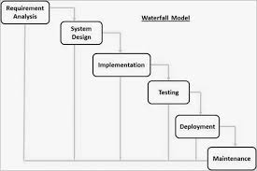

Picture 1. Waterfall Model

As shown in picture 1, an analysis is a Software Requirements Specification (SRS) that is a complete description of software behavior. Design is the planning and problem-solving process for a software solution. This implementation refers to the realization of business requirements and design specifications in the form of programs, databases or software components through programming. The testing phase is also known as verification and validation, which is a process to check that a software solution meets the requirements, specifications and completes the stated objectives. Process maintenance modifies software solutions once they are built and implemented to improve output, fix errors and improve performance and quality[7].

* 1. *Research Framework*

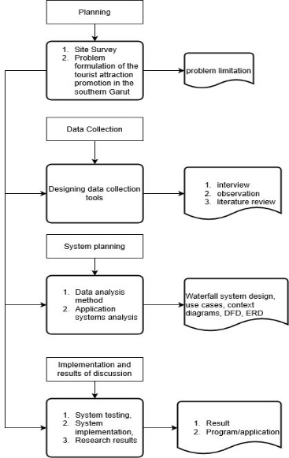

Picture 2. Research Flowchart

1. Result and Discussion
   1. *Use case diagram system design*

Use Case Diagrams describe the functionality expected of a system that emphasizes what the system makes and presents an interaction between actors and the system[9][10]. As shown in picture 3, user is an actor who uses these tourism applications, whereas admin is an actor who manages tourist information data. users search for places of interest by travel category or by tourist sites, then choose the category to look for tourist location info and routes.

Admin's job is to view or manipulate tourist attraction data. The admin inputs username and password in login menu, selects the tourist attraction data processing link on the menu. Admin can change, add, or clear the travel data.

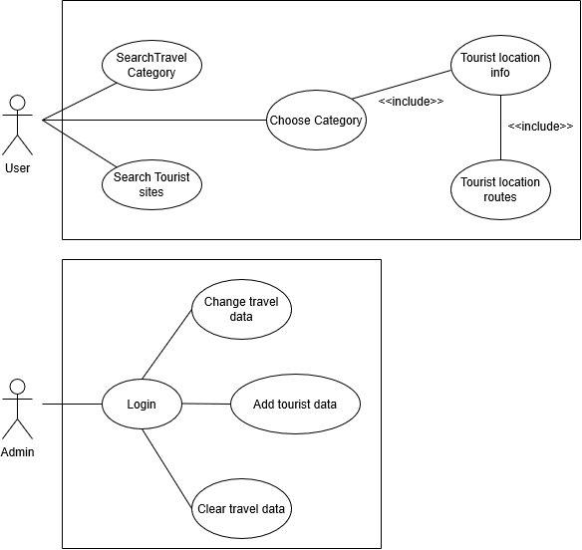

Picture 3. Use Case Diagram

The activity diagram looking for the tourism category above explains the activities that occur on the tourism website carried out by the user. Starting from the user opening a website page then the system displays the website page and the user clicks on the tour menu and the system displays tourism categories. The user clicks on the desired tourist attraction and the system displays tourist information. The search activity diagram image above describes the activity that occurs on a tourism website carried out by users. Starting from the user selects the search menu and enters the name of the tour desired then the system will display tours based on the results search. Once the results are displayed the user clicks and the system will display tourist attraction information based on search results.

* 1. *BD-Print Design*

The BD-Print application (in picture 4) is designed in two languages which aims to promote Southern Garut tourism objects in an integrated manner and can be recognized by foreign tourists. In addition to informing data about tourist objects and their routes, this application is also equipped with a database of restaurants, hotels, places of worship, playgrounds, malls, gas stations, and even ATM locations. The BD-Print application is certainly very helpful for those of you who want to visit Southern Garut without being accompanied by a guide. You can also file a complaint or comment through this application so that it can help the City Government respond to tourism developments.

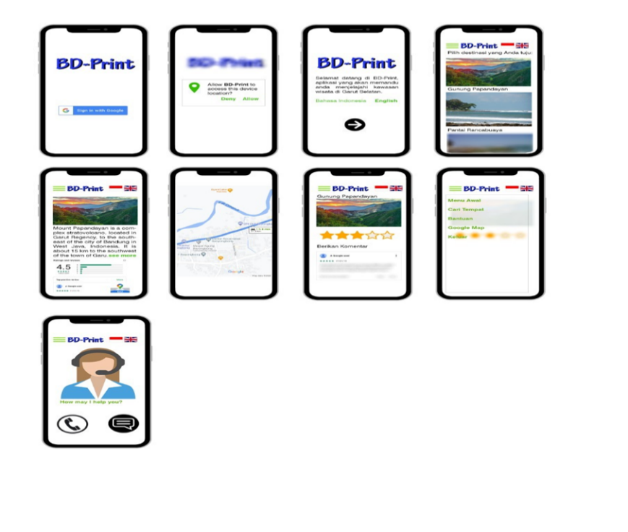

Picture 4. BD-Print Design

This research produces a bilingual digital application for Southern Garut Tourism Promotion based on Android. Through this application both local and international users get the information available in the application. The discussion at this stage is to test the system that has been designed beforehand to test the function of each application page. System testing includes testing the application input and output. In this test, it is carried out on an application via an Android cellphone, this test aims to see whether the application's Input and Output functions can run properly. For example: the following is a display of the results of entering the Mount Papandayan menu in the following image:

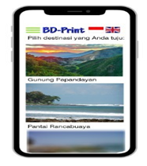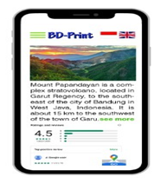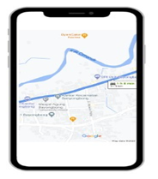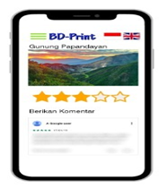

Picture 5. search results for Mount Papandayan icon, along with information and routes

1. Conclusion

Based on the explanation above, it can be concluded that with the creation of the BD-Print application, the tourism potential in Southern Garut will be better known by both local and international tourists. They will more easily get information about Southern Garut Tourism. This promotional information system is built more easily and efficiently. With this information system is expected to help Southern Garut Tourism in order to compete better because all information about the tourism object is easier to obtain by visitors.

References

[1] Zaei M E and Zaei M E 2013 the Impacts of Tourism Industry on Host Community *Eur. J. Tour. Hosp. Res.*

[2] Tavallaee S, Asadi A, Abya H and Ebrahimi M 2014 Tourism planning: an integrated and sustainable development approach *Manag. Sci. Lett.*

[3] Csapo J 2012 The Role and Importance of Cultural Tourism in Modern Tourism Industry *Strategies for Tourism Industry - Micro and Macro Perspectives*

[4] Karpova G A, Kuchumov A V., Testina Y S and Voloshinova M V. 2019 Digitalization of a Tourist Destination *ACM International Conference Proceeding Series*

[5] Prats-Planagumà L and Camprubí R 2009 E-tourism image: The relevance of networking for web sites destination marketing *Information Communication Technologies and City Marketing: Digital Opportunities for Cities Around the World*

[6] Encalada L, Boavida-Portugal I, Ferreira C C and Rocha J 2017 Identifying tourist places of interest based on digital imprints: Towards a sustainable smart City *Sustain.*

[7] Shalahuddin S 2014 Metode Pengembangan Perangkat Lunak *Waterfall*

[8] Bulman M 2017 SDLC - Waterfall Model *Indep.*

[9] Visual Paradigm 2019 What is Use Case Diagram? *Vis. Paradig.*

[10] Seidl M, Scholz M, Huemer C and Kappel G 2015 The Use Case Diagram