Design of Performance Reporting Information Systems Web-Based Temporary Staff at The Office of Communicatoin and Informatics, Blitar Regency

Wiji Setiyaningsih1, Hari Lugis Purwanto2, Gaguk Susanto3, Moh Ahsan4, Amak Yunus Eko5, Yesika Trestiarso6, Daryanto7

Faculty of Science and Technology, Kanjuruhan University Malang1, 2, 3, 4, 5, 6, Universitas Muhammadiyah Jember7

[wiji@unikama.ac.id](mailto:wiji@unikama.ac.id), [hari_lugis@unikama.ac.id](mailto:hari_lugis@unikama.ac.id), [gaguk.susanto@unikama.ac.id](mailto:gaguk.susanto@unikama.ac.id), [ahsan@unikama.ac.id](mailto:ahsan@unikama.ac.id), [amakyunus@unikama.ac.id](mailto:amakyunus@unikama.ac.id), [yesikatrestianto@gmail.com](mailto:yesikatrestianto@gmail.com), [daryanto@unmuhjember.ac.id](mailto:daryanto@unmuhjember.ac.id)

**Abstract**. The Office of Communication and Informatics of Blitar Regency carries out its main tasks supported by temporary personnel with their respective work targets. To find out the number of performance targets that have been carried out and performance appraisals per year, the temporary staff must make daily and monthly performance reports to the leadership. So far, technical reporting uses Microsoft Excel which must be printed one by one before being reported. If there are errors on the report must edit one by one. Each sheet stores daily reports so that many sheets are used to store reports in one month. Reports submitted to the leadership are still in copy which is prone to loss. This has a negative impact on the deadlines for collecting reporting and monitoring by the leadership. Based on these problems, a Web-Based Performance Reporting Information System was built to optimize performance reporting. The system is built with 3 access rights: admin, leadership, and non-permanent personnel, employee mastering and performance targets with targets, as well as daily and monthly reporting transactions. From the test results, the system with UAT 89.8% has been able to optimize performance reporting with the output of performance values per month and per year completed with graphs of performance targets.

1. Introduction

To help carry out their duties and functions, the Blitar Regency Communication and Information Office is supported by the presence of temporary personnel. So far, technical daily and monthly performance reporting for non-permanent personnel at the Blitar Regency Communication and Information Agency is still manual using Microsoft Excel. Reports must be printed one by one before being reported, if there is an error in the daily report you have to edit one by one, each sheet keeps the daily report so that many sheets are used to save the report in one month, and there are still many performance reports that have not been signed because the Section Head is often absent or on duty outside the office. Data storage management is also still stored in the computer files of each temporary employee. In addition, non-permanent staff experience difficulties when at any time they are asked for performance reporting data in the form of daily or monthly by their direct superiors or personnel because data storage is still stored on their respective computers and some are also stored in hardcopy if it has been printed, which is prone to loss and less effective data retrieval.

Performance reporting that is still manual has an impact on the collection of performance reports being delayed and the monitoring process by the section head is hampered because so far the section head has monitored the performance of precarious personnel through reports that have been printed and stored in an archive in the form of hardcopy which is prone to loss. If the head of the section is unable to attend because he has an assignment outside the city, monitoring the performance of the precarious personnel will also be timeless and inefficient. This causes the work targets and the number of performance targets for precarious workers to be incompatible with what has been done so that it can reduce the development of a sense of responsibility and are unable to increase the skills of non-permanent workers, as well as affect the sustainability of the temporary work contract at the Blitar Regency Communication and Informatics Office.

Based on the description of the problem, a web-based performance reporting information system was built at the Blitar Regency Information and Communication Office. The objectives of this study are 1). To design a web-based performance reporting information system; 2). To optimize daily and monthly performance reporting data management by non-permanent employees, as well as to optimize section heads in monitoring work targets and the number of performance targets for non-permanent workers to be more effective and timely.

1. Literature Review

**Information system**

Informaion system is a system that provides information for management in making decisions and also for running company operations, where the system is a combination of people, information technology and organized procedures. An information system is a system within an organization that meets the daily transaction management needs, supports operations, is managerial, and strategic activities of an organization and provides certain external parties with the required reports [1].

**Perfomance Report**

A performance report is a report that lists the results of both individual and team performance in one period. This report is used to communicate progress to employees and forecast future progress to stakeholders. The data displayed must be clear and unambiguous. The work results of the performance process are presented in table or graphical format and are visual based to make it easier to understand. That way, the report is easy to understand. Feedback reports are needed to measure the activities carried out in order to improve performance and accountability in implementing a plan or when implementing a budget, so that management can know the results of implementing the plan or achieving the set budget targets [2].

**Performance Reporting Information System**

There is research by Mukhammad I and Endang K regarding the performance reporting information system of employees of the environmental service, resulting in research that can help employees and supervisors of the Mojokerto City environmental service in reporting daily performance and submitting employee equipment [3]. Erid's research on analysis and design of employee performance reporting system using the work system framework with UML modeling resulted in research to overcome delays in submitting daily employee reports per month [4]. Meanwhile, Imam, Hanim, Radityo's research on Designing and Making Online-Based Performance Reporting Systems for Computer Institutions resulted in research with a reporting system application that could store list data and KPI realization and carry out hardware inventory [5]. Yulanda's research on the design of a web-based PDAM Pekanbaru employee performance reporting system with PHP and MYSQL resulted in research. With this system, employees were more efficient and effective in presenting reports and evaluating performance results [6]. Thus it can be concluded that the existence of an employee performance reporting information system can optimize the performance reporting process, and increase the effectiveness of monitoring and evaluating the achievement of employee performance targets by the leadership.

1. Research Methodology

The research method in the implementation of this research is to use a development method that applies the waterfall development model, which includes the stages: definition and analysis of system requirements, system and software design, implementation and unit testing, system integration and testing, and operation and maintenance [7] [8].

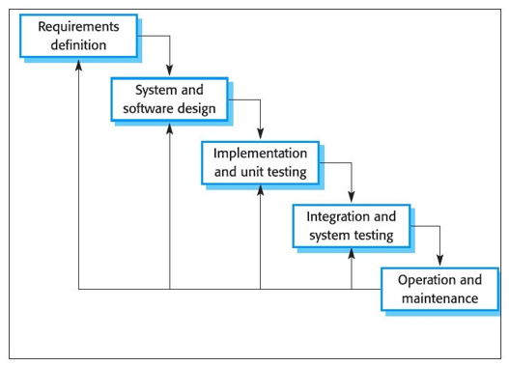

**Figure 1.** Waterfall Method Stages

## Definition And Analysis of System Requirements

The activity at this stage aims to identify the running system based on data at the Blitar Regency Communication and Information Office and collect the data needed to meet the needs for software development by conducting interviews and observations with related parties, namely the Head of the Application Development and E-Governance Section. Gov and two irregular forces. Interviews were conducted in November 2019. The following are the results of interviews with temporary staff related to user needs:

a. The initial need for users is to build a performance reporting information system for temporary personnel that can help optimize the management of daily and monthly performance reporting data by non-permanent workers, as well as optimize section heads in each field in monitoring work targets and the number of performance targets for non-permanent workers to be more effective. and on time.

b. In building a performance report information system for non-permanent personnel, the following information is needed: District Information and Communication Office employee data Blitar, data on work targets and the number of performance targets for non-permanent workers, performance report format is not fixed.

## System and Software Design

Activities in this stage compile a series of system work by determining the actors of the system and the tasks that must be done. In addition, making models to understand system requirements as well as system design. The models used in this study are:

1. Use case diagrams, sub-use case diagrams, activity diagrams, sequence diagrams, and class diagrams to describe the interactions that are carried out by each actor [9].
2. Interface design for making information system display design.

## Implementation and Unit Testing

At this stage, a performance report information system is built by coding. The system is built according to the model that was created in the previous stage. In the development of this system using the programming language PHP, HTML, Javascript, CSS and MySQL. And supported by XAMPP software and the CodeIgniter framework. After the coding is complete, then system testing is carried out using black box testing to find out errors that may occur in the system which will then be corrected [10] [11] [12].

## System Integration and Testing

The operational test of the performance report information system for non-permanent personnel at the Office of Communication and Information Technology in Blitar Regency was carried out by several actors, namely administrators, unit leaders, and non-civil servant employees. System operational testing can use User Acceptance Testing (UAT) [13] [14] [15] [16] through the following steps:

a. Planning

Designing a questionnaire list that will be filled in by 20 respondents consisting of the head of the e-gov application development and governance section, the head of the section for managing information and public opinion, the information system admin, 10 non-permanent staff and 7 other employees. Making research instruments consisting of several core points of the questionnaire, namely: information system interface, ease of access to information systems, suitability of functions that run on information systems.

b. Implementation

Provide a questionnaire sheet to a predetermined sample, testing, analyzing and establishing research instruments, evaluating, analyzing and processing the data that has been collected, prepare reports from research results.

## Operation and Maintenance

The finished information system is submitted to the user, then evaluates the operation of the system that has been run by the user. With this stage, it is hoped that the creation of an information system for temporary staff performance reports that is in accordance with the needs of the Blitar Regency Communication and Information Office.

1. Result and Discussion

## Analysis of System Requirements

1. Employee data is used as the basis for system user data, main performance data and additional productivity as well as daily and monthly reporting that can be managed by the admin.
2. Job targets consist of the types of performance targets with the number of targets in each section and field.
3. The main performance data is in the form of submissions from input non-permanent staff who can be verified by the admin or leader as the verifier.
4. Additional productivity data is in the form of submissions from non-permanent labor input that can be verified by the admin or leader as the verifier.
5. Verifiable key performance and additional productivity proposals can be calculated by name of the precarious worker.
6. Daily verified key performance and additional productivity data reports can be displayed as reports by name and date.
7. Monthly key performance and productivity data reports additions that have been verified can be displayed in the form of monthly reports based on name, month, and year.
8. This graph of the number of work targets shows the number of work targets that have been completed by precarious workers

## System and Software Design

The main use case diagram of the system aims to describe the interaction between 3 actors, namely the admin, unit leader and non-permanent employees with the system. This diagram serves to determine the functions in the system and who has the right to use these functions.

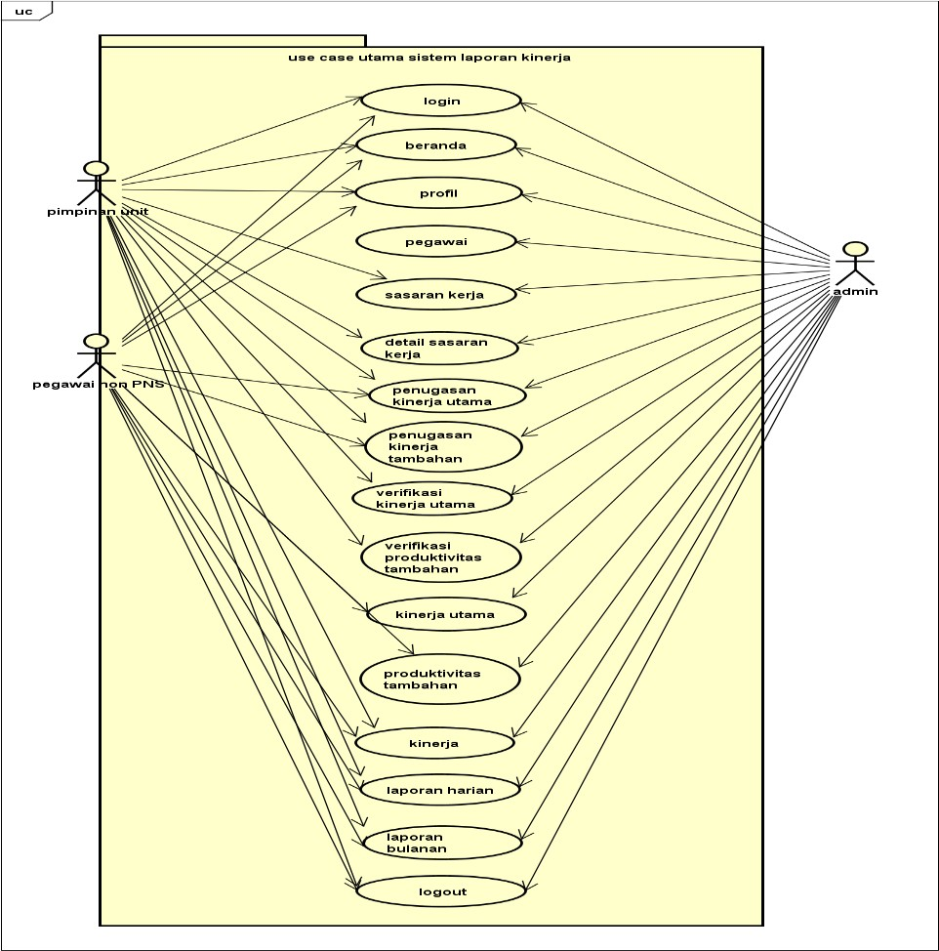

**Figure 2.** Use Case Diagrams of Performance Reporting Information Systems

Class diagram is a UML that is used to map the structure of the system by modeling classes, attributes, operations and relationships between objects.

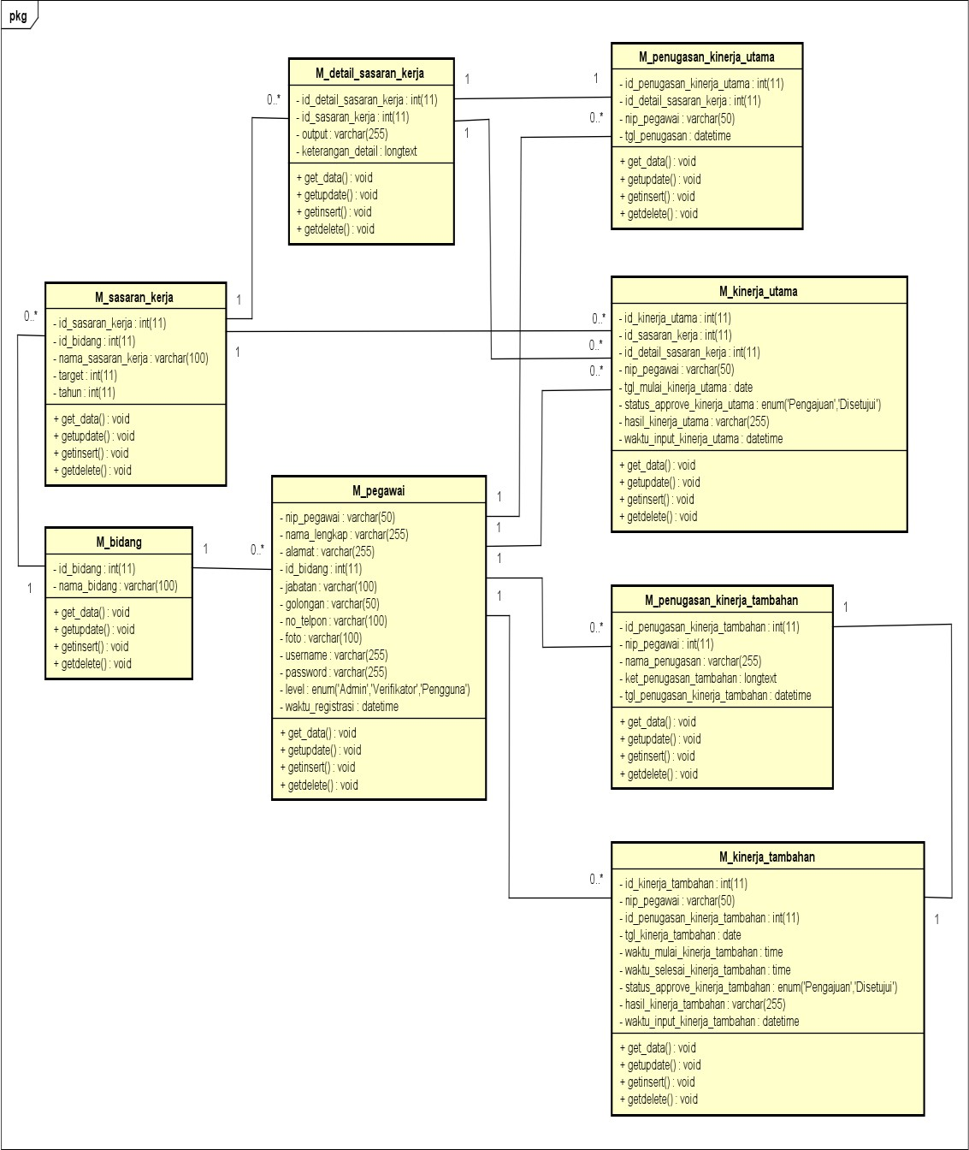

**Figure 3.** Class Diagrams of Performance Reporting Information Systems

## Implementation and Unit Testing

Figure 4 is the implementation of programming and testing for work target forms by the admin including adding data, editing data, and deleting data.

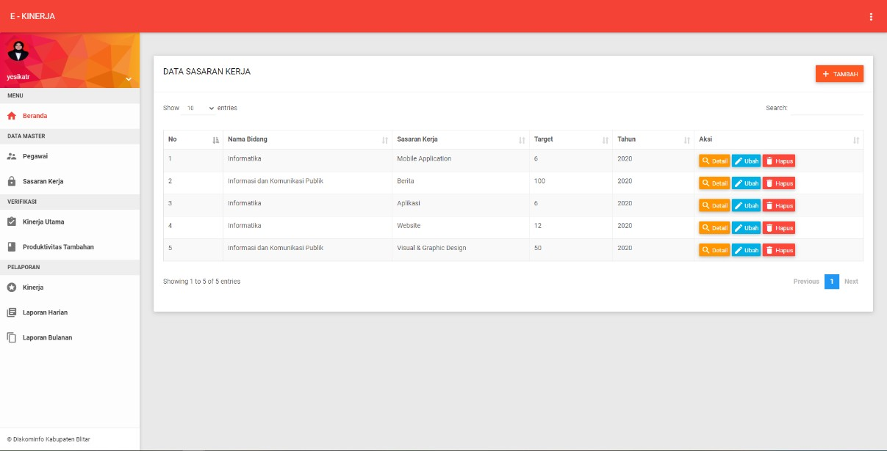

**Figure 4.** Job Target Interface by Admin

For the form of adding work target data as in Figure 5.

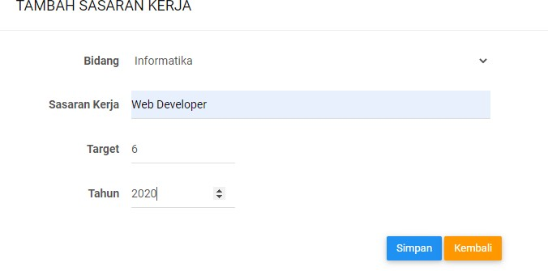

**Figure 5.** Form for Adding Job Target Data by Admin

Figure 6 is the implementation of programming and testing for daily performance reporting forms by non-permanent employees including adding data, editing data, and deleting data.

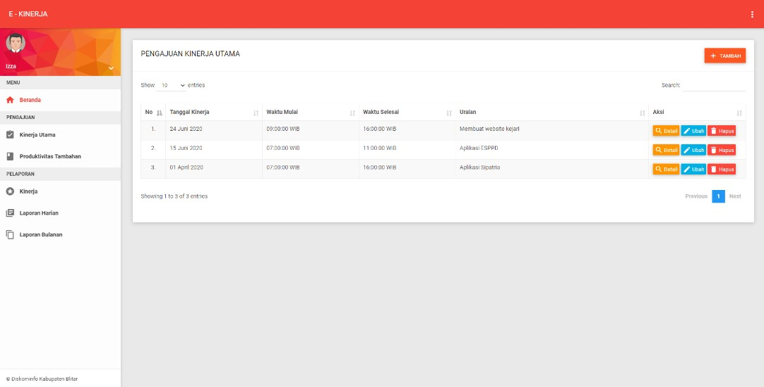

**Figure** **6**. Performance Reporting Interface by Employees

As for the form for adding performance reporting data by employees as shown in Figure 7.

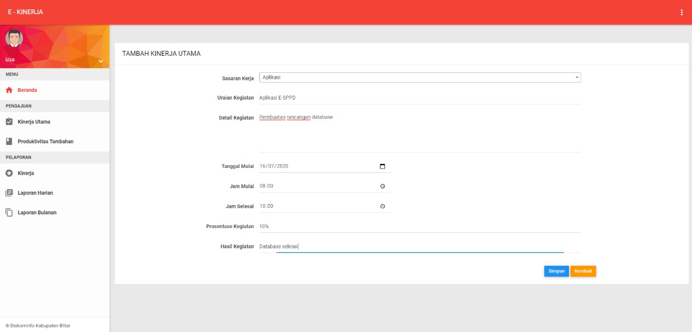

**Figure** **7**. Form for Addition of Performance Reporting Data by Employees

In Figure 8 below is the interface for the verification form for employee performance reporting by the leadership.

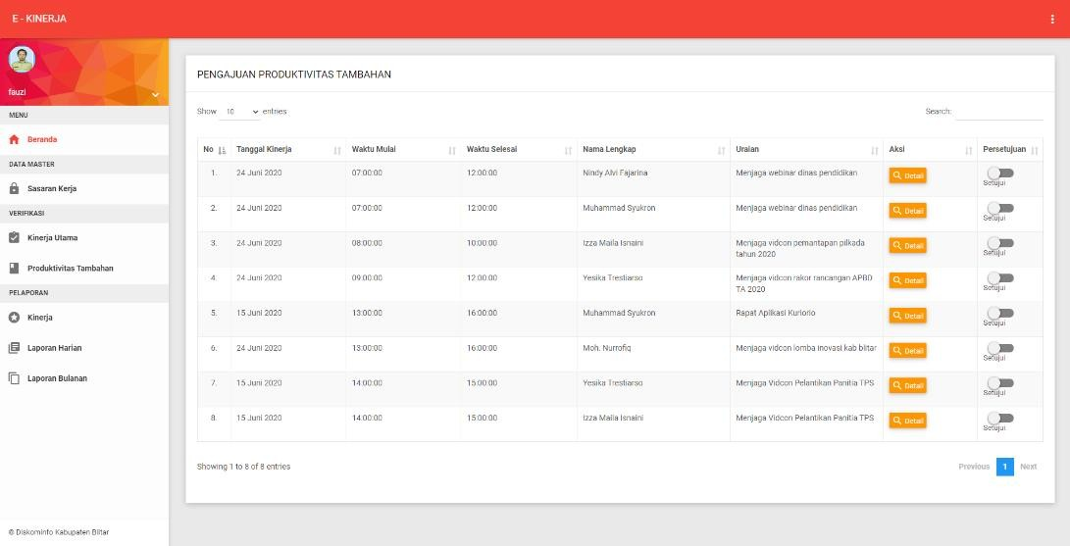

**Figure 8.** Interface Verification of Employee Performance Reporting by Leaders

Figure 9 shows a detailed interface of the main performance and additional performance of each employee.

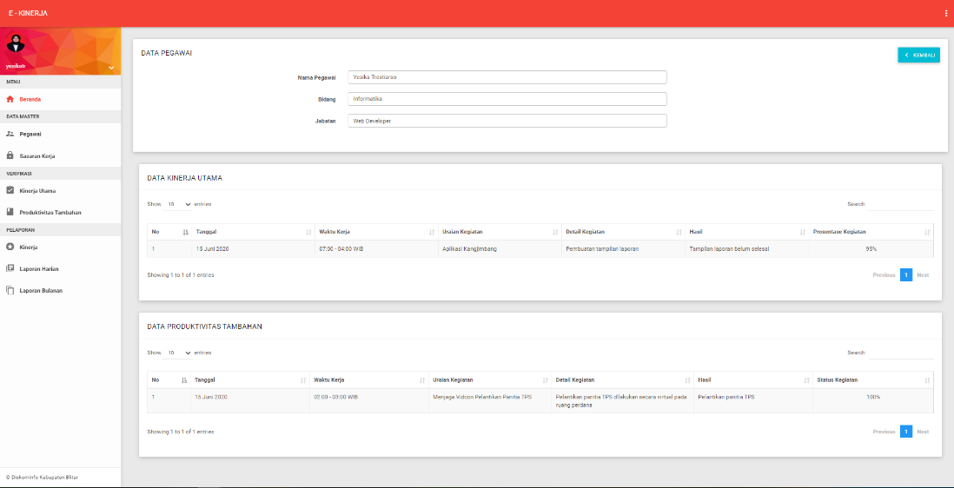

**Figure 9.** Interface of Main Performance Details and Additional Performance

In Figure 10 below, it displays a work target graphic.

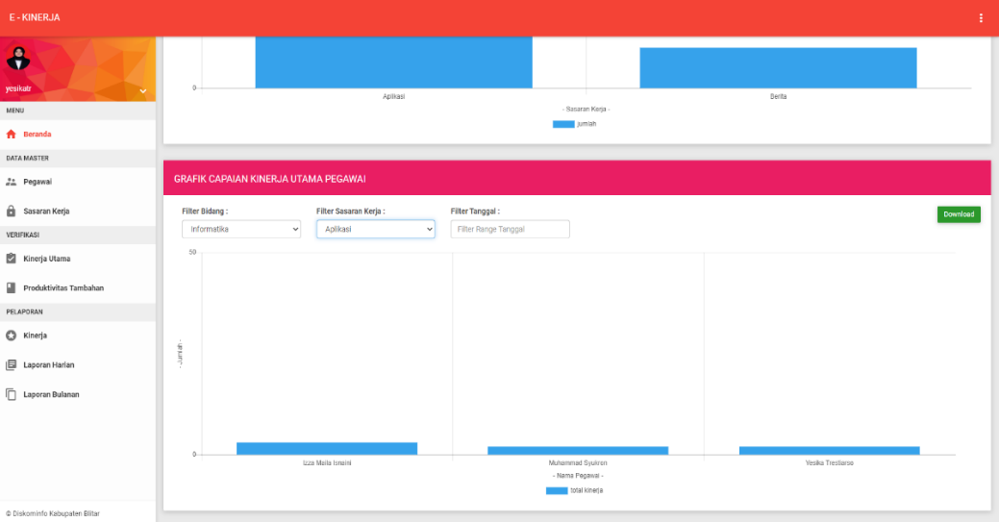

**Figure 10.** Graphical Interface Job Target

In Figure 11, the graphical interface of the performance each year.

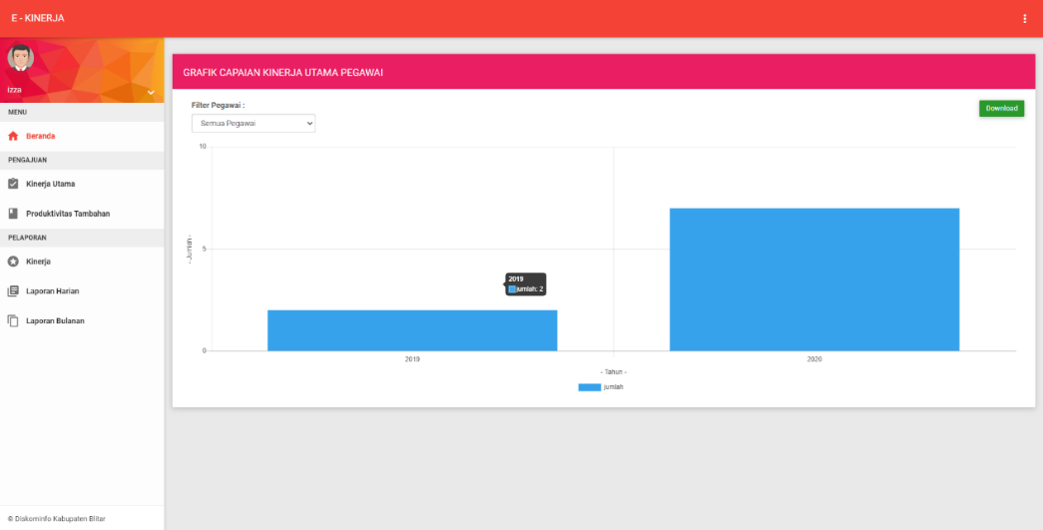

**Figure 11.** Employee Performance Graph Each Year

Whereas in Figure 12, it is the employee daily report interface.

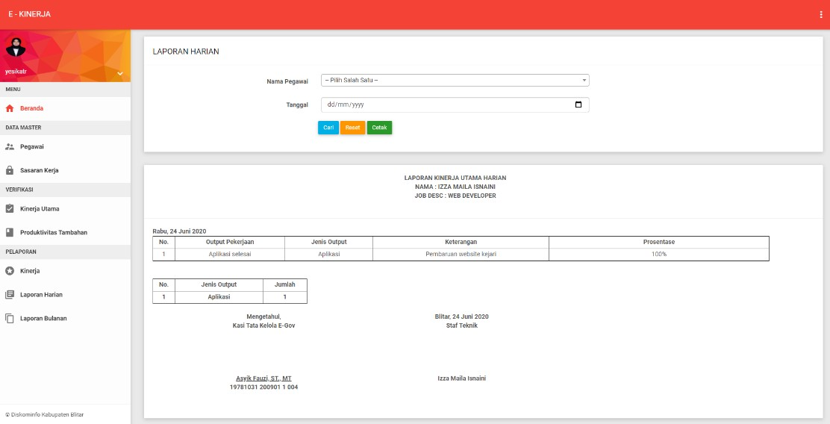

**Figure 12.** Employee Daily Performance Report

Figure 13 is an interface for the monthly performance reports of each employee.

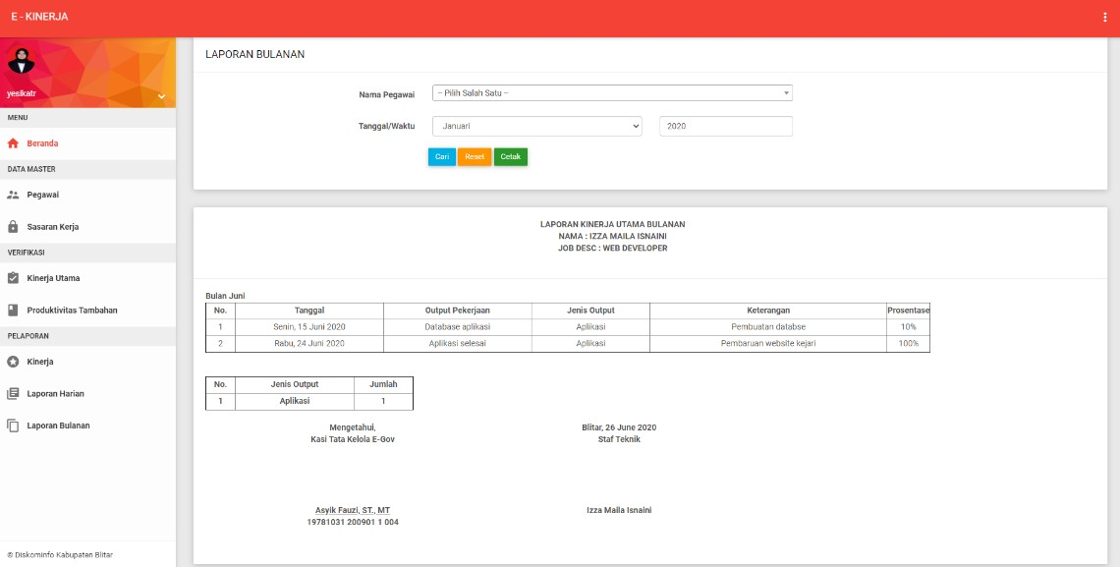

**Figure 13.** Employee Monthly Performance Report

**Table 1. Black Box Testing Work Target Form, Performance Reporting,**

**Performance Graph, Daily And Monthly Reports**

|  |  |  |  |  |
| --- | --- | --- | --- | --- |
| No | Function Tested | Test Scenario | Expected Results | Test Result |
| 1 | Add, Edit, Delete Work Target Form | Add work target data, delete one of the data, and change one of the data | Addition of performance target data is stored in the database. Deleting the record removes the record in the database. Editing maa changes the next data stored back to the database. | Valid |
| 2 | Add, Edit, Delete Performance Reporting Form | Add performance reporting data, delete one of the data, and change one of the data | Addition of performance reporting data stored in the database. Deleting the record removes the record in the database. Editing maa changes the next data stored back to the database. | Valid |
| 3 | Interface Verification of Employee Performance Reporting | Choose one data  employee performance, click the approval switch button. | Employee performance submission data has been successfully approved. Employee performance data can be seen in the performance menu and daily reports and monthly reports. | Valid |
| 4 | Detailed employee performance list interface | Select a performance date, click details to view details | The system displays details of employee performance consisting of main performance and additional performance | Valid |
| 5 | View Performance Graph based on Job Goals | Choose a performance goal and date | Displays employee performance charts based on work goals | Valid |
| 6 | View Graph of performance per year for each employee | Choose based on employee name | Displays a graph of employee performance achievements in 1 year | Valid |
| 7 | View Daily Reports | Choose by date and employee name | Displays the daily report output | Valid |
| 8 | View Monthly Reports | Choose by month and employee name | Displays the monthly report output | Valid |

From the UAT results with an average value of 89%, it can be concluded that the performance reporting information system of temporary personnel has an attractive appearance, menus that are easy to understand, the system is easy to operate, in accordance with predetermined formats and rules, and optimizes performance reporting management. as well as monitoring work targets.

1. Result and Discussion

Information System for Non-Permanent Personnel Performance Reporting of the Office of Communication and Informatics of Blitar Regency was built with administrator access rights who manage master data, the unit leader is in charge of verifying and approving the performance report data for temporary personnel and system users are non-permanent employees. The process in the system consists of employee data management, work objectives, main performance verification, additional performance verification, key performance data, additional performance, daily and monthly reporting of key performance and additional performance. Based on testing with black box testing, it was concluded that the system was running in accordance with the system design, and the average UAT test result was 89.8%. This means that the performance reporting information system can be used by the Office of Communication and Information of Blitar Regency which is able to increase the effectiveness of daily and monthly performance reporting, and optimize monitoring by the leadership.

References

1. Jeperson H 2015 *The Concept of Information Systems* (Yogyakarta: Deepublish)
2. LinovHR Admin 2020 The Main Benefit Of Performance Reports In The Company LinovHR
3. Mukhammad I P and Endang K 2020 Employee Performance Reporting Information System Environmental Services *EXPLORE* **10** 31
4. Erid A P 2018 Analysis And Design Of Employee Performance Assessment System Using Work System Framework With Uml Modeling *Intecoms: Journal of Information Technology and Computer Science* **1** 151
5. Imam T I, Hanim M A, Radityo P W 2020 Design and Development of Online Performance Reporting System for Computer Technician *JUITA: Jurnal Informatika* **8** 91
6. Yulanda 20019 Designing Web-Based PDAM Pekanbaru Employee Performance Reporting System with PHP and MYSQL *Scientific Journals CORE IT: Community Research Information Technology* **7** 1
7. Ian S 2011 *Software Engineering* (Jakarta: Erlangga)
8. Abdul K 2014 *Introduction to Revised Edition Information Systems* (Yogyakarta: ANDI) ISBN 9792921583
9. Rosa A S, and Muhammad S 2015 *Structured and Object Oriented Software Engineering* (Bandung: Informatics)
10. Linmin Y, Zhe D, Thomas R F 2011 *Information Gain of Black-Box Testing* (Switzerland: Springer International Publishing)
11. Jiangyuan Y, Zhiliang W, Xia Y, Xingang S, Jianping W 2014 Formal Modeling and Semantyc Black-Box Testing of SDN Data Plane *IEEE 22nd International Conference on Network Protocols*
12. Srinivas N, Jagruthi D 2012 Black Box and White Box Testing Techniques-A Literature Review *International Journal of Embedded Systems and Applications (IJESA)* **2** 29
13. Brian H, Pauline V G 2013 *User Acceptance Testing: a Step by Step Guide* (Swindon : BCS Learning & Development)
14. Pallavi P, Swati T 2015 AgileUAT: A Framework for User Acceptance Testing based on User Stories and Acceptance Criteria *International Journal of Computer Applications* **120** 16
15. Fatihah M, Wan F F Y, Masita A J, Suryani I, Noor M M N, Mohamad N H 2019 User Acceptance Testing (UAT) For The Development And Evaluation Of An Automated Learning Style Detection System *AIP Conference Proceedings* **2138**, 040019
16. Ganesh, Sanjay M, Anbuudayasnkar, Sivakumar 2014 *Enterprise Resource Planning User Acceptance Test* (Switzerland: Springer International Publishing)