**DEVELOPMENT OF DIGITAL ENGINEERING LEARNING WITH PROTEUS SOFTWARE MEDIA AND EMULATORS DEPARTMENT OF INFORMATICS ENGINEERING KANJURUHAN UNIVERSITY**

1 Syahminan. 2 Candra Wahyu Hidayat

Kanjuruhan University Malang

E-mail: [syahminan@unikama.ac.id](mailto:syahminan@unikama.ac.id)

**Abstract**: Proteus professional is a group of electronic software used to assist designers in designing and simulating a circuit electronic. This software has two functions at the same time in one package, one package as a software for drawing automatic schematics and can be simulated which is named ISIS. The second package is used to design the Printed Circuits Board (PCB) image which is named ARES.   
Directly, the conversion from schematic to PCB can be done in this Professional Proteus software. Prof. ISIS Prooteus has always friendly versions, starting from version 7.0 to 8. each version increase with the addition of library components that can be taken and used in drawing or designing. As an electronic frame designer, he first used ISIS as a medium that made it easier to play and simulate. The large number of libraries of the Proteus Professional ISIS onal ISIS software is said to be a complete simulation software, namely from active components, Analog, Trasistor, SCR, FET, types of buttons, types of switches / relays, digital ICs, amplifier ICs, programmable ICs ( microcontroller) and IC memory. Apart from being supported by complete components, it is also supported by the completeness of measuring instruments such as voltmeters, ampere meters, oscilloscopes, signal analyzers, and frequency generators. The completeness of the features provided makes Proteus Professional ISIS into an electronic simulation software Emulator writer is a service text media for writing programs, especially using digital number codes and can be collaborated with proteus, which is a window form media designed by the author to make it easier for beginners who want to learn about microcontroller programming, can be used to write programming / coding with code Binary and Hexa numbers are made in Indonesian with the aim that beginners who are just starting to learn about digital-based programming if there are errors in writing, instructions, or writing procedures, it will be shown in an Indonesian warning

Keywords: digital simulation with software

1. **Introduction**

Digital engineering is one of the basic courses that must be mastered for the Informatics engineering department. Understanding of basic logic gates, simplifying equations, understanding the functions and workings of logic gate ICs [1]. Therefore, in addition to being skilled at explaining course material, a teacher must also have extensive knowledge, be wise, and be able to socialize well. [2]. In Law number 20 of 2003 concerning the National Education System, one of which discusses education is a conscious and planned effort to create an atmosphere of learning and the learning process so that students actively develop their potential. [3]. The development of learning media is a form of teaching material that is systematically arranged in digital system learning. There are several problems, among others [4]. 1) there is no logic gate practicum. 2) testing the truth table so that the responsiveness of students to digital engineering subjects was previously tested only through manual calculations without testing using a module kit or application. [5]. The use of media in the cognitive learning process to teach reintroduction and differentiation of relevant stimuli,, [6]. In a logic gate circuit, simulations can be done to find out how the circuit works. The simulator software uses PROTEUS 8.0 [7]. By using the proteus 8 software learning media, one of the software that can be used to describe / design digital circuit schematics can assemble digital circuits both analog and digital.

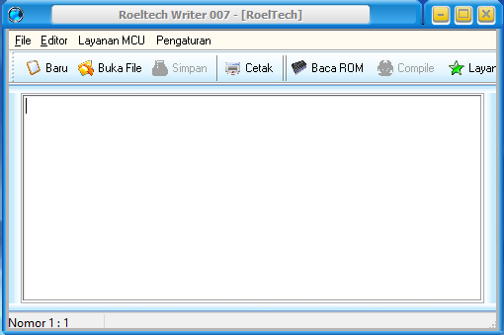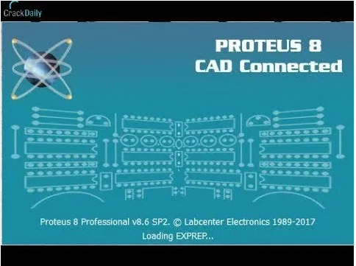

Picture 1 Tampilan Proteus Picture 2 Tampilan emulator

Software Proteus 8. By using this learning media, it is hoped that students will be more active and able to improve their learning outcomes. [8]. The compiler software uses Indonesian, including checking for errors both at the time of writing and after compiling the error instructions displayed are in Indonesian as for the appearance and form of the software writer as seen in Figure 2. the influence of digital learning media gives confidence in the results learn [9]. The development of Information and Communication Technology requires teachers to innovate in the learning process [10] The use of media is a necessity in learning [11]. Development of learning media that can be used to support simulation and digital learning [12]

**1. Methodology**

The method used in this research is the descriptive method of testing each series using a software application to prove between theory and practice by testing using the proteus 8 application. This method is used because the research is carried out by means of a questionnaire and tries to describe a need for proving theoretical results, proving the results outputs 0 and 1 and the results of a logic gate circuit from a digital system learning circuit full of numbers such as: a) number conversion, b) logic gate testing, c) truth table testing d) OR, NOT, AND, NAND logic gates. e) flipflop f) seven segments through this application proteus and emulator to test flipflops, counter,number functions.

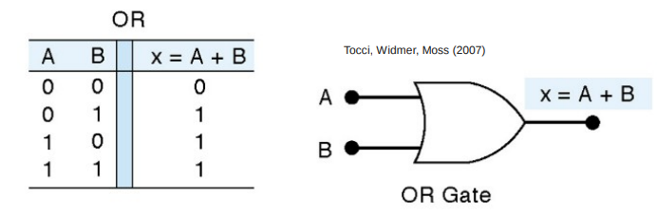

**Picture 3 Gate OR and tabel kebenar**

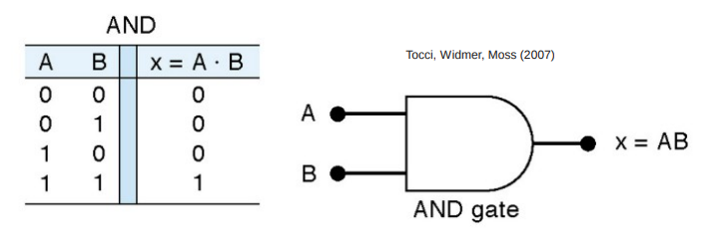

**Picture 3 Gate and tabel kebenar**

1. **Seven segments**

In the figure, the common anode seven segment is controlled using a PNP transistor, if there is a logic low on the base of the transistor, the 7 segment will turn on.

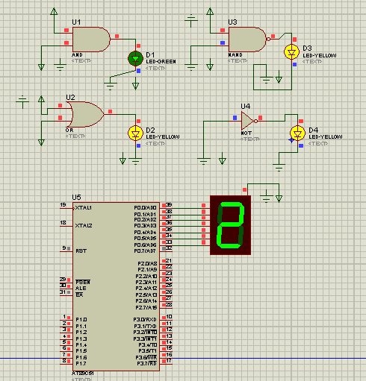

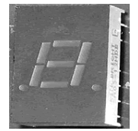

**Picture 4 view seven segments**

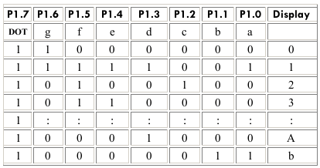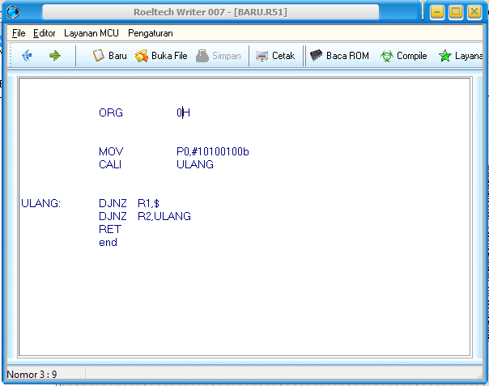

Picture **5 seven segments and digital numbers.**

For the seven segment display using additional application assistance so that it can be seen in the form of angga according to the 7 column truth table so that it can form the desired lift according to the column table as shown in Figure 5 to form lift 1 according to the binary word contained in the table column truth as well as the next number for example to display the number 2 then say binary as in Figure 5 above.

.

**Conclusion**

By using the proteus application, digital system learning activities are easier to understand and the process of understanding binary figures is faster to understand the meaning of each input and output on each logic gate such as OR, NOT, AND logic gates and NAND logic so that it is easier to conclude and determine the suitability of the results. calculations on the truth table with the display tested using the proteus application. Whereas with a seven segment display using a writer application proving the truth table by using the command that digital binary can be proven directly with the display results through proteus by using the binary digital number command 0 and 1.

**REFERENCES**

[1] Alfi Muhammad Akbar Baria1 “Perancangan dan realisasi modul praktikum teknik digital dan komputer sap-1 sebagai sarana perkuliahan d3 teknik telekomunikasi” e-Proceeding ofAppliedScience:Vol.1,No.1April2015Page789..

[2]Fivia Eliza “ Peningkatan Kompetensi Guru SMK Melalui Pelatihan Software

engineering” *Jtev (jurnal teknik elektro dan vokasional)**Volume 5 Number 2 2019 ISSN: 2302-3309*  Received October 30, 2019; Revised November 01, 2019; Accepted November 04, 19

[3] Aslamiyah Rambe” Penerapan *Software* Simulasi Elektronika Pada Pembelajaran Listrik

Dinamis Terhadap Hasil Belajar Fisika Siswa**”.**:http://jurnal.um- apsel.ac.id/index.php/al- muaddib/article/view/267 [*Home*](http://jurnal.um-tapsel.ac.id/index.php/al-muaddib/index)*> [Vol 2, No 2 (2017)](http://jurnal.um-tapsel.ac.id/index.php/al-muaddib/issue/view/27" \t "_parent) >*

[4] M. Najib Mustaqim ” pengembangan modul praktikum berbasis multimedia interaktif pada praktikum elektronika dasar materi dioda mahasiswa pendidikan fisika uin walisongo tahun 2015” Phenomenon : Jurnal Pendidikan MIPA. Vol 7, No 1 (2017).

[5] Agung Setyono “ pengembangan perangkat trainer elektronika digital menggunakan Perangkat lunak proteus untuk pembelajaran elektronika digital di jurusan teknik elektro universitas negeri surabaya “.Jurnal Pendidikan Teknik Elektro, Volume 04 No 03 Tahun 2015, 717-724.

[6]Bagus Yuliarman Lintang Permana “ Rancang bangun *trainer converter analog to digital* dan *digital to analog* sebagai media pembelajaran teknik audio video di smkn 7 surabaya” Jurnal Pendidikan Teknik Elektro Volume 05 Nomer 01 Tahun 2016, 277-283.

|  |  |
| --- | --- |
| |  | | --- | | [7] Syifaul Fuada “ Perancangan Sistem Kontrol Pada Prototip Pengering Kerupuk Berbasis IC Digital Menggunakan Software Proteus 7.0.Volume 6, No.1, Juni 2017.Jurnal lmiah Setrum 6:1 (2017) 88-96.  [8] syahminan, Risky “Tips Mudah belajar mikrokontroler” buku ajar HKI 0001800504.  <https://repository.unikama.ac.id/cgi/users/home?screen=EPrint%3A%3AView&eprintid=3760>.  [9] Nur Qomariah Panjaitan” Pengaruh Media Pembelajaran Digital Animasi dan Kepercayaan Diri terhadap Hasil Belajar Pendidikan Agama Islam Anak” Jurnal Obsesi : Jurnal Pendidikan Anak Usia Dini. Volume 4 Issue 2 (2020) Pages 588-596. DOI: 10.31004/obsesi.v4i2.404.  [10] Jeremia Engelita Wakas” peningkatan kemampuan komunikasi siswa sekolah Dasar melalui Digital storytelling Dalam pembelajaran Pendidikan agama kristen” Jurnal Pengabdian Masyaraka. Vol.1,No.1,2020,hal 1-10.  [12] Rivi Hamdani” pengembangan media pembelajaran berbasis augmented reality pada mata kuliah sistem digital di jurusan teknik informatika unesa” JURNAL IT-EDU Volume 04 Nomor 52 Tahun 2020 (153-161). | |