The Development of Thematic Modules Based on Strengthening Character Education (PPK) and Quick Response (QR) Code
Sri Rahayu*, Ericca Dia Pratiwi Andayani, Denna Delawanti Chrisyarani, Iskandar Ladamay
Elementary School Teacher Education Study Program, Universitas Kanjuruhan Malang

*srisk@unikama.ac.id

Abstract. Less attractive and effective learning modules in thematic learning and less reinforcement in character education make students bored and do not really implement strengthening character education in the school environment and society. Therefore, alternative teaching materials are needed in thematic learning and strengthening student character education. The purpose of this research is to develop thematic modules based on PPK and QR code. This study applied the Bog & Gall development research model. The data analysis technique used was quantitative and qualitative data analysis. The research instruments used were observation, questionnaires and documentation. The results of research on the development of thematic modules based on PPK and QR Code, it is known that the results of the analysis of media experts obtained a score of 92.86 percent with a very valid category, material experts obtained a score of 88.64 percent in the very valid category, linguists obtained a score of 75 percent with a fairly valid category, the response of educators obtained a score of 89.92 percent in the very practical category, the response of students obtained a score of 87.78 percent in the practical category. Based on the results of the explanation above, the thematic module based on PPK and QR Code can be used as a supplementary teaching material for the thematic book to make it easier for students to acquire the lesson content and apply characters education in schools and communities.
- Introduction
A number of studies have reported on the importance of character education for students to support their future success. Numerous countries in the world have strengthened the implementation of character education in their education systems, including Indonesia. The balance between cognitive abilities and positive character of students is one of the key factors that determine student success.
By having good character, students will have the tendency to increase their academic achievement [1]. In the last decades, character education has always been considered in every educational design [2]. In addition, it also found a correlation between character education programs on students' academic and social achievement [3].
In Indonesia, the implementation of character education has been carried out intensively since the implementation of the 2004 Competency-Based Curriculum (KBK). Technically, the implementation of character education is through formal education and is included in the curriculum. In Indonesia these days, the 2013 Curriculum is the latest curriculum that has integrated character education into the learning process as stated in the Content Standards and has been simplified into five main characters packaged in Strengthening Character Education (PPK). Where the thematic learning system is a strategy in implementing the 2013 Curriculum.
In its implementation, teachers need to provide innovative media and teaching materials as a source of learning for students. The teaching material that is often encountered is modules. Thus, it is expected that educators can create a more innovative module, thematic modules based on printed and electronic texts to help students. The use of modules to support learning activities is important to improve mastery of the material for both teachers and students.
Learning models are currently starting to develop along with the rapid development of technology and information [4,5]. Rapid technological developments allow changes in improving the teaching process, particularly in the use of electronic teaching materials. The electronic module enables students to acquire the complex skills needed in today's era of globalization [6,7]. The advantage of the electronic module is that it can be accessed via computers, tablets and so on, which are equipped with audio-video tutorials, worksheets and evaluations [8].
The difference with the results of previous studies is that researchers focus on designing thematic modules based on PPK and Quick Response (QR) code. Quick response code is a quick response that is useful for conveying information quickly and can respond quickly too. The use of a quick response code must be accompanied by a barcode capable of storing information horizontally as well as vertically.

- Method
This research model applied the Borg & Gall development research model which used five out of ten stages, namely:

Research and information collecting
planning
Develop preliminary form of product
Preliminary field testing
Main product revision
Main field testing
Operational product revision
Operational field testing
Final product revision
Disemination and implementation

However, this researcher arrived at the main product revision stage. The trial subjects in this study were ten students of grade V Elementary School. The instruments used were observation, questionnaires, and documentation. The questionnaire consisted of a student needs analysis questionnaire, a media expert questionnaire, material and language experts, educator response practitioners and students. The data analysis technique used was quantitative data and qualitative data. The results of input or suggestions from the validator were described by the researchers using qualitative or descriptive analysis. While the results of validation and student responses were analyzed by the researchers by using quantitative analysis.

- Result and Discussion
Research that has been conducted by the researchers has resulted a product in the form of a thematic module based on PPK and Quick Response (QR) code. It is known that the results of the analysis of media experts obtained a score of 92.86 percent with a very valid category, material experts obtained a score of 88.64 percent with a very valid category, linguists obtained a score of 75 percent in a moderately valid category, the response of educators obtained a score of 89.92 percent with very practical category, the response of students obtained a score of 87.78 percent with the practical category. Overall, the thematic modules based on PPK and the Quick Response (QR) code are described as follows.

Table 1. List of Thematic Module Visualization Descriptions
No | Information | Visual | No | Information | Visual
1. | The cover of the Thematic Module | 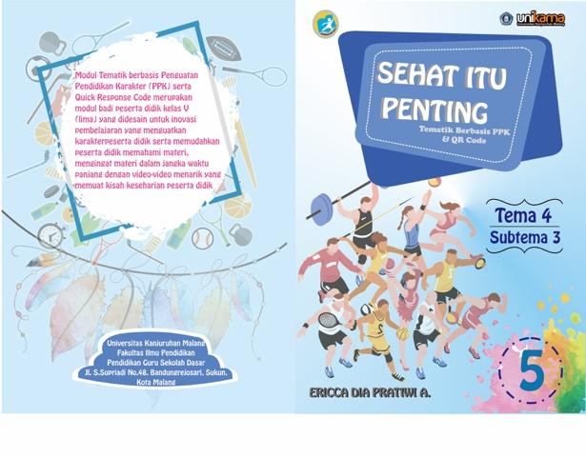 | 4. | Mapping of KI & KD | 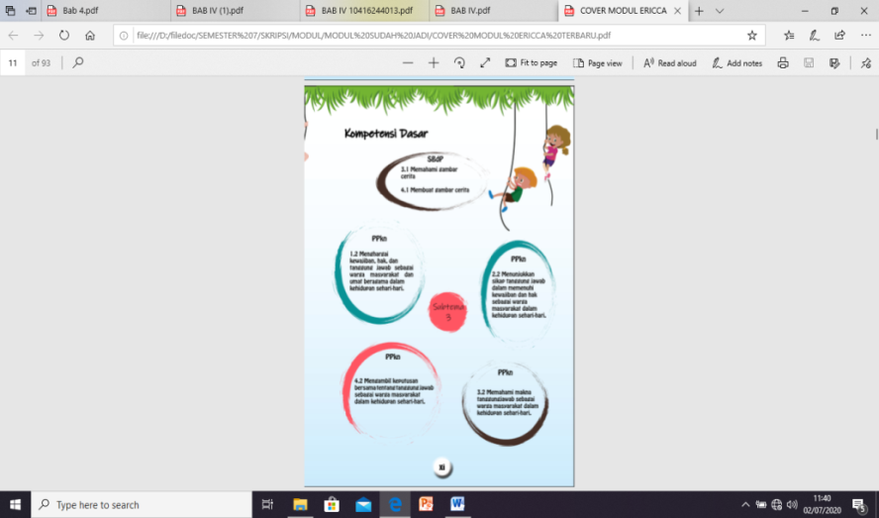
2. | Table of contents | 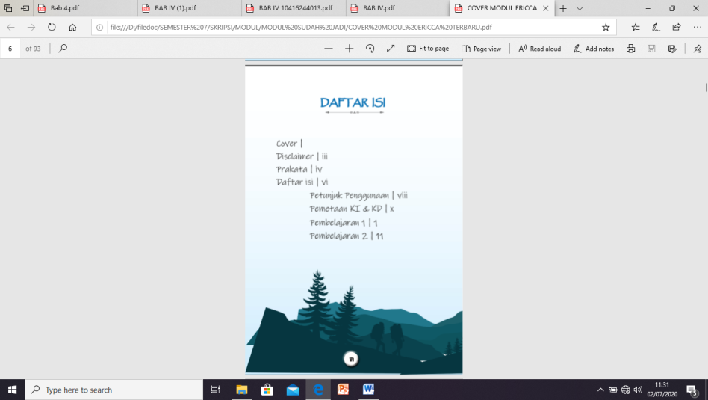 | 5. | The limitation of each study | 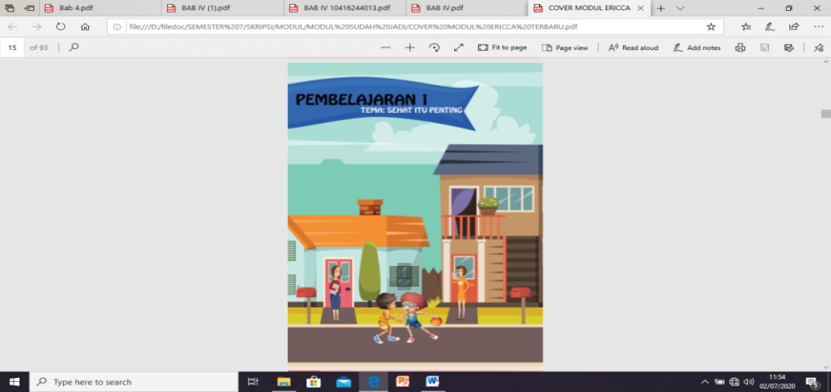
3. | Instructions for use | 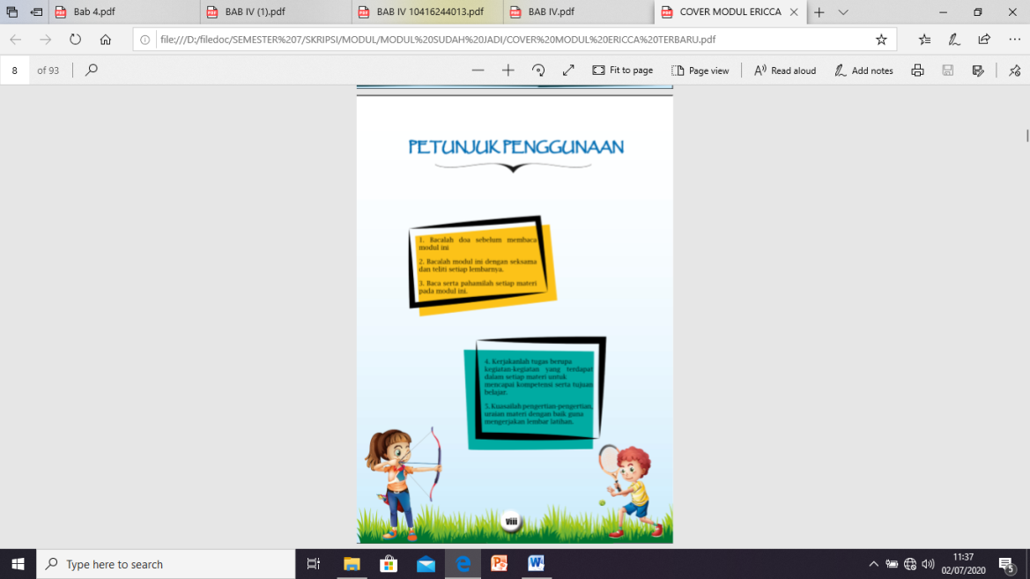 | 6. | Theory | 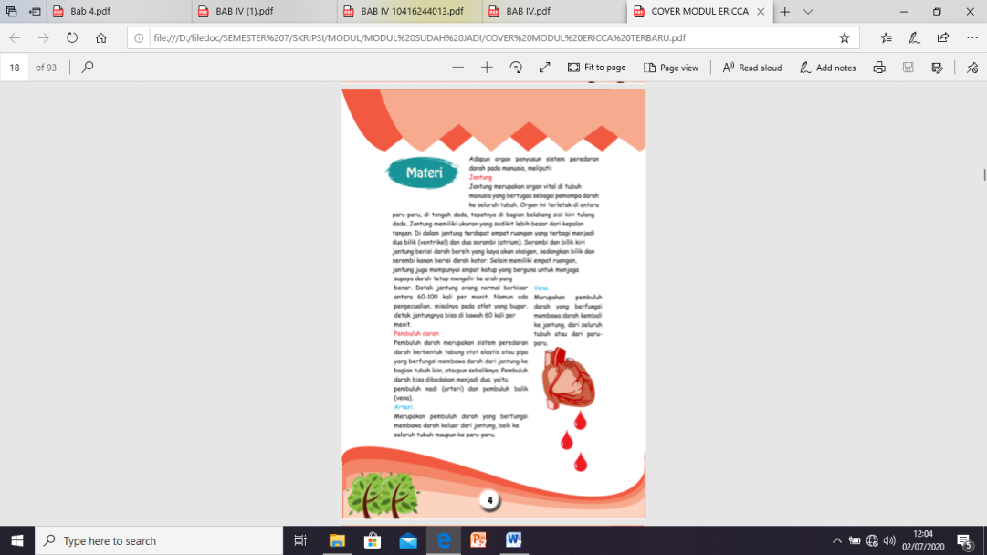
7. | Activities | 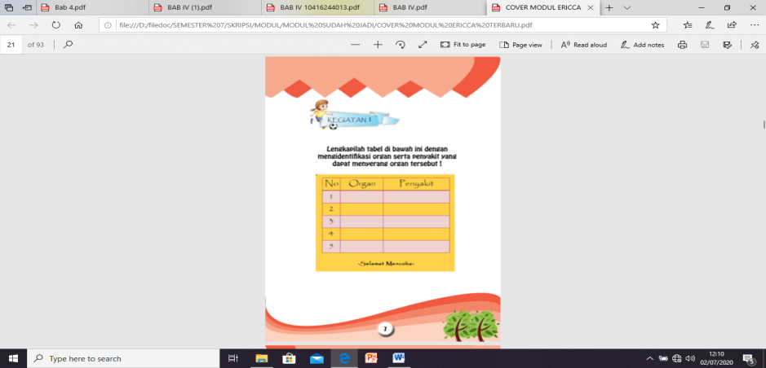 | 11. | Answer key | 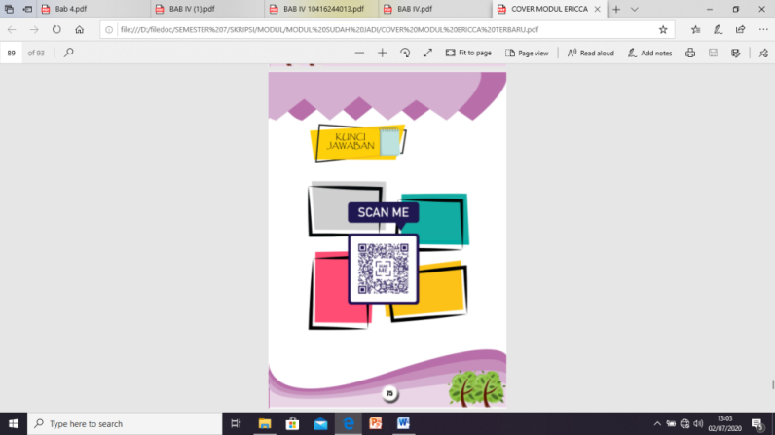
8. | Quick Response Code | 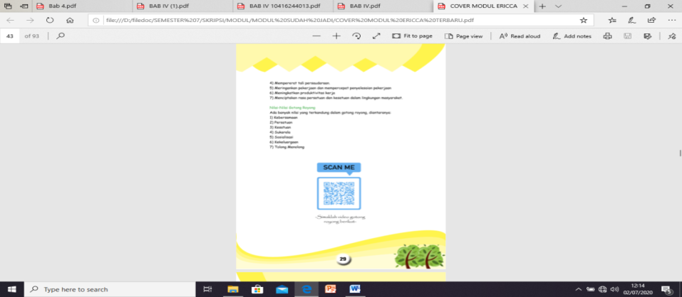 | 12. | Glossary | 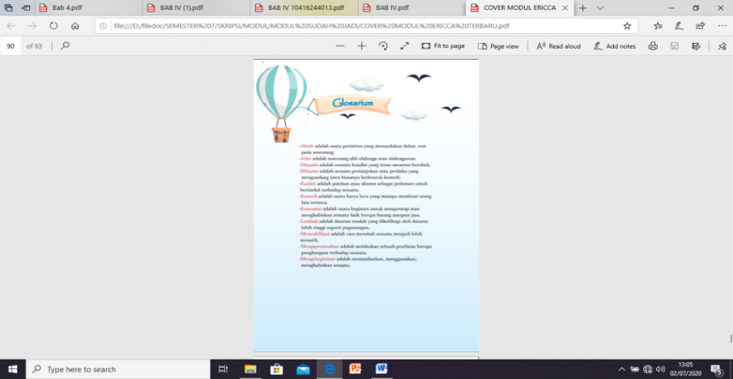
9. | Summary |  | 13. | References | 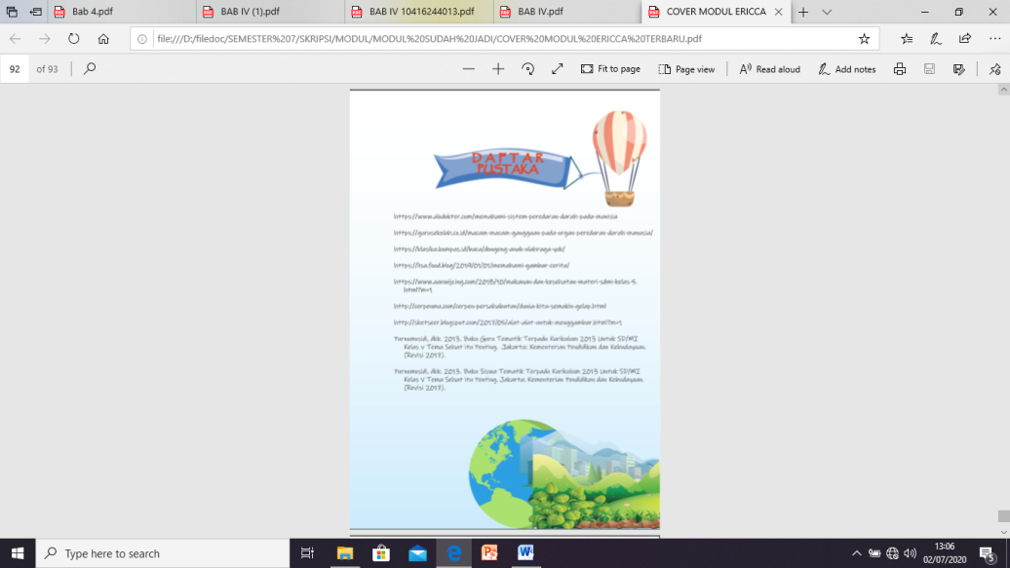
10. | Evaluation Problem | 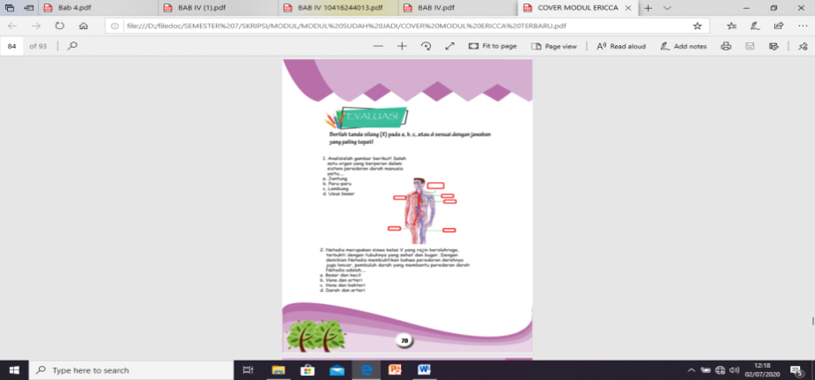 | 14. | Developer Profile | 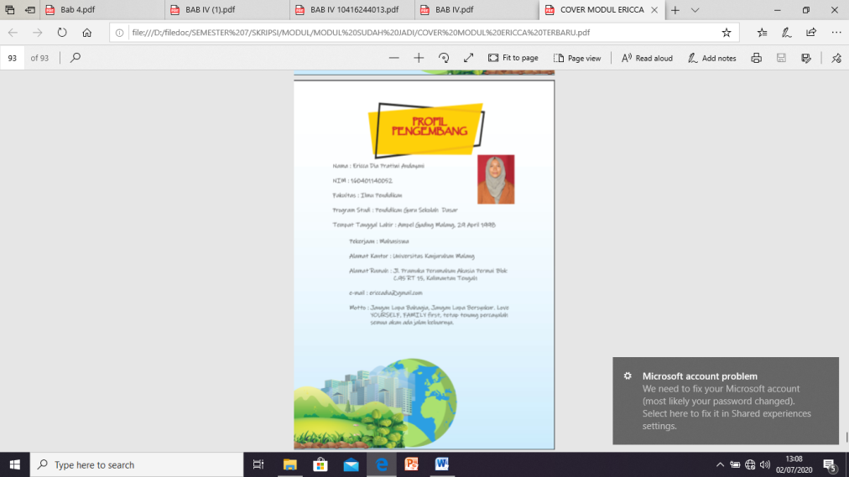

Based on the research results above, this study tries to develop a module based on Strengthening Character Education (PPK) and Quick Response (QR) code in the material for Theme 4 Subtheme 3 for Fifth Graders of Elementary Schools. This module is used in learning The Importance of Health which can be implemented to students at home and school. This module aims at increasing students' understanding of The Importance of Health and to strengthen character education for students. The researchers tested the feasibility and practicality of the products developed.
The development of this thematic module is motivated by several problems including the lack of innovative teaching materials because the teacher remains utilizing the theme book from the government, the lack of teaching materials that contain subject matter as well as instilling the strengthening of character education, the minimum use of technology in the teaching and learning process.
Modules as a support for the teaching and learning process as well as an alternative interactive learning solution are feasible to be developed to improve student learning outcomes [9]. The development of learning modules is very feasible and effective to improve student learning outcomes [10]. The development of an electronic module by integrating local wisdom is very effective in the learning process [11]. Other research results state that the electronic module with a multimedia approach helps students to better understand the learning content [12].
In the era of the industrial revolution 4.0 which has shaken the progress of education, the stakeholders related to education require to be aware and able to equip their students to be mentally prepared based on knowledge and character. They must acquire new skills, adapt, manage and take advantage of the Industrial Revolution 4.0 by becoming critical thinkers, problem solvers, innovators, communicators and have a leadership spirit where all of these criteria cannot be separated from character education [13].
The concept of character education during the industrial revolution 4.0 these days, based on the obtained findings, still does not involve students to participate in. The conventional teaching method used by the teacher does not allow students to involve themselves actively in the learning process. Students, then, only play a role as a passive listener. This condition will not be effective to instill character education among students. In addition, this condition is inversely proportional to the learning theory and expectations of students, especially in the digital era like today. The involvement of students using digital and computer technology significantly helps improve students' understanding of learning in today's digital era [14].
Education in the era of the industrial revolution 4.0 emphasizes student skills known as 4C, specifically creativity, critical thinking, communication, and collaboration [15]. In the context of schools, character education requires the cooperation of various parties and even the development of an appropriate system. Character education is a national movement that creates and fosters young generations who are ethical, responsible and caring [16].

- Conclusion
The results of research on the development of thematic modules based on PPK and QR Code, it is known that the results of the analysis of media experts obtained a score of 92.86 percent with a very valid category, material experts obtained a score of 88.64% in the very valid category, linguists obtained a score of 75 percent with a fairly valid category , the response of educators got a score of 89.92 percent in the very practical category, the response of students got a score of 87.78 percent with the practical category. Based on the results of the explanation above, the thematic module based on PPK and QR Code can be used as a companion teaching material for the theme book to make it easier for students to master the material and apply characters in schools and communities.

- References

[1] Nurhasanah N and Nida Q 2016 CHARACTER BUILDING OF STUDENTS BY GUIDANCE AND COUNSELING TEACHERS THROUGH GUIDANCE AND COUNSELING SERVICES J. Ilm. Peuradeun 4 65–76
[2] Abu L, Mokhtar M, Hassan Z and Darmanita Suhan S Z 2015 How to Develop Character Education of Madrassa Students in Indonesia J. Educ. Learn. 9 79
[3] Chang F and Muñoz M A 2007 School personnel educating the whole child: Impact of character education on teachers’ self-assessment and student development J. Pers. Eval. Educ. 19 35–49
[4] Ratheeswari K 2018 Information Communication Technology in Education J. Appl. Adv. Res. 3 45–7
[5] Maslin N M, Consultant P and Ltd S S 2010 Impact of Modern Technology HF Commun. 3 33–5
[6] Getuno D M, Kiboss J K, Changeiywo J and Ogola L B 2015 Effects of an E-Learning Module on Students ’ Attitudes in an Electronics Class J. Educ. Pract. 6 80–6
[7] Mills S C 2006 Using the Internet for Active Teaching and Learning (Ohio: Pearson Meerill Prentice Hall)
[8] Sugiani K A, Degeng I N S, Setyosari P and Sulton 2019 The Effects of Electronic Modules in Constructivist Blended Learning Approaches to Improve Learning Independence Int. J. Innov. Creat. Chang. 9 82–93
[9] Perinpasingam P T S, Arumugam N, Sathyaperbha and Mylvaganam G 2014 Development of a science module through interactive whiteboard Rev. Eur. Stud. 6 31–8
[10] Mangesa R T and Dirawan G D 2016 Development of Learning Module Work Competence Integrated Character Value of Electricity in Vocational High School Int. J. Appl. Eng. Res. 11 6943–8
[11] Sumarti S S, Supartono and Diniy H H 2014 Material Module Development of Colloid Orienting on Local-Advantage-Based Chemo- Entrepreneurship to Improve Students’ Soft Skill Int. Humanit. Manag. Sci. 2 42–6
[12] Lim J S C, Jailani Md Yunos and Ghazally Spahat 2005 The Development and Evaluation of an E-Module for Pneumatics Technology Malaysian Online J. Instr. Technol. 2 25–33
[13] Watson S and Sutton J M 2012 An Examination of the Effectiveness of Case Method Teaching Online: Does the Technology Matter? J. Manag. Educ. 36 802–21
[14] Heriyanto, Sator D, Komariah A and Suryana A 2019 Character Education in the Era of Industrial Revolution 4.0 and its Relevance to the High School Learning Transformation Process Utop. y Prax. Latinoam. 24 327–40
[15] Facione P a. 2011 Critical Thinking : What It Is and Why It Counts
[16] A. P 2011 THE NEED FOR CHARACTER EDUCATION Int. J. Soc. Sci. Humanit. Stud. 3 23–32

