The Ability of Nitrogen Atomic Absorption in The Formation of Iron Nitride on Flake Structure and Nodule in Cast Iron

Wayan Sujana¹, Komang Astana Widi¹, Teguh Rahardjo¹, Tutut Nani Prihatmi¹

¹⁾ Mechanical Engineering Department, National Institute of Technology of Malang Jln. Karanglo Km 2, Malang, Indonesia

aswidi@yahoo.com

Abstract. The nitriding process can be effectively applied to steel with alloying elements. The higher the alloying element in the steel maximizes the mechanical properties, including hardness. However, the raw material can be costly, therefore using cheap materials (without alloys) is a challenge in increasing surface hardness through iron nitride formation. Furthermore Grey and nodular cast iron have different properties and characteristics in the structure. This research focuses on the ability of the cast-iron structure to affect the nitride layer formation. Gas nitriding was conducted in a fluidized bed reactor with a 550ºC in 20 % N₂ and 80 % NH₃ atmosphere at a flow rate gasses of 0.7 m3/hr process temperature and holding for 2, 4, and 6 hours. Tests are conducted by observing the depth of hardening, SEM, and EDAX. According to the results, the nitriding process increases the surface hardness of cast iron. The highest hardness value is nodular cast iron with a holding time of 6 hours (345 HV) and a hardening depth of up to 20-micron meters. The compounds formed in the nitride layer include FeN, Fe₂₋₃N, Fe₄N, and Fe₂N. The compound formed is strongly influenced by the treatment time. Furthermore, the comparison of nitriding treatment on gray and nodular cast iron was influenced by the flake and nodule structure. In general, the nodule structure is responsible for maximum hardness. The longer treatment time allows the nitrogen atoms to diffuse more to the surface, while the flake structure limits the absorption of nitrogen atoms into the surface of the cast iron. Characterization of Nodular Cast Iron shows that The hardening depth distribution trend due to the nitriding process in nodular cast iron was not much different from gray cast iron.
- Introduction
Grey and nodular cast iron are widely used in manufacturing due to lower prices and significant properties, including hardness and optimal damping ability. Nitrogen atoms can stick to cast iron graphite [1]. The nitriding process on gray cast iron utilizing plasma technology does not result in optimal nitrogen atom penetration into the material [2]. The nitrocarburization process carried out on gray cast iron by previous researchers only resulted in a layer thickness between 10 to 14 micron meters and has the disadvantage that the surface roughness increases sharply [3]. So that this research will take advantage of gas technology with a fluidised bed reactor. This study determined the nitriding process's effect on the hardness value and the role of the microstructure on the surface of grey and nodular cast iron. The research aimed to improve the optimal surface hardness of grey and nodular cast iron. The ability to absorb nitrogen atoms in the nitriding process determines the surface hard nitride formation. Iron nitride formed on the surface affects changes in cast iron's surface structure, affecting other properties possessed by cast iron [4]. Nitriding is one of the thermochemical surface hardening treatments effectively applied. This is because the hard layer formed is very thin to affect cast iron's properties and initial characteristics [5].
Nitriding is a thermochemical treatment process where nitrogen is diffused onto the surface of the material (ferrous and non-ferrous) at 500-600 ⁰C for skin hardening due to an alloy's formation nitride layer on the specimen surface. The layers' thickness ranges from 0.2 to 0.7 mm, with a hardness of 900-1100 HV. Since the process temperature is very low, the possibility of gyometric distortion or cracking is very low. Some of the nitriding process's essential properties include abrasive and adhesive wear resistance and corrosion resistance [6].
Gas nitriding conducted by heating between 500 and 600 ⁰C in a heating reactor with an atmosphere containing nitrogen is widely used. Current fluidized bed technology has been utilized to produce a surface hardness of steel and iron for the thermochemical gas treatment process. Alumina powder is used as a medium for transferring heat from the kitchen wall to the specimen, increasing surface hardening quality. However, the quality of surface hardening is largely determined by the alloy of the material to be processed [7,8].

2. Research Methodology
Commercially available grey and nodular cast iron manufactured by KPS Steel was used in this study. Small plates (15 mm × 15 mm × 15 mm). preparation of specimen used wire cutting and milling process. Nitriding processes were conducted by fluidised bed reactors at National Institute of Technology of Malang. Samples were nitrided in a 20% nitrogen plus 80% Ammonia atmosphere at a flow rate gasses of 0.7 m3/hr. The process time was 2, 4 and 6 hour and temperatures were selected is 550◦C. The samples were then cooled in oil SAE 40 to the room temperature. After nitriding, the samples were cross-sectioned,mounted in Bakelite, mechanically ground, polished and then etched with nital alkohol 96% + asam nitrat 4%.. The microstructural characterization was per-formed by SEM and EDAX (at Sepuluh November Institute of Technology) to determine the thickness of the nitride layer and the structure formed and nitogen atomic deposition on the specimen. The nitride element formed, and the case depth was observed using EDAX and microhardness tests with Vickers (at National Institute of Technology of Malang).

3. Result
3.1. Test Data
a. Hardness Distribution Testing
The comparison of nitriding treatment on cast iron showed a significant change in hardness in nodular compared to grey cast iron, as shown in Figure 1. However, all cast iron specimens showed high hardness values on the surface to a depth of 20-micron meters. The hardness at a depth of 10 and 20 microns went up to 50 % and 25 %, respectively. At a depth of 30 microns and above, the hardness value was almost the same as the base metal. This showed the depth of hardening in average cast iron was only 20-micron meters. Nitride layers above 20 microns were very difficult to form.

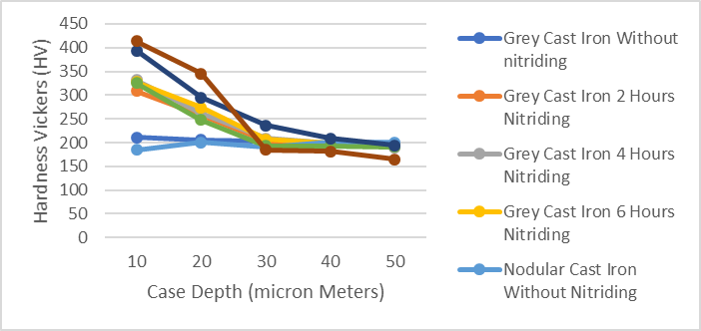
Figure 1. Depth profile of grey and nodular cast iron hardening
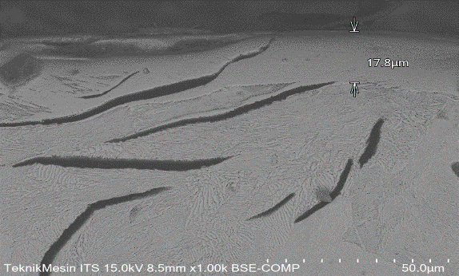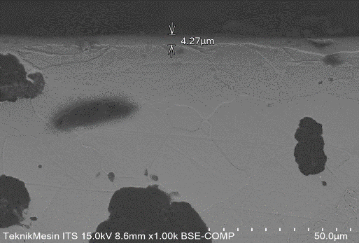
a b
Figure 2. Structure of surface nitride hard layer a) gray cast iron, b) nodular cast iron

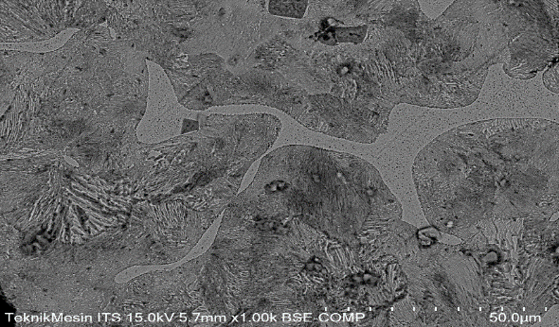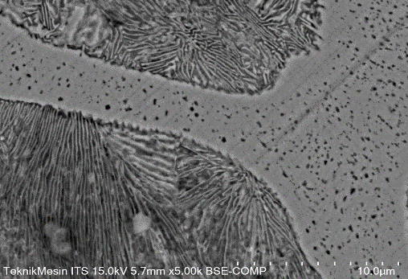
a b
Figure 3. Grey cast iron a) 1000x magnification, b) 5000x magnification
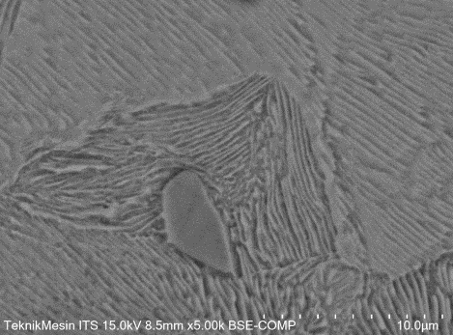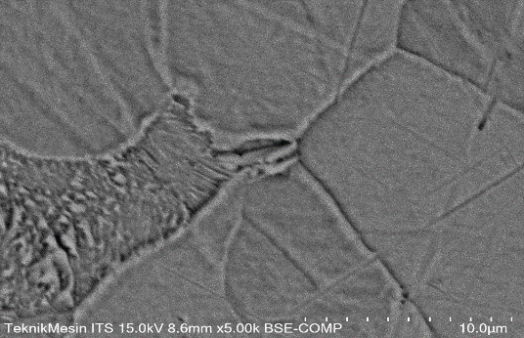
a b
Figure 4. Nodular cast iron a) 1000x magnification, b) 5000x magnification

3.2. SEM Observation Results
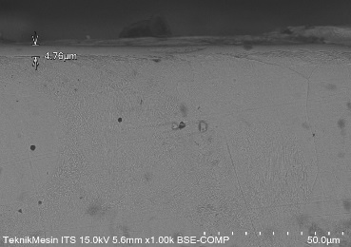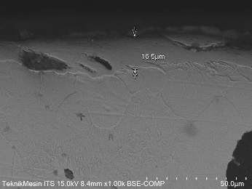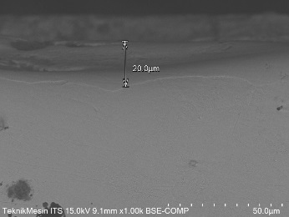
a b c
Figure 5. Nitride layer thickness in nodular cast iron a) 2 hours, b) 4 hours, c) 6 hours

From the results of SEM observations (Figure 5), the nitride layer was formed with a thickness of 4.67µm in the 2-hour treatment), 16.5 μm (4 hours treatment), and 20.0 μm (6 hours treatment). The longer the holding time, the higher the thickness of the nitride layer. Figure 6 showed the high nitrogen atom concentration value on the surface in the EDAX test.

Table 1. EDAX test results
 | Cast iron
 | Gray Cast Iron |  | Nodular Cast Iron
Without treatment | 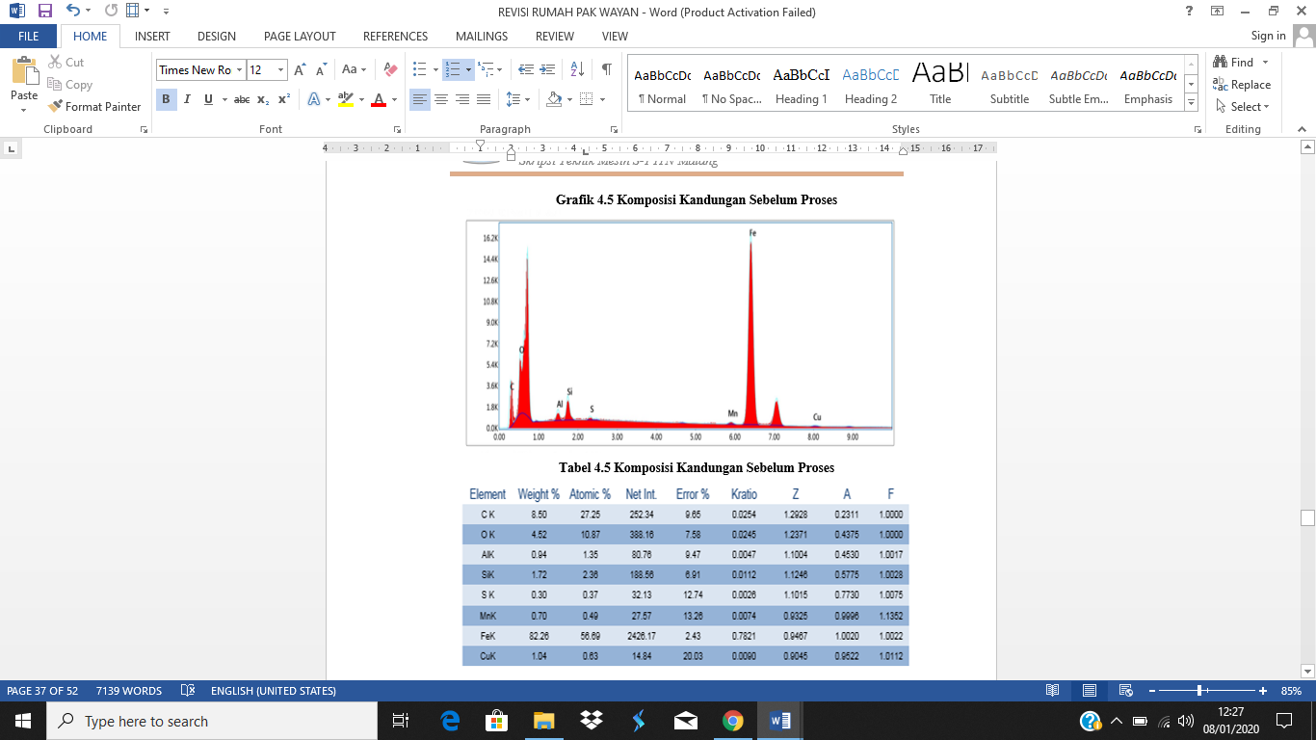
2 hours | 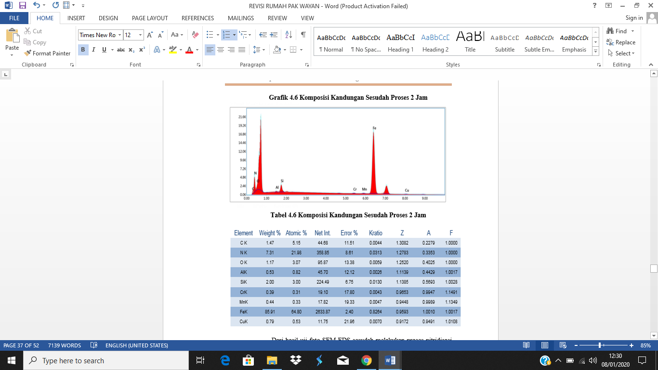 |  |  | 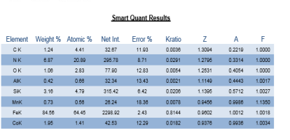
4 hours | 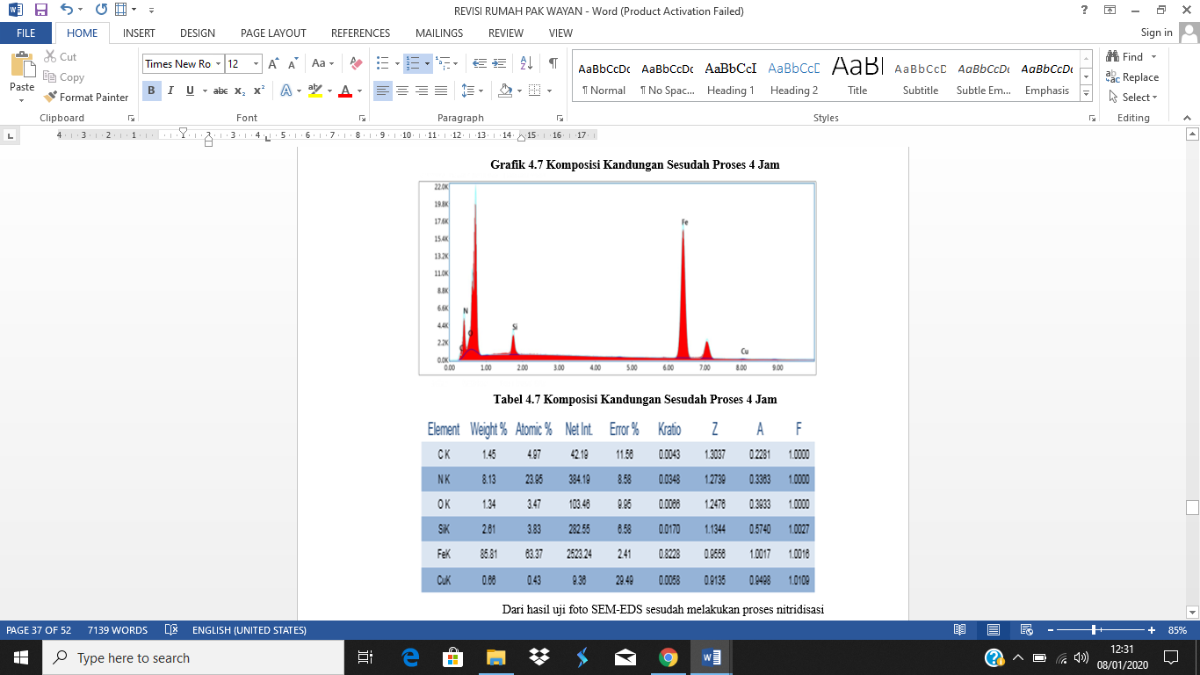 |  |  | 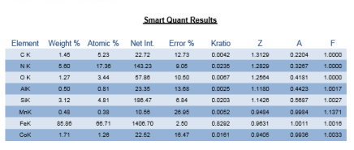
6 hours | 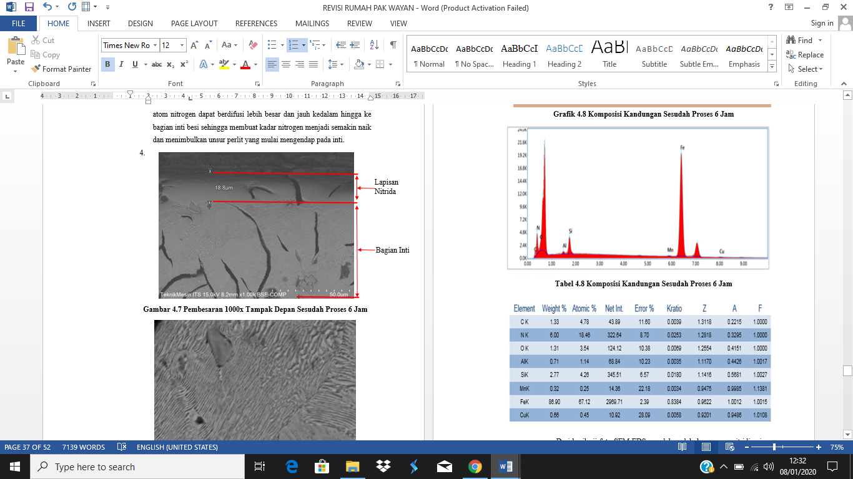 |  |  | 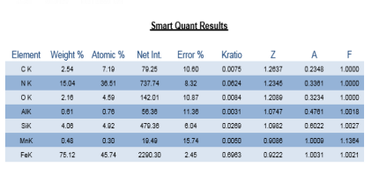

4. Discussion
The hard layer of iron nitride formed on the surface was shown in the SEM test results (Figure 2). Nodular cast iron had better coating hardness, though the nitride layer was thinner than grey cast iron. The spherical structure (nodule) in nodular cast iron had a lower stress concentration, hence the nitrogen atom was easily bound to the Fe in the complete formation of hard nitride (Figure 3b). According to Figure 3.a, the nitride layer formed on the surface is often more prone to crack propagation (breakage). This is because the grey cast iron structure in the form of a flake easily propagates to the surface [9]. Additionally, grey cast iron with an elongated structure (flake) had a high-stress concentration, especially in the tip area (Figure 3). This led to a lower hardness because it tended to fail. Figure 5 showed the structure of nodular cast iron where the grain boundaries were more neatly arranged, hence the stress concentration was more evenly distributed.
Longer holding time led to a higher surface hardness because iron and nitrogen's chemical reaction lasted longer. This increased the concentration of nitrogen on the sample surface from diffusion. Therefore, a longer diffusion time increases surface hardness [10]. The microstructure observation results showed that before and after the nitriding treatment for 2 hours at 550 ºC, a nitride layer formed on the specimen surface. This is because the nitrogen atom diffuses with the iron atom in the specimen. The results show that FeN compounds from nitrogen content reached 7.31% weight or 21.98% atoms/at. The nitridization process also reached optimal conditions to achieve optimal nitrogen dissolved in iron of about 20% to obtain hard properties Fe₄N.
Increasing the nitriding process's temperature surges the concentration of nitrogen atoms in the material [11]. The maximum solubility limit of nitrogen in iron at a nitriding temperature of 500-590 ºC is 0.1%. In case it is greater than 0.1%, nitride γ '(Fe₄N) is formed. Suppose nitrogen solubility in the iron exceeds 6%, the nitride γ '(Fe₄N) changes to ε (Fe₂₋). At temperatures below 500 ºC with more than 11% nitrogen content, nitride ξ ₃N (Fe₂N) immediately forms. Above 650 ºC, Fe₄N decomposes. Nitride γ ’and ε are physically visible on the iron surface as a white or compound layer [12].
According to the data from the SEM-EDS test photo, the microstructure of the specimen was conducted after or before the nitriding process. This appeared in flake graphite on gray cast iron, grain boundaries, and nitride coating. In nitrided specimens, a hard shell was formed in the form of a nitride alloy deposit (compound layer) containing Fe₄N. This was due to chemical bonding between nitrogen atoms and alloying elements present in grey cast iron specimens.
Therefore, the nitriding process on grey cast iron was best conducted at a temperature of 550 ºC with a nitriding time of 4 hours. The nitrogen atom content at this rate diffused largely and deeply into the iron core, increasing the nitrogen atomic content. In case the nitriding process took more than 4 hours, nitrogen could not diffuse well and deeply into the iron core due to the long processing time.
Analysis and Characterization of Grey Cast Iron shows that The SEM-EDS photo test showed that the grey cast iron decreased the concentration of carbon atoms after a nitriding treatment of up to 50 %. The nitrogen atomic content up to a depth of 17.8 µm was 21.98 % at, showing diffusion of atoms into the surface of the grey cast iron. This was reinforced by forming a nitride layer and high hardness values ​​on the surface [10]. Increasing the treatment to 4 hours led to a lower concentration of carbon atoms and vice versa. The higher the nitrogen atom up to 23.95 % at, the longer the treatment, increasing the diffusion of nitrogen atoms. However, the 6 hour-treatment showed a decrease in nitrogen atoms' concentration, reaching 18.46% at. This showed that atoms' diffusion was supersaturated, where nitrogen (N) atoms met to form nitrogen molecules (N₂) and released into the atmosphere. This supersaturated reaction occurred at a maximum layer thickness of 20 microns.
Analysis and Characterization of Nodular Cast Iron shows that The hardening depth distribution trend due to the nitriding process in nodular cast iron was not much different from grey cast iron. However, the resulting surface hardness was higher than grey cast iron, especially in the 6-hour nitriding treatment. This showed that the cast iron nodule (round) structure influenced the hardness value.
In the chemical composition test (EDS) with a nitriding treatment time of 2 hours, the nitrogen content was 6.87%, and the compound formed was Fe₂₋₃N. In the 4 hours of treatment, most of the structures formed were iron nitride compounds Fe₄N with a nitrogen concentration of 5.60%. By increasing the treatment time to 6 hours, the nitrogen concentration increased to 15.04%, hence the compounds formed were Fe₂N with high surface hardness values.

5. Conclusion
The grey cast iron showed the distribution of hardness, the highest being in the 4-hour process. Increasing the processing time to 6 hours led to a supersaturated reaction, accompanied by a decrease in hardness value. Nodular cast iron with a nodular structure still increased the hardness value up to 6 hours of treatment. This was indicated by the formation of the nitride compound Fe₂N on the surface of the nitride layer.

Acknowledgments
Authors acknowledge assistance or encouragement from colleagues, special work by technical staff, and financial support from KEMENRISTEK/BRIN.

REFERENCES

[1] Jingjing Qing, Simon Lekakh, Mingzhi Xu and Dan Field 2020 Formation of Complex Nuclei in Graphite Nodules of Cast Iron Carbon Journal Volume 171 276-288
[2] E. Roliński, A. Konieczny, and G. Sharp 2007 Influence of Nitriding Mechanisms on Surface Roughness of Plasma and Gas Nitrided/Nitrocarburized Gray Cast Iron Heat Treat. Prog. 39–46
[3] Edward Rolinski, A. Konieczny and G. Sharp 2009 Nature of Surface Changes in Stamping Tools of Gray and Ductile Cast Iron During Gas and Plasma Nitrocarburizing Journal of Materials Engineering and Performance 18(8):1052-1059
[4] D.Gölden E.HildebrandtL.Alff 2017 Thin film phase diagram of iron nitrides grown by molecular beam epitaxy Journal of Magnetism and Magnetic Materials Volume 422 407-411
[5] Emin Kondakci and Nuri Solak, 2020 The Effect of Microstructure on Nitriding Mechanism of Cast Iron International Journal of Metalcasting
[6] Jiajie Kang, Mingzheng Wang, Wen Yue, Zhiqiang Fu, Lina Zhu, Dingshun She and Chengbiao Wang, 2019 Tribological Behavior of Titanium Alloy Treated by Nitriding and Surface Texturing Composite Technology Materials (Basel). 12(2): 301
[7] Esa Haruman, Yong Sun, Hitendra Malik and Komang astana Widi, 2006 Low Temperature Fluidized Bed Nitriding of Austenitic Stainless Steel Solid State Phenomena 118:125-130
[8] Rahardjo Teguh 2008 Proses Nitriding Untuk Peningkatan Sifat Mekanik Permukaan Material Dies Jurnal Flywheel. Vol.1 No 2
[9] K.A. Widi, I. Wardana, W. Suprapto and Y.S. Irawan 2016 The Role of Diffusion Media in Nitriding Process on Surface Layers Characteristics of AISI 4140 with and without Hard Chrome Coatings Tribology in Industry Vol. 38, No. 3 308-317
[10] Wayan Sujana and Komang Astana Widi 2017 Compared of Surface Roughness Nitride Layers formed on Carbon and Low Alloy steel, International Journal of Engineering Research & Science (IJOER) Vol-3 Issue-5
[11] Rahayu Sri, Setiawan Ngainum, Virdhian Shinta dan Suhendi Endi 2017 Pengaruh Proses Powder Nitriding Terhadap Perubahan Kekerasan Dan Ketebalan Lapisan Difusi Pada Pahat Bubut High Speed Steel. JML Vol. 39 No. 1 J
[12] W.Sujana and K. A.Widi 2016 Serbuk Alumina Sebagai Katalis Didalam Reaktor Fluidised Bed Jurnal Flywheel Vol 7 No 1

