Geographic Information System (GIS): Potential Mapping of Agribusiness in Southern Part of West Java

T Maskun1,*, M Masluh2, E N Resmiawati2, Komarudin Tasdik3, Didin Muhafidin4, Gunawan Undang5 and Ova Nurisma Putra3

1Prodi Studi Teknologi Industri Pertanian, Universitas Al-Ghifari, Jl. Cisaranten Kulon No.140, Kota Bandung, Indonesia.

2Prodi Manajemen, Universitas Al-Ghifari, Jl. Cisaranten Kulon No.140, Kota Bandung, Indonesia.

3Program Studi Sistem Informasi, Sekolah Tinggi Manajemen dan Informatika (STMIK) Jabar, Kota Bandung, Indonesia.

4Program Studi Ilmu Adminsitrasi, Universitas Padjadjaran, Kota Bandung, Indonesia.

5Prodi Ilmu Administrasi, Program Pascasarjana, Universitas Pembinaan Masyarakat Indonesia, Jl. Teladan No.15, Kota Medan, Indonesia.

*tommaskun9@gmail.com

**Abstract**. In this study, a mapping of the potential for agribusiness in the southern part of West Java, which serves as policy material and business development in the development of local potential in the agribusiness sector, is carried out to improve the welfare of local communities. West Java Provincial Regulation Number 12 of 2014 divides the Southern part of West Java into 3 (three) Growth Center (PP) zones, namely PP Palabuhanratu, PP Rancabuaya, and PP Pangandaran. Policies for developing the southern part of West Java include agribusiness, agro-industry, marine industry, and integrated tourism. The potential of agribusiness in the southern part of West Java is vibrant and varied. Still, it has not been optimally developed to improve local communities' welfare, which is generally scattered in underdeveloped villages. The government and developers (entrepreneurs) have difficulty obtaining digital data updates. The purpose of this research is to map the regional potential in the field of agribusiness in the form of digital data to facilitate the development of agribusiness potential in coastal areas located on the shores of the Indian Ocean (Indonesian Ocean). The research method uses Geographical Information Systems. The results showed that agribusiness's potential and variants in PP Palabuhanratu are scattered in Cisolok District, Cikakak District, Palabuhanratu District, Simpenan District, and Ciemas District. PP Rancabuaya is spread in Caringin District, Cisewu District, Bungbulang District, and Mekarmukti District (in Garut Regency) as well as in Cidaun District (Canjur Regency). Meanwhile, PP Pangandaran is spread in Kalipucang District, Pangandaran District, Sidamulih District, Parigi District, and Cijulang District.

1. Introduction

Indonesia is known to have great agricultural and maritime potential in the world [1]. Suppose the southern part of West Java's agribusiness potential is managed optimally, will solve DKI Jakarta's problems, such as floods, traffic jams, and social disparities. The Jakarta problem is one of the contributors to Indonesia's bad image in the world's eyes. Good governance of agribusiness in the southern part of West Java can be one of the pillars of potential bilateral relations between the business and overseas Australia. Optimizing cooperation between the two countries in South West Java can reach maritime products because there is a Rancabuaya beach. It can be continued in agribusiness after maritime because agricultural products are spread not too far from Rancabuaya, Garut Regency, West Java. Indonesian people who work as farmers reach 34.36%. This percentage is above trade, manufacturing, and other occupations [2]. It was found that the highest share of Gross Domestic Product (GDP) in Indonesia is in the industrial sector, not agriculture.

The industrial sector contributed to economic growth by 19.66 percent [3]. The movement of people's attention to agriculture in Cisewu sub-district, Garut district, an area that is part of South West Java, is starting to appear among low-income communities and middle-class economic communities such as teachers who already have decent houses and four-wheeled vehicles. However, after harvesting, some of them experienced problems in marketing so that they suffered significant losses. For example, two pepper farmers in Cisewu village (2019-2020) experienced losses because, in pepper cultivation, the price ranges from IDR 150,000-IDR 250,000 per kg. However, from the end of 2019 to October 2020, pepper's prices around IDR 50,000 per kg. This shows that agribusiness optimization is needed so that farmers can benefit. Investors can easily find the potential for agribusiness in each region to stabilize prices for agricultural products. Price stability is needed by farmers to calculate the potential profit that will be obtained at harvest.

The southern region has lagged somewhat behind due to different sources of growth. This region is the source of growth in the agriculture, agro, and tourism sectors so that economic development is not carried out sporadically or unevenly. There needs to be a mapping according to the potential of the existing area [4]. Based on the analysis of diversity and institutions, rice agribusiness in West Java shows that the farming community has cultivated relatively well from the aspect of cultivation techniques. Important policy implications that need to be taken to improve rice agribusiness include reviving the civil servant, military, and police segments with the spirit of regional autonomy and nationalism through product quality assurance. Institutional alternatives that are considered to improve the performance of rice agribusiness development in West Java in the future include the small-medium scale agribusiness model [5]. Based on the Williamson index analysis, regional inequality in West Java is a high level of inequality. The inequality index in West Java Province in 2013 reached 0.61. According to Matolla in Puspandika (2007), and IW value above 0.5 means that the region has a high inequality level (Aprianoor & Muktiali, 2015: 488). Due to a lack of budget, the Cianjur Agriculture and Food Crops Office has difficulty building an agribusiness sub-terminal to increase bargaining power flow and provide information about agricultural products (YRI, 2012). Bandung and West Java hold good business potential for Rabobank Indonesia, which focuses on food and agribusiness. This is because the agriculture, fisheries, and forestry sectors rank third in the contribution of West Java's GRDP (Gross Regional Domestic Product) or around 8.9 percent (Lukihardianti, 2018). By paying attention to these problems, it appears that local governments are aware of the need for an agribusiness terminal. However, they have not stepped into digitizing the agribusiness terminal.

With the existence of GIS-based regional potential analysis and mapping, it can provide information to investors to encourage investment in the region concerned (Wibawa & Zulfikar, 2017: 538). In the same source, we need a GIS-based system that can support and monitor the implementation of local potential development to support e-government. Data and information displayed in the application are always linked to geographic position. Their geographic coordinates (latitude and longitude) are known and accessed via the internet by users (Wibawa & Zulfikar, 2017: 532). GIS-based programs can provide information to anyone who wants to know about the development of agricultural potential quickly and accurately, thereby saving time, effort, and costs (Wowor, 2010: 32). GIS-based applications can also be used for mapping agricultural land and commodity crops (Susanto, 2016: 1233). In these three studies, it appears that several Indonesian researchers are interested in the application of GIS in agriculture. These studies tend to provide information for agricultural land use, not for marketing agricultural products. Meanwhile, this research was conducted to help all stakeholders discover the potential of agribusiness digitally so that farmers' profits can be optimal. Agricultural product entrepreneurs have no trouble finding potential areas related to products needed by the market. The research scheme is shown in Figure 1.

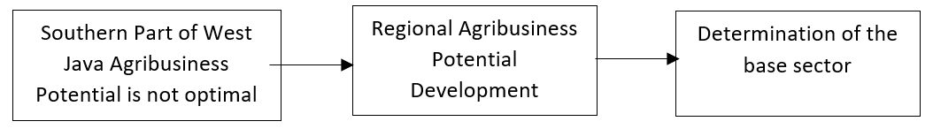

**Figure 1**. Agribusiness potential analysis scheme.

In this study, a mapping of the potential for agribusiness in the southern part of West Java (South West Java) was carried out, which functions as a policy material and business development in developing local potential in the agribusiness sector to improve the welfare of local communities. The research method uses Geographical Information Systems (GIS). According to West Java Provincial Regulation Number 12 of 2014 concerning Management of Metropolitan Development and Development and Growth Centers in West Java, the South West Java area is divided into 3 (three) Growth Center (PP) zones, namely PP Palabuhanratu, PP Rancabuaya, and PP Pangandaran. According to Regional Regulation No. 28/2010 concerning the Development of the Southern Region of West Java in 2010-2029, the policy for the Southern part of West Java's development direction includes agribusiness, agro-industry, marine industry, and integrated tourism. This research aims to map the regional potential in the agribusiness sector using GIS so that digital data can be obtained to facilitate the development of the potential for agribusiness in coastal areas located on the shores of the Indian Ocean (Indonesian Ocean). The potential of agribusiness in the southern part of West Java is vibrant and varied. Still, it has not been optimally developed to improve local communities' welfare, which is generally scattered in underdeveloped villages. The government and developers (entrepreneurs) have difficulty obtaining digital data updates.

1. Method

This research was conducted in all sub-districts in South West Java, Indonesia, using the Geographic Information System (GIS) method.

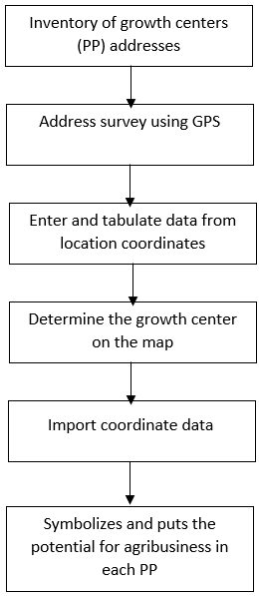

**Figure 2**. Research stages.

The steps taken in this study are shown in Figure 2, which includes:

* Address inventory of growth centers
* carry out an address survey using the Global Positioning System (GPS),
* Enter and tabulate data from the location coordinates using Microsoft Excel
* determine the growth center on Google Map to see the location on a wider scale,
* import coordinate data from Excel using Google Map, and
* symbolizes and places the potential for agribusiness in each PP in West Java's southern part.

1. Result and discussion

## Overview of agribusiness potentials of south west java

Cisewu Subdistrict is one of the areas in Garut district, Southern West Java. This sub-district has good agribusiness potential because it has several villages used to produce plantation products, such as cloves, pepper, rice, brown sugar, and others. Villages that produce pepper and cloves include Karangsewu village. Meanwhile, the Cisewu sub-district is an area that has road access to tourist attractions, Rancabuaya beach, which, along the way, can be optimized into agro-tourism and agribusiness areas. The main road, known as the South Ring Road, which runs along the coast of South Garut, Cianjur, and Sukabumi, is the infrastructure to support South West Java's economic progress. Even Cisewu also has a Tiwu Genteng tea garden (Panggalih village), which can be optimized for agribusiness and agro-tourism.

The chances of success for the Southern part of West Java can be seen from at least 3 aspects: geopolitics, urban planning management, and agricultural, industrial technology. Geopolitically, several South West Java areas experienced expansion, such as the Pangandaran district, which has separated from Ciamis and South Garut districts and is separating from Garut regency. Both examples of these areas have great potential in the agribusiness sector. Urban planning management is also a concern, especially in South Garut. Urban infrastructure development is underway. This region is usually the center of attention for governor candidates during the Pilkada in West Java because it has potential voters. In addition to these two aspects, agricultural, industrial technology must also receive great attention so that agricultural products have a more profitable selling value.

One of the problems with Indonesia's capital city, Jakarta, is the population factor. The floods sent from Bogor were exacerbated by the river in Jakarta, which had many garbage and many residential areas on the riverbanks. The population boom in Jakarta is due to urban areas, among others, from South West Java. Likewise, congestion in Jakarta, apart from the lack of discipline in the community when using the roads, too many vehicles also trigger it, many vehicles are caused by many urban residents as well. The densely populated Jakarta makes the government overwhelmed in dealing with social inequalities. Many rich people in Jakarta, many poor people. Many people live in luxurious buildings in Jakarta, and many people live in rickety huts. Related to this problem, if the agribusiness management of South West Java is optimal, it will suppress the urban flow from South West Java to Jakarta so that the population of Jakarta is not too dense. Thus, the Jakarta population's management will be easier to implement, both in overcoming floods, traffic jams, and social disparities.

The presence of good agro-business management in Southern West Java affects the alleviation of national problems and can also increase the benefits of bilateral relations between Indonesia and Australia. The Rancabuaya Sea can penetrate Australia so that the potential for marine product business relationships is more open. Because the Rancabuaya area is not too far from the agricultural centers of the population, the agribusiness relations between the two countries are also wider, as shown in Figure 3.

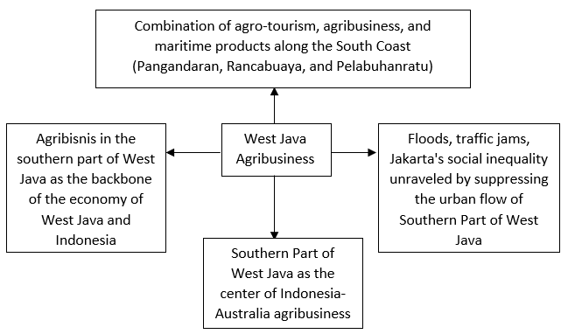

**Figure 3**. Southern Part of West Java Agribusiness and Indonesia's welfare.

The potential and variants of agribusiness in the Palabuhanratu Growth Center (PP) are scattered in Cisolok District, Cikakak District, Palabuhanratu District, Simpenan District, and Ciemas District. Meanwhile, PP Rancabuaya is scattered in Caringin District, Cisewu District, Bungbulang District, and Mekarmukti District (in Garut Regency) as well as in Cidaun District (Canjur Regency). Meanwhile, PP Pangandaran is spread in Kalipucang District, Pangandaran District, Sidamulih District, Parigi District, and Cijulang District.

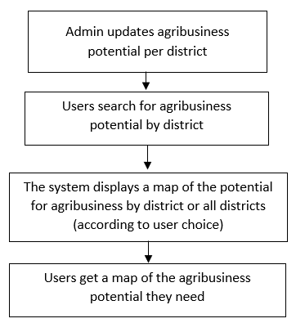

**Figure 4**. Agribusiness application data flow.

To be more optimal, it is necessary to make a GIS-based agricultural mapping of West Java in the South. GIS-based applications can be a solution for potential investors. They can increase profits for farmers so that South West Java can be a role model for provinces outside Java that Indonesia can progress rapidly with Information Technology-based agricultural and maritime resources. Further development of GIS in Southern West Java is also very open because West Java has Human Resources of the caliber of the Bandung Institute of Technology (ITB), Padjadjaran University (Unpad), and Bogor Agricultural Institute (IPB). The data flow in the system required based on the analysis results in this study is shown in Figure 4.

This application can be applied in government agencies, companies, institutions, or interested individuals. Simultaneously, this GIS application's end-users can consist of business actors, government, and the general public. Technically, South West Java's agribusiness map contains the features of the sub-districts name, the name of the potential product, the number of production, and the route, as shown in Figure 5.

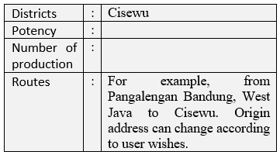

**Figure 5**. Example of the contents of the Cisewu potential map.

## Application of Agribusiness Potentials of South West Java based on GIS

If the user wants to see a map of agribusiness potential in West Java's southern part, the user can click the Map menu in Figure 6. After that, a display will appear, as shown in Figure 7. If the user clicks on one of the sub-district names on the left, for example, Cisewu, a display will appear as shown in Figure 8. If the user clicks the View menu on Google Maps (View in Google Maps), a display will appear in Figure 9. If the user clicks the Route menu in Figure 9, a display will appear, as shown in Figure 10.

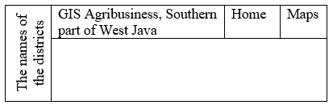

**Figure 6**. Main menu.

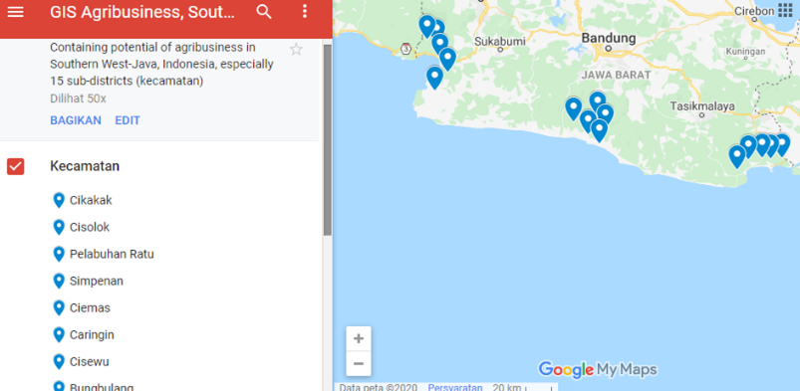

**Figure 7**. Map of agribusiness potential.

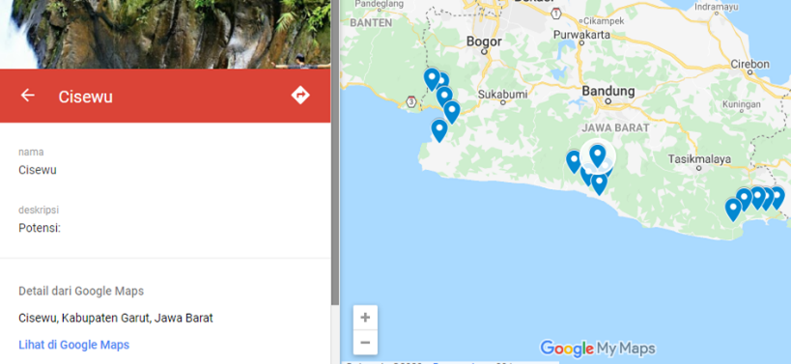

**Figure 8**. The potential of Cisewu sub-district agribusiness.

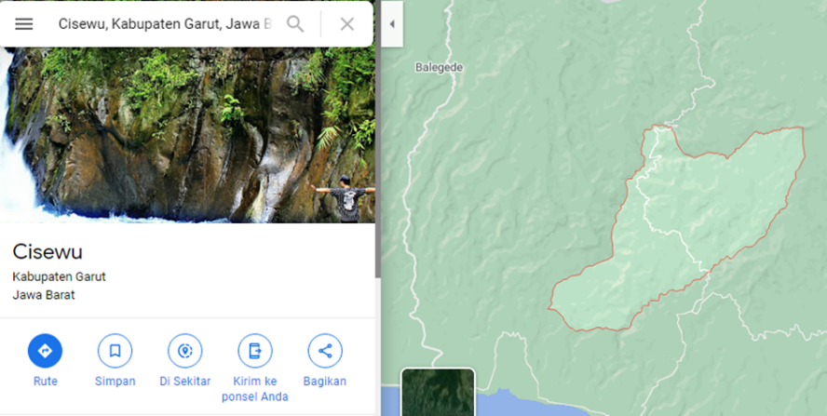

**Figure 9**. The route to the potential location of Cisewu agribusiness.

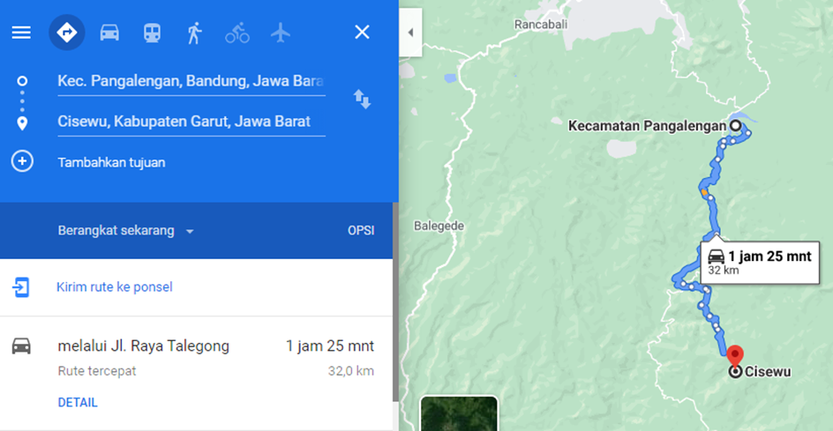

**Figure 10**. Determination of the mileage to the location of agribusiness.

If the user wants to find out how long it will take from a certain address to an agribusiness location, replace the writing Kec. Pangalengan, Bandung, West Java is the desired address of origin. While the destination address in Figure 10 is Cisewu. Figure 11 shows a page that can be used by the admin to change the names of the sub-districts and includes details of their potential and other settings that are deemed necessary to change.

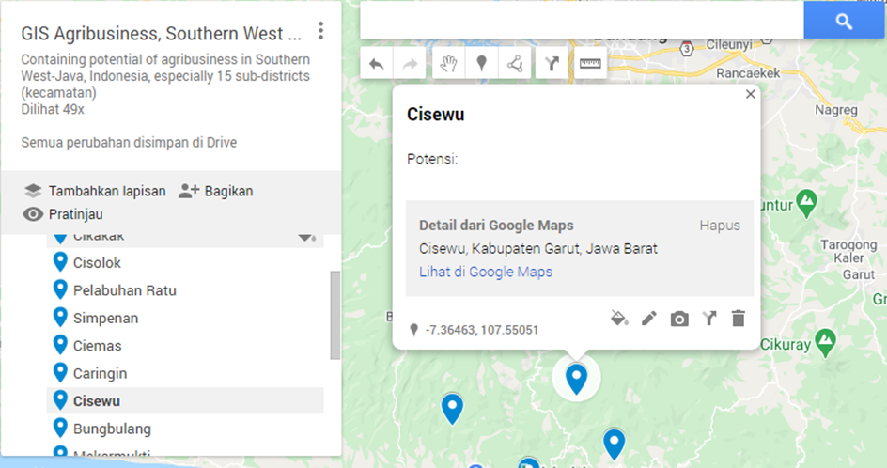

**Figure 11**. Admin page.

1. Conclusion

The results showed that agribusiness's potential and variants in PP Palabuhanratu are scattered in Cisolok District, Cikakak District, Palabuhanratu District, Simpenan District, and Ciemas District. PP Rancabuaya is spread in Caringin District, Cisewu District, Bungbulang District, and Mekarmukti District (in Garut Regency) as well as in Cidaun District (Canjur Regency). Meanwhile, PP Pangandaran is spread in Kalipucang District, Pangandaran District, Sidamulih District, Parigi District, and Cijulang District. Mapping the potential of agribusiness using a geographic information system (GIS) in the southern part of West Java is needed to optimize the marketing of agricultural products so that farmers and stakeholders get maximum benefits. The government needs this application to support policymaking, both local and central government. The combination of agribusiness, agro-tourism, and maritime products along the South Coast (Pangandaran, Rancabuaya, and Pelabuhanratu) can contribute to Indonesia's problems Jakarta, which routinely experiences flooding, traffic jams, and social disparities. The mapping of GIS-based agribusiness in the Southern part of West Java is one contributor to realizing this combination of Indonesia's welfare.

References

1. Rompas J, Engka D and Tolosang K 2015 Potensi sektor pertanian dan pengaruhnya terhadap penyerapan tenaga kerja di Kabupaten Minahasa Selatan *Efisiensi* 15
2. Kusumaningrum S I 2019 Pemanfaatan Sektor Pertanian Sebagai Penunjang Pertumbuhan Perekonomian Indonesia *Transaksi* 11 80–9
3. Susanto D 2018 Masihkah Indonesia Negara Agraris? *news.detik.com*
4. Praditya I I 2017 Penyebab Ekonomi Jawa Barat bagian Selatan Tertinggal *Liputan6.com*
5. Saptana S, Suwarto and Nur M 2003 Kinerja Kelembagaan Agribisnis Beras di Jawa Barat *Penyusunan Profil Investasi dan Pengembangan Agribisnis Beras di Jawa Barat*
6. Ahaliki, Budiyanto. 2016. Sistem Informasi Geografis (SIG) Pemetaan dan Analisis Daerah Pertanian di Kabupaten Gorontalo, Jtech 2016, 4(2), p. 116 – 122.
7. Ambarita, Arisandy. 2017. Sistem Informasi Geografis Potensi Tanaman Pangan (Studi Kasus: Kabupaten Halmahera Barat Provinsi Maluku Utara), Indonesian Journal on Networking and Security - Volume 6 No 1 – 2017, p. 53-62.
8. Ansar, Murad, Putra Guyup Mahadhian Dwi, Hartuti Hanifa. Pemetaan Lahan Pertanian di Kabupaten Lombok Timur Menggunakan Sistem Informasi Geografis (SIG), Jurnal Teknik Pertanian Lampung Vol. 9, No. 2 (2020), p. 140-148.
9. Dayat Dayat, Anwarudin Oeng, Makhmudi Maspur. 2020. Regeneration Of Farmers Through Rural Youth Participation In Chili Agribusiness, International Journal of Scientific & Technology Research Volume 9, Issue 03, March 2020, p. 1201-1206.
10. Fitria Dina Nurul, Harianto, Priyarsono D S, Achsani Noer Azam. 2020. Asymmetric Price Transmission with Threshold Behavior of Potatoes Market in Bandung Regency West Java, AGRARIS: Journal of Agribusiness and Rural Development Research, Vol. 6 No. 1 Januari-Juni 2020, p. 2527-9238 (e).
11. Gunawan, Budi. 2011. Pemanfaatan Sistem Informasi Geografis Untuk Analisa Potensi Sumber Daya Lahan Pertanian di Kabupaten Kudus, Jurnal Sains dan Teknologi, Volume 4, Nomor 2, Desember 2011, p. 122-132.
12. Harniati & Anwarudin, Oeng. 2018. The Interest and Action of Young Agricultural Entrepreneur on Agribusiness in Cianjur Regency, West Java, Jurnal Penyuluhan, September 2018 Vol. 14 No. 2, p. 189-198.
13. Manuaba I.B Wiskara, A. Mimi Fricicilia Crissy, Mustikawati Filya, Christiany Isabella. 2009. Rancang Bangun Sistem Informasi Geografis (SIG) Untuk Pemetaan Potensi Daerah Pesisir, IPTEKMA, Volume 1 No. 1, 2009, p. 032-037.
14. Mariyono, Joko. 2014. The Economic Performance of Indonesian Rice-based Agribusiness, International Journal of Administrative Science & Organization, January 2014, Volume 21 Number 1, p. 35-43.
15. Mariyono, Joko. 2019. Motivating Factors of Farmers to Engage Vegetable-based Agribusiness in East Java and Bali, Indonesia, Jurnal Ekonomi Pembangunan: Kajian Masalah Ekonomi dan Pembangunan, 20 (2), 2019, p. 163-175.
16. Maryania Ait, Haryantob Yoyon, Anwarudinc Oeng . 2017. Strategy of Agricultural Extension to Improve Participation of the Farmers in Special Effort in Increasing Rice Production, International Journal of Sciences: Basic and Applied Research (IJSBAR), International Journal of Sciences: Basic and Applied Research (IJSBAR) (2017) Volume 36, No 4, p. 163-174.
17. Pinoa Febriyanto, Pakasi Sandra E, Tamod Zetly, Lengkong Jeanne. 2015. Pemetaan Potensi Lahan Sawah di Kecamatan Ratahan Dengan Menggunakan Sistem Informasi Geografis, COCOS, Vol 6, No 13 (2015), p. 1-8.
18. Pritha, Aprianoor & Muktiali, Muhammad. 2015, Kajian Ketimpangan Wilayah di Provinsi Jawa Barat, Jurnal Teknik PWK Volume 4 Nomor 4 2015, p. 484-498.
19. Susanto Arief, Kharis Ahmad, Khotimah Tutik. 2016. Sistem Informasi Geografis Pemetaan Lahan Pertanian dan Komoditi Hasil Panen Kabupaten Kudus, Jurnal Informatika, Vol. 10, No. 2, Jul 2016, p. 1233-1243.
20. Wibawa, Chandra Wibawa & Zulfikar, Rizki. 2017. Analisis dan Pemetaan Potensi Daerah Berbasis GIS Menggunakan Model Rasio Pertumbuhan (MRP), Jurnal Teknik Informatika dan Sistem Informasi, Volume 3 Nomor 3 Desember 2017, p. 524-538.
21. Wowor, Aneke. Pemanfaatan Aplikasi GIS Untuk Pemetaan Potensi Pertanian di Kabupaten Minahasa Utara, Tekno/Volume08/No.54/DESEMBER 2010, p. 27-33.
22. Peraturan Daerah Provinsi Jawa Barat Nomor 12 Tahun 2014 tentang Pengelolaan Pembangunan dan Pengembangan Metropolitan dan Pusat Pertumbuhan di Jawa Barat (Diakses 30 Oktober 2020). https://dprd.jabarprov.go.id/jdih/pdf/2014/Perda-12-Tahun-2014.pdf
23. Peraturan Daerah Nomor 28 Tahun 2010 tentang Pengembangan Wilayah Jawa Barat Bagian Selatan Tahun 2010—2029, antara lain agribisnis, agroindustri, industri kelautan, dan pariwisata terpadu (Diakses 30 Oktober 2020). http://ditjenpp.kemenkumham.go.id/files/ld/2010/ProvinsiJawaBarat-28-2010.pdf