Design and Installation of SME and Households Scale Solar Power Plants (Solar Home System)

Nurhadi Nurhadi1, Muhamad Rifa’i2, Chandra Wiharya3

1Department of Mechanical Engineering, State Polytechnic of Malang, Jl. Soekarno Hatta 9, Malang 65141, Indonesia

2,3Department of Electronic Engineering, State Polytechnic of Malang, Jl. Soekarno Hatta 9, Malang 65141, Indonesia

1nurhadi@polinema.ac.id

**Abstract**. The higher cost of electricity encourages humans to develop alternative sources of electrical energy, by utilizing Solar Home System (SHS). The problem is that is difficult for Small and Medium Enterprises (SME/UKM) and poor society, due to lack of knowledge, skills and high costs. The purpose of study is to provide a brief and practical reference in determining the appropriate and economical SHS specifications. The method used are calculations, including calculation of electric loads, number of solar panels, minimum battery capacity and area of ​​the solar panel installation. The SHS system was then installed at UKM CITARA consists of 4 units of solar panels @ 100 WP (400 WP), 1 unit of 850 VA hybrid controller, 1 unit of VRLA 200 AH battery, 2 units of lamps @ 14 watts, MCB switch, voltmeter, and ammeter. The ability to generate electrical energy from solar panels on average per day in bright sunlight conditions, namely: 960 watts / 2 hours, or 480 watts / 4 hours, or 160 watts / 12 hours of use. SHS can be used to turn on a biophonic catfish pond water pump for 24 hours / day and turn on 2 lights for 12 hours / day.

**Keywords:** design, installation, SHS, biophonic catfish pond, UKM CITARA

1. Introduction

The higher cost of electricity encourages humans to develop alternative sources of electrical energy, one of which is by utilizing solar heat. The heat of the sun in Indonesia, which has a tropical climate, is very abundant throughout the year, so it is very potential to be developed into a source of electrical energy or a solar power plant (PLTS). Small PLTS for household is called Solar Home System (SHS). The problem is to design and install SHS for Small and Medium Enterprises (SME/UKM) and the poor society is a difficult one, due to a lack of knowledge, skills and relatively high costs. The design and installation of SHS for SMEs and households is important to provide a brief and practical reference in determining appropriate and economical SHS specifications, especially during the COVID 19 pandemic, many SMEs and communities were affected, where SMEs did not produce so there was no income, and the burden of people's lives is getting heavier.

Studies related SHS have been carried out quite a lot by researchers around the world. Bachtiar (2006) has planned SHS in Southeast Sulawesi (Indonesia), while Suriadi (2010) has planned a PLTS Housing Complex in Banda Aceh (Indonesia). Ghassan (2017) has built and tested SHS systems for cooking and lighting needs for communities in South Asia, South East Asia and Sub-Saharan Africa. Gustavsson (2005) uses a Lead-acid battery for SHS in Zambia. Fadlallah (2020) calculates the need for photovoltaic (PV) in Sudan, while Sabah (2019) does the same in Oman. Junpeng (2020) provides mandatory installation of SHS in China. Dzulfikar (2016) said that SHS generally uses 50-100 Wp (Watt peak) solar modules and generates daily electricity of 150-300 Wh. Solar panels are power plants capable of converting solar radiation that is converted into electricity (Iqtimal, 2018). Because the scale is small, it uses a DC (Direct Current) system, so as not to be exposed to losses and self-consumption due to the use of an inverter. With this small system, it is installed in a decentralized manner (one house, one generator) so that it does not need a distribution network.

The existing study of SHS generally provides an information in installing SHS by ideal method, for general public, whereas in this article, described how to determine a more precise and economical SHS specification for SMEs and poor society, so that it fits their needs and is more affordable, because they were affected by the Covid-19 pandemic. The design and installation of SHS that uses sunlight as a source of electrical energy is one solution to the problem of high electricity costs for SMEs and the community during a pandemic.

1. Method

The SHS design method based on electrical loads. This design method is carried out to determine the size of the solar panels, the battery capacity and the area required for the installation of solar panels for a solar energy system with a specified maximum capacity. The SHS design steps (Bachtiar: 2006) are as follows:

## Determine the Total Load Current in Ampere-Hours (Ah)

The ampere-hour of the equipment is calculated in DC ampere-hour / day. The load current can be determined by dividing the wattage rating of the various devices under load by the nominal PV system operating voltage.

I total load DC = Watt/V op x hours of use per day …………………..………..(1)

I total load AC = (Watt/V op x hours of use per day)/0.85 …….………….….. (2)

I total load = I total load DC + I total load AC ………………………….…………...(3)

Where: I total load = Total load current on Ampere hours (Ah)

## Determine the Losses and System Safety Factors

For PLTS systems with a power of 1000 Watt and below, a factor of 20% must be added to the loading as a replacement for system losses and for the safety factor. Therefore the ampere-hour of load specified in step 3.1 is multiplied by 1.20 so that:

Total load + Losses & Safety Factor = I total load x 1,20 ………………………(4)

## Determine the worst of Equivalent Sun Hours (ESH)

The sundial equivalent of a place is determined based on the insolation map of the world sun issued by Solarex (Solarex, 1996). Based on the insolation map of the world's sun, it is obtained:

ESH for the East Java Region = 4.5

## Determine Total Current Requirements for Solar Panels

The total current required for the solar panels is determined by dividing the Total load + losses and safety factor' by the ESH.

I total panels = (I total load x1,20)/ESH …………………………………..(5)

## Determine the Battery Capacity for Recommended Spare Time

Generally, photovoltaic solar electrical systems are equipped with storage batteries (accu) to provide energy to the load when operating at night or when the area where solar panels are installed is shown in table 1.

Table 1. The relationship between the installation location and the spare time of the photovoltaic module made by Solarex

|  |  |
| --- | --- |
| Latitude of installation location | Spare Time (Trec) |
| 0o – 30o (North or South) | 5 – 6 day |
| 30o – 50o (North or South) | 10 – 12 day |
| 50o – 60o (North or South) | 15 day |

Source: Solarex, 1996: Discover The Newest World Power, Frederick Court, Maryland USA

Ideally, based on the insolation map of the world (Solarex, 1996), the location of Indonesia's territory is located at 10o South Latitude - 10o North Latitude. This means that the reserve time for all regions of Indonesia, including East Java, is the same, namely 5 - 6 days. For budget efficiency and economy by looking at real conditions, the spare time can be shortened.

Capacity Ampere-hour (Ah) minimum of the battery calculated by the equation:

Battery cap = (I total load x 1,2) x Trec ……………………....(6)

Where:

Battery cap = Battery capacity (Ah)

T rec = Recommended spare time, varies based on latitude. T rec can be shortened for efficiency and economy by looking at real conditions.

## Determine the Optimum Module Arrangements for Solar Panels

The optimum arrangement is a method that will determine the total current requirement of the panels with the minimum number of modules possible. Determination of the minimum module configuration by calculating the minimum number of modules that provide the required panel current values as follows:

The number of modules arranged in parallel are:

Module parallel = $\frac{I total panel}{I ops module}$………………………………..(7)

where:

I total panel is Total current of panels

I ops. module is current operation of module

The number of modules arranged in series is determined by:

Module seri = $\frac{V system}{V module}$………………………………….…….(8)

where:

V system is the nominal voltage of the system

V module  is the nominal voltage of the module

The total modules required are:

The total modules = number of module series x number of module parallel …………..(9)

1. Result and Discussion

## The calculation result

* Total Load Current in Ampere-Hours (Ah)

The ampere-hour of the equipment is calculated in DC ampere-hour/day. The load current is determined by dividing the wattage rating of the various tools used in Poklahsar Citara, as shown in Table 2.

Table 2. The load current used in Poklahsar Citara

|  |  |  |  |  |  |  |
| --- | --- | --- | --- | --- | --- | --- |
| No | Names of Load | Power  (watt) | Number (unit) | Lifetime  (hour) | Watt jam (Wh) | Remaks |
| 1 | Catfish pond water pump | 25 | 1 | 24 | 600 | DC |
| 2 | Lighting | 14 | 2 | 12 | 336 | AC |
|  | Total | | | | 936 |  |

Source: Anonim, 2020

I total load = I total load DC + I total load AC, then it is obtained I total load = 936 watt jam = 936/12 volt = 78 Ah.

* The Losses and System Safety Factors

Total load + Losses & Safety Factor = I total load x 1,20 = 78 Ah x 1,2 = 93,6 Ah

* The worst of Equivalent Sun Hours (ESH) = 4,5
* Total current Panels Photovoltaic (PV) = 93,6 Ah/4,5 jam = 20,8 A
* Total number of modules required:

First, the type of module that will be used must be selected based on the specifications given by the manufacturer/distributor. Poly type module made by Solana, with data of 5.5 amperes operating current and 12 Volt nominal voltage, so that:

The number of modules arranged in parallel = 20,8 Ampere / 5,5 Ampere = 3,78 = 4 unit

The number of modules arranged in series = 12 Volt / 12 Volt = 1 unit

The module = modules parallel x modules series = 4 x 1 = 4 unit

* The Minimum Battery Capacity

By selecting a spare time (otonomy day) for 2 days, obtained

Battery cap = (I total load x 1,2) x T rec = 93,6 Ah/day x 2 day = 187,2 Ah

Then the selected battery capacity is 200 Ah.

* The area for installing solar panels

After the number of panels and battery requirements are known, the area required for the installation of the SHS is determined. For a solar panel with a capacity of 100Wp, it has dimensions of 1030 x 700 x 55 mm. If 4 units of panels are required, the area required is:

1. mm x 2 = 2.060 mm = 2,060 m and 700 mm x 2 = 1.400 mm = 1,4 m

So the area required is approximately 2 x 1.5 square meters, with a panel arrangement pattern as Figure 1.

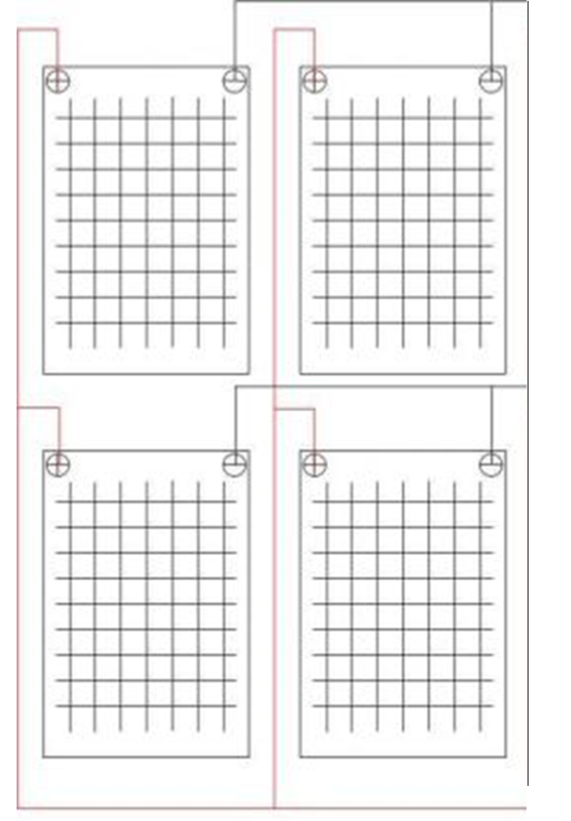

Figure 1. Design arrangement of solar panel

## Design installation

The design of the SHS installation that is installed is drawn simply using computer software to make it easier to understand the installation as a whole. SHS installation design as shown in Figure 2.

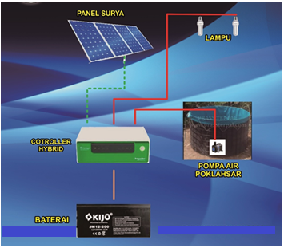

Figure 2. Design installation of SHS

## SHS Installation

The SHS components that are ready are then installed in a predetermined place. The solar panel is installed in a place that gets the most sunlight throughout the day, namely on the tile, while the battery and controller are installed in a place that is protected from heat and rain so that it is durable, namely inside the house. Installation process of SHS shown at Figure 3.

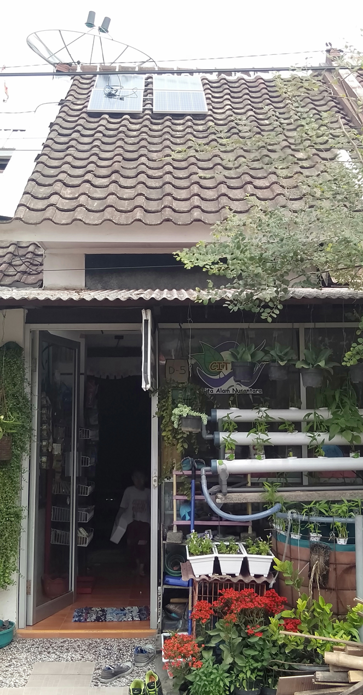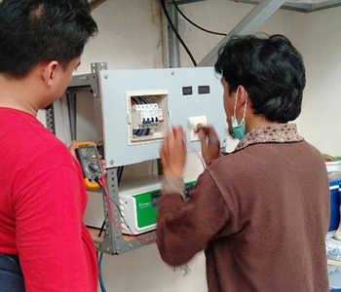

Figure 3. Installation process of SHS

1. Conclusion

To design a SHS required several steps including determine the total load current (Ah), determine the losses and system safety factors, determine the ESH, determine the total current requirements for solar panels, determine the battery capacity, and determine the optimum module arrangements. The SHS system was then installed at UKM CITARA consists of 4 units of solar panels @ 100 WP (400 WP), 1 unit of 850 VA hybrid controller, 1 unit of VRLA 200 AH battery, 2 units of lamps @ 14 watts, MCB switch, voltmeter, and ammeter with. SHS can be used to turn on a biophonic catfish pond water pump for 24 hours / day and turn on 2 lights for 12 hours / day.

Acknowledgement

This study was carried out within the statutory fund of the UPT P2M State Polytechnic of Malang.

References

1. Bachtiar, Muhammad, 2006, Design Procedures of Solar Home System, Jurnal SMARTek, Vol. 4, No. 3, August 2006: 176 - 182
2. Suriadi an Syukri, Mahdi, 2010, Planning an Integrated Solar Power Plant (PLTS) Using PVSYST Software in a Housing Complex in Banda Aceh, Jurnal Rekayasa Elektrika Vol. 9, No. 2, October 2010, pp 77-80
3. Ghassan, et all, 2017, Development and assessment of a solar home system to cover cooking and lighting needs in developing regions as a better alternative for existing practices, International Journal of Solar Energy, Elsevier. Volume 155, October 2017, Pages 7-17,
4. Fadlallah, O, Sulaiman, Eddine, Djamal and Benhadji Serradj, 2020, Determination of the optimal solar photovoltaic (PV) system for Sudan, International Journal of Solar Energy, Elsevier, Volume 208, 15 September 2020, Pages 800-813
5. Junpeng, Huang, at all, 2020, A policy study on the mandatory installation of solar water heating systems – Lessons from the experience in China, International Journal of Solar Energy, Elsevier, Volume 206, August 2020, Pages 614-627
6. Dzulfikar, Dafi dan Broto, Wisnu, 2016, Optimalisasi Pemanfaatan Energi Listrik Tenaga Surya Skala Rumah Tangga, VOLUME V, OKTOBER 2016, p-ISSN: 2339-0654, e-ISSN: 2476-9398
7. Iqtimal, Zian, Devi Sara, Ira dan Syahrizal, 2018, Aplikasi Sistem Tenaga Surya Sebagai Sumber Tenaga Listrik Pompa Air, Jurnal Online Teknik Elektro KITEKTRO, Vol.3 No.1 2018: 1-8, e-ISSN: 2252-7036
8. Solarex, 1996, Discover The Newest World Power, Frederick Court, Maryland USA
9. Anonim, 2020, Berbagai Cara Merancang Solar Home System Sesuai Kebutuhan, (Online) from [https://www.kompasiana.com/trojanganjen/5b20c0fcf13344243b3a1552/any methode to design -solar-home-according](https://www.kompasiana.com/trojanganjen/5b20c0fcf13344243b3a1552/any%20methode%20to%20design%20-solar-home-according) to the needs, accessed October, 10, 2020
10. Gustavsson, Mathias and Mtonga, Daniel, 2005, Lead-acid battery capacity in solar home systems—Field tests and experiences in Lundazi, Zambia, International Journal of Solar Energy, Elsevier, Volume 79, Issue 5, November 2005, Pages 551-558
11. Sabah, Abdul Wahab, et all, 2019, Selection of the best solar photovoltaic (PV) for Oman, International Journal of Solar Energy, Elsevier, Volume 188, August 2019, Pages 1156-1168
12. Krishnadass, et all, 2019, Evaluation of solar thermal system configurations for thermoelectric generator applications: A critical review, International Journal of Solar Energy, Elsevier, Volume 188, August 2019, Pages 111-142
13. Hadi, Awad Mustafa, 2018, Load-match-driven design of solar PV systems at high latitudes in the Northern hemisphere and its impact on the grid, International Journal of Solar Energy, Elsevier, Volume 173, October 2018, Pages 377-397
14. Kabalci, Yasin, et all, 2016, Design and implementation of a solar plant and irrigation system with remote monitoring and remote control infrastructures, International Journal of Solar Energy, Elsevier, Volume 139, 1 December 2016, Pages 506-517
15. H.Alsharif, Mohammed, 2017, Optimization design and economic analysis of energy management strategy based on photovoltaic/energy storage for heterogeneous cellular networks using the HOMER model, International Journal of Solar Energy, Elsevier, Volume 147, 1 May 2017, Pages 133-150
16. Valančius Rūt, Kęstutis, Mikučionienė, 2020, Solar energy as a tool of renovating soviet-type multi apartment buildings, International Journal of Solar Energy, Elsevier, Volume 198, 1 March 2020, Pages 93-100
17. Conrado, Salgado and Montelongo, AreliLopez, 2019, Barriers and solutions of solar water heaters in Mexican household, International Journal of Solar Energy, Elsevier, Volume 188, August 2019, Pages 831-838