**Digitization Of Takepan Sasak Manuscipt Based on the OPF Flipbook**

**L M Samsu11**st**, Muhammad Saiful2**rd**, Imam Fathurrahman3**rd**, Hariman Bahtiar4**rd

aFaculty of Engineering, Hamzanwadi University

Professor M Yamin No.35, Pancor, Selong, Kabupaten Lombok Timur

[lmsamsu311275@gmail.com](mailto:lmsamsu311275@gmail.com), [saipulslbm@gmail.com](mailto:saipulslbm@gmail.com), [kulq85@yahoo.com](mailto:kulq85@yahoo.com), [harimaob@gmail.com](mailto:harimaob@gmail.com)

**Abstrak.** In today's digital era, the electronic book or e-book is an innovation that can be used by the public One of the e-books, namely the Flipbook, is a 3-dimensional digital book that has an animated appearance like a book by combining elements of text, images, videos so that it is interesting ([7]–[9]). Research [10] shows that the use of flipbooks is feasible and very practical.. Another research [11] stated that the digital book design based on kvisoft flipbook is very good and keeps the book from being damaged. Therefore, the research [12] concluded that the media using flipbooks is one of the smart solutions and alternatives in today's digital era. The Sasak Takepan Manuscript is one of the local wisdom in Lombok Island. However, the takepan is made from dry palm leaves which is very easily damaged because over time the quality decreases so that it cannot be read [5]. Flipbooks are an alternative that can preserve local culture, especially the Takepan Sasak manuscript because it can be accessed digitally and studied by the wider community.

Keywords— Takepan Sasak, Digitalization, OPF Flipbook, e-book

**1.Introduction**

West Nusa Tenggara has many cultural heritages that must be protected in order to be preserved. One of them is Lombok Island which holds a large collection of manuscripts. In fact, this island is known as a "conservation laboratory" of Old Javanese manuscripts from an Islamic perspective [1]. For example, the Sasak Takepan Manuscript which is made and written on dry palm leaves using the reramputan language which is a mixture of several languages such as Sasak, Balinese, Javanese, and Malay which is known as the jejawan script which comes from the Javanese language ancient[2]. Takepan has a historical value that is still kept by the community until now [3] and even become one of the subjects in the local school curriculum [4]. However, many people still do not know these historical objects because they are lost, borrowed, or even traded. Although the number is starting to decrease, over time it will experience degradation due to termites, fungi, and scratches on the writing so that the letters in front of them cannot be read.[5].

In today's digital era, the electronic book is an innovation that can be used by the public. The use of this technology is supported by the government in delivering information from conventional to electronic books or e-books ([6]). One of the e-books, namely the Flipbook, is a 3-dimensional digital book that has an animated display like a book by combining elements of text, images, videos so that it is interesting ([7]–[9]). Research [10] shows that the use of flipbooks is feasible and very practical. Another study[11] states that kvsof flipbook-based digital book design is very good and keeps the book from being damaged. Therefore, research[12] concluded that the media using flipbooks is one of the smart solutions and alternatives in today's digital era. So that the takepan manuscript can be preserved, studied, and known by the public or the general public. Therefore, there is a need for digitization[13] , namely ebooks that make it easy to access the contents of the Lombok Sasak Takepan. So that in this research, the researcher made an electronic book or flipbook through the Kvisoft Flipbook Maker.

**2. Literature**

**Table 1.** A Matrix literature review and research position.

|  |  |  |  |  |
| --- | --- | --- | --- | --- |
| **No** | **Title** | ***Publication & Year*** | **Literature** | ***Author*** |
| **1** | Digital Flipbook Empowerment as A Development Means for History Learning Media | JPI (Jurnal Pendidikan Indonesia), 2020 | Making electronic books for history subjects so that they are easily understood by students | A, Muhammad Abror  Suryani, Nunuk  Ardianto, Deny Tri |
| **2** | The Design of Digital Book Content for Assessment and Evaluation Courses by Adopting Superitem Concept Based on Kvisoft Flipbook Maker in era of Industry 4.0 | Journal of Physics: Conference Series, 2019 | Creating a digital book for the Assessment and Evaluation course made with the Kvisoft Flipbook Maker application by adopting the superitem concept | Divayana, D. G.H.  Suyasa, P. W.A.  Ariawan, I. P.W.  Mahendra, I. W.E.  Sugiharni, G. A.D. |
| **3** | Developing Electrical Circuits Flipbook Using Flipbuilder | International Journal of Innovation Education and Research, 2019 | Develop an attractive e-book using the Flipbuilder which is integrated with the PhET Simulation software called the electric circuit flipbook. | Hidayatulloh, Mukhlis |

## 2.1 Manuskrip

Philology is a science that studies manuscripts related to the writings of the past with the assumption that the writings contain values that are still relevant to modern life[16].

## 2.1 Digitization

Information is important, especially in the industrial era 4.0. Utilization of increasingly advanced technological devices, people can take advantage of social media as information without having to meet face to face. Where the information becomes digital previously in analog format. This process is called digitization because it is a process of changing from an analog document to an electronic document[13], [14].

## 2.2 OPF FlipBook

OPF is an XML-based electronic book format created by electronic book systems. E-books or e-books in this format are used when Kvisoft Flipbook Maker is rendering to create an e-book with realistic 3D Flash effects and stunning page-turning.. A flipbook that can be presented in an electronic format is capable of displaying interactive simulations by combining text, images, audio, video, animation, and navigation.[15]

**3.Research Method**

**Figure 1.** Research Method

*3.1. The data collection stage*

This is the initial stage which is to collect data on the takepan manuscript located in Lombok east of sakra village West Nusa Tenggara

*3.2. Analysis Phase*

The system analysis stage is the stage of identifiers and designing the digitization of the Sasak Takepan script and the required needs.

*3.3. Digitalization and System Development Stage*

The stages of the design process, namely creating a storyboard in the form of text and images, are followed by the development of a design to create an electronic book using Kvisoft Flipbook Maker software.

*3.4. Experiment and Testing*

The results that have been tested from the electronic book and see whether the resulting system can match the wishes of the researcher..

*3.5. Evaluation*

The final stage is carried out to correct existing deficiencies by comparing the final result with the previous results, whether this interactive model can be implemented by the community in studying the Takepan Sasak script.

# **Results and discussion**

In the picture. It is the design result of Kvisoft Flipbook Maker which contains the ebook manuscript of takepan Lombok in * .exe format.

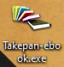

**Figure 2.** E-book Takepan Sasak Lombok

The following shows the cover of the Takepan Sasak Lombok e-book in 3D with features such as zoom out, zoom in, print, full screen, and others.

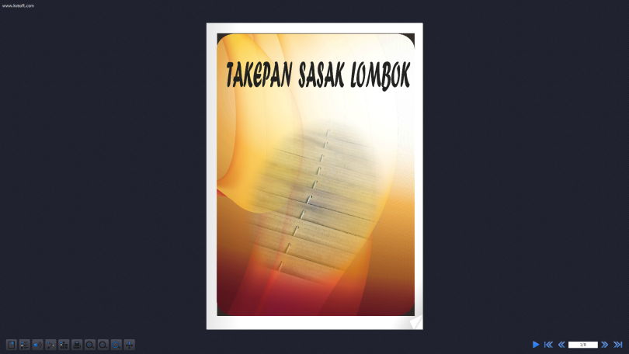

**Figure 4.** Cover e-book Takepan Sasak Lombok

One of the advantages of the e-book Takepan Sasak Lombok is that it makes it easy to access because there are navigation buttons such as the first page, previous, play, next, and others.

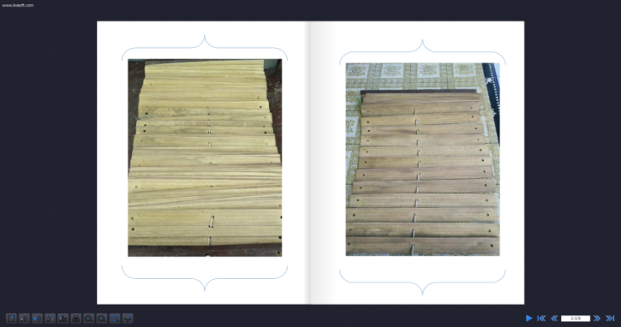

**Figure 5.** One of the contents pages of the e-book Takepan Sasak

1. **Conclusion**

The Takepan Sasak Lombok which is made from palm leaves is very easily damaged due to degradation over time so that it cannot be read. The flipbook is an alternative that can preserve local culture, especially Takepan Sasak because it can be accessed digitally and studied by the wider community.

1. **~~Suggestion~~**

~~It is hoped that future research can clarify the meaning and content of takepan so that people better understand the meaning contained in it.~~

Acknowledgment

**References**

[1] A. Rosidi, “Melihat Masa Lalu Orang Sasak,” 2008. [Online]. Available: http://terune-sasak.blogspot.com/2008/12/meliat-masa-lalu-orang-sasak.html.

[2] S. A. Hamid, “Translation of Manuscripts in Lombok : an Effort To Understand the Sasak ’ S Cultural Values,” *Mabasan*, vol. 7, no. 2, pp. 75–84, 2013.

[3] Y. Primadesi, “Peran Masyarakat Lokal dalam Usaha Pelestarian Naskah-Naskah Kuno Paseban,” *Komposisi J. Pendidik. Bahasa, Sastra, dan Seni*, vol. 11, no. 2, 2012, doi: 10.24036/komposisi.v11i2.88.

[4] M. Saiful, L. M. Samsu, and I. Fathurrahman, “Perancangan Kerangka Crowdsourcing Berbasis Wisdom Of Crowds Untuk Kamus Naskah Lontar (Takepan) Sasak Online,” *Infotek J. Inform. dan Teknol.*, vol. 3, no. 2, pp. 165–173, 2020, doi: 10.29408/jit.v3i2.2300.

[5] L. M. Samsu and I. Fathurrahman, “Adaptive Thresholding Algorithms and Morphological to Improve the Quality of Takepan Sasak Image Readability,” *J. Phys. Conf. Ser.*, vol. 1539, no. 1, 2020, doi: 10.1088/1742-6596/1539/1/012031.

[6] R. K. Abdul Ghofur, “PENGEMBANGAN e-BOOK BERBASIS FLASH KVisoft FlipBook PADA MATERI KINEMATIKA GERAK LURUS SEBAGAI SARANA BELAJAR SISWA SMA KELAS X,” *J. Inov. Pendidik. Fis.*, vol. Vol. 04, p. 2, 2015.

[7] D. Hardiansyah, “Pengembangan Media Flash Flipbook dalam Pembelajaran Perakitan Komputer untuk Meningkatkan Hasil Belajar Siswa Kelas X TKJ SMK Negeri 7 Surabaya,” *It-Edu*, vol. 1, no. 02, pp. 5–11, 2016.

[8] R. Diani, N. S. Hartati, and C. A. Email, “Flipbook berbasis literasi Islam: Pengembangan media pembelajaran fisika dengan 3D pageflip professional,” *Flip. Berbas. literasi Islam Pengemb. media pembelajaran Fis. dengan 3D pageflip Prof.*, vol. 4, no. 2, pp. 234–244, 2018, doi: 10.21831/jipi.v4i2.20819.

[9] S. Damarsasi, D. G., & Saptorini, “Pengembangan E-Modul Berbasis Flip Book Maker Materi,” *J. Pendidik. Ilmu Sos.*, vol. 27, pp. 1–10, 2018.

[10] M. Hidayatulloh, “Developing Electrical Circuits Flipbook Using Flipbuilder,” *Int. J. Innov. Educ. Res.*, vol. 7, no. 2, pp. 124–134, 2019, doi: 10.31686/ijier.vol7.iss2.1331.

[11] D. G. H. Divayana, P. W. A. Suyasa, I. P. W. Ariawan, I. W. E. Mahendra, and G. A. D. Sugiharni, “The Design of Digital Book Content for Assessment and Evaluation Courses by Adopting Superitem Concept Based on Kvisoft Flipbook Maker in era of Industry 4.0,” *J. Phys. Conf. Ser.*, vol. 1165, no. 1, pp. 0–6, 2019, doi: 10.1088/1742-6596/1165/1/012020.

[12] M. A. A, N. Suryani, and D. T. Ardianto, “Digital Flipbook Empowerment as A Development Means for History Learning Media,” *JPI (Jurnal Pendidik. Indones.*, vol. 8, no. 2, p. 266, 2020, doi: 10.23887/jpi-undiksha.v8i2.24122.

[13] Z. Zahidah, A. Noorhidawati, and A. N. Zainab, “Exploring the needs of Malay manuscript studies community for an e-learning platform,” *Malaysian J. Libr. Inf. Sci.*, vol. 16, no. 3, pp. 31–47, 2011.

[14] S. Bandi, M. Angadi, and J. Shivarama, “Best Practices in Digitisation: Planning and Workflow Processes,” *Emerg. Technol. Futur. Libr. Issues Challenges*, no. January, pp. 332–339, 2015.

[15] M. Burch and D. Weiskopf, “A flip-book of edge-splatted small multiples for visualizing dynamic graphs,” *ACM Int. Conf. Proceeding Ser.*, vol. 2014-August, no. August, pp. 29–38, 2014, doi: 10.1145/2636240.2636839.

[16] Barried, Siti Barorah, dkk.(1994).Pengantar Teori Filologi.Yogyakarta: BPPF Seksi Filologi Fakultas Sastra UGM