Dynamical analysis of diphtheria epidemic model with natural immunity rate on exposed individuals
Nailul Izzati¹, Anita Andriani²
¹Department of Electrical Engineering, Faculty of Engineering, Hasyim Asy’ari University, Tebuireng - Jombang, 61471 Indonesia.
²Department of Informatics Management, Faculty of Information Technology, Hasyim Asy’ari University, Tebuireng - Jombang, 61471 Indonesia.

nailulizzati@unhasy.ac.id
Abstract. Diphtheria disease remains endemic in some countries due to the lack of vaccination coverage. Particularly in the developing country such as Indonesia, where immunization and health care are something that need to be pursued and optimized. In the last three years, based on data from Indonesian Ministry of Health, there are still areas in Indonesia that its complete basic immunization coverage are less than 50%. Apart from being caused by low vaccination coverage, other factors as nutritional adequacy, environmental hygiene and virulence levels of the disease also influence the occurrence of diphtheria outbreaks. This study proposes a mathematical model that considering natural immunity rate of the exposed individuals in the spread of diphtheria. Stability analysis of the equilibrium point of the model is carried out so that the behavior of the system is known. Based on the analysis, it is known that the system has two equilibrium points, i.e disease-free equilibrium point and endemic equilibrium point. The stability analysis and numerical simulations show that both equilibrium points are conditionally stable. Disease-free equilibrium point is stable if $R_{0}<1$, whereas endemic equilibrium point is stable if $R_{0}>1$.
- Introduction
Diphtheria is one of the infectious diseases that still looms over Indonesia. During 2017-2019, there were 2870 diphtheria cases and 96 deaths reported [1] [2]. Diphtheria is a disease caused by bacteria Corynebacterium diphteriae. Diphtheria is characterized by inflammation at the site of infection, especially in the mucous membranes of the pharynx, larynx, tonsils, nose and skin. 94% of diphtheria cases attack the tonsils and pharynx, some of the symptoms are pain in the throat, when swallowing food and high fever. The death due to diphtheria occurs if the infected one does not get a proper treatment and has weak immunity. The mortality rate is about 5-10% for children less than 5 years, and 20% for adults. The cause of death is mostly due to airway obstruction, damage of the heart muscle, and abnormalities of the central nervous system and kidneys [3].
Regardless of the mortality rate of diphtheria, the disease could be prevented by carrying out complete and routine immunizations according to the child's age. Complete basic immunization is one of the programs of Indonesian government to provide diphtheria vaccine. However, the program still needs to be improved, as there were provinces where the complete basic immunization coverage is less than 50%, such as Papua (29,6%) [1] and Aceh (49,6%) [2]. Aside from having a complete basic immunization, the natural immunity level of an individual also plays important role in preventing diphtheria. A strong natural immunity could be obtained from adequate nutrition, healthy lifestyle, and good personal and environmental hygiene. The physical environment of the house, such as the type of floor and ventilation, also affects the spread of diphtheria [4].
Many studies discussed mathematical model of the spread of diphtheria, such as [5], [6], [7], [8], [9], [10]. Some of them consider the effect of vaccination program on the spread. Some studies also mentioned the important role of immunization coverage and natural immunity to prevent diphtheria. A study about regression model stated that the increase of percentage of diphtheria immunization coverage and the number of community health centers be able to decrease the number of diphtheria cases [7]. Here, we study the dynamics of a mathematical model SEIQR that considering natural immunity rate of the exposed individuals in the spread of diphtheria.
- Methods
This study is carried out by constructing a compartmental diagram and its mathematical expression. The dynamics of the model proposed then analyze by discovering the equilibrium points on its steady states. Stability analysis of the equilibrium points is figured out from the eigenvalues of the characteristic equation. Numerical simulations are executed by Maple and elaborated to illustrate the effect of parameter values on $R_{0}$ and the dynamics occur in the model. Numerical simulations also meant to verified the stability analysis.
- Results and Discussions
This section discusses the process of constructing a mathematical model that describes the spread of diphtheria with the influence of natural immunity rate on exposed individuals. The model is described as a schematic flow and mathematically expressed as an ordinary differential equations. Stability analysis, basic reproduction number and numerical simulations of the model are also discussed.

Proposed mathematical model
In the spread of diphtheria, let an area with a total population of $N$ is divided into five groups, i.e. susceptable, exposed, infected, quarantine, and recovered. Individuals who do not get vaccinated are included in the susceptable group ($S$), while those who get vaccinated are assumed to be immune and included in the recovered group ($R$). The existence of interaction rate of the susceptible and the infected allows the transmission of diphtheria disease. A susceptible individual who interacts with an infected individual is called an exposed individual ($E$). Exposed individuals who have strong natural immunity are likely not to be infected by diphtheria and are assumed to be included in the susceptable group. While the exposed individuals who have weak natural immunity could be infected by a certain period of time. The infected individual ($I$) will receive treatment and be quarantined. The infected individual in quarantine ($Q$) may recover or die due to diphtheria disease. We assume that individuals who recovered ($R$) cannot be infected by diphtheria anymore, or have become immune to diphtheria. This model also assumes that the population number is affected by natural mortality rate. Based on the assumptions built, we obtaine a compartment diagram presented in Figure 1. The model proposed is mathematically expressed by equations (1)-(5).

S

E

I

Q

R

$$\left(1-p\right)μN$$
$$pμN$$
$$\frac{αSI}{N}$$
$$βE$$
$$γI$$
$$εQ$$
$$δS$$
$$δE$$
$$δI$$
$$δQ$$
$$δR$$
$$ϕE$$
$$θI$$
Figure 1. Compartment diagram of diphtheria epidemic model with natural immunity rate on exposed individuals
$$\frac{dS}{dt}=\left(1-p\right)μN-\frac{αSI}{N}-δS+ϕE$$ | (1)
$$\frac{dE}{dt}=\frac{αSI}{N}-βE-ϕE-δE$$ | (2)
$$\frac{dI}{dt}=βE-γI-δI-θI$$ | (3)
$$\frac{dQ}{dt}=γI-εQ-δQ$$ | (4)
$$\frac{dR}{dt}=pμN+εQ-δR$$ | (5)
Parameters of the system are defined as follows: $p$ is proportion of vaccinated people within population, $μ$ is birth rate, $δ$ is natural mortality rate, $α$ is the rate of interaction of the susceptible and infected, $β$ is transmission rate, $ϕ$ is proportion of the number of exposed individuals with good natural immune, $γ$ is the handling or treatment rate (the rate of infected individuals get quarantined each time unit), $ε$ is recovery rate, $θ$ is mortality rate due to diphtheria. All variables and parameters are positive.

Steady state
Dynamics of the model, i.e. system (1)-(5), could be studied from the stability of its equilibrium points. The system has two steady states, disease-free equilibrium state $E_{0}=\left(\frac{\left(1-p\right)μN}{δ},0,0,0,\frac{pμN}{δ}\right)$ and endemic equilibrium state $E_{1}=\left(\hat{s},\hat{e},\hat{i},\hat{q},\hat{r}\right)$. State $E_{0}$ is always feasible because all the parameters are positive, whereas $E_{1}$ is conditionally feasible. State $E_{1}$ is lengthy algebraic expressions regarding system parameters. Thus, further analysis of state $E_{1}$ is carried out numerically.

Basic reproduction number
The value of $R_{0}$ indicates the transmission potential of a disease. To study the basic reproduction number $R_{0}$, we take the derivative of effected classes given in equation (2) and (3) of the model. Let $x=\left(E,I\right)$ and $\frac{dx}{dt}=F-V$, where $F=\left(\begin{aligned}\frac{αSI}{N} \\ 0\end{aligned}\right)$ and $V=\left(\begin{aligned}\left(β+ϕ+δ\right)E \\ -βE+\left(γ+δ+θ\right)I\end{aligned}\right)$. Then, we obtain $F=\left(\begin{matrix}0 & \frac{α\left(1-p\right)μ}{δ} \\ 0 & 0\end{matrix}\right)$ and $V=\left(\begin{matrix}β+ϕ+δ & 0 \\ -β & γ+δ+θ\end{matrix}\right)$, i.e. Jacobian of $F$ and $V$ at disease-free equilibrium ($E_{0}$), respectively. $F$ is the matrix of rates of secondary effected individuals, and $V$ is the matrix of transmission rates.
The value of $R_{0}$ is defined as the dominant eigen value of $FV^{-1}$, where
$FV^{-1}=\left(\begin{matrix}\frac{αβ\left(1-p\right)μ}{δ\left(β+ϕ+δ\right)\left(γ+δ+θ\right)} & \frac{α\left(1-p\right)μ}{δ\left(γ+δ+θ\right)} \\ 0 & 0\end{matrix}\right)$.
The eigen values of $FV^{-1}$ are $λ=0$ and $λ=\frac{αβ\left(1-p\right)μ}{δ\left(β+ϕ+δ\right)\left(γ+δ+θ\right)}$ therefore the basic reproduction number of the model is $R_{0}=\frac{αβ\left(1-p\right)μ}{δ\left(β+ϕ+δ\right)\left(γ+δ+θ\right)}$.

Local asymptotic stability
In this subsection, the local stability of disease-free and endemic equilibrium are discussed. Jacobian matrix of the system at disease-free state is given by matrix $J_{E_{0}}$.
$J_{E_{0}}=\left(\begin{matrix}-δ & ϕ & -\frac{α\left(1-p\right)μ}{δ} & 0 & 0 \\ 0 & -β-ϕ-δ & \frac{α\left(1-p\right)μ}{δ} & 0 & 0 \\ 0 & β & -γ-δ-θ & 0 & 0 \\ 0 & 0 & γ & -ε-δ & 0 \\ 0 & 0 & 0 & ε & -δ\end{matrix}\right)$.
Solving $\left|J_{E_{0}}-λI\right|=0$, led us to equation (6), which gives the eigen values of $J_{E_{0}}$.
$\left(δ+λ\right)\left(ε+δ+λ\right)\left(δ+λ\right)\left[-λ^{2}-λ\left(γ+2δ+θ+β+ϕ\right)-\left(β+ϕ+δ\right)\left(γ+δ+θ\right)+\frac{αβ\left(1-p\right)μ}{δ}\right]=0$. | (6)
From equation (6), we know that three of the eigen values are negative, i.e. $λ_{1,2}=-δ$, $λ_{3}=-ε-δ$, and the other two, $λ_{4}$ and $λ_{5}$, are defined by polynomial (7).
$$\frac{1}{\left(β+ϕ+δ\right)\left(γ+δ+θ\right)}λ^{2}+\frac{\left(γ+2δ+θ+β+ϕ\right)}{\left(β+ϕ+δ\right)\left(γ+δ+θ\right)}λ+1-R_{0}=0$$ | (7)
It is clear that $λ_{4}$ and $λ_{5}$ are negative if $1-R_{0}>0$. In other words, disease-free equilibrium $E_{0}$ is asymptotic stable if $R_{0}<1$ and unstable if $R_{0}>1$.
As mentioned in subsection 3.2, endemic equilibrium $E_{1}$ is not always feasible. $E_{1}$ is only feasible and stable under particular condition, i.e $R_{0}>1$. The existence of $E_{1}$ is shown by some scenarios discussed in subsection 3.5.

Numerical simulation
Here, numerical simulations of the system are presented. The initial condition of the simulations is 95% of the total population is susceptible and 5% remained is infected, i.e. $S(0)=0,95$, $E(0)=0$, $I(0)=0,05$, $Q(0)=0$, $R(0)=0$. Some of parameter values are taken from former researches (i.e. $α=0,57$ [5], $β=0,23$ [11], $ε=0,5$ [5]), or processed from various data sources (i.e. $μ=0,019$ and $δ=0,006$ [12], $θ=0,05$ [3]), and some are chosen hypothetically (See Table 1). Here, we elaborate some scenarios to describe the dynamics of the system.
 | Table 1. Values of the parameters and numerical simulation results.
Parameter |  | Scenario
 |  | A1 | A2 | B1 | B2 | C1 | C2 | D1 | D2 | E
$$γ$$ |  | 0 | 0,3 | 0,3 | 0,3 | 0,3 | 0,3 | 0,3 | 0,3 | 0.3
$$ϕ$$ |  | 0 | 0 | 0 | 0 | 0,3 | 0,3 | 0,9 | 0,9 | 1
$$p$$ |  | 0 | 0 | 0,3 | 0,9 | 0,3 | 0,9 | 0,3 | 0,9 | 1
$$R_{0}$$ |  | 31,413 | 4,941 | 3,459 | 0,494 | 1,523 | 0,218 | 0,719 | 0,103 | 0
Feasible steady states |  | $E_{0}$, $E_{1}$ | $E_{0}$, $E_{1}$ | $E_{0}$, $E_{1}$ | $$E_{0}$$ | $E_{0}$, $E_{1}$ | $$E_{0}$$ | $$E_{0}$$ | $$E_{0}$$ | $$E_{0}$$
Stable steady states |  | $$E_{1}$$ | $$E_{1}$$ | $$E_{1}$$ | $$E_{0}$$ | $$E_{1}$$ | $$E_{0}$$ | $$E_{0}$$ | $$E_{0}$$ | $$E_{0}$$
$$S_{f}$$ |  | 0,101 | 0,641 | 0,641 | 0,317 | 1,456 | 0,317 | 2,217 | 0,317 | 0
$$E_{f}$$ |  | 0,078 | 0,064 | 0,040 | 0 | 0,019 | 0 | 0 | 0 | 0
$$I_{f}$$ |  | 0,320 | 0,042 | 0,026 | 0 | 0,013 | 0 | 0 | 0 | 0
$$Q_{f}$$ |  | 0 | 0,025 | 0,015 | 0 | 0,007 | 0 | 0 | 0 | 0
$$R_{f}$$ |  | 0 | 2,050 | 2,229 | 2,850 | 1,568 | 2,850 | 0,950 | 2,850 | 3,167
Total population |  | 0,499 | 2,822 | 2,951 | 3,167 | 3,063 | 3,167 | 3,167 | 3,167 | 3,167
Table 1 shows the results of the scenarios considered in numerical simulations. Scenario A1-A2 illustrate the system in the absence of vaccination program and natural immunity rate of the exposed individuals. From scenario A1, it is known that if there are no prevention nor treatment against diphtheria outbreaks, in this case the complete basic immunization coverage and natural immunity rate are 0, and there is no quarantine for infected individuals, then over time the total population decreases by 50% with $R_{0}=31,413$. Whereas in scenario A2, even without natural immunity or vaccination, with the treatment in quarantine, the $R_{0}=4,941$ is lower than the A1 scenario. Scenarios B1-B2 show the role of immunization coverage in the absence of natural immunity rate. It shown that in scenario B2, with a higher immunization coverage, the $R_{0}$ is lower than scenario B1. The same goes in scenario C1-C2 and D1-D2, with a proportion of population who have strong natural immunity, the higher immunization coverage, the lower $R_{0}$. And scenario E shows the result if the coverage of basic immunization program and natural immunity rate were 100%. From Table 1, it is also known that the scenario with a higher natural immunity rate has a lower $R_{0}$. Scenarios with a higher $R_{0}$ have a higher number of exposed and infected individuals. Meanwhile, scenarios with lower $R_{0}$ tended to have a higher number of recovered individuals. The dynamics of the system for some scenarios are plotted in Figure 2.
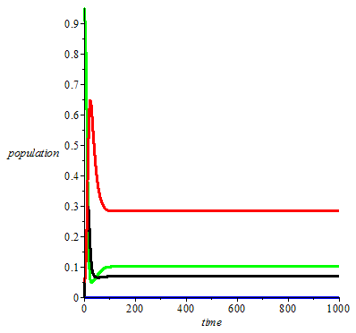  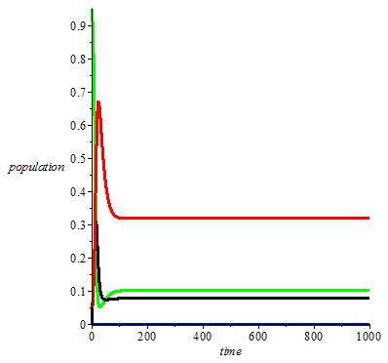  (a) | 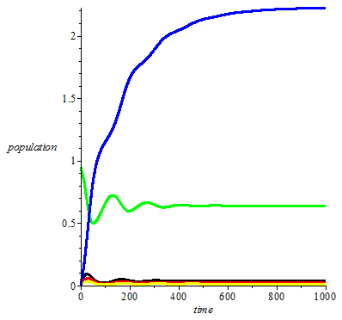  (b) | 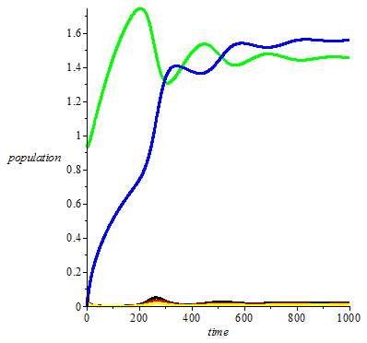  (c)
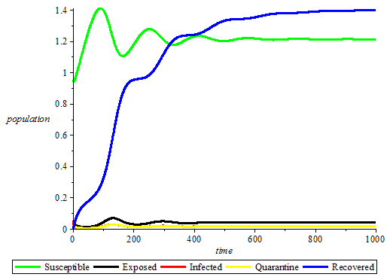
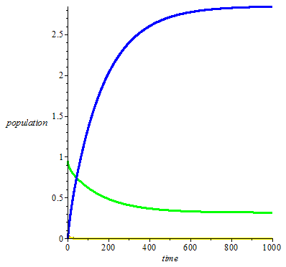  (d) | 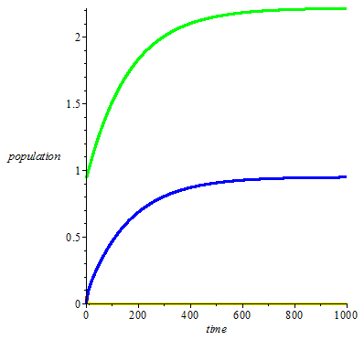  (e) | 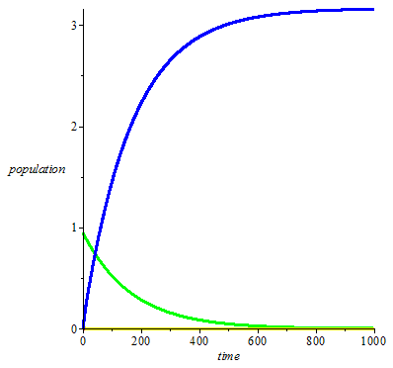  (f)
Figure 2. (a) Population densities with respect to number of days for $ϕ=p=0$, (b) $ϕ=0$, $p=0,3$, (c) $ϕ=0,3$, $p=0,3$, (d) $ϕ=0,3$, $p=0,9$, (e) $ϕ=0,9$, $p=0,3$, (f) $ϕ=p=1$.
The results obtained are in accordance with the concept of basic reproduction number, i.e if $R_{0}>1$, then each existing infection causes more than one new infection. The disease will be transmitted between people, and there may be an outbreak or epidemic. And if $R_{0}<1$, then each existing infection causes less than one new infection, and the disease will decline and eventually die out [13], [14].
- Conclusion
Based on the results and discussion, it is known that the higher the complete basic immunization coverage, the lower $R_{0}$. And the more people with strong natural immunity, the lower $R_{0}$. At the same time, an increase in these two factors causes the exposed, infected, and quarantine decrease, while the recovered increase. The system would be disease free if $R_{0}< 1$, and there might be an outbreak if $R_{0}>1$. The results shown that the complete basic immunization coverage and the natural immunity rate of the exposed population influence the dynamics of the model. This leads to bifurcation in the system. However, the existence of bifurcation is not discussed in this article.
- Acknowledgement
This study is supported and fully funded by Directorate of Research and Community Service, Ministry of Research and Technology of Republic of Indonesia. Authors would like to thank all colleagues for their contributions to this study, especially to LPPM Hasyim Asy’ari University and Rosydina Robi’aqolbi as Head of Al-Ishlah Health Clinic and staffs.
References
- D Budijanto et al 2019 Profil Kesehatan Indonesia 2018 (Jakarta: Ministry of Health of Republic Indonesia) pp 210, 136
- D Budijanto et al 2020 Data dan Informasi Profil Kesehatan Indonesia 2019 (Jakarta: Ministry of Health of Republic Indonesia) pp 155, 118
- N D Anggraeni et al 2017 Pedoman Pencegahan dan Pengendalian Difteri (Jakarta: Ministry of Health of Republic Indonesia) p 6
- J Prabowo and D U Iriani 2020 Journal of Religion and Public Health (JRPH) 1(1) 20-25
- G Puspita, M Kharis, and Supriyono 2017 UNNES J. Math. 6 25-35
- F Ilahi and A Widiana 2018 IOP Conf. Ser.: Mater. Sci. Eng. 434 012006
- M Ohyver and H Pudjihastuti 2018 Procedia Computer Science 135 643–647
- H S Husain 2019 J. Phys.: Conf. Ser. 1280 022051
- B Djaafara et al 2020 Transmission Dynamics and Control Strategies During the 2017 Diphtheria Outbreak in Jakarta, Indonesia: A Modelling Study https://ssrn.com/abstract=3516127 or http://dx.doi.org/10.2139/ssrn.3516127
- N Izzati et al 2020 J. Phys.: Conf. Ser. 1663 012042
- M I Fathoni, Mardlijah, and Hariyanto 2015 Pros. Sem. Nas. Mat. dan Pend. Mat. 2015 (Surabaya: Universitas Negeri Surabaya) pp 229-38
- Ministry of National Development Planning, Central Bureau of Statistics Indonesia and United Nations Population Find (UNPFPA) Indonesia 2013 Indonesia Population Projection 2010-2035 (Jakarta: BPS-Statistic Indonesia) pp 34, 84-468
- O Diekmann et al 1990 J. Math. Biol. 28 pp 365–382 https://doi.org/10.1007/BF00178324
- P L Delamater et al 2019 Emerging Infectious Diseases 25(1) https://doi.org/10.3201/eid2501.171901

