MDLC Model For Developing Multimedia E-Learning on Energy Concept For Primary School Students

Farida Nur Kumala1, Anik Ghufron2, Pratiwi Puji Astuti2, Mega Crismonika3, Muhammad Nur Hudha1

1Universitas Kanjuruhan Malang, Jl. S. Supriadi no. 48, Malang 65148, Indonesia

2 Universitas Negeri Yogyakarta, Jl. Colombo Yogyakarta No.1, Sleman 55281, Indonesia

3Jatiguwi 02 Elementary School, Malang Indonesia.

[anikghufron@uny.ac.id](mailto:anikghufron@uny.ac.id)

**Abstract**. This study aims to develop multimedia material at the elementary school level using the MDLC (Multimedia Development Life Cycle) model. Multimedia being developed are learning modules and videos. MDLC consists of methods consisting of concept, design, collection of materials, assembly, testing, and distribution. In developing multimedia using MDLC is based on a flowchart system and a learning video story board. The results showed that the multimedia developed was in accordance with the MDLC steps. Based on the results of alpha and beta tests, it shows that the e-learning multimedia developed is feasible and practical for use by elementary school students. Multimedia that is developed uses a variety of learning sources that can enrich student knowledge and more interactive.

1. Introduction

The emergence of the Covid-19 virus which has spread throughout the world has had an impact starting from an economic and educational perspective [1],[2],[3]. Affecting 1.5 billion children and young people due to school closures [4],[5], [6]. This has resulted in a sharp decline in the world of education, especially student interest in learning [7]. This is due to the learning system which is usually carried out face- Based on this, the latest technology is needed to support online or online learning [8],[9],[10] which is attractive and in accordance with the conditions of students [11],[12]. According to [13] E-Learning requires students to sit, study at a computer and be connected to the internet; utilize various digital technologies in learning activities [14]. using media that take advantage of the internet [15]; and E-Learning can also connect educators and students in online learning spaces [16].

Based on this, it is necessary to develop E-Learning multimedia that is able to develop student interest in learning. Multimedia is currently mostly in the field of education such as visualization, simulation and other interactive learning[17][18]. Multimedia has several benefits, namely increasing student learning activities [19]; student learning performance [20]; learning process [21]; makes learning not monotonous [22].

Multimedia In this study, it was developed using the MDLC method. MDLC is often used to develop multimedia [23], [24], [25]. The MDLC model has stages that are quite easy to understand and use to develop multimedia such as alphabet and number development applications [26], interactive learning media [27]; Educational games [28][29]. There is no multimedia development for elementary school students, for example learning tools (videos and e-modules) using the MDLC model. The purpose of this research is to develop multimedia (interactive emodules and videos) on energy concepts in elementary schools. The development of multimedia on the concept of energy is based on students' difficulties to understanding the abstract concepts.

1. Method

This study uses the MDLC (Multimedia Development Life Cycle) method which consists of concept, design, material collecting, assembly, testing, and distribution. The research steps are shown in the following Figure 1.

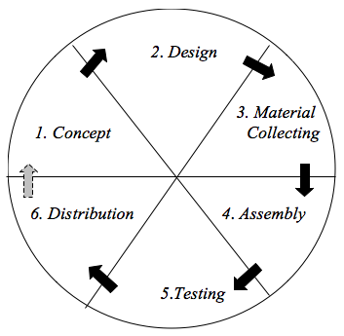

**Figure 1**. Step of MDLC

1. Concept

At this stage, the objectives, subjects and multimedia concepts are determined. The intended subjects are elementary school students. The purpose of multimedia development is that students are able to study material, take quizzes and observe complete and interesting learning videos that will be assembled in a moodle-based LMS.

2. Design

At this stage, the design is carried out regarding the development of making specifications regarding the design of the developed program, the appearance of the media developed in accordance with previously developed concepts. This stage develops the storyboard and flow chart.

3. Material Collecting

The stages of collecting materials used for multimedia development. Materials - The materials used are images, illustrations, materials in the e-module, video, animation and audio.

4. Assembly

This is the stage of making and assembling the materials that have been developed based on story boards and flowcharts. The development of learning videos and Adobe Primary Pro 2019, while the e-module uses the Kvisoft Flipbook Maker and adobe flash.

5. Testing

The testing phase is used to see the ability, ease of learning media used. This stage has two steps, namely alpha testing and beta testing. Alpha testing consists of testing the application features, and testing markers. Feature testing takes the form of testing buttons and displays. Beta testing is measured using a questionnaire to measure visitor interest in the delivery of information. In addition, the increase in validity at the testing stage is carried out by testing from researchers and research subjects who are experts (material, multimedia and language experts) and users (teachers and students).

6. Distribution

This stage is the stage of media storage. Multimedia storage is planned to be developed on a moodle-based LMS.

1. Results

Based on the objectives developed and the characteristics of the research subject. Then the design is carried out by developing a flowchart e module, a learning video story board. Flowchart and story board are shown in Figure 1.

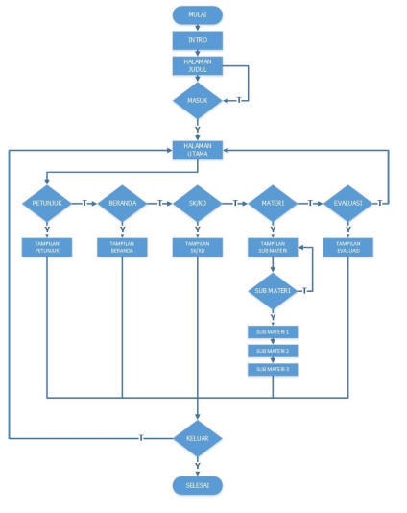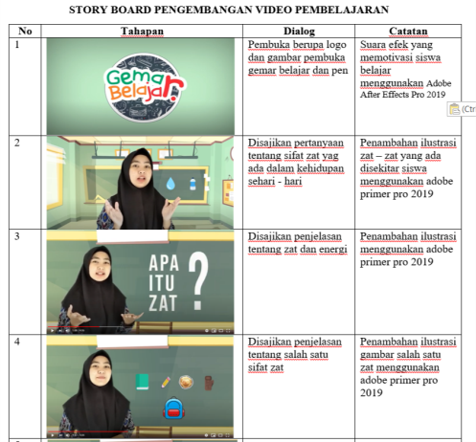

**Figure 2**. Flowchart of e-module development and video storyboard

Then an assembly is carried out to develop e modules and videos by combining the materials that have been collected. The e-module is equipped with videos, animations about energy and several buttons to direct the learning links to other learning resources such as children's articles. In the video combined with sound, animation in the form of illustrations of substances / objects. The development process is shown in Figure 3.

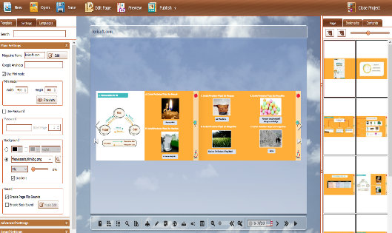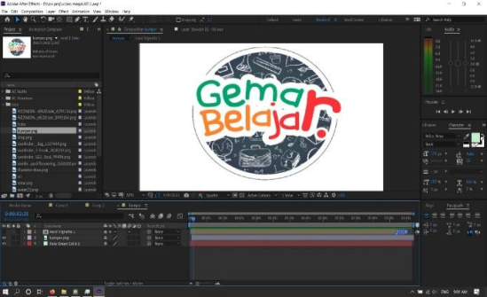

**Figure 3**. Development of learning video using Kvisoft Flipbook Maker and e module use Adobe Primer Pro 2019

The results of the development are tested by running the multimedia that has been developed. Performed after completing the assembly stage by running the application. This stage has two steps, namely alpha testing and beta testing. The results of alpha testing are stated that all buttons on the e module can be used properly and can be accessed easily. Beta testing is carried out by testing the attractiveness, practicality and accuracy of the media being developed. The test results are shown in

**Table 2.** The result of Beta testing

|  |  |  |  |
| --- | --- | --- | --- |
| No | Aspect | Percentage | Criteria |
| 1 | Material expert | 90% | Very Good |
| 2 | Media expert | 93,8% | Good |
| 3  4  5  6 | Linguist expert  Teacher  Student  Effectiveness | 80,53%  93,96%  92,7%  94% | Very Good  Very Good  Very Good  Very Good |

Based on table 2. It can be seen that the media developed has been valid by users and experts. Then proceed with the distribution stage. This stage is used to store multimedia that has been developed. In this study, multimedia that has been developed is include into the Moodle-based LMS (Figure 4).

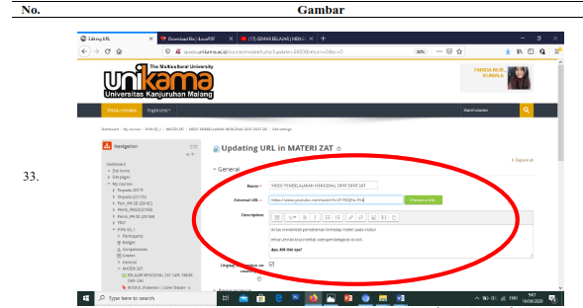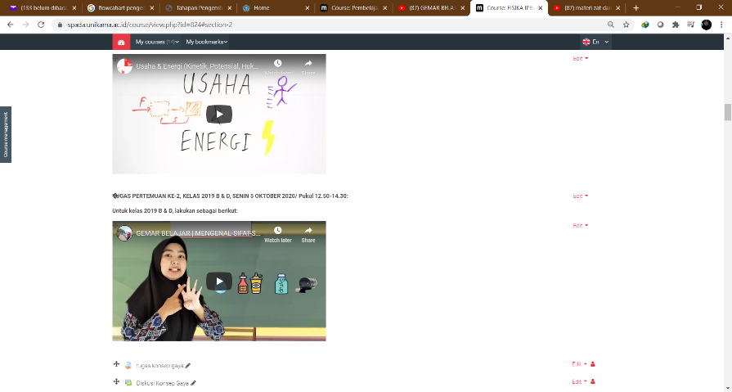

**Figure 4**. multimedia include in moodle based LMS

1. Discussion

The multimedia e-learning developed is based on setting goals according to the MDLC steps. Multimedia developed in this study are videos and interactive e-modules that can be used by students in online learning / e-learning. The materials contained in the multimedia e module contain videos, images, photos and links to the related material being studied. The results of multimedia development according to experts, teachers and students are declared valid and attractive to students. This is because multimedia displays pictures, illustrations and videos that are attractive to students in learning. Interesting learning can motivate [30] and give meaning to student learning [31][32]. In addition, the images can make the concept not abstract [33] for student, more deeply with the addition of related links. This makes it easier for students to activate various learning resources [34]. Multimedia can improve learning outcomes [35]; improve student learning process [36]; stimulate student learning activities [37]; student learning performance [38].

1. Conclusion

Multimedia development using the MDLC model consists of concept, design, material collecting, assembly, testing, and distribution. Based on the test results it is known that the developed multimedia is feasible. Multimedia that has been developed is used in e-learning learning using the Moodle platform which is expected to increase student interest in learning. Students' interest in learning can be increased through interactive and contextual media.

**Acknowledgement**

A deep grateful is addressed to Universitas Kanjuruhan Malang for their full supports in accomplishing this study.

References

[1] E. Dewa, M. Ursula, J. Mukin, and O. Pandango, “Pengaruh Pembelajaran Daring Berbantuan Laboratorium Virtual Terhadap Minat dan Hasil Belajar Kognitif Fisika,” vol. 3, no. 2, pp. 6–7, 2020.

[2] J. Anderson, *Should School Close when Coronavirus Cases are Still Rare? Quartz*. 2020.

[3] T. Azzi-Huck & Shims, *Maning the Impact of COVID-19 on Education System around the World*. 2020.

[4] UNESCO, “Education: Form Distruption to recovery, Scool Clusures Caused by Coronavirus (Covid-19),” 2020. .

[5] M. W. J. Couzin-Frangkel, G. Vogel, *Not open and shut. School openings across the globe suggest ways to keep the coronavirus at bay, despite outbreaks*. 2020.

[6] A. & S. Arora, “Impact of Pandemic COVID-19 on the Teaching-Learning Process: A study of Hhigher Education Teachers. Prabadhan: Indian Journal of Management 13(4),” 2020.

[7] I. Jamil, S.H., & Apriliasanda, “Pengaruh Pmebelajran Daring Terhadap Minat Belajar Mahasiswa Paa Masa Pandemi Covid-19,” *Behav. Account. J. 3(1).*, 2020.

[8] S. Aulia, “Pembelajaran Daring pada Masa Pandemi.,” 2020. https://www.suara.com/yoursay/2020/11/0175556/pembelajaran-daring-pada-masa-pandemi.

[9] R. Aderholt, *CoronaVirus Outbreak Shiningan Even Brighter Light on nternet disparities in Rural America. The Hill.* 2020.

[10] Karp & McGowan, “‘Clear as mud’ Schools ask for online learning help as coronavirus polivy confusion persists Australia news,” *The Guardian*, 2020.

[11] N. Collie, R., Shapka, J., & Perry, *Prediting Teacher Commitment: The Impact of SchoolClimate and Social-Emonational Learning. Psychologycal in the School, 48(10)*. 2011.

[12] M. Najeemah, “School Climate and Teachers’ Commitment: A case study of Malaysia.,” *Int. J. Econ. Bus. Manag. 1(2)*, pp. 65–75, 2012.

[13] &Wardono Dewi, K., “Peningkatan Literasi Matematika mahasiswa Melalui Pembelajaran Inovasi Realistik E-Learning Edmodo Bermuatan Krakter Cerdas Kreativ Mandiri,” *. J. Mat. Kreat. 6(1)*, pp. 93–100, 2015.

[14] D. Lase, “Education in the Fourth Industrial Revolustion Age,” *Jctes*, vol. 1, no. 1, pp. 28–43, 2019.

[15] S. Wardono, Waluya., Mariani, S., & Candra, “Mathematics Literacy on Problem Based Learning with Indonesian Realistic Matematics Edukation Approach Assited E-Learning Edmodo,” *Jounal Phys. Conf. Ser.*, p. 639, 2016.

[16] D. Fitriana, “Peran Media E-Learning dalam Pembelajaran Untuk Mengoptimalkan Kemampuan Literasi Matematika dan Norma Sosiomatematik.,” *Pros. Semin. Nas.*, pp. 58–62, 2020.

[17] M. S. S. B. G. Dan, B. Curless, D. Salesin, “Schematic Storyboarding for Video Visualization and Editing.,” *J. ACM Trans. Graph.*, vol. 25, no. 3, pp. 862–871, 2006.

[18] J. M. S. A. F. Barbara, “A Model for Developing Multimedia Learning Projects (MERLOT),” *J. Online Learn. Teach.*, vol. 6, no. 2, pp. 491–507, 2010.

[19] C. Wang, T. Fang, and Y. Gu, “Learning performance and behavioral patterns of online collaborative learning: Impact of cognitive load and affordances of different multimedia,” *Comput. Educ.*, vol. 143, no. 5, p. 103683, 2020, doi: 10.1016/j.compedu.2019.103683.

[20] D. A. Patterson, “Impact of a multimedia laboratory manual: Investigating the influence of student learning styles on laboratory preparation and performance over one semester,” *Educ. Chem. Eng.*, vol. 6, no. 1, pp. e10–e30, 2011, doi: 10.1016/j.ece.2010.10.001.

[21] S. D. Holubar, J. P. Hassinger, E. J. Dozois, B. G. Wolff, M. Kehoe, and R. R. Cima, “Impact of a Multimedia e-Learning Module on Colon Cancer Literacy: A Community-Based Pilot Study,” *J. Surg. Res.*, vol. 156, no. 2, pp. 305–311, 2009, doi: 10.1016/j.jss.2009.03.099.

[22] C. Adamczyk, M. Holzer, and R. Putz, “Student learning preferences and the impact of a multimedia learning tool in the dissection course at the University of Munich,” *Ann. Anat.*, vol. 191, no. 4, pp. 339–348, 2009, doi: 10.1016/j.aanat.2009.03.003.

[23] S. Aleem, L. F. Capretz, and F. Ahmed, “Game development software engineering process life cycle: a systematic review,” *J. Softw. Eng. Res. Dev.*, vol. 4, no. 1, 2016, doi: 10.1186/s40411-016-0032-7.

[24] R. Ramadan and Y. Widyani, “Game development life cycle guidelines,” *2013 Int. Conf. Adv. Comput. Sci. Inf. Syst. ICACSIS 2013*, pp. 95–100, 2013, doi: 10.1109/ICACSIS.2013.6761558.

[25] M. O. Al-Jabari, T. K. Tamimi, and A.-A. N. Ramadan, “Multimedia Software Engineering Methodology: A Systematic Discipline for Developing Integrated Multimedia and Software Products,” *Softw. Eng.*, vol. 8, no. 1, pp. 1–10, 2019, doi: 10.5923/j.se.20190801.01.

[26] H. Sugiarto, “Penerapan Multimedia Development Life Cycle Pada Aplikasi Pengenalan Abjad Dan Angka,” *IJCIT (Indonesian J. Comput. Inf. Technol.*, vol. Vol.3 No.1, no. 1, pp. 26–31, 2018.

[27] M. Mustika, E. P. A. Sugara, and M. Pratiwi, “Pengembangan Media Pembelajaran Interaktif dengan Menggunakan Metode Multimedia Development Life Cycle,” *J. Online Inform.*, vol. 2, no. 2, p. 121, 2018, doi: 10.15575/join.v2i2.139.

[28] R. I. Borman and Y. Purwanto, “Impelementasi Multimedia Development Life Cycle pada Pengembangan Game Edukasi Pengenalan Bahaya Sampah pada Anak,” *J. Edukasi dan Penelit. Inform.*, vol. 5, no. 2, p. 119, 2019, doi: 10.26418/jp.v5i2.25997.

[29] S. L. Rahayu, Fujiati, and R. Dewi, “Educational Games as A learning media of Character Education by Using Multimedia Development Life Cycle (MDLC),” *2018 6th Int. Conf. Cyber IT Serv. Manag. CITSM 2018*, no. Citsm, pp. 7–10, 2019, doi: 10.1109/CITSM.2018.8674288.

[30] Sudrajat A, *Media Pembelajaran.* surakarta: pustaka belajar, 2008.

[31] F. N. Setiawan, D. A. Shaleha, and P. Ridlatus, “Contextual-Based Animal Encyclopedia : HOTS on Elementary School ’ s Student s,” vol. 417, no. Icesre 2019, pp. 132–137, 2020.

[32] F. Kumala and D. Setiawan, “Local wisdom-based e-encyclopedia as a science learning medium in elementary school,” in *4th Annual Applied Science and Engineering Conference*, 2019, pp. 1 – 7, doi: 10.1088/1742-6596/1402/6/066061.

[33] C. Sundaygara, H. Y. Pratiwi, and M. N. Hudha, “Pengembangan bahan ajar media pembelajaran fisika dengan pendekatan multi representasi untuk meningkatkan kemampuan pembuatan alat-alat praktikum calon guru fisika,” *Momentum Phys. Educ. J.*, vol. 2, no. 2, pp. 86–93, 2019, doi: 10.21067/mpej.v2i2.2709.

[34] J. A. Pereira, E. Pleguezuelos, A. Merí, A. Molina-Ros, M. C. Molina-Tomás, and C. Masdeu, “Effectiveness of using blended learning strategies for teaching and learning human anatomy,” *Med. Educ.*, vol. 41, no. 2, pp. 189–195, 2007, doi: 10.1111/j.1365-2929.2006.02672.x.

[35] S. Aloraini, “The impact of using multimedia on students ’ academic achievement in the College of Education at King Saud University,” *J. King Saud Univ. - Lang. Transl.*, vol. 24, no. 2, pp. 75–82, 2012, doi: 10.1016/j.jksult.2012.05.002.

[36] N. Barzegar, S. Farjad, and N. Hosseini, “The Effect of Teaching Model Based on Multimedia and Network on the Student Learning (Case Study:Guidance Schools in Iran),” *Procedia - Soc. Behav. Sci.*, vol. 47, pp. 1263–1267, 2012, doi: 10.1016/j.sbspro.2012.06.809.

[37] F. Zhang, “Significances of Multimedia Technologies Training,” *Phys. Procedia*, vol. 33, pp. 2005–2010, 2012, doi: 10.1016/j.phpro.2012.05.315.

[38] H. Kassim, H. Nicholas, and W. Ng, “Using a multimedia learning tool to improve creative performance,” *Think. Ski. Creat.*, vol. 13, pp. 9–19, 2014, doi: 10.1016/j.tsc.2014.02.004.