Increasing Maintenance Service Time Efficiency using Production and Operations Management (POM-QM)
Ellysa Nursanti¹, Indrawaty Y. Marit¹, Sibut², Diva O. Shafitri³
¹Industrial Engineering, National Institut of Technology ITN Malang, Indonesia
²Mechanical Engineering, National Institut of Technology ITN Malang, Indonesia
³Industrial Engineering, State University of Malang, Indonesia

ellysa.nursanti@lecturer.itn.ac.id
Abstract. A number of studies have shown that lack of service server capacity may cause queuing problem. In fact, there are other factors cause queues, i.e. the speed of mechanical work. The low speed of mechanical work decreases customer loyalty level. This study aims to accelerate maintenance service time. Maintenance scheduling has done by calculating the dependency logic of each maintenance activity. In Critical Path Method (CPM), scheduling has done by determining the list of activities and duration of each, identifying previous activities, determining the sequence of activities and describing them in network form, entering each data into the Production and Operations Management (POM-QM) program, then identifying whether the activity is on a critical path or not. Maintenance activities in this research are classified into 3 i.e. 1) Carburettor and CVT light service packages, 2) injection and CVT light service packages, and 3) Oil and spare parts replacement. After processing the data, a comparison was made between before and after improvement. The result shows that CPM speed up maintenance service times. The acceleration efficiency of carburettor and CVT light service packages is 49.23%, injection and CVT light service packages are 49.23 %, and oil spare parts replacement are 13.63 %.
- Introduction
The Indonesian Central Bureau of Statistics stated that the number of motorbiker increases every year. Motorbikes require routine maintenance so that they can avoid damage on their components[1]. When failure/damage happened, then it must be repaired or replaced. This requires more costs[2–4]. The increasing number of motorbike needs more in maintenance time has to be provided, which means queues due to limitations of service station. Service station has issued booking service policy and using a queue card[5], which done in FIFO (First in First out). However, this solution seems not quite effective yet. This is risk[6]. A queue delivered a huge negative impact on customer satisfaction which may cause customer lost[7]. Scheduling will help mechanics to do their jobs faster[8]. An activity will be successful if it is accompanied by a good network analysis[9,10]. There are some methods in maintenance scheduling using network analysis, i.e. PDM, PERT, CPM, which each may result in different performance[4,11]. The Precedence Diagram Method (PDM) is a network which arrows are only to show the activities concerned[12]. Program Evaluation and Review Technique (PERT) is a method that can identify priority activities[3,11]. The Critical Path Method (CPM) is a method similar to PERT, but has differences in estimating the time needed to complete the project so that activities might be completed according to the plan [13–17].
In authorized service station, maintenance of motorcycle has been classified to many service packages. Some of them are 1) Carburettor and CVT light service package, 2) injection and CVT light service package, and 3) Oil and spare parts replacement. Service station provided some working station and their mechanics. Even though the services are classified, but working station and mechanics are not. Mechanics and working stations are available for all service packages. In doing their jobs, they have their own to do lists for each service package[5,18].
Based on observation and concerning the customers queue, this research proposed to accelerate those maintenance service time so that it may reduce the queue number of customer and impact in customer satisfaction and loyalty.
- Research Stages
Maintenance scheduling in this research conducted using CPM network analysis. Production and Operation Management (POM-QM) used as Quantitative Method to give a hand in doing CPM network analysis. Starting with service package classification, i.e. Carburetor and CVT light service package, Injection and CVT light service package, and also Oil and spare parts replacement. Each package has a list of maintenance activities, their duration, and their dependency relation. In this stage, observation and analysis needed to modify and restructure any possibilities to accelerate maintenance service time. Each alternative processed in POM-QM Program, using CPM working structure. Processing steps using POM-QM Program are as follow. In the project module, select single time estimate, then input number of tasks. Input in accordance with existing data then solve. Time service before and after modifying the precedence, sequence of activities has compared to calculate the time efficiency.

Carburettor and CVT Light Service Package
List of activities for carburetor and CVT light service package before scheduling (Table 1). Activities are rearranged in dependency logical order. Dependency logic is obtained from interviews and direct observations on field. The total duration required for the carburretor and CVT light service package prior to scheduling was 65 minutes. There was a queue of carburetor and CVT light service packages because so far the workshop has only been assigned by scheduling based on experience.

Injection and CVT Light Service Package
Description of activities, their relation and duration of Inspection and CVT Light Service Package can be seen in Table 2. Activity components are also assigned in dependency logical order. Dependency logic is obtained from interviews and observation as well. It takes 65 minutes to complete the service package. There was also a queue of injection and CVT light service packages due to experience scheduling based.

Table 1. Carburettor and CVT Light Service Package  Activity Code Activity Activity Duration (Minute) Predecessor  1 Light check 0,5  2 Horn check 0,5  3 Remove the cover body 7  4 Engine oil check 1 3  5 Oil filter check 1 3  6 Spark plug check 0,2 3  7 Spark plug adjustment 0,8 6  8 Carburetor cleaning 7,5 3  9 Carburetor adjustment 2,5 8  10 Fuel filter cleaning 0,8 3  11 Fuel filter replacement 0,3 3  12 Air filter cleaning 0,8 3  13 Air filter replacement 0,3 3  14 Check valve 0,8 3  15 Valve adjustment 4,2 14  16 Clutch check 0,3 3  17 Coupling adjustment 1,7 16  18 Brake check 0,1  19 Brake adjustment 0,9  20 Light switch adjustment 1  21 Battery check 2  22 Check tire pressure 0,1 3  23 Increase in tire pressure 1,9 22  24 Shock breaker check 1 3  25 Check of steering handlebar 0,1 3  26 Steering handlebar adjustment 0,9 25  27 Check wheel bearings 1 3  28 CVT examination 15 3  29 Cover installation 10 9,11,13,15,17,28  30 Nuts and Bolts Check 0,2 29  31 Nuts and Bolts Tightening 0,8 30  Total 65 | Table 2. Injection and CVT light  Service Packages  Activity Code Activity Activity Duration (Minute) Predecessor  1 Lamp Check 0,5  2 Horn Check 0,5  3 Body Cover Removal 7  4 Engine Oil Check 1 3  5 Oil Filter Check 1 3  6 Spark Plug Examination 0,1 3  7 Spark Plug Setup 0,9 6  8 Injector Cleaner 10 3  9 Fuel Filter Cleaning 0,8 3  10 Fuel Filter Replacement 0,2 9  11 Air Filter Cleaning 0,8 3  12 Air Filter Replacement 0,2 11  13 Check Valve 0,8 3  14 Valve Adjustment 4,2 13  15 Clutch Check 0,3 3  16 Coupling Adjustment 1,7 15  17 Brake Check 0,1  18 Brake Adjustment 0,9 17  19 Brake Light Switch Setting 1  20 Battery Check 2 3  21 Tire Pressure Check 0,3  22 Increase Tire Pressure 1,7 21  23 Shock Beaker Check 1 3  24 Steering Handlebar Check 0,1  25 Steering Handlebar Adjustment 0,9 24  26 Wheel Bearing Check 1 3  27 CVT examination 15 3  28 Cover installation 10 10,12,14,16,20,23,27  29 Nuts and Bolts Check 0,1 28  30 Nuts and Bolts Tightening 0,9 29  Total 65

Oil and spare part replacement
Description of maintenance activities for oil and sparepart replacement before scheduling can be seen in Table 3. It takes 65 minutes to accomplish the project.

Table 3. Oil and Sparepart Replacement
Activity Code | Activity | Activity Duration (Minute) | Predecessor
1 | Lamp Check | 0,5
2 | Horn Check | 0,5
3 | Body Cover Removal | 7
4 | Engine Oil Check | 1 | 3
5 | Oil Filter Check | 1 | 4
6 | Spare Parts Replacement | 0,5 | 3
7 | Cover installation | 0,5 | 5
Total |  | 11

- Result
  - Carburetor and CVT Light Service Package
The time taken on a Carburetor and CVT Light Service Package, which initially took 65 minutes to 33 minutes. Acceleration duration for injection and CVT light service packages is 32 minutes. Critical path for carburetor and cvt service package can be seen in Figure 1.

Injection and CVT Light Service Package
Critical path for Injection and CVT Service Package can be seen in Figure 2, which initially took 65 minutes to 33 minutes. Acceleration duration for injection and CVT light service packages is 32 minutes.

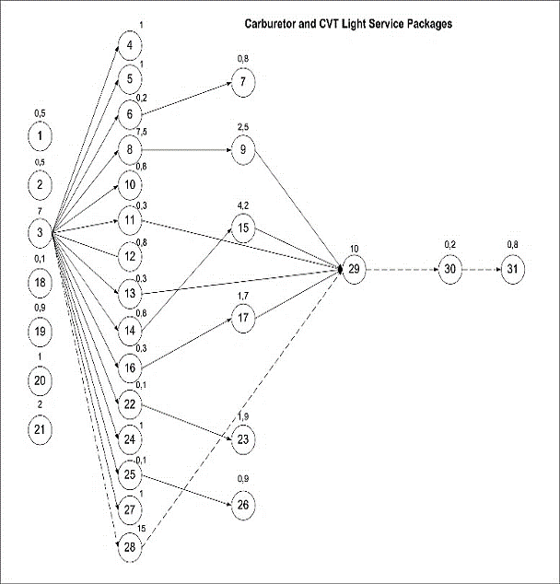 | 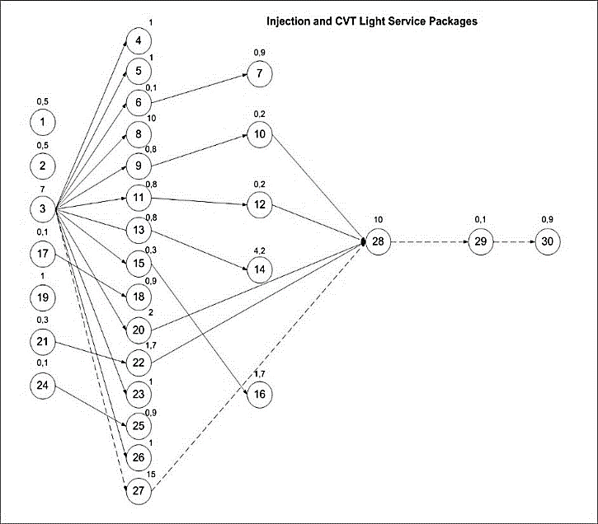
Figure 1. The Critical Path of Carburetor and CVT Light Service Package | Figure 2. The Critical Path of Injection and CVT Light Service Package

Oil and sparepart replacement service packages
Critical path for Oil and Sparepart Replacement can be seen in Figure 3. The total duration if lightweight carburetor and CVT package after scheduling is 9,5 minutes, from previous condition 11 minutes.

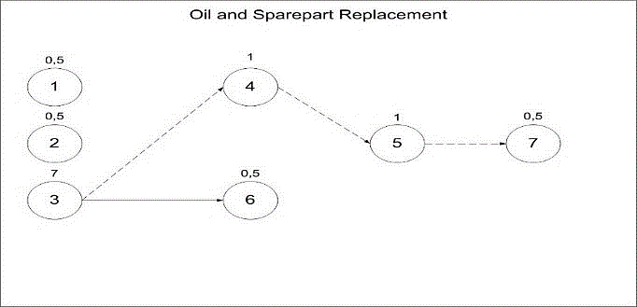
Figure 3. The Critical Path of Oil and Sparepart Replacement

Both critical and non critical activities can be carried out simultaneously which can speed up maintenance service time. Comparison of two conditions, before and after the proposed improvement in scheduling for each service packages, can be seen in Table 4 and Figure 4 as follow.

Table 4. Comparison before and after improvement
Type of service package | Before improvement (minute) | After Improvement (minute)
Carburetor and CVT light service package | 65 | 33
Injection and CVT light service package | 65 | 33
Oil and spare parts replacement | 11 | 9,5

Figure 4. Time Comparison Before and After Improvement

Therefore, this new maintenance schedule using CPM POM-QM delivered result of time efficiency as follow. 49,23% for Carburetor and CVT Light Service Packages, 49,23 for Injection and CVT Light Service Packages, and 13,63% for Oil and Spare Parts Replacement.
- Conclusion
Maintenance scheduling using the critical path method POM-QM results in an acceleration in duration, by simultaneously carrying out activities both are on the critical and non-critical paths. Carburetor and CVT Light Service Packages get 32 minutes of acceleration results with an efficiency of 49.23%, Injection and CVT Light Service Packages get 32 minutes of acceleration results with an efficiency of 49.23%, and Oil and Spare Parts Changes get acceleration results for 1.5 minutes with an efficiency of 13.63%. For further research, this could be developed by concerning all maintenance service packages and simulation of specialization of mechanics and their working station and get the new higher efficiency behavior.
- References
[1] Jorge M. Simões, Gomes C F and Mahmoud M. Yasin 2011 A literature review of maintenance performance measurement: A conceptual framework and directions for future research J. Qual. Maint. Eng. 17 116–37
[2] Nursanti E, Ma’ruf A, Simatupang T and Iskandar B P 2012 Cost and availability functions using imperfect maintenance policy for a serial system ISBEIA 2012 - IEEE Symp. Business, Eng. Ind. Appl. 386–91
[3] Lermen F H, Morais M de F, Matos C, Röder R and Röder C 2016 Optimization of Times and Costs of Project of Horizontal Laminator Production Using Pert/Cpm Technical Indep. J. Manag. Prod. 7 833–53
[4] He Y, Gu C, Chen Z and Han X 2017 Integrated predictive maintenance strategy for manufacturing systems by combining quality control and mission reliability analysis Int. J. Prod. Res. 55 5841–62
[5] Mahendra W D, Sukarsa I M and Cahyawan A K A 2020 The “Reminder” and “Online Booking” Features in the Android-Based Motorcycle Repair Shop Marketplace Int. J. Comput. Appl. Technol. Res. 9 047–52
[6] Nursanti E, Sibut, Hutabarat J and Septiawan A 2018 Risk management in subsea pipelines construction project using Delphi method, FMECA, and continuous improvement ARPN J. Eng. Appl. Sci. 13 3834–8
[7] Handoko F, Nursanti E, Gatot G, Edwin Tjahjadi M, Hutabarat J, Mulyadi L and Kustamar K 2018 Green Industrial System in Indonesia MATEC Web Conf. 164 1–7
[8] Handoko F, Nursanti E, Harmanto D and Sutriono 2016 The role of tacit and codified knowledge within technology transfer program on technology adaptation ARPN J. Eng. Appl. Sci. 11 5275–82
[9] Vyas R S and Mechanical 2013 Scheduling Project Management Using Crashing CPM Network to get Project completed on Time Int. J. Eng. Res. Technol. 2 1–13
[10] Marmier F, Varnier C and Zerhouni N 2009 Proactive, dynamic and multi-criteria scheduling of maintenance activities Int. J. Prod. Res. 47 2185–201
[11] Maulana A and Kurniawan F 2019 Time Optimization Using Cpm, Pert and Pdm Methods in the Social and Department of Kelautan Building Development Project Gresik District IJTI (International J. Transp. Infrastructure) 2 57–66
[12] Glenwright Jr. E T 2004 Let’s Scrap the Precedence Diagramming Method. AACE Int. Trans. 1
[13] Marit I Y, Nursanti E and Vitasari P 2020 Critical path method to accelerate automotive maintenance duration Int. J. Sci. Technol. Res. 9 6777–82
[14] Marit I Y, Nursanti E and Vitasari P 2020 Analysis of time acceleration using Critical Path Method (CPM) to increase motorcycle maintenance in authorized service station IOP Conf. Ser. Mater. Sci. Eng. 885
[15] Bishnoi N 2018 Critical Path Method ( CPM ): A Coordinating Tool Int. Res. J. Manag. Sci. Technol. 9 459–67
[16] Aliyu A 2013 Project Management using Critical Path Method (CPM): A Pragmatic Study Glob. J. Pure Appl. Sci. 18
[17] Adibhesami M A, Ekhlassi A, Mohebifar A and Mosadeghrad A M 2019 Improving time-cost balance in critical path method (CPM) using Dragonfly Algorithm(DA) Int. J. Ind. Eng. Prod. Res. 30
[18] Pinna D C, Ahluwalia R S, Carvalho A N and Senna P 2015 Supply chain scheduling: A motorcycle assembly case study IFAC-PapersOnLine 28 1527–32

