A Robust Method of Rectifying a Tilted Image to Truly Vertical
M E Tjahjadi¹ and F Handoko²
¹ Departement of Geodesy, National Institute of Technology (ITN) Malang
² Departement of Industrial Engineering, National Institute of Technology (ITN) Malang

¹ edwin@lecturer.itn.ac.id
Abstract. Unmanned Aerial Vehicle (UAV) is burgeoning technology for conducting aerial photography ranging from recreational purposes to engineering works. Due to its physical design, a mounted camera onto the UAV body is afflicted by engine and other vibrations during flight data acquisitions. In such condition, it is impossible to maintain the camera optical axis truly vertical while it is directed downward to the ground. Unavoidable aircraft tilts causes captured images to be exposed with the camera axis tilted slightly from vertical. In survey and mapping activity when vertical images are intended, the amount by which the optical axis deviates from vertical of more than 3 degrees is not met the work specification. Truly vertical images are necessary for producing high quality map from aerial images. This paper offers robust solution to rectify tilted images to generate equivalent truly vertical ones. We use exterior orientation parameters of the tilted images to perform double steps of transformation while resampling grid tessellations of the vertical images. To visualize the result, the transformation processes are coded by C++ programing language. The program results show a feasibility of our approach.
- Introduction
In recent years, novel topographic survey data utilizing low-altitude Unmanned Aerial Vehicle (UAV) are increasing in demands [1,2]. High resolutions of captured aerial images have great potential in many applications such as archeology, 3D city modelling, cadastral and topographic mapping. During the course of modelling and mapping related activities employing UAV, quick dimensional inspections of photographed objects from a single nadir view image are frequently needed. Perfect vertical images are rarely obtained due to unavoidable aircraft perturbation during flight data acquisitions. A vertically downward optical axis camera is always deviated, and off-nadir view images are recorded which sometimes has tilts of more than 3 degrees that is prohibited according to a photogrammetric practice and standard [3]. Therefore, the captured oblique images should be rectified to the true vertical ones before they can be utilized for measurements.
Oblique images photographed from flying UAV contains displacements in feature position due to sensor motions, perspective effects, and terrain relief [4]. When the image is rectified to the equivalent vertical image, feature displacements caused by tilt should be removed [5]. State of the art method in photogrammetric literatures points out that orthorectification technique can remove the displacements [6–8]. Although it is perceived as the favorable method to generate truly vertical photo, rigorous computation methods using sophisticated computer resources impede daily basis operations in mapping practices. Therefore, this paper offers a novel and robust method to rectify tilted image to become true vertical one by exploiting projective relationship between the oblique image and its equivalent vertical photo.
This method assumes that camera position and attitude are available while photographing images. It means that exterior orientation parameters (EOP) are known in advance whether it can be obtained directly from GPS/IMU [9]. When Ground Control Points (GCP) are available, the EOPs are also can be computed by using a pose estimation [10] or space resection techniques [11,12]. The method uses the image’s EOP to transform tilted image coordinates of the four image corners into the corresponding coordinates of the vertical images through an object space system. Then, a warping process is conducted using projectivity relationship. Hence, the paper is organized as follows: a projective equation that relates the tilted and the vertical images is elaborated in the method section; its implementation through programming interface is outline in a result and discussion section; and summary of the method is pointed out in conclusion.
- Methods
To set focus for a discussion to follow, a quick review of the collinearity model and 2D projective transformation is first given based on Figure 1, which has an ultimate goal of developing a solution to rectify a tilted image with its known EOPs into its equivalent nadir view vertical one. Three primary coordinate systems involved, the object space coordinate system (X, Y, Z), the tilted image plane coordinate system (x, y, -f), and the vertical coordinate system (x_{r}, y_{r}, -f) where the camera’s focal length is denoted with f. When the EOPs are known its rotation matrix from object space to tilted image space can be retrieved as follows.
$M=\left[\begin{matrix}\cos{φ}\cos{κ} & \cos{ω}\sin{κ}+\sin{ω}\sin{φ}\cos{κ} & \sin{ω}\sin{κ}-\cos{ω}\sin{φ}\cos{κ} \\ -cos{φ}\sin{κ} & \cos{ω}\cos{κ}-\sin{ω}\sin{φ}\sin{κ} & \sin{ω}\cos{κ}+\cos{ω}\sin{φ}\sin{κ} \\ \sin{φ} & -\sin{ω}\cos{φ} & \cos{ω}\cos{φ}\end{matrix}\right]$ (1)
The $ω, φ, κ$ in equation (1) are rotational elements of the EOP to indicate rotations in a sequence order of the X, Y and Z axes respectively [11]. These rotations are considered to be positive in a right handed sense relative to their respective axes. In any case, they will be implicitly expressed in the nine elements of a 3x3 rotation matrix M. This matrix M is orthogonal and will have the same sense of being applied to the object space coordinates parallel to the tilted image coordinate system. When considering only the rotational elements, the collinearity model becomes [11]:
${\left[\begin{matrix}X & Y & Z\end{matrix}\right]}^{T}=M^{T}{\left[\begin{matrix}x & y & -f\end{matrix}\right]}^{T}$ (2)
A transformation of vector positions from the tilted image coordinate system into the object space system is expressed in equation (2). If the vector positions of feature points such as a and b as depicted in Figure 1 can be converted to the object space system, they analogously can also be converted back into the equivalent vertical image coordinate system denoted as a’ and b’ by using [13]:
${\left[\begin{matrix}x_{r} & y_{r} & -f\end{matrix}\right]}^{T}=-fZ^{-1}{\left[\begin{matrix}X & Y & Z\end{matrix}\right]}^{T}$ (3)
The transformation from the tilted image plane to the equivalent vertical image plane using object space system as an intermediary becomes possible since the origins of the two coordinate systems are coincide at the camera perspective centre and they have an equal camera’s focal length [13]. Equation (3) converts back the vectors positions in the object space system to the equivalent vertical image plane. Therefore, known coordinates of the four corners of the tilted image plane can be converted to the equivalent coordinates on the vertical image plane. Using these four pair sets of the corner’s coordinates of the two images, a projective equation can be established as follows [13,14].
$\left[\begin{matrix}x \\ y \\ 1\end{matrix}\right]=\left[\begin{matrix}a_{1} & a_{2} & a_{3} \\ a_{4} & a_{5} & a_{6} \\ a_{7} & a_{8} & 1\end{matrix}\right]\left[\begin{matrix}x_{r} \\ y_{r} \\ 1\end{matrix}\right]$ (4)
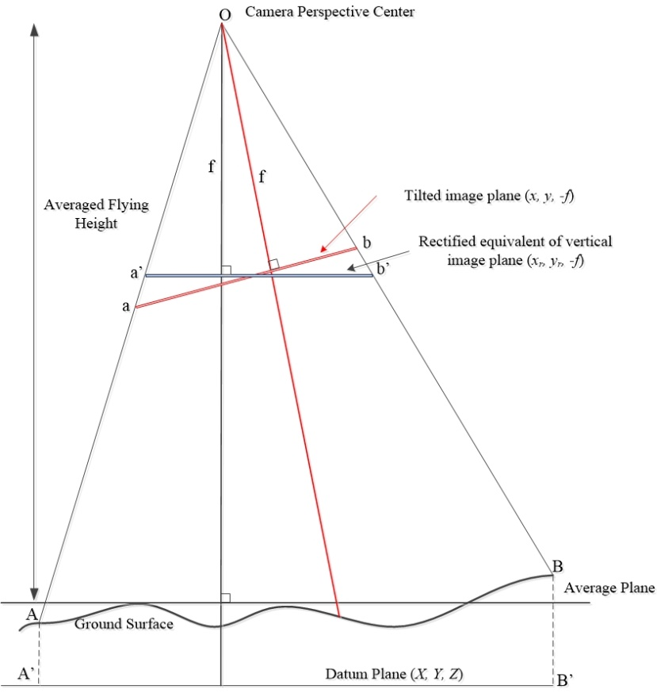
Figure 1. Original tilted image plane and equivalent vertical image plane in the object space coordinate system
Equation (4) expresses the 2D projective transformation using homogenous coordinates, and a₁, .., a₈ are the projective transformation parameters. Essentially this transformation establishes linear functions to map one to one correspondences on every pixel between the two images. The linear version of the equations accommodates all four pair coordinates of the corner of the two image planes to fit a least squares solution of L + V = Ax and it is depicted in matrix-vector forms as follows:
$\left[\begin{matrix}x_{1} \\ y_{1} \\ \begin{matrix}x_{2} \\ y_{2} \\ \begin{matrix}x_{3} \\ y_{3} \\ \begin{matrix}x_{4} \\ y_{4}\end{matrix}\end{matrix}\end{matrix}\end{matrix}\right]+\left[\begin{matrix}v_{x1} \\ v_{y1} \\ \begin{matrix}v_{x2} \\ v_{y2} \\ \begin{matrix}v_{x3} \\ v_{y3} \\ \begin{matrix}v_{x4} \\ v_{y4}\end{matrix}\end{matrix}\end{matrix}\end{matrix}\right]=\left[\begin{matrix}\begin{matrix}x_{r1} & y_{r1} & \begin{matrix}1 & 0 & \begin{matrix}0 & 0 & \begin{matrix}{-x}_{1}x_{r1} & {-x}_{1}y_{r1}\end{matrix}\end{matrix}\end{matrix}\end{matrix} \\ \begin{matrix}0 & 0 & \begin{matrix}0 & x_{r1} & \begin{matrix}y_{r1} & 1 & \begin{matrix}{-y}_{1}x_{r1} & {-y}_{1}y_{r1}\end{matrix}\end{matrix}\end{matrix}\end{matrix} \\ \begin{matrix}\begin{matrix}x_{r2} & y_{r2} & \begin{matrix}1 & 0 & \begin{matrix}0 & 0 & \begin{matrix}{-x}_{2}x_{r2} & {-x}_{2}y_{r2}\end{matrix}\end{matrix}\end{matrix}\end{matrix} \\ \begin{matrix}0 & 0 & \begin{matrix}0 & x_{r2} & \begin{matrix}y_{r2} & 1 & \begin{matrix}{-y}_{2}x_{r2} & {-y}_{2}y_{r2}\end{matrix}\end{matrix}\end{matrix}\end{matrix} \\ \begin{matrix}\begin{matrix}x_{r3} & y_{r3} & \begin{matrix}1 & 0 & \begin{matrix}0 & 0 & \begin{matrix}{-x}_{3}x_{r3} & {-x}_{3}y_{r3}\end{matrix}\end{matrix}\end{matrix}\end{matrix} \\ \begin{matrix}0 & 0 & \begin{matrix}0 & x_{r3} & \begin{matrix}y_{r3} & 1 & \begin{matrix}{-y}_{3}x_{r3} & {-y}_{3}y_{r3}\end{matrix}\end{matrix}\end{matrix}\end{matrix} \\ \begin{matrix}\begin{matrix}x_{r4} & y_{r4} & \begin{matrix}1 & 0 & \begin{matrix}0 & 0 & \begin{matrix}{-x}_{4}x_{r4} & {-x}_{4}y_{r4}\end{matrix}\end{matrix}\end{matrix}\end{matrix} \\ \begin{matrix}0 & 0 & \begin{matrix}0 & x_{r4} & \begin{matrix}y_{r4} & 1 & \begin{matrix}{-y}_{4}x_{r4} & {-y}_{4}y_{r4}\end{matrix}\end{matrix}\end{matrix}\end{matrix}\end{matrix}\end{matrix}\end{matrix}\end{matrix}\right]\left[\begin{matrix}a_{1} \\ a_{2} \\ \begin{matrix}a_{3} \\ a_{4} \\ \begin{matrix}a_{5} \\ a_{6} \\ \begin{matrix}a_{7} \\ a_{8}\end{matrix}\end{matrix}\end{matrix}\end{matrix}\right]$ (5)
Equation (5) gives a robust and linear relationship between the two planar image planes, four corner points of each image are sufficient to solve system equations. The transformation preserves rectilinear properties and intersection points of straight line. In contrast, length, angles and area properties are not invariant. Once a solution from is obtained, all of the parameters in equation (4) to carry out rectification process to obtain a tilt-free distortion image as illustrated in Figure 2.
Here the pixel value (i.e. RGB colour) at position (x, y) in the original image appears in the rectified image, after pixel value interpolation f(x, y). The rectification process transforms the pixel tessellation coordinates from the tilted image to the equivalent vertical image utilizing projective transformation of equation (4), or f(x, y) as depicted in Figure 2. This is known as a direct method [5].
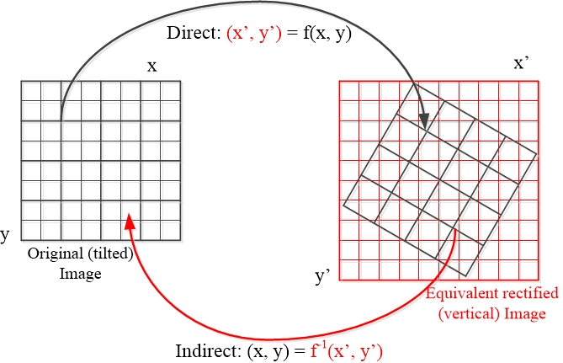 | 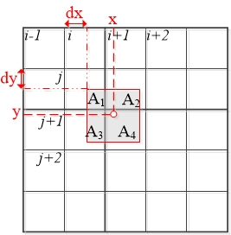
Figure 2. Direct and Indirect rectification process | Figure 3. Bilinear interpolation takes accounts 2x2 adjacent pixel values.
The direct method only assigns pixels values that are given by the original image, which means that some pixels grid of the result image might not get pixels values. They have to be filled after the transformation in the second pass through the resulting image. The other flow of transformation is called Indirect method. The indirect rectification method is applied in which the rectified image is processed pixel by pixel. By reversing the geometric transformation flow of equation (4), or f⁻¹(x’, y’), an exact pixel value to one pixel grid on the output image can be assigned. The pixel value of the input image must be interpolated at the reverse transformed position (x, y) as the location of the pixel which was transformed into the original does not correspond into an integer location.
The interpolation process when doing the indirect method is known as resampling. The original pixel values are altered on the result according to the employed resampling algorithm. It is widely known that bi-linear interpolation (Figure 3) is the best choice among the existing methods in terms of computing speed and algorithm simplicity. The bi-linear interpolation takes accounts 2x2 adjacent pixel values of the computed pixel location. A weighted average adjacent pixel values is the outcome in which the weight is given by the relative coverage of the current pixel, as shown in Figure 3. The interpolation rule is given by:
$g\left(x,y\right)=A_{1}g\left(i,j\right)+A_{2}g\left(i+1,j\right)+A_{3}g\left(i,j+1\right)+A_{4}g\left(i+1, j+1\right)$ (6a)
$A_{1}+A_{2}+A_{3}+A_{4}=1$ (6b)
$g\left(x, y\right)=g\left(i, j\right)+dx\left[g\left(i+1,j\right)-g\left(i,j\right)\right]+dy\left[g\left(i,j+1\right)-g\left(i,j\right)\right]+dxdy\left[g\left(i+1, j+1\right)-g\left(i+1,j\right)-g\left(i, j+1\right)+g\left(i,j\right)\right]$ (6c)
Where g(x, y) represents interpolated pixel value, and dx and dy are integer values (Figure 3).
- Results and Discussion
In this research, a DJI Phantom Pro 4 is employed with a focal length of about 8.8mm to capture images at a flying height of around 150m above the ground surface. The camera is set to face a nadir view direction and its specification is listed in table 1. Approximately 400 images are photographed during the aerial acquisition, but only two of them presented here to represent a low oblique image with a tilt of about 3⁰ and a high oblique image with a tilt of around 25⁰. Rotational parameters of them are presented in table 2.
Table 1. Camera’s sensor specification
 | CMOS sensor size  (mm) | Image resolution  (pixels) | Pixels size  (mm)
Width | 13.20 | 4864 | 0.0027138
Height | 8.80 | 3648 | 0.0024123

Table 2. Rotation parameter of the captured images
Rotation Parameter (degrees) | Tilted image 1  (Low oblique image) | Tilted image 2  (High oblique image)
ω (Omega) | 0.1 | -25.0
ϕ (Phi) | 0.003 | -0.127
κ (Kappa) | 1.6 | 179.728
The camera’s sensor specifications in table 1 are used to generate four corner points coordinates of the original image. Together with the rotation parameters in table 2, equation (1) – (3) are used to generate four corner points of each tilted image. The input image coordinates and their output of each tilted image are illustrated in table 3.
Table 3. The corner coordinates in pixels before and after transformation processes. The tilted image 1 and tilted image 2 become vertical image 1 and vertical image 2 respectively.
Corner point | Input image |  | Vertical image 1 |  | Vertical image 2
 | column | row | column | row | column | row
- Top Left | 0 | 0 | 0 | 0 | 0 | 0
- Top Right | 4863 | 0 | 4952 | 0 | 5368 | 0
- Bottom Right | 4863 | 3647 | 4952 | 3806 | 5368 | 3059
- Bottom Left | 0 | 3647 | 0 | 3806 | 0 | 3059
After the input and output of corner points are obtained, the next step is to calculate the projective transformation parameter as well as to resample the outputs. Both direct and indirect methods are used to clarify the results differences between them as illustrated in Figure 4. To ascertain whether the tilt angles are already reduced on the resulted vertical image, the rotation elements can be extracted from the eight projective parameters as described in [15,16].
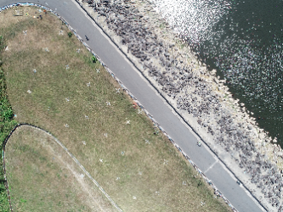 | 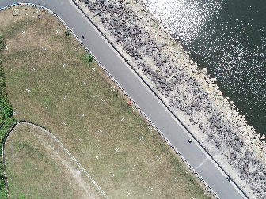 | 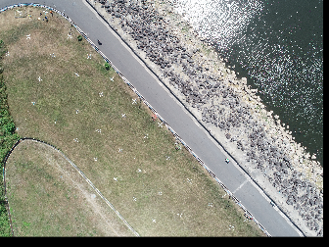
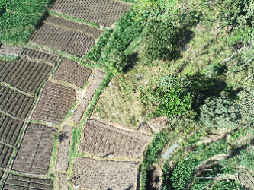 | 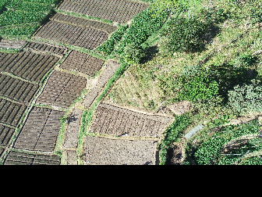 | 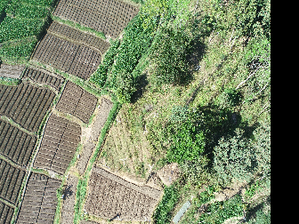
(Input Image) | (Direct Method) | (Indirect Method)
Figure 4. Top row: the low oblique image (top left) is transformed to the equivalent vertical images. Bottom row: the high oblique image (bottom left) is transformed to the equivalent vertical images. Results on the direct method and on the indirect method are shown in the second and third column.
- Conclusions
This paper presents a robust solution to rectify tilted images to generate equivalent truly vertical ones by using the EOPs only. Resampling process is enabled by finding image corner points coordinates both on the tilted image and the equivalent vertical one using rotation only collinearity model. Indirect rectification method is preferred due to its simplicity on the interpolation process. C++ codes are developed to visualize the results.

Acknowledgments
This work was funded by Ministry of Research, Technology and Higher Education of the Republic of Indonesia.
References
- Xuelian M, Nan S, Xukai Z, Chunyan L, Kaiguang Z, Xiaomin Q and Weeks E 2017 Photogrammetric UAV Mapping of Terrain under Dense Coastal Vegetation: An Object-Oriented Classification Ensemble Algorithm for Classification and Terrain Correction Remote Sens. 9 1–23
- Tjahjadi M E, Handoko F and Sai S S 2017 Novel image mosaicking of UAV’s imagery using collinearity condition Int. J. Electr. Comput. Eng. 7 1188–96
- Scott M 2013 Photogrammetric Products Manual of Photogrammetry: 6th Edition ed J C McGlone (Bethesda, Maryland: American Society for Photogrammetry & Remote Sensing) pp 1009–43
- Altena B and Goedemé T 2014 Assessing UAV platform types and optical sensor specifications ISPRS Ann. Photogramm. Remote Sens. Spat. Inf. Sci. II 17–24
- Novak K 1992 Rectification of Digital Imagery Photogramm. Eng. Remote Sens. 58 339–44
- Barazzetti L, Brumana R, Oreni D, Previtali M and Roncoroni F 2014 True-orthophoto generation from UAV images: Implementation of a combined photogrammetric and computer vision approach ISPRS Ann. Photogramm. Remote Sens. Spat. Inf. Sci. II(5) 57–63
- Agüera-Vega F, Carvajal-Ramírez F and Martínez-Carricondo P 2017 Accuracy of Digital Surface Models and Orthophotos Derived from Unmanned Aerial Vehicle Photogrammetry J. Surv. Eng. 143 4016025-1-4016025–10
- Mesas-Carrascosa F J, Rumbao I C, Berrocal J A B and Porras A G-F 2014 Positional Quality Assessment of Orthophotos Obtained from Sensors Onboard Multi-Rotor UAV Platforms Sensors 14 22394–407
- Honkavaara E 2004 In-flight camera calibration for direct georeferencing Int. Arch. Photogramm. Remote Sens. Spat. Inf. Sci. 35 166–72
- Tjahjadi M E 2016 A fast and stable orientation solution of three cameras-based UAV imageries ARPN J. Eng. Appl. Sci. 11 3449–55
- Tjahjadi M E and Handoko F 2017 Single frame resection of compact digital cameras for UAV imagery International Conference on Electrical Engineering, Computer Science and Informatics (EECSI) vol 4, ed M A Riyadi, M Facta, D Stiawan and H Rahmawan (Yogyakarta: IEEE Computer Society Press) pp 409–13
- Tjahjadi M E and Agustina F D 2017 Single image orientation of UAV’s imagery using orthogonal projection model 2017 International Symposium on Geoinformatics, ISyG 2017 (Malang, Indonesia: IEEE Computer Society Press) pp 19–24
- Mikhail E M, Bethel J S and McGlone C J 2001 Introduction to Modern Photogrammetry (New York: John Wiley & Sons, Inc.) ) p 479
- Wolf P, Dewitt B and Mikhail E 2000 Elements of Photogrammetry with Applications in GIS (New York: McGraw-Hill Companies Inc.) ) p 624
- Kobayashi K and Mori C 1997 Relations between the Coefficients in the Projective Transformation Equations and the Orientation Elements of a Photograph Photogramm. Eng. Remote Sens. 63 1121–7
- Seedahmed G H 2006 Direct Retrieval of Exterior Orientation Parameters Using a 2D Projective Transformation Photogramm. Rec. 21 211–31

