Analysis Of The Mixing Of HydrogenGas In The Refigerant (R314a) On The Cooling Engine Performance

**Djoko Hari Praswanto*1, Soeparno Djiwo**1**, Eko Yohanes Setyawan**1**, Tutut Nani Prihatmi**1

1 Departement of Mechanical Engineering, National Institute of Technology Malang, Indonesia

[*djoko@lecturer.itn.ac.id](mailto:*djoko@lecturer.itn.ac.id)

**Abstract.** Refrigerant is a cooling fluid in an air conditioning system. The synthetic refrigerants use this time namely HCFC which have high Ozone Depletion Potential (ODP) and Global Warming Potential (GWP). Therefore it necessary the research to find alternative refrigerants such as HFC and HC which more popular with R134a, R32,etc. This research will do the development with using hydrogen as an environmental friendly refrigerant. The purpose of this research are to find out the quality of the addition of hydrogen gas as an environmental friendly refrigerant replace the synthetic refrigerants which have high ODP and GWP and to relieve compressor performance. This research used an experimental method. R134a mix hydrogen with variant 85%: 15%, 70%: 30%,55%: 45% then performance cooling engine test. The results of research known mixing R134a with Hydrogen which have COP and EER in 55% R134a with 45% hydrogen is great. Because more hydrogen mix make density of the refrigerant and energy the compressor is low and the cooling rate is better. The conclusion is the effect of the addition of hydrogen can improve the performance of the cooling engine and suggested other research with use pure hydrogen and ODP and GWP test.

1. **Introduction**

Refrigerant or cooling fluid is a fluid which used to absorb heat through a phase change from liquid to gas (evaporation) and dissipate heat through a phase change from gas to liquid (condensation) so in general it can be said that is a heat transfer in a cooling system. Each refrigerant has different thermodynamic characteristics, which will affect the refrigeration effect and performance coefficient (COP) of the refrigerant itself [1]. There are two main groups of refrigerants, namely synthetic refrigerants and natural refrigerants. Synthetic refrigerants are obtained chemically, where synthetic refrigerants have high stability, are non-flammable, colorless, odorless and have no toxins. But synthetic refrigerants have a disadvantage that is not environmentally friendly so it can damage the ozone layer. Most synthetic refrigerants have high ozone depletion potential (ODP) and global warming potential (GWP) [2]. Synthetic refrigerant compounds include chlorofluorocarbon (CFC), hydrochlorofluorocarbon (HCFC) and hydrofluorocarbon (HFC). These three synthetic refrigerants can harm the ozone layer which can cause a global crisis [3]. Meanwhile, natural refrigerants or commonly called hydrocarbons (HC) are refrigerants that are extracted from natural gas and have storage period of less than one year in the atmosphere [4]. Hydrocarbon refrigerants have a lower viscosity, density and pressure than synthetic refrigerants. It does not harm the ozone layer so it does not cause global warming effects.

Some researchers have obtained research results on natural refrigerants, namely butane, propane, and CO2 to replace synthetic refrigerants [5,6]. In the cooling index results, GWP and ODP obtained on alternative refrigerants which have hydrocarbon refrigerant class also have significant weakness that is flammable [6]. Even though it has flammability, the compound characteristics are not dangerous if it used with the correct procedure. Hydrocarbon compounds can burn easily if there is a reaction with oxygen or air and a certain amount of ignition source. If one of three factors it is not available, there will not be a fire [7]. The most commonly used alternative refrigerant is R134a. R134a refrigerant has good properties, non-toxic, non-flammable and relatively stable [8]. However, this type of refrigerant has several drawbacks. One of them it has the potential as a substance that can cause global warming effects. Therefore, European regulation Number. 2006/40 / EC and Number. 517/2014 limits the applications of HFCs that have Global Warming Potential (GWP) of more than 150 in MAC systems and Vapor Compression Refrigeration (VCR) [9]. To reduce the high GWP value of Refrigerant R134a, several adjustments were made [10,11]. One of them is mix R134a Refrigerant with a substance which are suitable for refrigerant mixture. R134a refrigerant has ODP and GWP values ​​as shown in table 1.

**Table 1.** ODP and GWP value of refrigerant synthetics and Natural [9]

|  |  |  |  |  |
| --- | --- | --- | --- | --- |
| Refrigerant type | Refrigerant name | ODP1 | GWP2 | Comments |
| CFC | R11 | 1.00 | 4750 | Very high ODP and GWP |
|  | R12 | 0.82 | 10900 | No longer sold |
| HCFC | R22 | 0.06 | 1810 | Medium ODP and GWP |
|  | R124 | 0.03 | 610 | Phasing out via montreal protocol |
| HFC | R134a | 0 | 1430 | Zero ODP, Medium GWP |
|  | R410A | 0 | 2090 |
| HC | R717 | 0 | 0 | Zero ODP, Low GWP |
|  | R744 | 0 | 1 |
|  | R290 | 0 | <20 |

1 Ozone depletion potential, 2 Global warming potential

In several previous research about hydrocarbon refrigerants used compounds such as methane, ethane and others. The compounds used previously which used as fuel namely fossil fuels, so these compounds will also become extinct and still have pollutants. In this research, researcher using hydrogen compounds as a mixture of refrigerant R134a, because hydrogen compounds which are compounds that are being developed as a substitute for compounds obtained from fossils. By mixing hydrogen and refrigerant R134a to minimize errors in research so that fire does not occur. This is done to see the performance of cooling machine with using these refrigerants, until new refrigerants are found with the main compound hydrogen. Hydrogen compounds have the opportunity to be made environmentally friendly refrigerants that have physical properties as shown in Table 2. The mixing of hydrogen and R134a is a novelty of hydrocarbon research which has never been studied.

**Table 2.** Physical properties of hydrogen compounds [12]

|  |  |
| --- | --- |
| Phase | Gas |
| Density | (0 ºC, 101.325 kPa) 0,08988 g/L |
| Melting point | 14,01 K (-259,14 ºC, -434,45 ºF) |
| Boiling point | 20,28 K (-252,87 ºC, -423,17 ºF) |
| Triple point | 13,8033 K, 7,042 kPa |
| Critical Point | 32,97 K, 1,293 MPa |
| Heat of melting | 0,117 kJ.mol-1 |
| Heat of evaporation | 0,904 kJ.mol-1 |
| Calor capacity | (25 ºC) 28,836 J.mol-1.K-1 |

The purpose of this research is to determine the effect of hydrogen compounds on refrigerant R134a on the performance of the refrigerant. The parameters studied were cooling rate, COP and EER. The performance coefficient (COP) is a value that describes the power that is measured by comparing the heat released from the instrument to the work of the cooling engine. This coefficient is similar to the thermal efficiency of a heat engine, because the heat output data is obtained compared to the energy required. From this COP it can be analyzed that the higher COP make lower the compressor work on the cooling engine performance process. Meanwhile, the energy efficiency ratio (EER) is to measure the efficiency of an air conditioner working at a certain outdoor temperature. The unit used to measure the cooling capacity uses the unit Btu / h (British thermal unit per hour) while the unit of power required by the compressor is measured using watt. From this EER value it can be analyzed that the higher of the EER value make more efficient the AC performance [13].

1. **Research methodology**

This research used experimental methods with the aim to analyzed the effect of hydrogen compounds on refrigerant R134a on cooling engine performance. The parameters measured are temperature and pressure on the compressor, condenser, expansion valve and evaporator, current, voltage on the compressor. The parameters obtained from the measurement results by calculating the cooling rate, coefficient of performance (COP) and energy efficiency ratio (EER). Research schematic on a cooling machine as in figure 1

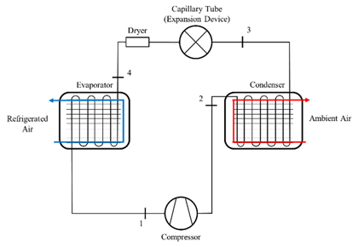

**Figure 1.** Schematic diagram of the refrigeration system with the measurement location [14].

The first step before testing is to mix hydrogen and refrigerant R134a with a predetermined mass ratio in the test tube, then the refrigerant mixture is fed into the cooling engine system through the compressor. Whereas the position of the instrument temperature sensors and pressure gauge in each process as shown in Figure 2.

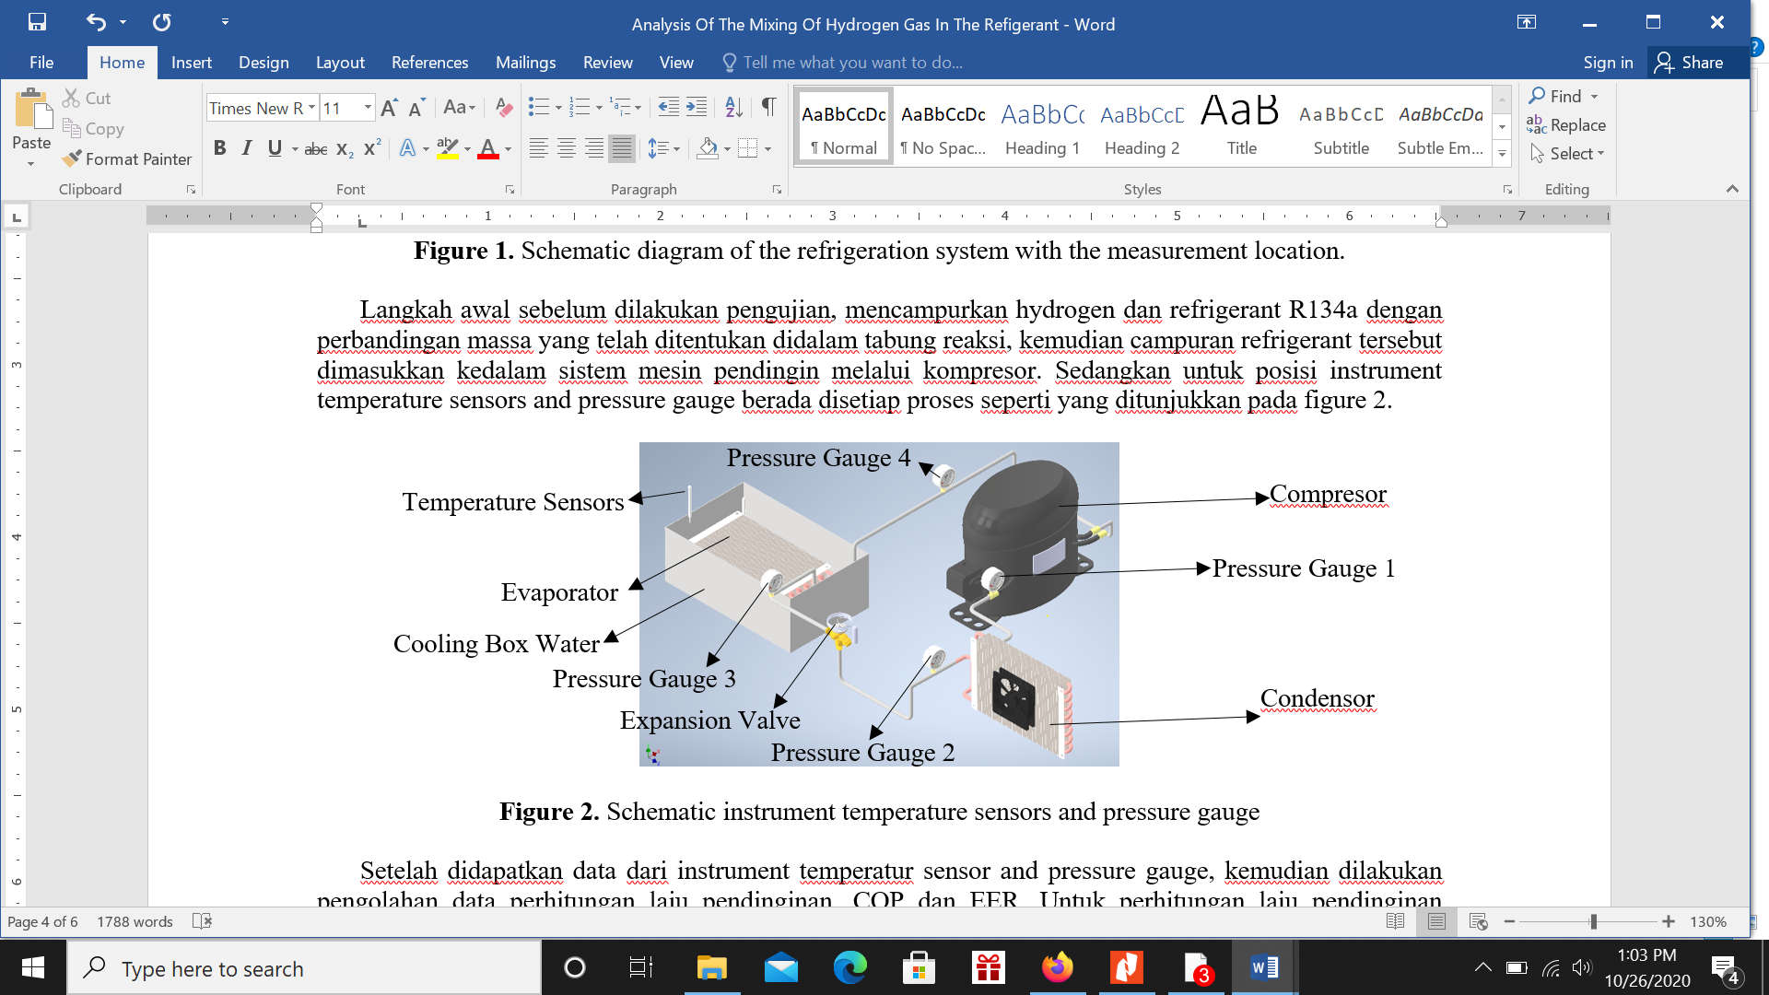

**Figure 2.** Schematic instrument temperature sensors and pressure gauge

After obtaining data from the temperature sensor and pressure gauge instrument, the data processing for calculating the cooling rate, COP and EER is carried out. To calculate the cooling rate using the convection heat transfer equation as in equation 1 [15].

$Q=K.A.∆T$ (1)

Q is heat transfer, K is thermal conductivity and ΔT is diffrence temperature 1 dan 2. Then to calculate COP and EER using equations 2 and 3 as follows [16]

$COP=\frac{Heat Output}{Electrical Energi Input (watt)}$ (2)

$EER=\frac{Cooling Capacity (\frac{Btu}{h})}{Electrical Energy Input (w)}$ (3)

1. **Result and discussion**

**3.1 Coeficient of Performance COP and Energy Efficiency Ratio**

The results of this research, the data on COP and EER calculations were obtained. To make easy the analysis to find the causes and effects that occur, it can be shown in a graph in Figure 3.

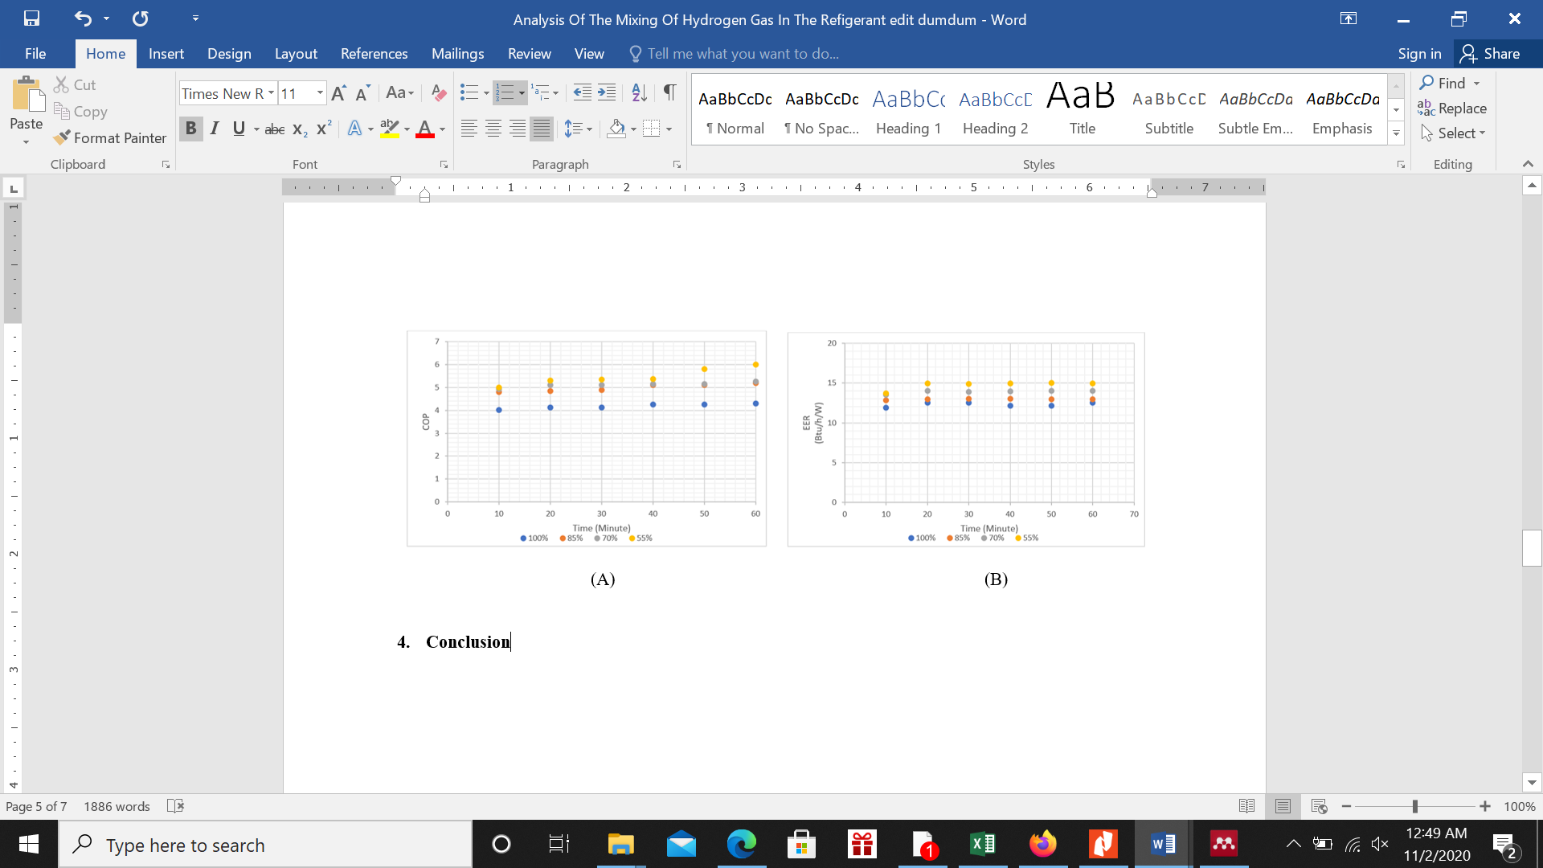

Figure 3. (A) COP of time, (B) EER of time

In Figure 3 above shown the higher percentage of the hydrogen mixture (45% hydrogen and 55% R134a) make the higher of COP and EER values also. The higher COP and EER values ​​can increase the heat output value which is also higher, while the electrical energy required is low, it can be shown in Figure 4. There are 2 factors can affect the COP and EER namely heat output and electrical energy. The phenomenon that occurs in Figure 3 (A) above cause of the small amount of electrical energy required.

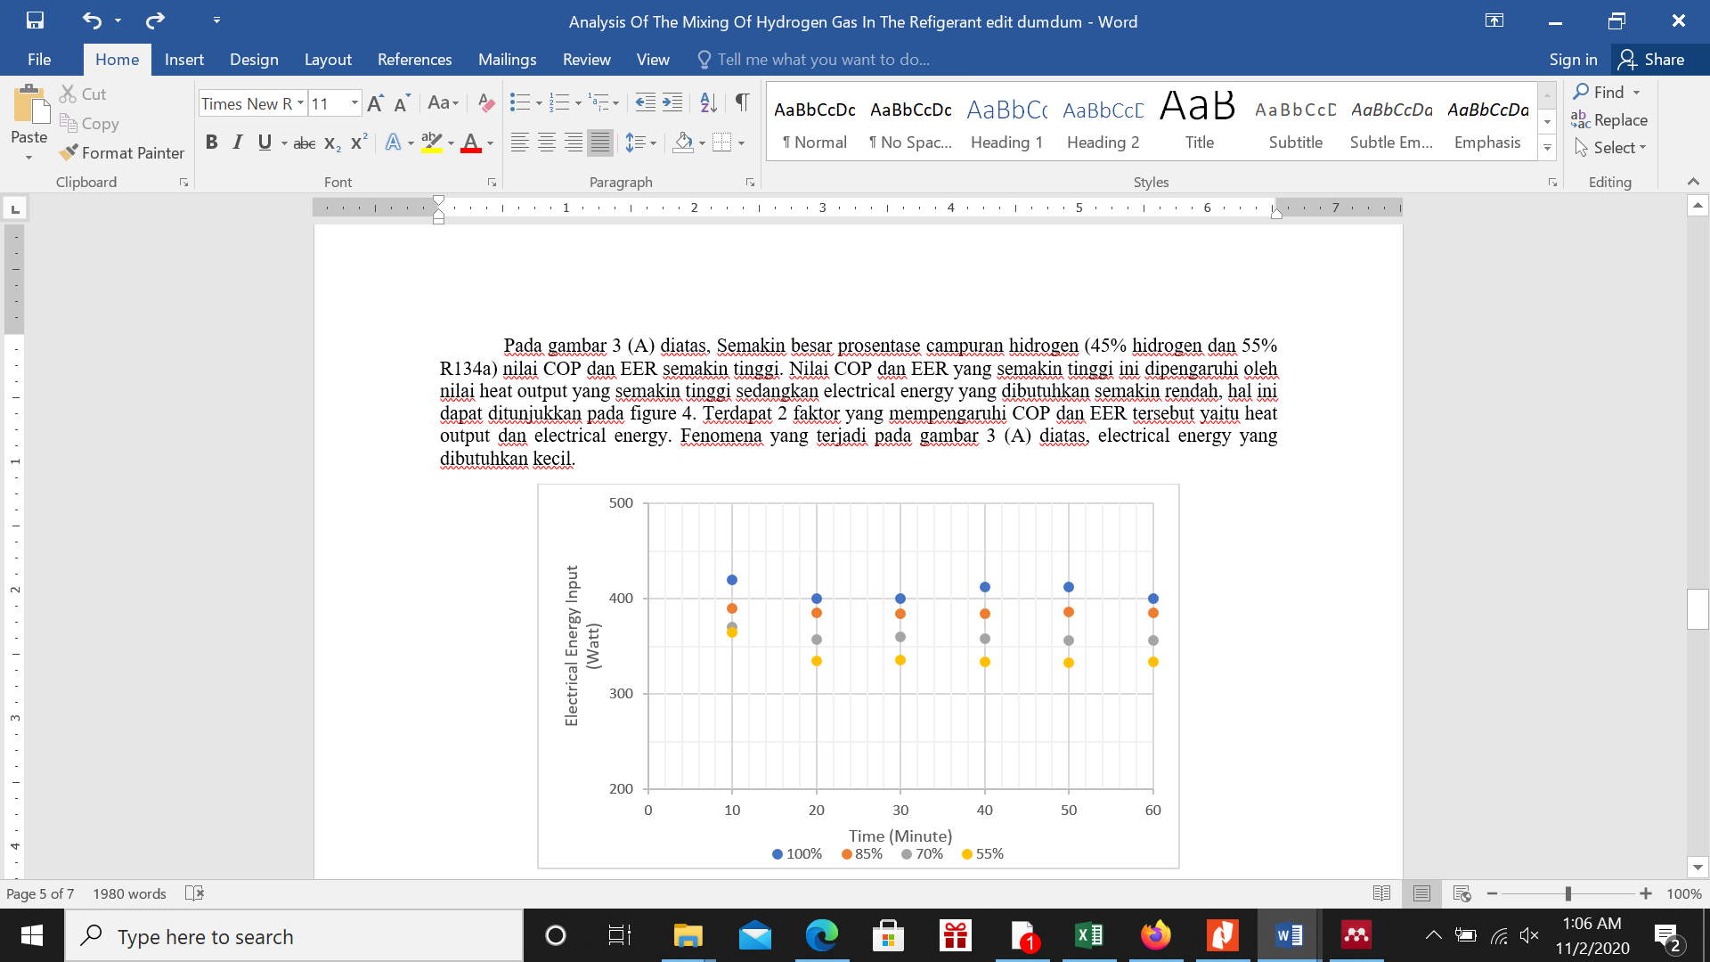

Figure 4. Electrical energy of time

Figure 4 above shown that the percentage of 45% hydrogen and 55% R134a mixture requires less electrical energy. Due to the work performance of the compressor is light because of the low cooling fluid pressure as shown in Figure 5.

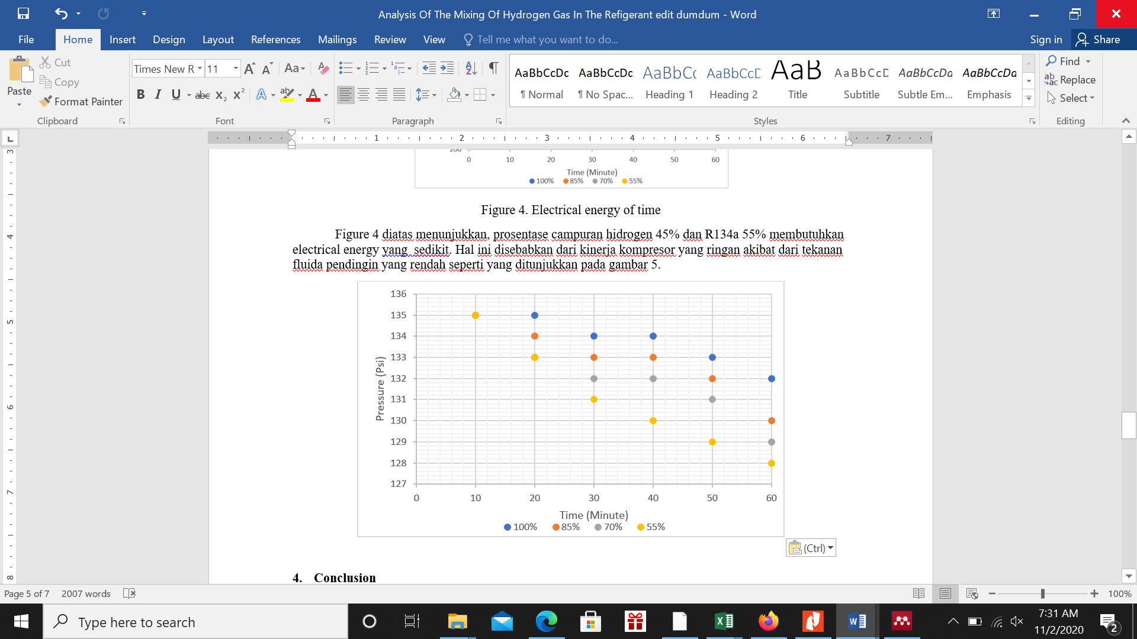

Figure 5. Pressure in compresor of time

From every differences in the percentage of the hydrogen and refrigerant R134a mixture, the higher of hydrogen mixture (45% hydrogen and 55% R134a) make the fluid pressure after passing through the compressor is low caused by the smaller density of the fluid mixture so can flow with easily. From the calculation of the density of mixture, the data is obtained as in Table 3.

**Table 3.** Density mixed hidrogen and refrigerant R134a

|  |  |
| --- | --- |
| The ratio of Hidrogen and refrigerant R134a mixture | Density |
| 0% : 100% | 14.35 |
| 15% : 85% | 12.20 |
| 30% : 70% | 10.05 |
| 45% : 55% | 7.90 |

In Table 3 shows that the higher of the hydrogen mixture percentages create the smaller density of mixture, it caused of the density significant difference. In table 2 which in the introduction chapter, the hydrogen density is 0.8988 g/L while the density of R134a is 14.35 g/L so that if it mixed with more percentage of the hydrogen mixture the density value will be smaller. This is the basic cause if the higher percentage of the hydrogen mixture make the smaller the COP and EER values. So the density, the fluid pressure in the compressor and the electrical energy are the factors that cause of the COP and EER values.

1. **Conclusion**

The higher percentage of the hydrogen mixture can be effect the COP and EER values because of several factors namely the density of mixture, the fluid pressure in the compressor and the electrical energy. Much more the hydrogen mixture create the smaller of the density so that the fluid pressure in the compressor is getting lower. With low fluid pressure, the compressor performance is getting lighter so that the electrical energy needed is getting smaller. It causes of COP and EER be higher in the hydrogen mixture 45% hydrogen and 55% R134a Refrigerant. So that the higher percentage of the hydrogen mixture and R134a refrigerant and then the higher of the COP and EER values ​​and optimum cooling rate.

**Reference**

[1] Budiyanto M A and Shinoda T 2017 Stack effect on power consumption of refrigerated containers in storage yards *Int. J. Technol.* **8** 1182–90

[2] Harby K 2017 Hydrocarbons and their mixtures as alternatives to environmental unfriendly halogenated refrigerants: An updated overview *Renew. Sustain. Energy Rev.* **73**

[3] Baskaran A and Koshy Mathews P 2012 A Performance Comparison of Vapour Compression Refrigeration System Using Eco Friendly Refrigerants of Low Global Warming Potential *Int. J. Sci. Res. Publ.* **2**

[4] Kamal N 2017 Design of Domestic refrigerator using Propylene ( R1270 ) as refrigerant **02** 14–8

[5] Fatouh M, Ibrahim T A and Mostafa A 2010 Performance assessment of a direct expansion air conditioner working with R407C as an R22 alternative *Appl. Therm. Eng.* **30**

[6] Torrella E, Cabello R, Sánchez D, Larumbe J A and Llopis R 2010 On-site study of HCFC-22 substitution for HFC non-azeotropic blends (R417A, R422D) on a water chiller of a centralized HVAC system *Energy Build.* **42**

[7] Zhang W, Yang Z, Li J, Ren C X and Lv D 2015 Study of the explosion characteristics and combustion products of air conditioner using flammable refrigerants *J. Fire Sci.* **33**

[8] Austin N, Kumar P S and Kanthavelkumaran N 2012 Thermodynamic Optimization of Household Refrigerator Using Propane – Butane as Mixed Refrigerant **2** 268–71

[9] Teli H, Ghogale A, Naik G, Raul S and Eknath P 2018 Review Study on LPG as an Alternative Refrigerant for Refrigeration SSPM College of Engineering , Dist : Sindhudurg , Maharashtra , India **6** 2016–8

[10] Zakaria Z, Shahrum Z and Engineering R E 2011 the Possibility of Using Liquified Petroleum Gas in **9** 347–54

[11] S M M, S D T, D A D, M P S, S G V and Professor A 2016 *Performance Evolution of Domestic Refrigerator Using LPG Cylinder*

[12] Pal A, Uddin K, Thu K and Saha B B 2018 Environmental assessment and characteristics of next generation refrigerants *Evergreen* **5**

[13] Prabha T D J and Rambabu V 2015 Experimental investigation on the performance of air conditioner using R32 Refrigerant *IOSR J. Mech. Civ. Eng.* **12**

[14] Shi Y, Guo X and Zhang X 2016 Study on Economized Vapor Injection Heat Pump System Using Refrigerant R32 *Int. J. Air-Conditioning Refrig.* **24**

[15] Colbourne D and Suen K O 2015 Comparative evaluation of risk of a split air conditioner and refrigerator using hydrocarbon refrigerants *Int. J. Refrig.* **59**

[16] Raskar S V and Mutalikdesai S V 2011 A Review of Hydroflorocarbons (HFC’S) Refrigerants as an Alternative to R134a Refrigerant *Int. J. Curr. Eng. Technol.* **6** 1596–600