Improvement Of Calorific Value In Sew Powder Biomass With Carbonization and Densification Methods

A Anam*, M Asroni and T Rahardjo

Mechanical Engineering, National Institute of Technology Malang, Malang, Indonesia

*asrofulan@gmail.com

**Abstract**. Energy is a source of life that is needed by all people in the world, including the industrial community in Indonesia, which currently still depends on fossil energy sources such as oil and coal. These energy sources will be exhausted and non-renewable, so the use of new renewable energy sources is absolutely necessary to fulfil and maintain the sustainability of industrial processes, such as biomass fuel. This paper presents experimental results of biomass fuel from teak sawdust (TS) waste which aims to increase the calorific value by carbonization and forming pellets with added cotton seed oil (CS) and starch (S). Composing the teak sawdust for 100 minutes; temperature 200 °C-50 °C; and Variation of the mixture ratio of the three ingredients in gram size (TS:CS:S) are M1 = 1000: 100: 500, M2 = 1000: 250: 500, M3 = 1000: 400: 500, M4 = 1000: 550: 500, and M5 = 1000: 700: 500. The results showed that the M5 mixture had the highest calorific value, 4539.49 call/gr with the density value of 2.60 gr / mm2, moisture content of 4.45%, and ash content of 5.17%.

Keywords: Energy, biomass, calorific value, teak

1. Introduction

Energy is a source of life that is indispensable for the entire world community, including for the industrial community in Indonesia. Energy needs in Indonesia currently depend heavily on fossil energy sources that cannot be repaired, such as coal fuel, natural gas, and fuel oil (BBM). The energy source is widely used by people in the industrial sector. The fuels used by the people in Indonesia today are oil and coal on a large scale, thus causing the supply in nature to be increasingly limited and scarce and the price is expensive (Anam, 2020). These energy sources will be depleted and cannot be renewed, so the utilization of renewable energy sources, like biomass, is absolutely required to fulfill and maintain the sustainability of industrial processes, both industries that produce energy themselves and those that produce other products (Motghare, 2016).

Biomass is a source of energies from many woods, activities wastes of forest processing industry, agriculture and plantations; animal wastes such as cow, buffalo, and horse. The potential for biomass energy sources is very competitive to be used as fuel, such as teak powder waste of the furniture industry (Silalahi, 2000). This waste has the opportunity to be optimally utilized as an alternative energy that is beneficial to the needs of the community, industry and the wider community by converting teak sawdust into charcoal pellet fuel combined with a mixture of other raw materials (Rajput, 2020).

Teak sawdust is a biomass that has not been used optimally and has a relatively large calorific value with the main components of cellulose, hemicellulose, lignin and wood extracts (Mutmainnah, 2017). According to Wulandari (2011), wood sawdust is a porous material that can absorb water filling the pores which can reduce its quality if it is used as direct fuel. So it is necessary to do treatment in order to obtain quality teak sawdust biomass with high heating value. A few of the treatments to obtain quality teak sawdust biomass with a high calorific value are through the pyrolysis or charcoal process (Yank, 2016); mixture of any difference woods (Saeed, 2019) (Jamradloedluk, 2017); densification of biomass (Iftikhar, 2019). Experimental treatments and tests to obtain quality teak sawdust biomass with high heating value had been carried out to replace fossil fuel sources.

1. Research materials and method

The biomass materials of this study are teak sawdust waste (TS) (Figure 1), obtained from the rest of the furniture industry process; cotton seed oil (CS); and starch (S). TS is sieved to obtain a uniform powder size before the charring process (Figure 2). After coking, TS is re-filtered and put in a mixing container and added with CS and S. Composing the TS for 100 minutes; temperature 200 °C-50 °C; and Variation of the mixture ratio of the three ingredients in gram size (TS:CS:S) are M1 = 1000: 100: 500, M2 = 1000: 250: 500, M3 = 1000: 400: 500, M4 = 1000: 550: 500, and M5 = 1000: 700: 500.

After the ingredients are mixed, they are put into a pellet machine (Figure 3) using a hydraulic system as a driving force for a pressing machine with components, namely the solenoid valve, pressure gauge, pressure valve, and controller. The working principle of the pellet pressing device is that the pressure is controlled by the pressure valve, the solenoid is used to regulate the rise and fall of the press piston, the controller functions as a solenoid drive, the pressure gauge is used to determine the pressing pressure.

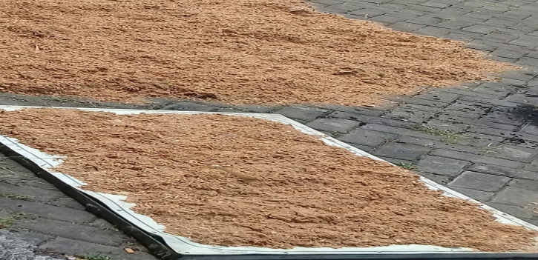

Figure 1. Teak Sawdust Waste (TS)

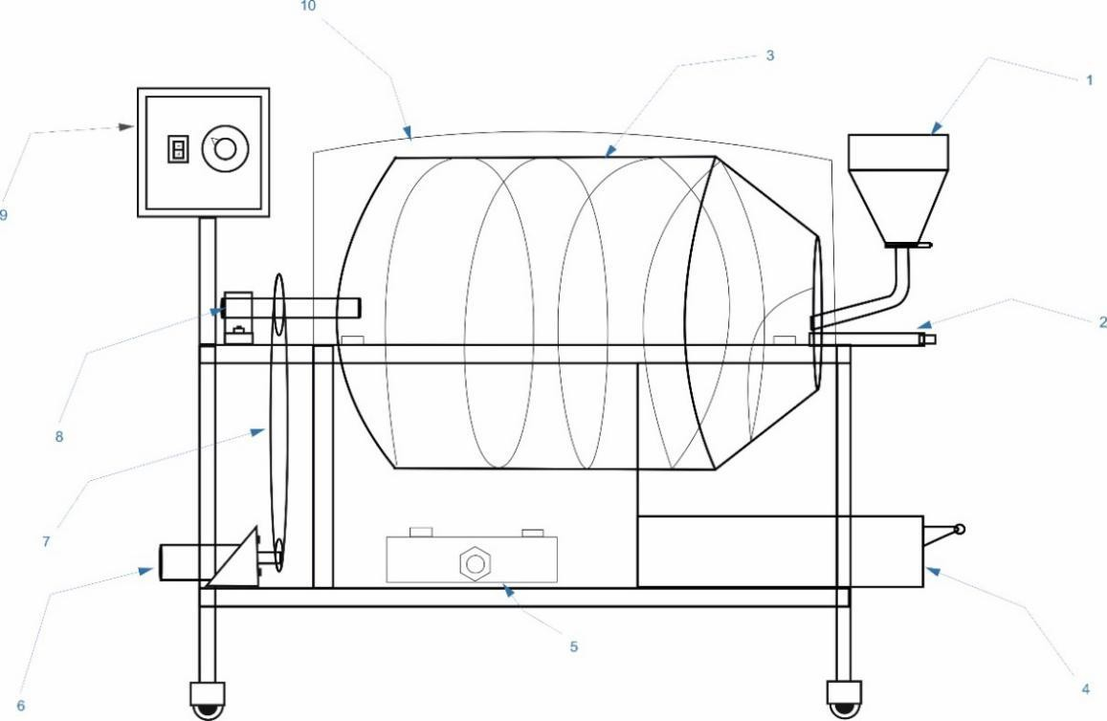

Figure 2. Charcoal Tool

Remark:

1. The funnel for entering raw materials.
2. Charcoal domes / tubes.
3. Check ventilation.
4. Carried containers.
5. Stove.
6. Dynamo.
7. Gear assembly.
8. Axle tube charring.
9. Controller.
10. Cover of the charcoal tube.

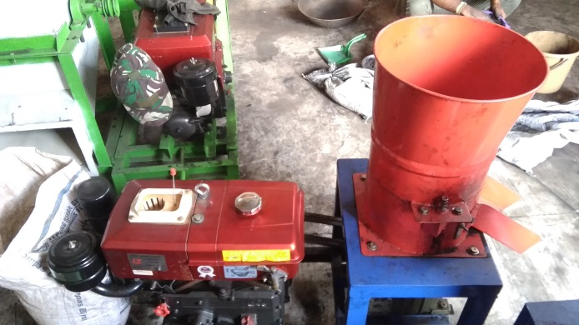

Figure 3. Densification Tool

Several addition tools are used:

1. Pellet burner.
2. Thermocouple.
3. Stopwatch.
4. Digial scale.
5. Moisture meter.
6. Pellet mold.
7. Results and discussion

## Calorific and ash values of biomass sawdust

The results of the charcoal pellet combustion experiment showed that the variation in the ratio of the mixture had an effect on the calorific and ash values of biomass sawdust. The calculation of the heating calorific value of combustion was carried out by means of averaging data analysis.

**Table 1.** Heating calorific value of combustion

|  |  |  |  |  |
| --- | --- | --- | --- | --- |
| Specimen | Teak Powder (gr) | Cotton seed oil (gr) | Starch (gr) | Calorific value (cal/gr) |
| M1 | 1000 | 100 | 500 | 4208.32 |
| M2 | 1000 | 250 | 500 | 4271.61 |
| M3 | 1000 | 400 | 500 | 4387.12 |
| M4 | 1000 | 550 | 500 | 4457.66 |
| M5 | 1000 | 700 | 500 | 4539.49 |

**Table 2.** Ash value of combustion

|  |  |  |  |  |
| --- | --- | --- | --- | --- |
| Specimen | Teak Powder (gr) | Cotton seed oil (gr) | Starch (gr) | Ash value (%) |
| M1 | 1000 | 100 | 500 | 27.50 |
| M2 | 1000 | 250 | 500 | 19.08 |
| M3 | 1000 | 400 | 500 | 18.95 |
| M4 | 1000 | 550 | 500 | 12.07 |
| M5 | 1000 | 700 | 500 | 5.17 |

## According to the first data (Table 1), it is shown that the highest calorific value is in the M5, namely 4539.49 cal / g, and the lowest is in M1, 4208.32 cal / g. This explains that the variation of the mixture between teak sawdust charcoal, cottonseed oil, and starch affects the calorific value of the biomass pellets, namely by increasing the concentration of cottonseed oil, the calorific value of each mixture will also increase. Meanwhile, increasing the heating value will reduce the ash content from the combustion, as shown in Table 2. The table shows that the lowest residual ash content is in mixture 5 and the highest is in mixture 1, namely 5.17% and 27.50% respectively.

## Density and moisture values of biomass sawdust charcoal pellets

## Based on the test of sawdust biomass charcoal pellet specimens, it is shown that the density and moisture values affect the calorific value of each charcoal pellet specimen. Density changes in each material were analyzed the mean data.

**Table 3.** Density of biomass sawdust charcoal pellets

|  |  |  |  |  |
| --- | --- | --- | --- | --- |
| Specimen | Teak Powder (gr) | Cotton seed oil (gr) | Starch (gr) | Density (gr/cm3) |
| M1 | 1000 | 100 | 500 | 2.00 |
| M2 | 1000 | 250 | 500 | 2.35 |
| M3 | 1000 | 400 | 500 | 2.40 |
| M4 | 1000 | 550 | 500 | 2.55 |
| M5 | 1000 | 700 | 500 | 2.60 |

Concert with the Table 3, it tells that the highest density value is in M5, 2.60% and the lowest is in M1, 2.00%. It describes that the density value affects the calorific value of each charcoal pellet specimen, the highest and the lowest calorific values are in the M5 and M1, namely 4539.49 cal/g with 2.60% and 4208.32 cal/g with 2.00% of density values respectively*.*

**Table 4.** Moisture of biomass sawdust charcoal pellets

|  |  |  |  |  |
| --- | --- | --- | --- | --- |
| Specimen | Teak Powder (gr) | Cotton seed oil (gr) | Starch (gr) | Moisture (%) |
| M1 | 1000 | 100 | 500 | 12.63 |
| M2 | 1000 | 250 | 500 | 10.32 |
| M3 | 1000 | 400 | 500 | 8.30 |
| M4 | 1000 | 550 | 500 | 6.54 |
| M5 | 1000 | 700 | 500 | 4.45 |

Based on the Table 4, it is shown that moisture value also affects the calorific value of each charcoal pellet specimen. The highest and the lowest moisture values are M1 and M5, 12.62% with 4539.49 cal/g and 4.45% with 4208.32 cal/g of the calorific values severally.

1. Conclusion

Based on the result and discussion of the study, any conclusions are:

1. Improving of calorific value in sew powder biomass is effected by mixture of teak sawdust charcoal (TS), cotton seed oil (CS), and starch (S).
2. By increasing the concentration of cottonseed oil, the calorific value of each mixture will also increase.
3. The highest calorific value is in the M5, 4539.49 cal/g, and the lowest is in M1, 4208.32 cal/g.

References

1. Anam A, dan Majid M.A, (2020), *Characteristics of Sugarcane Leaf Waste as a Renewable Energy Source Based on the Densification Method*, Jurnal Rekayasa Mesin Vol.15 No.1, pp. 59-65
2. Motghare K. A., et al. (2016), *Comparative Study of Different Waste Biomass for Energy Application*. Waste Manajemen 47, pp. 40-45.
3. Silalahi, (2000), *Research on making wood briquettes from sawdust*. Bogor: Hasil Penelitian Industri. DEPERINDAG, Indonesia.
4. Rajput S.P., Jadhav S.V., dan Thorat B.N. (2020), *Methods to improve properties of fuel pellets obtained from different biomass sources: Effect of biomass blends and binders*. Fuel Processing Technology 199, pp. 1-12.
5. Mutmainnah I.R, (2017), *Utilization of Teak Saws (Tectona Grandits L.F) Waste as Alternative Energy Using Pyrolysis Method*. Universitas Islam Negeri Alauddin Makassar, Indonesia.
6. Wulandari F.I., (2011), *Effect of Addition of Sawdust Powder (Tectona Grandits L.f), on the Alloys of Clay and Garbage Ash on the Quality of Red Bricks in Karanganyar Regency*. Universitas Sebelas Maret, Surakarta, Indonesia.
7. Yank A., Ngadi M., Kok R. (2016), *Physical properties of rice husk and bran briquettes under low pressure densification for rural applications*. Biomass and Bioenergy 84, pp. 22-30.
8. Saeed M.A., Farooq M., Andrews G.E., Phylaktou H.N. (2019), *Ignition sensitivity of different compositional wood pellets and particle size dependence*. Journal of Environmental Management 232, pp. 789-795.
9. Iftikhar M., Asghar A., Ramzan N., Sajjadi B., Chen W.Y. (2019), *Biomass densification: Effect of cow dung on the physicochemical properties of wheat straw and rice husk based biomass pellets*. Biomass and Bioenergy 122, pp. 1-16.
10. Jamradloedluk J. dan Lertsatitthanakorn (2017), *Influences of Mixing Ratios and Binder Types on Properties of Biomass Pellets*. Energy Procedia 138, pp. 1147-1152.
11. Mian et al. (2019), *Kinetic study of biomass pellet pyrolysis by using distributed activation energy model and Coats Redfern methods and their comparison*, Bioresource Technology 294, pp. 1-8.
12. Basuki T, Hartono J., (2011), *Economic Analysis of the Use of Cotton Seed Oil (MBK) for Biofuels*. Balai Penelitian Tanaman Tembakau dan Serat (BALITAS).
13. Sudding, (2015), *Effect of the Amount of Starch on the Time Burned to Ash*, Jurnal Chemica, Vol. 16 No. 1, pp. 27-36.