Digital performance assessment: measure a pharmacy physics laboratory’s skill

M A Dhina1,*, G Hadisoebroto1, I E Setiawati2, G Undang3, M Masluh4 and S R Mubaroq5

1Faculty of Mathematics and Natural Sciences, Universitas Al-Ghifari, Jl. Cisaranten Kulon No.140, Kota Bandung, Indonesia.

2Prodi Administrasi Negara, Faculty of Social and Polotical Sciences, Universitas Al-Ghifari, Jl. Cisaranten Kulon No.140, Kota Bandung, Indonesia.

3Prodi Ilmu Administrasi, Program Pascasarjana, Universitas Pembinaan Masyarakat Indonesia, Jl. Teladan No.15, Kota Medan, Indonesia.

4Prodi Manajemen, Faculty of Economic, Universitas Al-Ghifari, Jl. Cisaranten Kulon No.140, Bandung, Indonesia.

5Technical and Vocational Education Program, Sekolah Pascasarjana, Universitas Pendidikan Indonesia, Jl. Dr. Setiabudi No 229, Bandung 40154, Indonesia.

*meiryakmaradhina@gmail.com

**Abstract**. This research is motivated by the importance of skill assessment in pharmacy physics laboratory learning. In general, laboratory skills assessments do not have a specific standard for each assessment. When students perform their performance and skills in doing practicum, they are not well observed and measured. An alternative assessment that can measure a pharmacy physics laboratory’s skill is to use a performance assessment. This study aims to design a digital performance assessment application that can be used to assess student laboratory skills. The development of a digital performance assessment application uses the Waterfall Model Software Development Life Cycle (SDLC) approach, which consists of the main stages of needs analysis, system and software design, system implementation and testing, and maintenance. The digital performance assessment design generally consists of an assessment instrument database and a user interface. Lecturers, as experts, are tasked with making assessment instruments. Meanwhile, the user interface is used by laboratory assistants/instructors to provide skill scores during student practicum. This application is then integrated with the existing web-based electronic module (e-mulsi). In the end, students can see the overall practicum score. The design of a digital performance assessment application is an alternative in a learning assessment platform that is more interesting, actual, and able to present real-time information on practicum learning in the laboratory. Policymakers are expected to consider integrating the use of these applications into a practical learning curriculum.

1. Introduction

Practicum enables students to make direct observations, predict, analyze, and conclude experimental results [1–4]. Students' understanding can be known through an evaluation sheet or assessment sheet to foster students' active and skilled attitudes in practicum activities [5–7]. Laboratory-based learning invites students to be able to play an active role in developing their potential and abilities. The lecturer conditions this form of active role through practicum held in the laboratory so that learning will be more fun because students are directly involved in constructing their understanding. Laboratory-based learning makes lecturers as facilitators able to foster students' active attitude in utilizing all the learning resources they need to become more efficient for students [1]. Learning will be more efficient if students can apply the material obtained in social life [8,9].

Professional lecturers can record students' overall progress, in terms of knowledge, attitudes, and skills [10]. Lecturers can record student progress by assessing students' overall abilities. Good learning will not succeed without a good assessment [6,11]. Assessment is a process of gathering and processing information to determine the achievement of student learning outcomes. In other words, assessment is a systematic activity to obtain information about what students know and do [12]. Valuation is seen as the process of measuring certain characteristics, such as a description of the objective. In contrast, evaluation is seen as the process of measuring a characteristic and determining the value or price of an object. In general, laboratory skills assessments do not have a specific benchmark for each assessment. When students perform their performance and skills in doing practicum, they are still not well observed and measured [13]. An alternative assessment that can be used to measure the pharmacy physics laboratory's skills is to use performance assessment [14].

Performance assessment can be said to be an action test. In this assessment, students are expected to practice and carry out several student activities and then carry out student assessments based on the assessment guidelines. Pharmacy lab performance assessment is an assessment that asks students to perform several performances in doing pharmacy physics practicum. This performance assessment examines several aspects in its assessment, namely, aspects of the process, results, and laboratory work [15].

The current learning trend returns to the idea that students will be better off if the environment is created naturally or following their environment. Learning will be more meaningful if students experience what they learn. Learning that is oriented towards mastery of the material has proven to be successful in short-term memory competitions but fails to equip students to solve problems in long-term life. Contextual learning is a learning concept that helps lecturers to link the material being taught with students' real-world situations. Contextual learning encourages students to make connections between the knowledge they have and their application in their lives. The concept of contextual learning is expected to be more meaningful for students [16].

The problem that has occurred so far is that students can still not do practicum independently and do not understand practicum material. One of the causes of this problem is that students have not mastered performance skills during the pharmacy physics practicum, so the lecturers only tend to assess the final result or only the cognitive value. Performance skills are essential in pharmacy practicum activities to critically and creatively foster self-confidence in learning pharmaceutical physics. However, it can be integrated with current technological advances to support improving training programs and laboratory skills assessment [17]. This study aims to design a digital performance assessment application that can be used to assess student skills during the pharmacy physics practicum.

1. Method

Following the objective, this research is developing a pharmacy physics practicum learning platform in the laboratory. The development of this digital performance appraisal application uses the Waterfall Model Software Development Life Cycle (SDLC) approach, which consists of the main stages of needs analysis, system and software design, system implementation and testing, and maintenance [18,19]. Overall digital performance assessment of database instruments and user interfaces. Application design using the programming language Codeignitor [20]. While the database used is MySql [21].

|  |  |
| --- | --- |
|  |  |
| **Figure 1**. Flowchart of data management (master), the checklist of practical performance. | **Figure 2**. Flowchart of student lab performance checklist score input. |

The users of this performance assessment application are lecturers, laboratory assistants, and administrators. The user interface is designed to be easy to use by the user. Figure 1 is a data management design flowchart (master), a checklist of practical performance. An Administrator level user does this process. Figure 2, the input flowchart of the student practicum performance checklist scores. This process is done by the laboratory level user and done when the practicum is in progress. Figure 4, the input flowchart of the student practicum report scores. This process is done by a Lecturer level user and done when students submit their practicum reports. While figure 4 is a flowchart view, a recapitulation of students' practicum values. A lecturer level user can access this process. The result of the value from the recapitulation is the final value that has been calculated using the formula 60% for the weight of the reported value plus 40% for the weight of the checklist value.

|  |  |
| --- | --- |
|  |  |
| **Figure 3**. Flowchart of student lab report score input. | **Figure 4**. Flowchart view recapitulation of student practicum scores. |

1. Result and discussion

The digital performance assessment design generally consists of an assessment instrument database and a user interface. Lecturers, as experts, are tasked with making assessment instruments. Meanwhile, the user interface is used by laboratory assistants/instructors to provide skill scores during student practicum. This application is then integrated with the existing electronic module (e-mulsi). In the end, students can see the overall practicum score.

Figure 5 is a sample coding result of the digital performance assessment design to manage the lab performance checklist data.

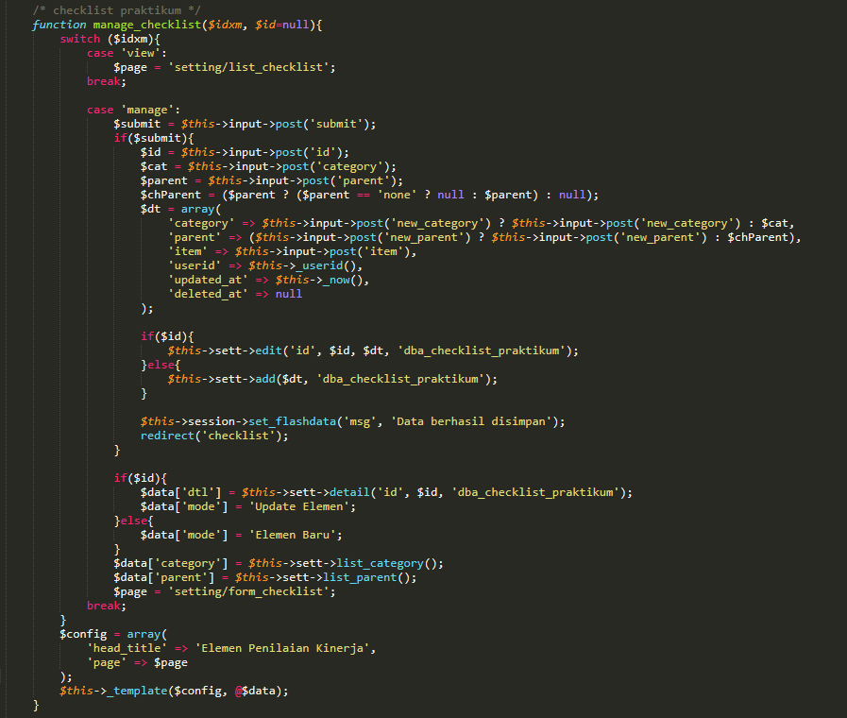

**Figure 5**. Code to manage lab performance checklist data.

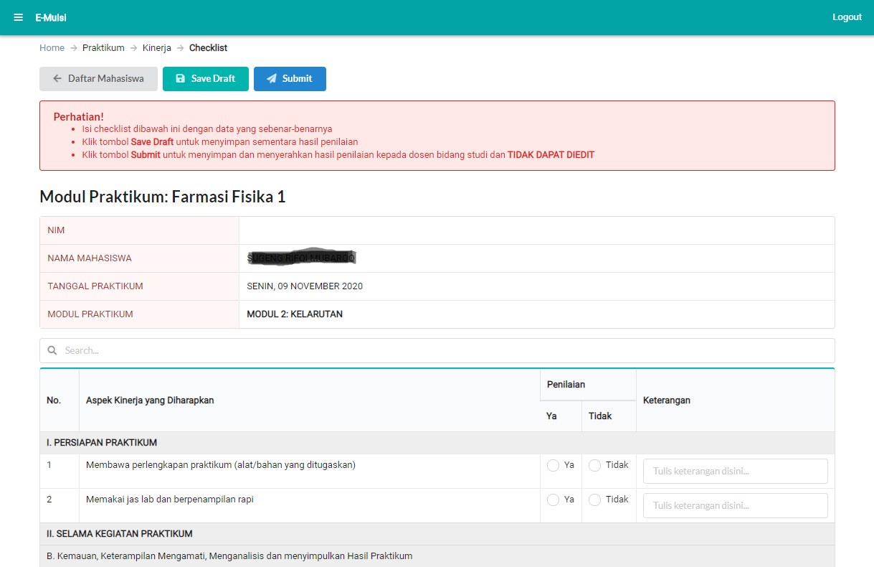

**Figure 6**. Display user interface when conducting a performance assessment.

In this digital performance assessment application, there are two functions to adjust the practical performance checklist feature: delete and display a list of the lab performance checklist items. For the delete function, in this case, it uses a white delete or not a permanent delete so that if an unwanted deletion occurs, the data is still in the database, only the status is deleted, and the data can be restored. Another feature in this application is that the practical value input function will output true or false codes are 200 and 500 codes. The true and 200 values ​​are the values ​​given when successfully saving the value to the database. False and 500 are the values ​​given if the data fails to be saved to the database due to technical problems such as a dead internet network or communication runtime out to the e-mulsi.com server.

Digital Performance assessment, while doing pharmacy physics practicum, can be used easily, utilizing a device connected to the internet. The user interfaces, when conducting a performance assessment, can be seen in figure 6. This application is made responsive to various devices.

1. Conclusion

Digital Performance assessment was designed as a tool for learning assessment in pharmacy physics laboratories. Performance assessments in digital platforms can provide complete, actual, interesting information and are part of manual assessments' transformation towards a more objective assessment. The design of this digital performance appraisal application can present real-time information on practicum learning in the laboratory. Digital Performance assessment implementation is integrated with existing web-based electronic modules (e-mulsi). Digital assessments provide various facilities for lecturers and laboratory assistants to assess student performance skills during practical work in a more comprehensive laboratory. Lecturers can assess the entire laboratory learning process, not only assessing the final result or only the cognitive value. Policymakers are expected to consider integrating the use of these applications into a practical learning curriculum.

References

[1] Gurvitch R and Metzler M W 2009 The effects of laboratory-based and field-based practicum experience on pre-service teachers’ self-efficacy *Teach. Teach. Educ.* **25** 437–43

[2] Baranov A V 2016 Virtual students’ Laboratories in the physics practicum of the technical university *2016 13th International Scientific-Technical Conference on Actual Problems of Electronics Instrument Engineering (APEIE)* vol 1 (IEEE) pp 326–8

[3] Suryaningsih Y 2017 Pembelajaran berbasis praktikum sebagai sarana siswa untuk berlatih menerapkan keterampilan proses sains dalam materi biologi *BIO Educ. J. Sci. Biol. Educ.* **2**

[4] Dhina M A and Mubaroq S R 2012 Efektifitas Model Pembelajaran Investigasi Kelompok Untuk Meningkatkan Keterampilan Proses Sains dan Keterampilan Berpikir Kritis Siswa SMA *J. Pendidik. Fis.* **5** 137–55

[5] Mudrika M, Nahadi N and Kurnia K 2018 A development of performance assesment instrument for measuring cognitive and psychomotor competence on vinegar titration practicum *International Conference on Mathematics and Science Education of Universitas Pendidikan Indonesia* vol 3 pp 348–52

[6] Xu Y and He L 2019 How pre-service teachers’ conceptions of assessment change over practicum: implications for teacher assessment literacy *Frontiers in Education* vol 4 (Frontiers) p 145

[7] Widayanti W, Yuberti Y, Irwandani I and Hamid A 2018 Pengembangan lembar kerja praktikum percobaan melde berbasis project based learning *J. Pendidik. Sains Indones. (Indonesian J. Sci. Educ.* **6** 24–31

[8] Moss P and Petrie P 2019 Education and social pedagogy: What relationship? *London Rev. Educ.* **17** 393–405

[9] Spiel C, Schwartzman S, Busemeyer M, Cloete N, Drori G, Lassnigg L, Schober B, Schweisfurth M and Verma S 2018 The contribution of education to social progress

[10] Cowie B and Cooper B 2017 Exploring the challenge of developing student teacher data literacy *Assess. Educ. Princ. Policy Pract.* **24** 147–63

[11] Van Roy R and Zaman B 2018 Need-supporting gamification in education: An assessment of motivational effects over time *Comput. Educ.* **127** 283–97

[12] Hawe E and Dixon H 2017 Assessment for learning: a catalyst for student self-regulation *Assess. Eval. High. Educ.* **42** 1181–92

[13] Hensiek S, DeKorver B K, Harwood C J, Fish J, O’Shea K and Towns M 2016 Improving and assessing student hands-on laboratory skills through digital badging *J. Chem. Educ.* **93** 1847–54

[14] Susilaningsih E, Khotimah K and Nurhayati S 2018 Development of performance assessment instrument based contextual learning for measuring students laboratory skills *IOP Conference Series: Materials Science and Engineering* vol 349 p 12018

[15] Shavelson R J, Zlatkin-Troitschanskaia O and Mariño J P 2018 International performance assessment of learning in higher education (iPAL): Research and development *Assessment of learning outcomes in higher education* (Springer) pp 193–214

[16] Rahmawati S, Subali B and Sarwi S 2019 The effect of ethnoscience based contextual learning toward students’ learning activity *J. Prim. Educ.* **8** 152–60

[17] Deeley S J 2018 Using technology to facilitate effective assessment for learning and feedback in higher education *Assess. Eval. High. Educ.* **43** 439–48

[18] Dhina M A, Hadisoebroto G, Mubaroq S R, Puspa R V M and Deswati D A 2019 E-mulsi: The digital module for pharmacy physics lab work *Journal of Physics: Conference Series* vol 1402 (IOP Publishing) p 44076

[19] Widiaty I, Riza L S, Ana, Abdullah A G, Mulyana A and Mubaroq S R 2019 Web-Based Digital Learning Application of Iconic Batik in Batik Learning at Vocational High School *J. Eng. Sci. Technol.* **14** 2475–84

[20] Wibawa S C, Wahyuningsih Y, Sulistyowati R, Abidin R, Lestari Y and Maulana D A 2018 Online test application development using framework CodeIgniter *IOP Conference Series: Materials Science and Engineering* vol 296 (IOP Publishing) p 12041

[21] Satoto K I, Isnanto R R, Kridalukmana R and Martono K T 2016 Optimizing MySQL database system on information systems research, publications and community service *2016 3rd International Conference on Information Technology, Computer, and Electrical Engineering (ICITACEE)* (IEEE) pp 1–5