Raman spectra of polyethylene glycol / cellulose acetate butyrate biopolymer blend

Dian Marlina1, Mega Novita2, Muchamad Taufiq Anwar3, Haryo Kusumo4, Harumi Sato5

1Faculty of Pharmacy, Universitas Setia Budi, Jl. Letjen Sutoyo, Mojosongo, Kec. Jebres, Kota Surakarta, Central Java 57127, Indonesia

2Faculty of Engineering and Informatics, Universitas PGRI Semarang, Jl. Sidodadi-Timur No.24 Semarang, Central Java 50232, Indonesia

3Faculty of Information Technology, Universitas Stikubank, Jl. Trilomba Juang No 1 Semarang, Central Java 50241, Indonesia

4Department of Informatics Management, Universitas Stekom, Jl. Majapahit 605, Kec. Pedurungan, Semarang, Central Java 50192, Indonesia

5Graduate School of Human Development and Environment, Kobe University, Tsurukabuto Nada-ku, Kobe 657–8501, Japan

marlina@setiabudi.ac.id

**Abstract**. Various ratio combinations of polyethelene glycol (PEG)/cellulose acetate butyrate (CAB) were investigated by Raman spectroscopy in order to understand their crystalline structure conformations. PEG/CAB spectral features due to the composition dependence revealed the gradual transformation from crystalline PEG-like structure to the amorphous CAB-like structure as increasing the ratio of CAB. Bands appeared in the C-H stretching and C-H bending regions clearly exposed the transition of the PEG to the CAB-spectral features with the transition point at about PEG/CAB (30/70). Band at 1737 cm-1 in the C=O stretching region described the existence of a very weak hydrogen bond arise between PEG and CAB. In the C-O-C region, the drastic spectral change suggested that the hydrogen bond interaction takes place in the back bone of PEG.

1. Introduction

In the development of new biopolymer materials, blending technique of natural polymers has received considerable interest. It is one of the most simple and inexpensive approaches for producing new polymer material with unique and attractive properties based on the characteristic of two or more polymers [1]. Polyethylene glycol was targeted in this study as it is one of the most commercially important polyether used for various applications [2]. Moreover, the development of the PEG polymer blend is still very popular. PEG has been successfully blended with several polymers such as poly(lactide) (PLA) [3], poly(ε-caprolactone) (PCL) [4], poly(ρ-dioxanone) (PPDO) [5], and poly(3-hydroxybutyrate) (PHB) [6].

Cellulose acetate butyrate (CAB) is cellulose derivative which a promising material to be blended with other polymer since they are widely available in the earth. CAB has been successfully blended with PHB producing a better mechanical toughness of PHB and improving PHB elongation of break [6–9]. However, there is a few study have been reported on the blending of PEG and CAB.

|  |  |
| --- | --- |
| PEG Structural Formula V1.svg  **(a)** | **(b)** |
| **Figure 1.** Chemical structure of (a) polyethylene glycol (PEG) and (b) cellulose acetate butyrate (CAB) | |

Figure 1 shows the chemical structure of PEG and CAB. In order to generate a good polymer blend system, hydrogen bond between these two polymers plays a prominent role in stabilizing the crystalline structure conformation of blend polymer system. The existence and role of this prominent hydrogen bond has been reported in numerous study in homo polymer [9], copolymer [10], and polymer blend system [11,12]. Therefore, this study has been focused in the monitoring of the hydrogen bond between PEG and CAB in order to understand crystalline structure conformation of PEG/CAB biopolymer blend.

1. Methods

Film sample of PEG/CAB biopolymer blend with multiple ratio combinations of (100/0), (90/10), (80/20), (70/30), (60/40), (50/50), (40/60), (30/70), (20/80), (10/100), and (0/100) were prepared by mixing low molecular weight of PEG (Mn = 2.0x104) and CAB (Mn = 6.5x104) obtained from Aldrich Chemical Co., Ltd. Without any purification process, PEG and CAB with determined weight were dissolved separately in chloroform (CHCl3) at 60OC while stirring them until both of them completely solubilized. Blended the two solutions in a beaker glass and continue stirring for 48 hours at 60OC, the mixture was then transferred into a petri dish to evaporate the solvent at room temperature for 24 hours until a film sample was obtained. The thickness of the obtained film sample was controlled about 100μm thick by melted and pressed the sample on a hot plate. Finally, the 100μm thick film sample was inserted into a vacuum oven at 60OC for 12 hours in order to obtain the perfect crystallization conformation of the blend sample. Raman spectra measurements have been done for the eleventh ratio combinations of the PEG/CAB film sample at room temperature. The measurements were conducted by using Kaiser Hololab 5000 with excitation wavelength of 785 nm, resolution of 4 cm-1, accumulation number of 10 times, and exposure time of 10 second.

1. Results and discussion

Raman spectra of PEG/CAB biopolymer blend film sample with various ratio combinations of (100/0), (90/10), (80/20), (70/30), (60/40), (50/50), (40/60), (30/70), (20/80), (10/100), and (0/100) in the C-H stretching region and C=O stretching region are shown in Figure 2. In the C-H stretching region which lies from about 3000–2700 cm-1 there are several bands can be obtained due to the presence of PEG and CAB. The highest PEG component of (100/0) have 6 bands appeared at 2946, 2937, 2911, 2886, 2836, and 2779 cm-1. These bands are related to the crystalline phase of PEG. While, the highest CAB component of (0/100) shows 2 major bands at 2937 and 2875 cm-1 also another 2 shoulder bands at 2965 and 2913 cm-1 which are associated to the amorphous phase of CAB. The additions of the CAB ratio in the PEG/CAB blend sample cause a change in the Raman spectra which is gradually transfer from the PEG-like spectrum to the CAB-like spectrum with transition point at the ratio combination of (30/70). It indicates that the crystalline conformation of the blend sample could be modified from the crystalline phase of PEG to the amorphous phase of CAB vice versa due to its ratio combination.

PEG does not have C=O functional group (Figure 1) hence there is no band of the highest ratio combination of PEG/CAB (100/0) appear in the C=O stretching region from about 1800–1700 cm-1. On the other hand, PEG/CAB (0/100) shows a peak at 1737 cm-1 which is related to the C=O functional group of CAB amorphous phase (Figure 2). This C=O stretching band is clearly shown in the ratio combinations of PEG/CAB (80/20), (70/30), (60/40), (50/50), (40/60), (30/70), (20/80), and (10/90). On the case of PEG/CAB (90/10), the baseline at around 1737 cm-1 slightly increases with small number of signal to noise ratio. Therefore, it is difficult to determine wheatear that is a real peak or not. Peak position of this C=O stretching band is somewhat shift to the lowest wavenumber as the addition of PEG ratio in the blend samples. This phenomenon indicates that there might be an interaction occurs between PEG and CAB which most likely a hydrogen bond interaction. This interaction has a prominent role in stabilizing PEG/CAB biopolymer blend structure. The band position at around 1737 cm-1 is little bit higher than the C=O stretching band of poly(3-hydroxybutyrate) (PHB) at 1723 cm-1 associated with a weak hydrogen bond interaction [13]. Therefore, the little higher position of PEG/CAB C=O stretching band indicates that PEG-CAB possess a weaker hydrogen bond interaction compare than a homopolymer PHB.

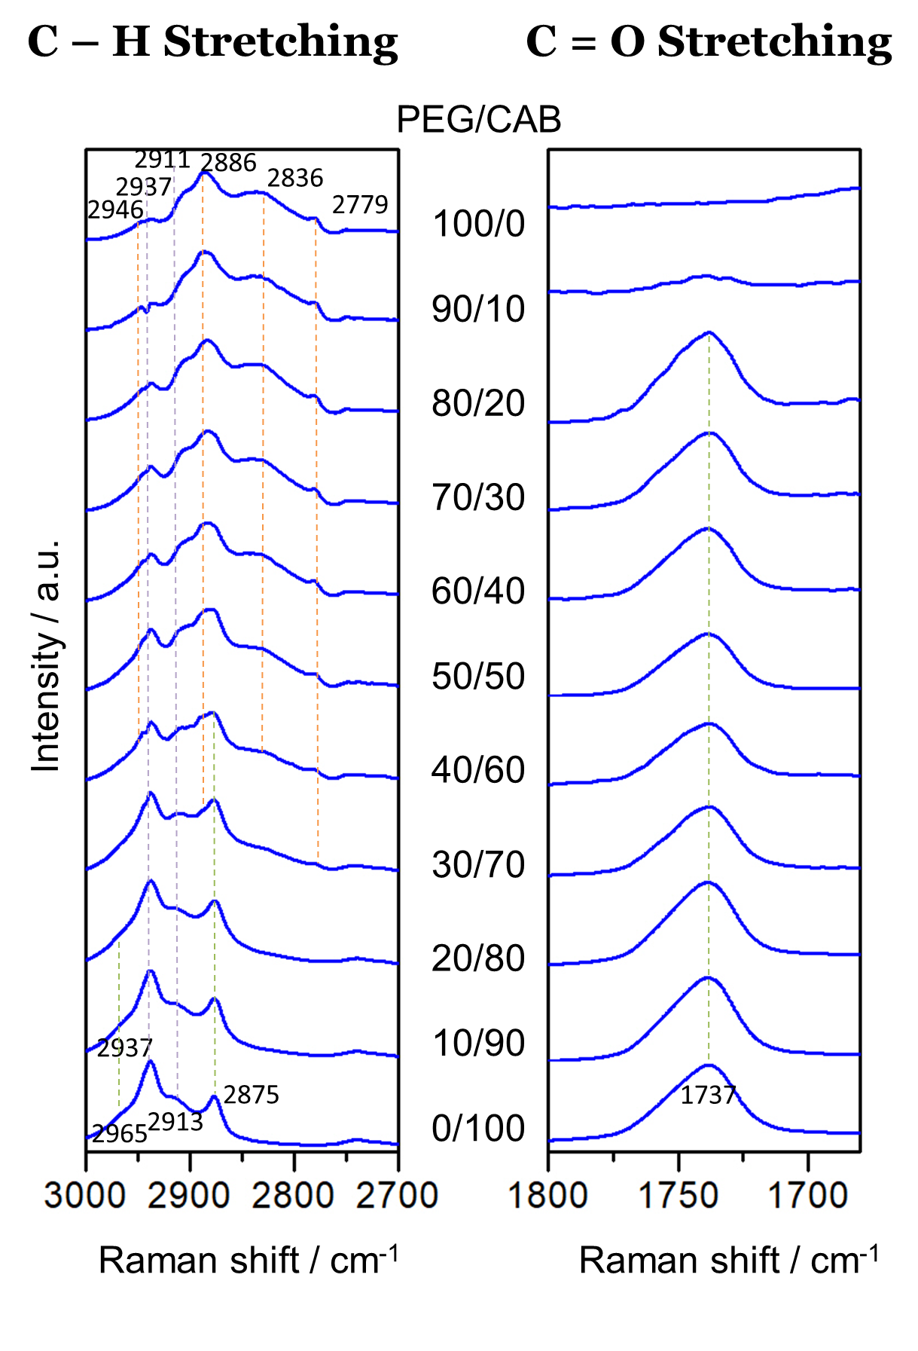

**Figure 2.** Raman spectra of PEG/CAB biopolymer blend film sample with eleventh ratio combinations measured at room temperature in the C-H stretching region (3000–2700 cm-1) and C=O stretching region (1800–1650cm-1).

Figure 3 presents Raman spectra of PEG/CAB biopolymer blend film sample with various ratio combinations of (100/0), (90/10), (80/20), (70/30), (60/40), (50/50), (40/60), (30/70), (20/80), (10/100), and (0/100) in the C-H bending region and C-O-C stretching region at around 1500–1400 cm-1 and 1000–800 cm-1 respectively. In the C-H bending region pure PEG (100/0) shows 3 bands at around 1480, 1467, and 1445 cm-1 due to the crystalline phase of PEG. On the other hand pure CAB (0/100) has 2 bands appear at around 1451 and 1415 cm-1 due to the amorphous phase of CAB. The blend of PEG and CAB with increases PEG ratio resulting in a change of the form of spectra; from the PEG-like spectra to the CAB-like spectra with the transition point at around (30/70). It is a same result with the spectra behavior of the blend sample in the C-H stretching region. Therefore, it also indicates that the crystalline structure conformation of PEG transform into the amorphous structure conformation of CAB due to the blending ratio modification.

Spectral bands obtained in the C-O-C stretching region of Raman spectroscopy represent back bone of polymers. In this C-O-C stretching region, there are 2 major bands of the pure PEG at around 859 and 843 cm-1 related to the crystalline structure conformation of PEG. While, pure CAB shows bands at 923, 895, 866, and 836 cm-1 due to its amorphous structure conformation. The change of PEG-like spectra to CAB-like spectra also can be seen in this region clearly with the same transition point at around PEG/CAB (30/70). Among the entire spectra region, the spectra transformations in this region are very obvious. It is the indication that in the PEG back bone, the hydrogen bond between two polymers PEG and CAB mostly occurs.

1. Conclusion

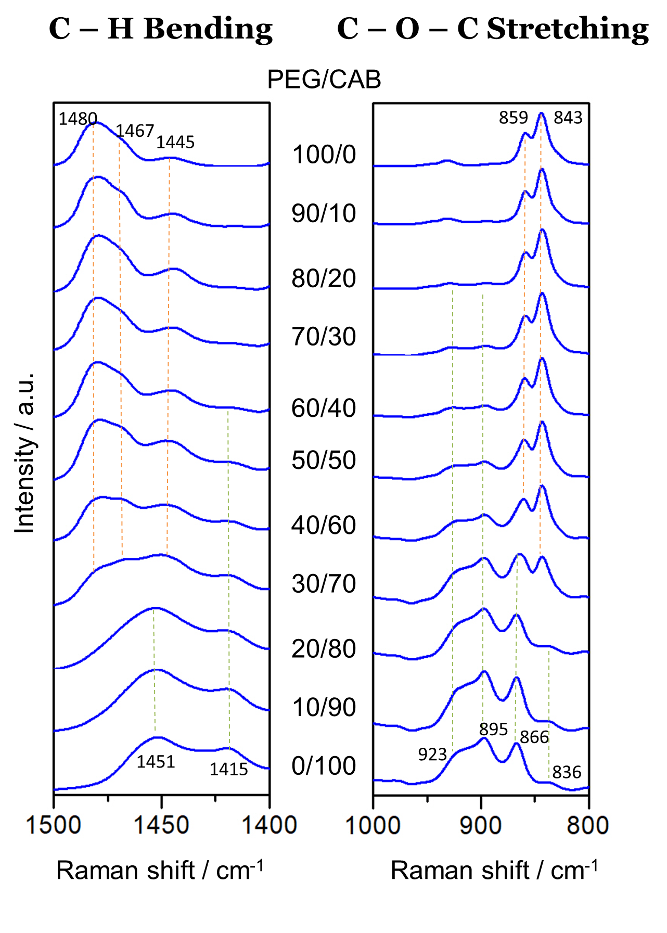

**Figure 3.** Raman spectra of PEG/CAB biopolymer blend film sample with eleventh ratio combinations measured at room temperature in the C-H bending region (1500–1400 cm-1) and C-O-C stretching region (1000–800cm-1).

Crystalline structure transformation of PEG/CAB biopolymer blend has been investigated in this study by using Raman spectroscopy. There are 4 regions in Raman spectra; C-H stretching region (3000–2700 cm-1), C=O stretching region (1800–1700 cm-1), C-H bending region (1500–1400 cm-1), and C-O-C stretching region (1000–800 cm-1) that provided the information of the spectra transformation from the PEG-like structure to the CAB-like structure along with the addition of CAB ratio in the blend composition. Spectra features in the C-H stretching and C-H bending regions clearly exposed the transition point at about PEG/CAB (30/70). Band at 1737 cm-1 in the C=O stretching region describes the hydrogen bond that might occurs between PEG and CAB which is weaker than a homopolymer PHB. Moreover, the dramatic change of the spectra in the C-O-C region indicated that the hydrogen bond principally occurs in the PEG back bone.

References

[1] Higgins J S, Tambasco M and Lipson J E G 2005 Polymer blends; Stretching what we can learn through the combination of experiment and theory *Progress in Polymer Science (Oxford)*

[2] Leung H W 2014 Polyethylene Glycol *Encyclopedia of Toxicology: Third Edition*

[3] Hu Y, Hu Y S, Topolkaraev V, Hiltner A and Baer E 2003 Crystallization and phase separation in blends of high stereoregular poly(lactide) with poly(ethylene glycol) *Polymer (Guildf).* **44** 5681–9

[4] Luo C, Chen W and Gao Y 2016 Fractional crystallization behavior of PCL and PEG in blends *Polym. Sci. Ser. A* **58** 196–205

[5] Zheng L, Wang Y Z, Yang K K, Wang X L, Chen S C and Li J 2005 Effect of PEG on the crystallization of PPDO/PEG blends *Eur. Polym. J.* **41** 1243–50

[6] Suttiwijitpukdee N, Sato H, Zhang J, Hashimoto T and Ozaki Y 2011 Intermolecular interactions and crystallization behaviors of biodegradable polymer blends between poly (3-hydroxybutyrate) and cellulose acetate butyrate studied by DSC, FT-IR, and WAXD *Polymer (Guildf).* **52** 461–71

[7] Sato H, Suttiwijitpukdee N, Hashimoto T and Ozaki Y 2012 Simultaneous Synchrotron SAXS/WAXD Study of Composition Fluctuatins, Cold-Crystallization, and Melting in Biodegradable Polymer Blends of Cellulose Acetate Butyrate and PHB *Macromolecules* **45** 2785–95

[8] Suttiwijitpukdee N, Sato H, Zhang J and Hashimoto T 2011 Effects of intermolecular hydrogen bondings on isothermal crystallization behavior of polymer blends of cellulose acetate butyrate and poly(3-hydroxybutyrate) *Macromolecules* **44** 3467–77

[9] Suttiwijitpukdee N, Sato H, Unger M and Ozaki Y 2012 Effects of Hydrogen Bond Intermolecular Interactions on the Crystal Spherulite of Poly(3-hydroxybutyrate) and Cellulose Acetate Butyrate Blends: Studied by FT-IR and FT-NIR Imaging Spectroscopy *Macromolecules* **45** 2738–48

[10] Marlina D, Sato H, Hoshina H and Ozaki Y 2018 Intermolecular interactions of poly(3-hydroxybutyrate-co-3-hydroxyvalerate) (P(HB-co-HV)) with PHB-type crystal structure and PHV-type crystal structure studied by low-frequency Raman and terahertz spectroscopy *Polymer (Guildf).* **135** 331–7

[11] Marlina D, Hoshina H, Ozaki Y and Sato H 2019 Crystallization and crystalline dynamics of poly(3-hydroxybutyrate) / poly(4-vinylphenol) polymer blends studied by low-frequency vibrational spectroscopy *Polymer (Guildf).*

[12] Marlina D, Park Y, Hoshina H, Ozaki Y, Jung Y M and Sato H 2020 A study on blend ratio-dependent Far-IR and low-frequency raman spectra and WAXD patterns of poly(3-hydroxybutyrate)/poly(4-vinylphenol) using homospectral and heterospectral two-dimensional correlation spectroscopy *Anal. Sci.*

[13] Sato H, Dybal J, Murakami R, Noda I and Ozaki Y 2005 Infrared and Raman spectroscopy and quantum chemistry calculation studies of C-H⋯O hydrogen bondings and thermal behavior of biodegradable polyhydroxyalkanoate *Journal of Molecular Structure*