**How to Learn Oscillation and Wave in SAMR Framework?**

**Hena Dian Ayu1*, Akhmad Jufriadi1*, Syelvy Erine Mustika, Maris Kurniawati1, Hestiningtyas Yuli Pratiwi1, Chandra Sundaygara1, Muhammad Nur Hudha1**

1Physics Education Study Program, Universitas Kanjuruhan Malang

[*akhmadjufriadi@unikama.ac.id](mailto:*akhmadjufriadi@unikama.ac.id)

[*henadian@unikama.ac.id](mailto:*henadian@unikama.ac.id)

**Abstract.** This study was to see how to optimize the application and laboratory software on Oscillation and Wave material. This study was conducted using computers and android equipped with Internet access in SAMR framework. SAMR is a framework that requires the use of technology in learning The design of this research is content analysis. The results show that the Olabs application is complete and the most capable of explaining the formula if it is reviewed mathematically and physis meaning. This application is also able to explain the oscillator and wave phenomena well. Based on this research, during the Covid-19 pandemic, students can do STEM (science, technology, engineering and mathematics) from home, one of which is with the help of the Olabs and PhET application.

1. **Intoduction**

Technophobia has become a problem that is often taken for granted by teachers and students. Many teachers have refused to integrate technology into learning on the grounds that they do not know how[1]. Teachers sometimes have difficulty finding the right technology media to be integrated in learning. Especially science learning activities, namely during practicum[2]. Teachers have considered that practicum should be done directly as a psychomotor skill. This has had an impact on students' ICT skills and student motivation in learning science[3]. Especially during the current covid-19 pandemic. Where learning has been required to be based online and blended learning.

SAMR framework has become a solution to technology integration problems in learning[4]. SAMR has shown how teachers should increase the level of technology use in the classroom[5]. SAMR has levels in integrating technology in the classroom, namely Substitution, Augmentation, Modification, Redefinition[6]. These levels aim to increase the level of students' cognitive development of a material. Several studies have shown that SAMR is able to have an impact on improving students' thinking skills. There have been several technologies that can be used to support this framework, especially practicum activities[7][8][9]. Practical activities with virtual laboratories can be done using PhET Laboratory applications, Olabs, Praxilabs, electric circuit studio, Physics classroom, simphy and others.

Some researchers have integrated the use of technology, especially virtual laboratories in online-based classes in science learning[2][10]. The research that has been done has proven technology to be able to have an impact on improving students' thinking skills[11][12][13][14][15][16]. Several studies have compared the effectiveness of the learning management system and the online-based media used. However, this research does not specifically show a comparison of the effectiveness of the technology used in the classroom, especially in terms of the use of virtual laboratories[17][18][19]. This study will compare the effectiveness of the virtual laboratory application in explaining the concept of learn Oscillation and Wave. The applications that have been selected for conceptual analysis are PhET Laboratory and Olabs, because there are open source application and have oscillation and wave simuation.

1. **Methods**

The research design that has been used is content analysis. In-depth analysis has been carried out on the accuracy of the concept to be conveyed, ease of use, quality of appearance, supporting learning tools, instructions for use and ease of access as well as application operation. The instruments that have been used are questionnaires and direct observation of the application content. Data has also been collected from 20 application users to determine the response to the application

1. **Result and Discussion**

Concept analysis has been carried out on how the application helps students understand the concepts of vibration, wave, wavelength, frequency and amplitude. Based on the direction of propagation, the waves are generally divided into transverse waves and longitudinal waves. In longitudinal waves, media particles make periodic vibrations along the direction of propagation of the wave. This has led to alternative compression and purification. For example, in the case of a slinky the wave along the compressed spring is a longitudinal wave. Meanwhile, when the media particles move up and down periodically, perpendicular to the direction of the wave propagation, this is known as a transverse wave. This wave consists of alternate crests and troughs. In this type of wave the disturbance of the wave moves forward, the medium particles show an upward movement, the maximum downward displacement is known as a trough. Meanwhile, the position of the top displacement is known as the peak[20].

With the help of this application, it is hoped that students will understand the differences in the physical and mathematical meanings of wavelengths in the concept of longitudinal waves and transverse waves. The wavelength (λ) of longitudinal waves has been defined as: The distance covered by one complete smoothing and one complete compression. It is physically represented as the distance between two successive compressions or clarifications. Frequency has been defined as the number of vibrations made by a particle in a slinky/string per unit time. It is denoted by the symbol *f*. T represents the time period it takes to complete one wavelength.

$$f=\frac{1}{T }$$

$$fT=1$$

In transverse waves, the wavelength can be defined as, The distance between two successive crests or the distance traveled by one full crest or one complete trough or the distance between two successive troughs. Transverse waves are physically generated along the slinky or string by jerking the free ends up and down uniformly. Wavelength (λ) in this concept has been interpreted as the distance traveled by disturbances over a period of time. Wave Velocity or Pulse Velocity is the distance traveled by waves per second[20].

$$Velocity= \frac{Distance }{time}$$

$$v=\frac{λ}{T}$$

$$v= λ\frac{1}{T }$$

Because $f=\frac{1}{T }$, therefore, $v=fλ$,

It means, $wave velocity=wave frequency ×wave length$.

Figure 1 and Figure 2 have shown the difference in how the olabs and PhET applications teach the concept of oscillators and waves. Especially the concept of wavelength, period and frequency in the concept of propagating waves based on the direction of propagation. Olabs uses slinky as object while PhET uses strings as object. Olabs has been able to explain precisely the concept of vibrations, wavelengths, frequencies and periods. Physical transverse waves have been described in terms of visible peaks and troughs when the free end of the slinky / string is jerked at right angles to its length. The concept of longitudinal waves has been physically explained by the compression and smoothing seen when the free end of the slinky / string is compressed periodically. Olabs has been developed by the ministry of electronics and information technology, India. So that the application presented is adjusted to the grade of the student class. This causes this application to be more targeted and in accordance with the needs of the concept of education at the junior and senior high school levels. Olabs has been equipped with description features about theory, procedure, animation, simulator, video, resources, voice and feedback. However, Olabs has limited depth of concept delivery. Even though it has many supporting features, the Olabs display simulation aspect is simpler than PhET.

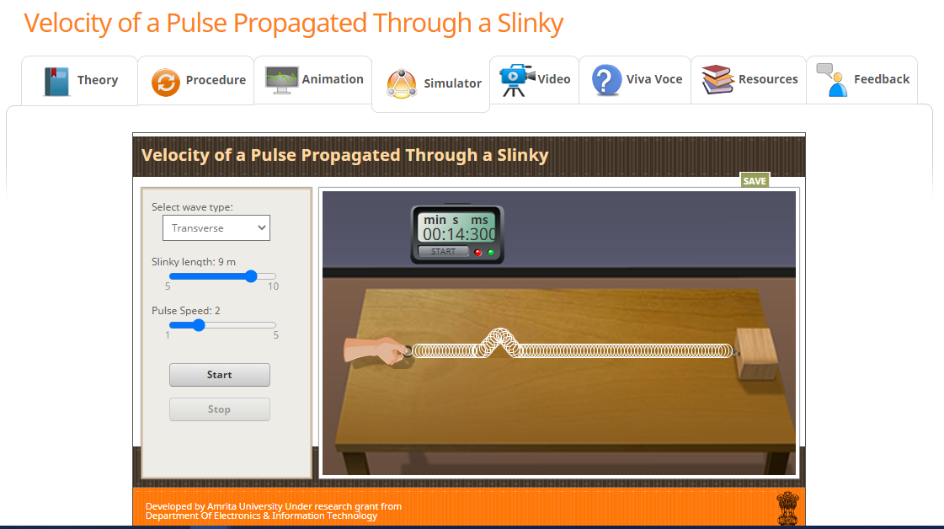

Figure 1. Olabs explaining the concept of wave, amplitude, wavelength and frequency by slinky

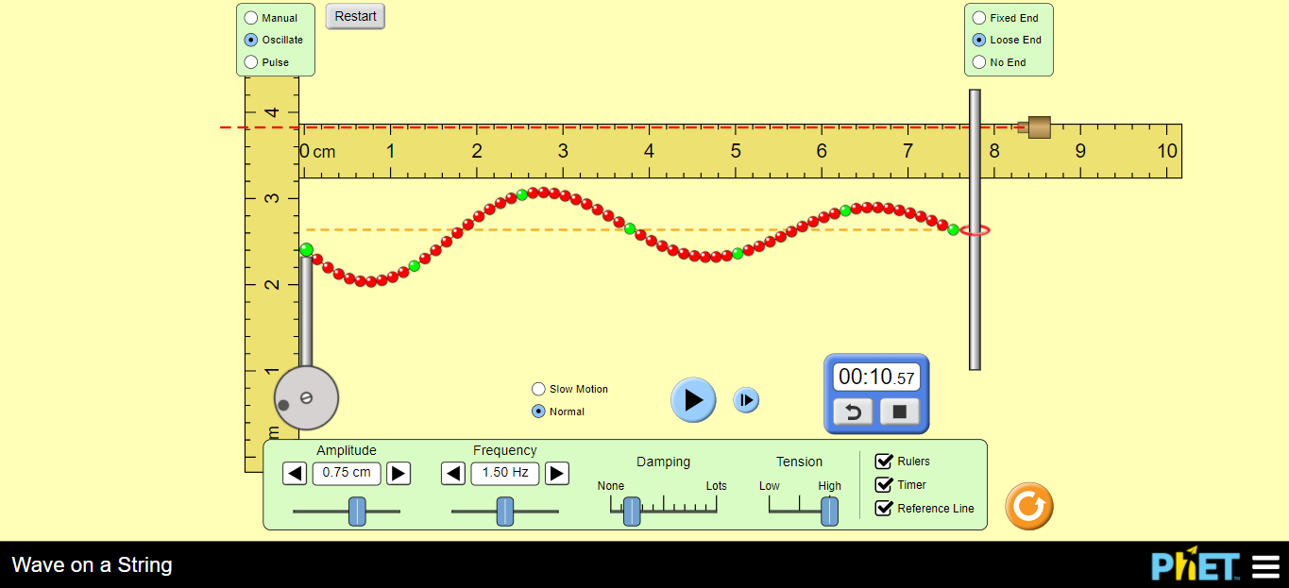

Figure 2. PhET explaining the concept of wave, amplitude, wavelength and frequency by string

PhET has been able to display simulations with many features so that students can understand the concept of waves more deeply. although this has not been able to explain the difference in the concept of transverse waves and longitudinal waves. PhEt has only explained the concept of transverse waves. PhET Colorado has been developed by the university of Colorado, USA. The level of concepts taught is more profound and varied. However, for the junior and senior high school levels, it is sometimes too detailed to exceed the expected learning outcomes so that it seems futile. Unlike Olabs which is equipped with various features, PhET Colorado only provides interactive simulation features with a more attractive and more comprehensive appearance.

This research has focused only on open source applications. So that the application comparison in the concept of oscillations and waves that has been done is less comprehensive. This research does not cover how students understand the application of wave and application concepts in everyday life. whereas the concept of waves based on the direction of propagation can have an impact on how wave attenuation occurs, how the properties of particle motions[21][22][23]. This more in-depth analysis will have an impact on the analysis of the characteristics of the material on which the waves propagate. so that students can better understand the physical concept of waves in the real world not only in mathematical concepts.

The use of virtual laboratory applications is a level of modification and redefinition of the SAMR framework[24][25][7]. The proper management of the use of the SAMR framework in the classroom can streamline classroom learning. The class can be in the form of online, blended or face-to-face classes. The virtual laboratory construction in this research is proven to have features and the right concept path for oscillations and waves. So that the virtual laboratory application can be used to optimize students' thinking skills[6][26][27].

1. **Conclusion**

The use of the right application has an impact on improving students' thinking skills, especially understanding a concept. Using the right application has proven that STEM from home is easy to do. This research has shown that the use of the Olabs application has advantages in explaining the concept of Oscillation and Wave more comprehensively. This research has limitations in the analysis of open source applications. Further analysis can be carried out on all virtual laboratory applications regardless of the open source aspect.

**References**

[1] Hast M and Howe C 2012 Research in Science & Technological Education Understanding the beliefs informing children ’ s commonsense theories of motion : the role of everyday object variables in dynamic event predictions 37–41

[2] Fuhrmann T, Schneider B and Blikstein P 2018 Should students design or interact with models? Using the Bifocal Modelling Framework to investigate model construction in high school science *Int. J. Sci. Educ.* **40** 867–93

[3] Han S, Capraro R and Capraro M M 2015 How Science, Technology, Engineering, and Mathematics (Stem) Project-Based Learning (Pbl) Affects High, Middle, and Low Achievers Differently: the Impact of Student Factors on Achievement *Int. J. Sci. Math. Educ.* **13** 1089–113

[4] Medel R, Guzmán G and Ramírez-Guillén F 2008 First record of Discoxylaria myrmecophila (Ascomycotina, Xylariales) from Veracruz with new reports from Jalisco, Morelos, and Nuevo Leon (Mexico) *Mycotaxon* **106** 1–6

[5] Boelens R, De Wever B and Voet M 2017 Four key challenges to the design of blended learning: A systematic literature review *Educ. Res. Rev.* **22** 1–18

[6] Onyango G and Gitonga R 2017 Exploring how technology complements constructivism using a lesson plan *2017 IST-Africa Week Conf. IST-Africa 2017* 1–11

[7] Aprinaldi A, Widiaty I and Abdullah A G 2018 Integrating SAMR learning model in vocational education *IOP Conf. Ser. Mater. Sci. Eng.* **434**

[8] Yang S C 2007 E-critical/thematic doing history project: Integrating the critical thinking approach with computer-mediated history learning *Comput. Human Behav.* **23** 2095–112

[9] Vo H M, Zhu C and Diep N A 2017 The effect of blended learning on student performance at course-level in higher education: A meta-analysis *Stud. Educ. Eval.* **53** 17–28

[10] Elfeky A I M, Masadeh T S Y and Elbyaly M Y H 2020 Advance organizers in flipped classroom via e-learning management system and the promotion of integrated science process skills *Think. Ski. Creat.* **35** 100622

[11] Ayu H D, Saputro S, Sarwanto and Mulyani S 2020 Meta-Analysis of a Blended Learning Approach: Implications for Student Critical Thinking **417** 87–94

[12] Pratiwi H Y, Sujito S, Ayu H D and Jufriadi A 2018 The Importance of Hybrid Teaching and Learning Model to Improve Activities and Achievements *fthe Annual Conference on Social Sciences and Humanities (ANCOSH 2018) - Revitalization ofLocal Wisdom in Global and Competitive Era* pp 326–30

[13] Ayu H D, Pratiwi H Y, Kusairi S and Muhardjito 2017 Developing E-Scaffolding to Improve the Quality of Process and Learning Outcomes *J. kependidikan*

[14] Ayu H D, Jufriadi A, Pratiwi H Y and Sujito S 2018 The Implication of E-Scaffolding in Mathematical Physics - Students Achievement and Motivation 119–22

[15] Trisnayanti Y, Khoiri A, Miterianifa and Ayu H D 2019 Development of Torrance test creativity thinking (TTCT) instrument in science learning *AIP Conf. Proc.* **2194**

[16] Miterianifa, Trisnayanti Y, Khoiri A and Ayu H D 2019 Meta-analysis: The effect of problem-based learning on students’ critical thinking skills *AIP Conf. Proc.* **2194**

[17] Mohammad M T and Al ali Z T 2017 A Hybrid Spiral Project Based Learning Model for Microprocessor Course Teaching *Kurdistan J. Appl. Res.* **2** 125–30

[18] Alvarez L H R 2010 Minimum guaranteed payments and costly cancellation rights: A stopping game perspective *Math. Financ.* **20** 733–51

[19] Dhina M A, Hadisoebroto G and Mubaroq S R 2019 Development of E-Practicum Module for Pharmacy Physics Learning *Momentum Phys. Educ. J.* **3** 95–102

[20] Serway R A and Jewett J W 2004 *Physics For Scientists and Engineers* (Thomson Brook/ Cole)

[21] Ayu H D and Sarwanto S 2019 Analysis of seismic signal in order to determine subsurface characteristics *J. Phys. Conf. Ser.* **1375**

[22] Aikenhead G S 2005 *Science Education for Everyday Life: Evidence-based Practice (Ways of Knowing in Science & Mathematics)*

[23] Ahmadi S D and Marandi S S 2014 Social Software in the Classroom: The Case of Wikis for Scaffolding *Procedia - Soc. Behav. Sci.* **98** 100–8

[24] Puentedura R R 2014 *SAMR and TPCK: A Hands-On Approach to Classroom Practice*

[25] Hamilton E R, Rosenberg J M and Akcaoglu M 2016 The Substitution Augmentation Modification Redefinition (SAMR) Model: a Critical Review and Suggestions for its Use *TechTrends* **60** 433–41

[26] Hunter J 2003 *Technology Integration and High Possiblitity Classrooms - Building from Tpack* vol 1

[27] Zhai X, Zhang M, Li M and Zhang X 2019 Understanding the relationship between levels of mobile technology use in high school physics classrooms and the learning outcome *Br. J. Educ. Technol.* **50** 750–66