Development of physics modul based on STEM problem based learning on newton’s motion law material for senior high school
Apit Fathurohman¹, Esti Susiloningsih², Anissa Arianti³
¹⁾ Physics Education, Faculty of Teacher Training and Education, Sriwijaya University
²⁾ Primary School Teacher Education, Faculty of Teacher Training and Education,
Sriwijaya University
³⁾ Post Graduate Student of Physics Education, Faculty of Teacher Training and
Education, Sriwijaya University

Abstract. This research is a development research which aims to produce senior high school physics module based on STEM Problem Based Learning on Newton’s Motion Law Material that is valid and practical. The design of development by using a model of ADDIE that modified with Tessmer’s formative evaluation method. Tessmer's formative evaluation stages in this study include self evaluation, expert review, one-to-one and small groups. Data were collected through interviews, expert testing and questionnaires at the expert review stage using 2 material experts, 2 design experts, and 2 linguists. The one-to-one and small group stages and Field Tests were conducted at SHS Number 1 Banyuasin, South Sumatra. The results of the expert review stage obtained the final score of material validation 1 (very feasible or very valid), design validation 0.91 (very feasible or very valid) and language validation 0.95 (very feasible or very valid). For the final score of practicality obtained from one-to-one trials 0.74 (moderate or practical) and small groups 0.84 (high or very practical). Based on the results of the evaluation shows that the modules is categorized as valid and practical. It is recommended that this module can be used as an alternative teaching for Newton’s motion law material.

- Introduction
The fourth industrial revolution is different from the previous three. This is because machines and artificial intelligence play a significant role in enhancing productivity and wealth creation, which directly changes and challenges the role of human beings. The fourth industrial revolution will also intensify globalisation. Therefore, technology will become much more significant, because regions and societies that cope positively with the technological impact of the fourth industrial revolution will have a better economic and social future (Schäfer, 2018). Job profiles at many workplaces are set to change because of technological impact. This means that major conversion and adaptation measures will also be necessary in the fields of education and employee development (Weber, 2015).

Education is required that can form a creative, innovative, and competitive generation. One of them can be achieved by optimizing the use of technology as an educational aid that is expected to produce output that can adapt and change the era for the better. Without exception, Indonesia also needs to improve the quality of graduates according to the world of work and the charges of digital technology (Lase, 2019). Indonesia as a large country with a wealth of natural resources and abundant human resources should be a nation that plays a great role in the development of science and technology. STEM education can be used in other scientific fields by utilizing the principles of STEM as a basis for learning and developing potential students (Nugroho, Permanasari, & Firman, 2019) .

Integrated STEM education is an effort to combine science, technology, engineering, and mathematics into one class that is based on connections between the subjects and real world problems (Stohlmann, Moore, & Roehrig, 2012). There are some benefits using STEM education, such as: Improving professional development, meeting workplace demands, STEM education for sustainable work, innovative models of secondary education, and domestic development (Ismail, 2018). Technology Education teachers may use educational technology to deliver lessons and for assessment. However, the confusion between the two disciplines is clearly a problem for most educators. The Leaders in Technology and Engineering Education recently made a name change from “Technology Education” to “Technology and Engineering Education” in an attempt to alleviate the confusion and have a solid identity within the educational community (White, 2012).

II. Research Method
This type of research is development research which aims to produce senior high school physics module based on STEM Problem Based Learning on Newton’s Motion Law Material that is valid and practical.
The subjects of this study were second grade high school students, the one-to-one trial stage will be carried out on 3 class, the small group trial stage will be carried out on 9 class XI, and the test stage effectiveness is one class of second grade high school students which is carried out at the field test stage. The research model used in this research is the ADDIE model modified with Tessmer's formative evaluation. Data collection techniques in this study include interviews, expert validation, and questionnaires. The data analysis technique used is validation by 2 material experts, 2 design experts and 2 language experts, and practical data analysis.

III. Results and Discussions
3.1 Analysis
The initial stage of development research is needs analysis. The needs analysis consists of curriculum analysis, lesson plan analysis (RPP), material analysis and analysis of the characteristics of high school students.
In the analysis of curriculum was adjusted to the 2013 high school physics curriculum of the Ministry of Education and Culture. Based on the framework of the 2013 Curriculum, the goal of learning physics is to master concepts and principles and have the skills to develop knowledge and a confident attitude as provisions for continuing education at a higher level and developing science and technology (Kemdikbud, 2014). At the stage of analyzing the Learning Implementation Plan which is based on Core Competencies, Competency Standards, Basic Competencies, learning indicators and learning objectives from the Newton’s Motion Law. The core competencies of KI-3 are understanding, applying, analyzing factual, conceptual, procedural knowledge based on their curiosity about science, technology, arts, culture and humanities with insights into humanity, nationality, statehood and civilization regarding the causes of phenomena and events, and applying procedural knowledge in a specific field of study according to their talents and interests to solve problems. Whereas KI-4 are processing, reasoning, and presenting in the realm of the concrete and the realm abstract related to the development of what he learns in school independently, and be able to use methods according to scientific principles.
Basic competence in this material is to analyze the interaction of forces and the relationship between force, mass and motion of objects in straight motion. Conducting the experiment and the presentation of the results related to the interaction of forces and the relationship of force, mass, and acceleration in straight motion and their physical meaning. As for learning indicators for Newton's law of motion, namely: 1) Applying Newton's First, Second, and III Laws; 2) Analyze the forces on the object (weight, normal force, rope tension, friction); 3) Presenting and communicating the results of discussions and observations.
The next phase is material analysis, Newton's law of motion material was chosen because Newton's law of motion material is one of the difficult materials and misconceptions often occur in physics subjects, and this material also includes material which also includes essential material on basic physiology or mechanics in college. From the results of previous research, it shows that students' mastery of concepts and understanding of this material is still low. Based on the basic competencies of the newton motion law material, it is analyzing the interaction of forces and the relationship between force, mass, and movement of objects in straight motion. Conducting the experiment and the presentation of the results related to the interaction of forces and the relationship of force, mass, and acceleration in straight motion and their physical meaning. As for the learning indicators for Newton's law of motion, namely: 1) Applying Newton's First, Second and Third Laws; 2) Analyze the forces acting on the object (weight, normal force, rope tension, friction); 3) Presenting and communicating the results of discussions and observations. From the basic competencies and expected indicators, STEM Problem Based Learning is an alternative solution.
The analysis phase of student characteristics, based on the results of interviews with teachers of physics subjects, is still teacher-centered. Only some students are active in the learning process. Based on the questionnaire that the percentage obtained was 65.6% (21 students out of 32 students) students still did not understand the physics books they had. Students are more interested if physics learning is presented with problems related to daily life with a percentage of 68.7% (22 of 32 students) and students need learning resources in the form of modules with a percentage of 78.1% (25 of 32 students).

Design
At the design stage, there is a self-evaluation stage carried out by self-evaluating the products that have been developed which are supported by comments and suggestions from peers, as well as comments and suggestions from the physics teacher as a reference in evaluating the product.
Colleagues provide suggestion that module that has been created has not brought up the STEM PBL yet, the problem used is not related to daily life, not related to the material of Newton's motion law yet and suggest to the existence of typing or writing errors, then colleagues suggest much more literature from relevant journals or books. After repairs and revisions were made, a specific prototype was obtained. The making of teaching materials in the form of modules is adjusted to module components consisting of an introduction, student activity sheets, worksheets, worksheet answer keys, and test sheets, glossary, and module design bibliography can be seen in table 1.
Table 1. Product Design
Cover  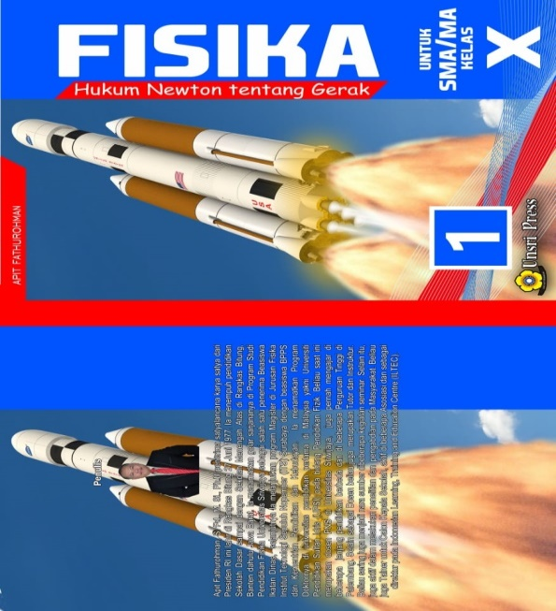  Content  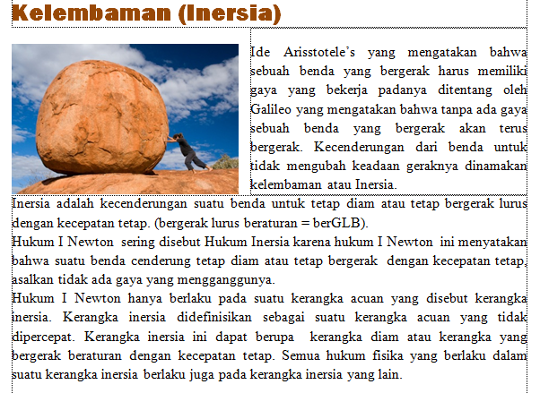  Student activity  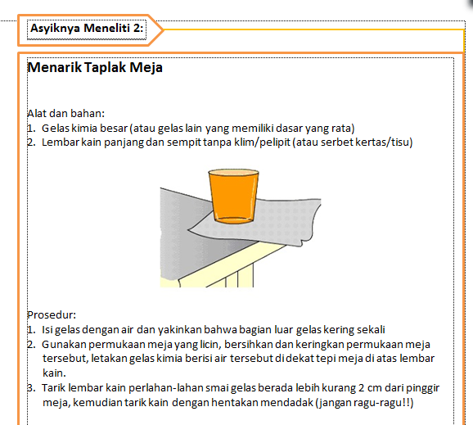  Example Question  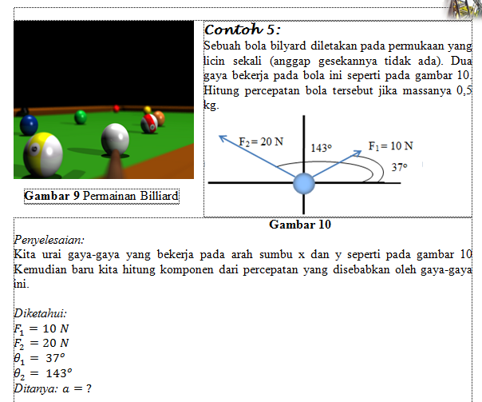  The answer of sample  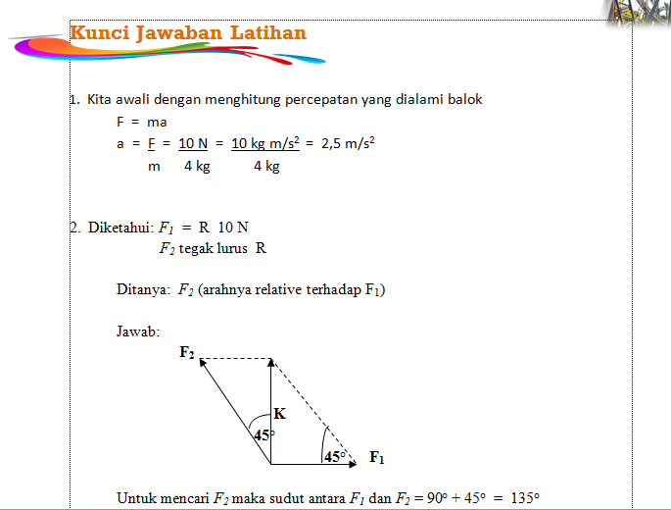 | Introduction  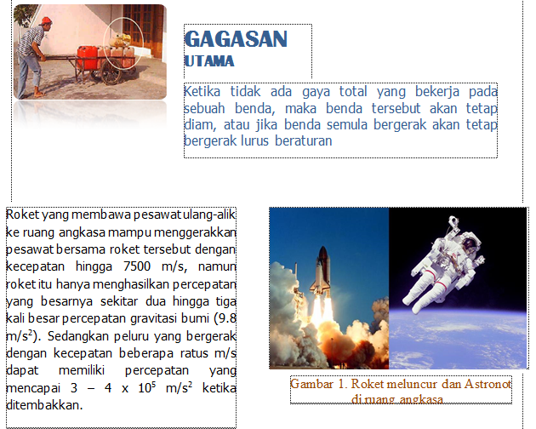  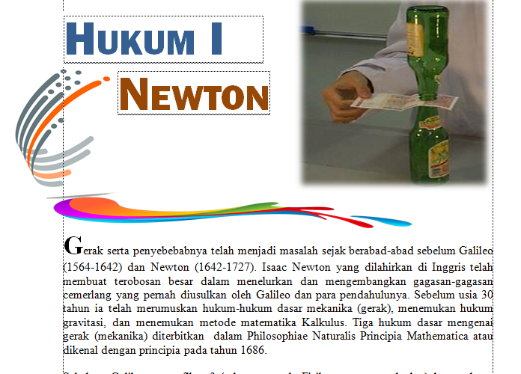Practice  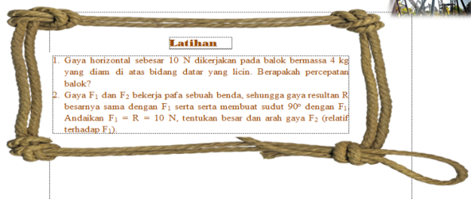  Mengenal Fisika Beta  “Begitu Dekat dan Nyata”    Summary  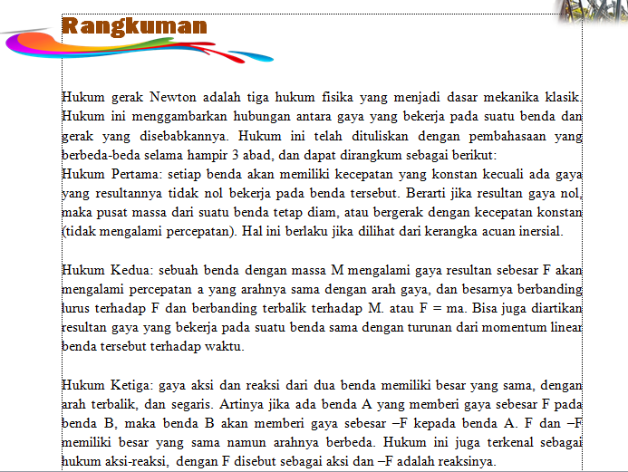Evaluation test  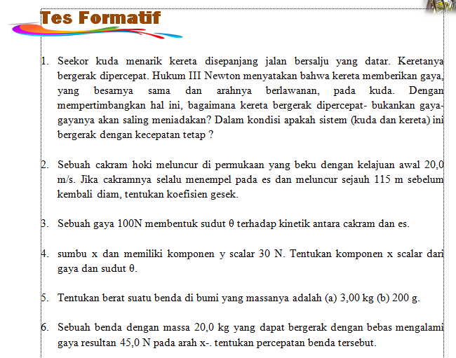

Development
In this development phase, products began to be developed that were in accordance with the learning approach and model used, namely the STEM Problem Based Learning and also developing validation instruments used to measure and assess the products being developed. The product developed has been repaired with peers and has gone through the self-evaluation stage which resulted in a specific prototype. At this phase it is modified by using Tessmer's formative evaluation consisting of expert reviews, which aims to validate the modules that have been developed then after that one to one test, and a small group test where to assess the practicality of the developed module.

3.4 Expert Review
The product of this research is in the form of a physics module based on STEM problem based learning on Newton's Law Material, which has been carried out in the self-evaluation and repair phase with peers which produces a specific prototype. Next to the expert review phase, it involves 6 validators/experts consisting of 2 material experts, 2 design experts and 2 linguists. Based on the results of discussions with experts, it turns out that some improvements or revisions still have to be made to some parts of the module, including content, writing format, layout, images and color combinations in the module so that it can be seen that the module developed meets the valid criteria. After fulfill the valid criteria, the module can then be tested at a later phase as well as the writing format and layout so that it can be tested later. The expert review score on the module can be seen in table 2 below.
Table 2. Results of the Interpretation of the Validation Test

Expert | Expert 1 | Expert 2 | Mean | Category
Material | 1 | 1 | 1 | very decent
Design | 0,93 | 0,89 | 0,91 | very decent
Linguist | 0,91 | 1 | 0,95 | very decent

3.5 One to One
One to one stage was carried out on 3 students of SMA senior high school. The physics module that has been revised is based on comments and suggestions from peers along with the expert review stage, namely in the form of a specific prototype, the physics module is tested on students. Students are selected, based on the category of high, medium and low ability levels as measured by student test scores and determined by the Standard Deviation formula. On the practicality assessment sheet, there is also a comment and suggestion. Where comments and suggestions from students are used as evaluation material for the product being developed. In trying out the physics module, students are given a product in the form of a specific prototype. Each of the students is given a practical assessment questionnaire regarding the physics module. After students provide comments and suggestions and fill out a questionnaire sheet. The results of the practicality questionnaire obtained an average value of 0.74 with the moderate or practical category.

3.6 Small Group
The revised physics module based on comments and suggestions from the expert review stage and the one to one stage, namely in the form of prototype I. Prototype I was tried out at the small group stage involving 9 students consisting of 3 high category students, 3 medium category students and 3 students low category. Students selected are also based on high, medium and low categories as seen from the student's ipk. In the small group stage, just like the one to one stage, students are given a physics module in the form of prototype I, and then asked to fill out a practical assessment questionnaire and provide comments and suggestions. Comments and suggestions at the small group stage are used as material for product revisions.
The results of the practicality questionnaire obtained an average value of 0.84 with the high or very practical category. This shows that the physics module based on STEM Problem Based Learning material of Newton's laws motion that was developed can be used in the learning process in high school.

IV. Result
The result of this research is a produce senior high school physics module based on STEM Problem Based Learning on Newton’s Motion Law Material and has been proven valid and practical using the modified ADDIE model using Tessmer's formative evaluation. Based on the results of the research that has been done, at the expert review stage, the material expert score was 1 in the very valid category, the design expert's score was 0.91 in the very valid category and the linguist's score was 0.95 with the very valid category. Based on the one to one and small group trials, it was obtained an average score of 0.74 in the medium category and 0.84 which means very practical

DATAR PUSTAKA
Ismail, Z. (2018). Benefits of STEM Education. (September). Retrieved from https://assets.publishing.service.gov.uk/media/5c6c0ec740f0b647abb525a7/418_Benefits_of_STEM_Education.pdf
Lase, D. (2019). EDUCATION AND INDUSTRIAL REVOLUTION 4.0 Delipiter. Jurnal Handayani, 10(1), 48–62. https://doi.org/10.24114/jh.v10i1
Nugroho, O. F., Permanasari, A., & Firman, H. (2019). The movement of stem education in Indonesia: Science teachers’ perspectives. Jurnal Pendidikan IPA Indonesia, 8(3), 417–425. https://doi.org/10.15294/jpii.v8i3.19252
Schäfer, M. (2018). the Fourth Industrial Revolution: How the Eu Can Lead It. Tạp Chí Nghiên Cứu Dân Tộc, (23). https://doi.org/10.25073/0866-773x/94
Stohlmann, M., Moore, T., & Roehrig, G. (2012). Considerations for Teaching Integrated STEM Education. Journal of Pre-College Engineering Education Research, 2(1), 28–34. https://doi.org/10.5703/1288284314653
Weber, E. (2015). Industrie 4.0 – Wirkungen auf Wirtschaft und Arbeitsmarkt. Wirtschaftsdienst, 95(11), 722–723. https://doi.org/10.1007/s10273-015-1894-8
White, D. W. (2012). What Is STEM Education and Why Is It Important? Congressional Research Service, (August), 1–15. Retrieved from https://www.ccc.edu/departments/Documents/STEM_labor.pdf

