Mercury Content of *Sardinella lemuru* Caught in East Java and Bali Waters

Aida Sartimbul1,2*, Janu Alfiqry Amandani1, Defri Yona1,2, M Arif Zainul Fuad1,2

1Faculty of Fisheries and Marine Science, Brawijaya University, Malang 65145, East Java, Indonesia

2Marine Resources Exploration and Management (MEXMA) Research Group, Brawijaya University, Malang 65145, East Java, Indonesia

aida@ub.ac.id

**Abstract**. *Sardinella lemuru* is a small pelagic fish which is mostly caught in Java and Bali waters. It is important because of its high Omega-3 fatty acid. As pelagic fish that are found in relatively shallow waters and near the coast, it could be contaminated from the land. The purpose of this study is to analyse the mercury content of *S. lemuru* caught in three fishing ground in East Java (Prigi and Muncar) and Bali (Kedonganan). Fish samples were collected from November 2019 to March 2020 and analysed their mercury content by using Atomic Absorption Spectroscopy (AAS). Furthermore, the Estimated Daily Intake (EDI) and Maximum Tolerable Intake (MTI) were also calculated. The results showed that mercury concentration in *S. lemuru* were 0.938 ± 0.45 mg / kg and 0.58 ± 0.65 mg / kg for Kedonganan and Prigi, respectively. While, there is undetected mercury for Muncar fish samples. The mercury concentration identified are above the Indonesia standards (SNI and BPOM = 0.5mg / kg). Moreover, the EDI value was higher than Provisional Tolerable Daily Intake -WHO. The mean value of MTI is 0.121 mg / week. If fish contaminated mercury was consumed in one week exceeds the MTI value, the heavy metal could affect the human health.

Keywords : ***Sardinella lemuru*, mercury, East Java, Bali, EDI, MTI**

1. Introduction

Pelagic fish is one of the fish that is very popular with the people of Indonesia because it is abundant and relatively cheap. This fish is easy to find because of its presence in shallow waters and close to the coast. This fish is a schooling species and forms high biomass around the upwelling area, such as Bali Strait to South Java[1]–[3]. Upwelling is the process of rising seawater mass from the bottom to the sea surface which carries a lot of nutrients for fish life[4], [5].

In addition to being abundant, *S. lemuru* has benefits because it contains high Omega-3 fatty acids[6] which are the 3rd highest after mackerel and salmon[7]. Omega-3 is known to be useful for human health, such as preventing coronary heart disease[8], preventing stunting[9], maintaining immunity[10], and many other benefits. Although *S. lemuru* has high benefits, due to its presence on the surface of the water, it is necessary to be aware of the presence of heavy metal pollutants (such as mercury) which are harmful to human health.

It has been documented that mercury causes the death of many people in Minamata Japan due to intake of mercury-tainted seafood[11]. Mercury, a poisonous metal, has been shown to accumulate biologically in the tissues of fish, and humans who consume it[12]. Previous studies reported that mercury is found in some waters and sediments where there is a lot of human activity[13]. Mercury is also found in various marine products, such as Crassostrea cuculata oysters and Crassostrea glomerate[14]. However, information on mercury content in pelagic fish in East Java and Bali waters is very limited, for example monitoring of mercury in several fish species including pelagic fish in Gresik waters (East Java)[15].

Limited information regarding the content of heavy metals in *S. lemuru* is the reason for this study. The results of this study are expected to provide important information for the community so that people are more alert and know the safe limits of consuming *S. lemuru* and can become one of the government inputs in food safety policy.

1. Material and Method

*Sardinella lemuru* used in this study represented commercially available fish species most consumed by the community and the most abundant catch of the season. The study sites are in the South of East Java and the Bali Strait which is known as the fishing ground of *S. lemuru* in Indonesia. There were three sampling sites of this study, i.e. Prigi Water (South of East Java), Muncar Water (East of East Java) and Kedonganan (Bali Water) (Figure 1). Sampling was conducted from November 2019 to March 2020. Fish samples put in a plastic bag and stored in the refrigerator, then soon analyzed in the laboratory.

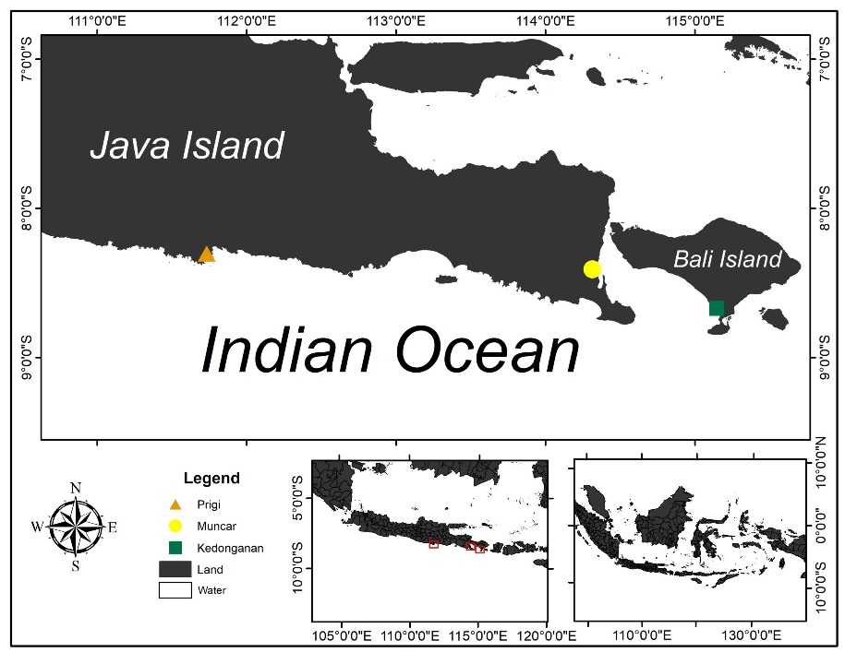

Figure 1. The three biggest fish landing of *Sardinella lemuru* in East Java and Bali Water: Prigi (red triangle), Muncar (yellow circle) and Kedonganan (green square).

Heavy metal analysis

Sample preparation was conducted by separating the digestive tract, gills, and meat from each fish then mashed and weighed up to - + 5gr. The sample was then subjected to a wet digestion process using Aquaregia reagent and analysis using Atomic Absorption Spectroscopy (AAS).

Data analysis

Estimated Daily Intake (EDI) is used to determine the estimation of heavy metals that enter the body within 1 day obtained by formula 1 below[16]:

$EDI=C \left(mg/kg\right)×daily fish consumption (g/day)$ (1)

C is the heavy metal concentration found in the sample; The daily fish consumption of the people of East Java is 45.2 grams/day in Bali Province, which is 37.7 grams/day [17].

Maximum Tolerable Intake (MTI) is used to determine the value of weekly consumption that can be tolerated by the body in units of mg/kg. Before looking for the MTI value, first, the Maximum Weekly Intake (MWI) value is calculated using formula 2 below:

$MWI=BW×PTWI (Provisional Tolerable Weekly Intake)$ (2)

BW is the estimated body weight of adults in Indonesia, which is 60kg. The PTWI value is the maximum tolerance limit per week issued by the WHO (World Health Organization). The PTWI value of the heavy metal mercury is 0.004 mg/kg body weight. The maximum weight limit for *S. lemuru* meat that the body can tolerate in one week (MTI) can then be calculated using the formula below [18]:

$MTI=\frac{MWI}{heavy metal concentrations in fish samples}$ (3)

The results of MTI calculations can then become a consideration for the community in consuming *S. lemuru* in a week.

1. Result and Discussion

The concentration of mercury obtained in *S. lemuru* samples is shown in Figure 2. The concentration of mercury obtained at the Prigi fishing ground is 0.58 ± 0.65 mg/kg, Kedonganan fishing ground is 0.938 ± 0.45 mg/kg, and fishing ground Muncar is undetectable.

If a comparison is made with the concentration of mercury in fish in other locations in the world (Table 2), the mercury concentration obtained in this study is quite high. The mercury concentration obtained is above the threshold value issued by BPOM and SNI, which is 0.5 mg/kg. In general, Mercury enters the waters due to human activities such as the gold craft industry around the estuarine of Mati River, Badung Regency, Bali Province[19] and can also be sourced from gold mining activities that produce mercury waste and are carried by rivers and toward into the sea[20], a mixture of facial / skin whitening ingredients (cosmetics), gold mining/gold processing waste, electrical equipment, antiseptic, diuretic, anti-fungal, insect repellent, and can be used as a preservative in vaccines [21], [22].

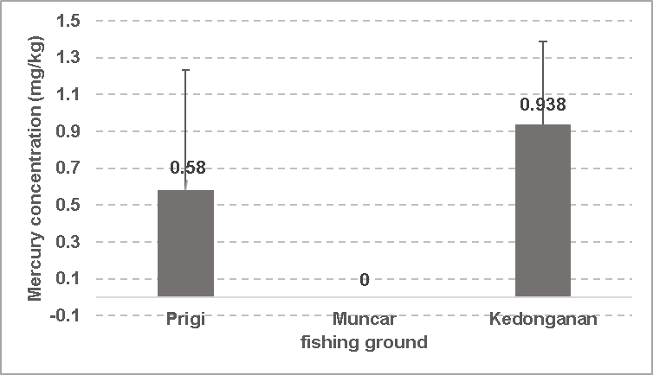

Figure . Mercury concentrations in *S. lemuru* caught in Prigi, Muncar, and Kedonganan fishing ground. Mercury concentration in *S. lemuru* caught in Prigi and Muncar fishing grounds exceeded the safe threshold.

In this study, a negative correlation was found between the concentration of heavy metals in *S. lemuru* and fish size (Figure 3). The Pearson coefficient value obtained is 0.392 which means that there is a weak correlation. The negative correlation between heavy metal concentrations and fish size does not necessarily mean that fish do not receive heavy metal concentrations at the beginning of their life phase, and absorb heavy metals when they are large; conversely, it is determined by the variation in feeding rate with the developmental stages of individual fish[23]. The concentration of heavy metals contained in fish depends on the balance between absorption and release of heavy metals, both of which are influenced by various factors such as habitat, location, feeding behavior, and life stage of the fish. Young individuals with high dietary and metabolic activity showed a higher accumulation of heavy metals when compared to older fish[24]. High concentrations of mercury were also present in a study conducted by [25] on Luvar fish (*Luvarus imperialis*) and tuna fish (*Thunnus spp.*), heavy metals can accumulate in the fish body through the bioaccumulation process.

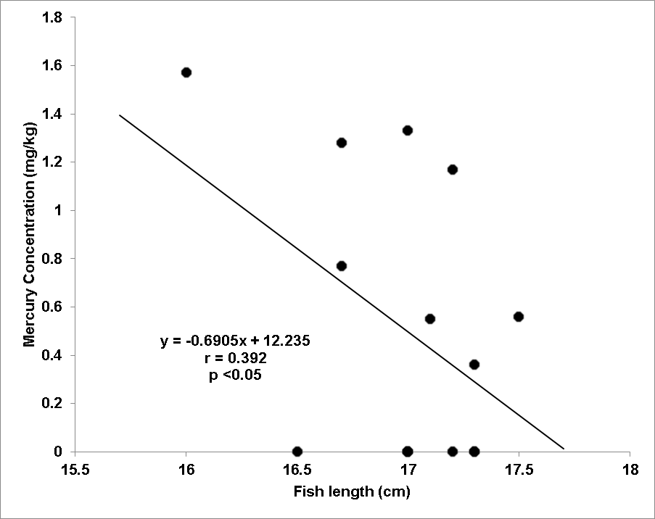

Figure 3. Weak correlation between fish length and mercury concentration.

The estimated daily intake (EDI) obtained was above the PTDI (Provisional Tolerable Daily Intake) value set by WHO, namely 0.00057 mg/kg/day (Table 1). This value states that the concentration of heavy metals that enter the body in one day is already above the body's tolerance value for heavy metal mercury, of course, this can affect the health of the consumer's body[26].

The Maximum Tolerable Intake (MTI) obtained in the sample has very lightweight. This indicates that *S. lemuru* contains very high concentrations of mercury. The maximum value of mercury concentration that can enter the body (MWI) for adults assuming a weight of 60kg is 0.24 mg Hg/week. If people consume *S. lemuru* that exceeds the MTI value, the heavy metal is toxic in the human body [26], [27].

Table 1. EDI (Estimated Daily Intake) and MTI (Maximum Tolerable Intake) value.

|  |  |  |
| --- | --- | --- |
| *Fishing ground* | Estimated Daily Intake Mercury (Hg) | MTI Mercury / Hg (mg fish /week) |
| Prigi | 0,026 | 0,414 |
| Muncar | 0 | 0,000 |
| Kedonganan | 0,035 | 0,256 |
| Average | 0,031 | 0,223 |

Table 2. Comparison of heavy metal concentration from different locations in the world

| Location | Species | Hg | Reference |
| --- | --- | --- | --- |
| Arabian Gulf | *Stolephorus indicus* | 0.053 | [28] |
| Black Sea, Turkey | *Psetta maxima* | 0,045 ± 0,02 | [29] |
|  | *Scomber scombrus* | 0,060 ± 0,03 |  |
|  | *Merlangius merlangus* | 0,084 ± 0,05 |  |
|  | *Mugil cephalus* | 0,070 ± 0,04 |  |
|  | *Pomatomus saltor* | 0,062 ± 0,03 |  |
|  | *Trachurus trachurus* | 0,078 ± 0,05 |  |
| The Congolese Atlantic Coastal, Republic of Congo | *Arius latiscutatus* | 0.41±0.23 | [30] |
|  | *Pentanemus quinquarius* | 0.47±0.32 |  |
|  | *Pseudotolithus elongatus* | 0.49±0.32 |  |
|  | *Pseudotolithus senegalensis* | 0.33±0.08 |  |
|  | *Trichiurus lepturus* | 0.34±0.18 |  |
| Tunisian Sea | *Sardinella aurita* | 0.339 | [31] |
|  | *Sardina pilchardus* | 0.647 |  |
| Atlantic Ocean, South east Brazil | *Sardinella brasiliensis* | 0.128 ± 0.045 | [32] |
|  | *Caranx latus* | 0.211 ± 0.113 |  |
|  | *Katsuwonus pelamis* | 0.210 ± 0.362 |  |
| Peninsular, Malaysia | *Selaroides leptolepis* | 0.252 | [33] |
|  | *Selar boops* | 0.555 |  |
|  | *Atule mate* | 0.458 |  |
|  | *Decapterus muruadsi* | 0.317 |  |
|  | *Decapterus macrosoma* | 0.354 |  |
|  | *Megalaspis cordyla* | 0.319 |  |
| Prigi (Indonesia) | *Sardinella lemuru* | 0,58±0,65 | This research |
| Muncar (Indonesia) | *Sardinella lemuru* | 0 | This research |
| Kedonganan (Indonesia) | *Sardinella lemuru* | 0,938±0,45 | This research |

1. Conclusion

The heavy metal mercury found in *S. lemuru* is above the threshold set by BPOM and SNI. Heavy metal concentrations were also found to be above average mercury in fish in other countries. There is a negative correlation between fish size and the concentration of heavy metal mercury, this is influenced by the habitat, location, feeding behavior, and life stage of the fish. Estimated Daily Intake (EDI) is above the PTDI provisions issued by the WHO. The Tolerable Weekly Intake (TWI) obtained has a small weight because it contains a very high concentration of mercury for consumption. This study provides important information for the community so that people are more alert and know the safe limits of consuming *S. lemuru* and can become one of the government inputs in food safety policy.

1. Acknowledgement

The author would like to thank all those who helped in the preparation of this article, especially the Ministry of Research and Technology-National Research and Innovation Agency of the Republic of Indonesia and the Ministry of Education and Culture - Higher Education of the Republic of Indonesia for publication funding.

Reference

[1] G. R. A. Kartika, A. Sartimbul, and W. Widodo, “*Varian Genetik Sardinella Lemuru Di Perairan Selat Bali*,” *JK*, vol. **10**, no. 1, Art. no. 1, May 2017, doi: 10.21107/jk.v10i1.1615.

[2] A. Sartimbul, E. Rohadi, S. N. Ikhsani, and D. Listiyaningsih, “*Morphometric and meristic variations among five populations of Sardinella lemuru Bleeker, 1853 from waters of Bali Strait, northern and southern- east Java and their relation to the environment*,” vol. **11**, no. 3, p. 10, 2018.

[3] P. J. P. Whitehead, “*FAO SPECIES CATALOGUE Vol.7. Clupeoid fishes of the world (Suborder Clupeoidei) : An annotated and illustrated catalogue of the herrings, sardines, pilchards, sprats, shads, anchovies and wolf-herrings.*,” vol. **7**, FAO, 1985, pp. 103–104.

[4] R. D. Susanto, T. S. Moore, and J. Marra, “*Ocean color variability in the Indonesian Seas during the SeaWiFS era: OCEAN COLOR VARIABILITY*,” *Geochem. Geophys. Geosyst.*, vol. **7**, no. 5, p. n/a-n/a, May 2006, doi: 10.1029/2005GC001009.

[5] R. B. yoga, H. Setyono, and G. Harsono, “*Dinamika Upwelling Dan Downwelling Berdasarkan Variabilitas Suhu Permukaan Laut Dan Klorofil-A Di Perairan Selatan Jawa*,” *Jurnal Oseanografi*, vol. **3**, no. 1, pp. 57–66, 2014.

[6] Mahrus, S. B. Sumitro, N. Widodo, and A. Sartimbul, “*The Association between Genetic Variations and Omega-3 Production on Sardinella lemuru in Lombok Strait*,” *IOSRJAVS*, vol. **1**, no. 6, Art. no. 6, 2012, doi: 10.9790/2380-0161216.

[7] N. Rubio-Rodríguez, S. Beltrán, I. Jaime, S. M. de Diego, M. T. Sanz, and J. R. Carballido, “*Production of omega-3 polyunsaturated fatty acid concentrates: A review*,” *Innovative Food Science & Emerging Technologies*, vol. **11**, no. 1, pp. 1–12, Jan. 2010, doi: 10.1016/j.ifset.2009.10.006.

[8] S. Wahjuni, *Omega-3 dapat Menurunkan Inflamasi Akibat Hiperkolesterolemia*, 1st ed. Kampus Universitas Udayana Denpasar: Udayana University Press, 2016.

[9] N. Muslihah, A. Khomsan, D. Briawan, and H. Riyadi, “*Complementary food supplementation with a small-quantity of lipid-based nutrient supplements prevents stunting in 6-12-month-old infants in rural West Madura Island, Indonesia*,” *Asia Pacific Journal of Clinical Nutrition*, vol. **25**, no. S1, Dec. 2016, doi: 10.6133/apjcn.122016.s9.

[10] S. Gutiérrez, S. L. Svahn, and M. E. Johansson, “*Effects of Omega-3 Fatty Acids on Immune Cells*,” *IJMS*, vol. **20**, no. 20, p. 5028, Oct. 2019, doi: 10.3390/ijms20205028.

[11] T. Nitta, *Marine pollution in Japan, in Marine Pollution and Sea Life: M. Ruivo (Ed.),*. Rome: West Byfleet, Surrey, Fishing News, 1972.

[12] D. H. Adams and G. V. Onorato, “*Mercury concentrations in red drum, Sciaenops ocellatus, from estuarine and offshore waters of Florida*,” *Marine Pollution Bulletin*, vol. **50**, no. 3, pp. 291–300, Mar. 2005, doi: 10.1016/j.marpolbul.2004.10.049.

[13] D. Vélez and R. Montoro, “*Arsenic Speciation in Manufactured Seafood Products*,” *Journal of Food Protection*, vol. **61**, no. 9, pp. 1240–1245, Sep. 1998, doi: 10.4315/0362-028X-61.9.1240.

[14] A. M. S. Hertika, K. Kusriani, E. Indrayani, D. Yona, and R. B. D. S. Putra, “*Metallothionein expression on oysters (Crassostrea cuculata and Crassostrea glomerata) from the southern coastal region of East Java [version 2; peer review: 2 approved]*,” *F1000Research*, vol. **8**, no. 56, pp. 1–17, 2020, doi: https://doi.org/10.12688/f1000research.17381.2.

[15] A. Soegianto, N. Moehammadi, B. Irawan, M. Affandi, and Hamami, “*Mercury concentrations in edible species harvested from Gresik coast, Indonesia and its health risk assessment*,” *Cah. Biol. Mar*, vol. **51**, pp. 1–8, 2010.

[16] E. Junqué, M. Garí, A. Arce, M. Torrent, J. Sunyer, and J. O. Grimalt, “*Integrated assessment of infant exposure to persistent organic pollutants and mercury via dietary intake in a central western Mediterranean site (Menorca Island),*” *Environmental Research*, vol. **156**, pp. 714–724, Jul. 2017, doi: 10.1016/j.envres.2017.04.030.

[17] Kementerian Pertanian, “*Direktori Perkembangan Konsumsi Pangan*.” Badan Ketahanan Pangan Kementerian Pertanian, 2019.

[18] M. Türkmen, A. Türkmen, Y. Tepe, A. Ateş, and K. Gökkuş, “*Determination of metal contaminations in sea foods from Marmara, Aegean and Mediterranean seas: Twelve fish species*,” *Food Chemistry*, vol. **108**, no. 2, Art. no. 2, May 2008, doi: 10.1016/j.foodchem.2007.11.025.

[19] H. Sumekar, I. E. Suprihatin, and Irdhawati, “*Kandungan Logam Pb Dan Hg Dalam Sedimen Di Muara Sungai Matikabupaten Badung Bali*,” *Journal of Applied Chemistry*, vol. **3**, p. 5, 2015.

[20] M. Junaidi, B. D. Krisnayanti, and C. Anderson, “*Risk of Mercury Exposure from Fish Consumption at Artisanal Small-Scale Gold Mining Areas in West Nusa Tenggara, Indonesia*,” *Journal of Health and Pollution*, vol. **9**, no. 21, pp. 1–10, Mar. 2019, doi: 10.5696/2156-9614-9.21.190302.

[21] T. W. Clarkson and L. Magos, “*The Toxicology of Mercury and Its Chemical Compounds*,” *Critical Reviews in Toxicology*, vol. **36**, no. 8, pp. 609–662, Jan. 2006, doi: 10.1080/10408440600845619.

[22] T. T. Putranto, “P*encemaran Logam Berat Merkuri (Hg) Pada Airtanah*,” vol. **32**, no. 1, p. 10, 2011.

[23] A. Farkas, J. Salánki, and A. Specziár, “*Age and size specific patterns of heavy metals in the organs of freshwater fish Abramis brama L. populating a low-contaminated site*,” *Water Research*, vol. **37**, no. 5, pp. 959–964, Mar. 2003, doi: 10.1016/S0043-1354(02)00447-5.

[24] J.-L. Liu *et al.*, “*Heavy metals in wild marine fish from South China Sea: levels, tissue- and species-specific accumulation and potential risk to humans*,” *Ecotoxicology*, vol. **24**, no. 7–8, pp. 1583–1592, Oct. 2015, doi: 10.1007/s10646-015-1451-7.

[25] V. Yusa, T. Suelves, L. Ruiz-Atienza, M. L. Cervera, V. Benedito, and A. Pastor, “*Monitoring programme on cadmium, lead and mercury in fish and seafood from Valencia, Spain: levels and estimated weekly intake*,” *ing.agua*, vol. **1**, no. 1, p. ix, Jul. 2008, doi: 10.4995/ia.2014.3293.

[26] M. F. Rayyan, D. Yona, and S. H. J. Sari, “*Health Risk Assessments Of Heavy Metals Of Perna Viridis From Banyuurip Waters In Ujung Pangkah, Gresik*,” *JFMR*, vol. **3**, no. 2, pp. 9–17, Jul. 2019, doi: 10.21776/ub.jfmr.2019.003.02.2.

[27] F. Mirawati, E. Supriyantini, and R. A. T. Nuraini, “*Kandungan Logam Berat Timbal (Pb) Pada Air, Sedimen, Dan Kerang Hijau (Perna viridis) Di Perairan Trimulyo Dan Mangunharjo Semarang*,” *Bul. Oseano. Mar.*, vol. **5**, no. 2, Art. no. 2, Oct. 2016, doi: 10.14710/buloma.v5i2.15731.

[28] N. Alizada, S. Malik, and S. B. Muzaffar, “*Bioaccumulation of heavy metals in tissues of Indian anchovy (Stolephorus indicus) from the UAE coast, Arabian Gulf*,” *Marine Pollution Bulletin*, vol. **154**, p. 111033, May 2020, doi: 10.1016/j.marpolbul.2020.111033.

[29] M. Tuzen, “*Toxic and essential trace elemental contents in fish species from the Black Sea, Turkey*,” *Food and Chemical Toxicology*, vol. **47**, no. 8, Art. no. 8, Aug. 2009, doi: 10.1016/j.fct.2009.04.029.

[30] R. B. Suami *et al.*, “*Concentration of heavy metals in edible fishes from Atlantic Coast of Muanda, Democratic Republic of the Congo*,” *Journal of Food Composition and Analysis*, vol. **73**, pp. 1–9, Oct. 2018, doi: 10.1016/j.jfca.2018.07.006.

[31] C. R. Joiris, L. Holsbeek, and N. Laroussi moatemri, “*Total and Methylmercury in Sardines Sardinella aurita and Sardina pilchardus from Tunisia*,” *Marine Pollution Bulletin*, vol. **38**, no. 3, pp. 188–192, Mar. 1999, doi: 10.1016/S0025-326X(98)00171-4.

[32] C. A. da Silva, E. Tessier, V. T. Kütter, J. C. Wasserman, O. F. X. Donard, and E. V. Silva-Filho, “*Mercury speciation in fish of the Cabo Frio upwelling region, SE-Brazil*,” *Braz. j. oceanogr.*, vol. **59**, no. 3, pp. 259–266, Sep. 2011, doi: 10.1590/S1679-87592011000300006.

[33] N. I. Ahmad *et al.*, “*Mercury levels of marine fish commonly consumed in Peninsular Malaysia,*” *Environ Sci Pollut Res*, vol. **22**, no. 5, pp. 3672–3686, Mar. 2015, doi: 10.1007/s11356-014-3538-8.